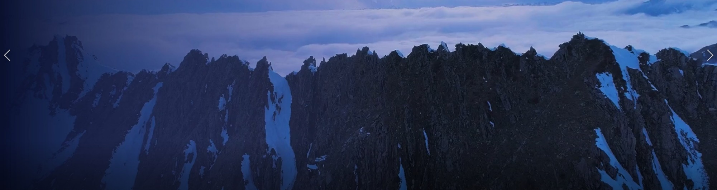
Men’s Advance from CCC

When: Thursday February 23re 5pm – Saturday February 25th 5pm 2023

Cost: $50

What’s included? Food, lodging, tell Sky or Kellen by March 20th if you definitely need a bed, if not, half of us will be on the floor with your own mat). Also tell us, if you have any room on your sled or an extra sled so that we can point people to you if they don’t have one.

What can we do there?
Campfire, clay pigeon shooting, snow machine ride, ptarmigan hunt, play cards/games, ice fishing

Schedule:
Thursday 5pm Leave church parking lot
Thursday 6pm Leave on snow machines from East end parking lot
Saturday 4pm Leave East End parking lot back to church
Directions:

Coordinates to Basargin rd. Parking lot: 59.83349, -151.10063
Coordinate to Rocky’s cabin on Caribou lake: N 59 53 47.879 W 151 02 28.795

Directions to Basargin rd blue shed parking lot: Go out east end about 19 miles, turn left on Basargin rd, go about 3.5 miles to take a left on Willard Rd.
What to bring:
- Sleeping bag
- Sleeping mat/cot
- Earplugs (snoring)
- Towel
- Gun
- Pen/notepad
- Bible
- Water bottle

Contact Sky Cady (907-299-1483) or Kellen Stock for more information


There is no cell service at the lake. Kellen will have his InReach for emergencies, if you need to get hold of your husband please text Jess at 907-395-7285 and she will text him and pass a message along. Please only use this for emergencies!

Thank you men!
See you there!

