Faith Evangelical Lutheran Church, Washington, IL
Reformation Sunday
October 30, 2022

Welcome
Confession and Forgiveness

P: In the name of the Father, and of the + Son, and of the Holy Spirit.
C: Amen.
You may make the sign of the cross as a reminder of your baptism.
P: Almighty God, to whom all hearts are open, all desires known, and from whom no secrets are hid: cleanse the thoughts of our hearts by the inspiration of your Holy Spirit, that we may perfectly love you and worthily magnify your holy name, through Jesus Christ our Lord.
C: Amen.
P: Let us confess our sin in the presence of God and of one another.
Please keep silence for reflection
P: Most merciful God,
C: we confess that we are captive to sin and cannot free ourselves. We have sinned against you in thought, word, and deed, by what we have done and by what we have left undone. We have not loved you with our whole heart; we have not loved our neighbors as ourselves. For the sake of your Son, Jesus Christ, have mercy on us. Forgive us, renew us, and lead us, so that we may delight in your will and walk in your ways, to the glory of your holy name. Amen.
P: In the mercy of almighty God, Jesus Christ was given to die for us, and for his sake God forgives us all our sins. As a called and ordained minister of the church of Christ, and by his authority, I therefore declare to you the entire forgiveness of all your sins, in the name of the Father, and of the + Son, and of the Holy Spirit.
C: Amen.
Faith Lutheran Church
2206 Washington Rd,
Washington, IL 61571
Website and online worship:
www.shareourfaith.org
Church: 309-745-9306
faithlth@shareourfaith.org
Pastor John Rothfusz
Home: 309-745-9282
pastor@shareourfaith.org
Peace: As forgiven children of God, we have peace
with God, and peace with one another.
P The peace of the Lord be with you always.
C And also with you.
P Let us share that peace with one another.

Hymn Sing – Please raise your hand and call out the number of a favorite song from the red book.

P The Lord be with you
C And also with you.
Let us pray together the Prayer of the Day.
Almighty God, gracious Lord, we thank you that your Holy Spirit renews the church in every age. Pour out your Holy Spirit on your faithful people. Keep them steadfast in your word, protect and comfort them in times of trial, defend them against all enemies of the gospel, and bestow on the church your saving peace, through Jesus Christ, our Savior and Lord, who lives and reigns with you and the Holy Spirit, one God, now and forever. Amen.

Children’s Message

First Reading: Jeremiah 31:31-34 Pew Bible Page #634
³¹The days are surely coming, says the Lord, when I will make a new covenant with the house of Israel and the house of Judah. ³²It will not be like the covenant that I made with their ancestors when I took them by the hand to bring them out of the land of Egypt—a covenant that they broke, though I was their husband, says the Lord. ³³But this is the covenant that I will make with the house of Israel after those days, says the Lord: I will put my law within them, and I will write it on their hearts; and I will be their God, and they shall be my people. ³⁴No longer shall they teach one another, or say to each other, “Know the Lord,” for they shall all know me, from the least of them to the greatest, says the Lord; for I will forgive their iniquity, and remember their sin no more.

R The Word of the Lord
C Thanks be to God

Psalm 46 Read responsively by whole verse
¹God is our refuge and strength,
a very present help in trouble.
²Therefore we will not fear, though the earth be moved,
and though the mountains shake in the depths of the sea;
³though its waters rage and foam,
and though the mountains tremble with its tumult.
⁴There is a river whose streams make glad the city of God,
the holy habitation of the Most High.
⁵God is in the midst of the city; it shall not be shaken;
God shall help it at the break of day.
⁶The nations rage, and the kingdoms shake;
God speaks, and the earth melts away.
⁷The Lord of hosts is with us;
the God of Jacob is our stronghold.
⁸Come now, regard the works of the Lord,
what desolations God has brought upon the earth;
⁹behold the one who makes war to cease in all the world;
who breaks the bow, and shatters the spear, and burns the shields with fire.
¹⁰“Be still, then, and know that I am God;
I will be exalted among the nations; I will be exalted in the earth.”
¹¹The Lord of hosts is with us;
the God of Jacob is our stronghold.
Second Reading: Romans 3:19-28 Pew Bible Page #912
¹⁹Now we know that whatever the law says, it speaks to those who are under the law, so that every mouth may be silenced, and the whole world may be held accountable to God. ²⁰For “no human being will be justified in his sight” by deeds prescribed by the law, for through the law comes the knowledge of sin.
²¹But now, apart from law, the righteousness of God has been disclosed, and is attested by the law and the prophets, ²²the righteousness of God through faith in Jesus Christ for all who believe. For there is no distinction, ²³since all have sinned and fall short of the glory of God; ²⁴they are now justified by his grace as a gift, through the redemption that is in Christ Jesus, ²⁵whom God put forward as a sacrifice of atonement by his blood, effective through faith. He did this to show his righteousness, because in his divine forbearance he had passed over the sins previously committed; ²⁶it was to prove at the present time that he himself is righteous and that he justifies the one who has faith in Jesus.
²⁷Then what becomes of boasting? It is excluded. By what law? By that of works? No, but by the law of faith. ²⁸For we hold that a person is justified by faith apart from works prescribed by the law.

R The Word of the Lord
C Thanks be to God

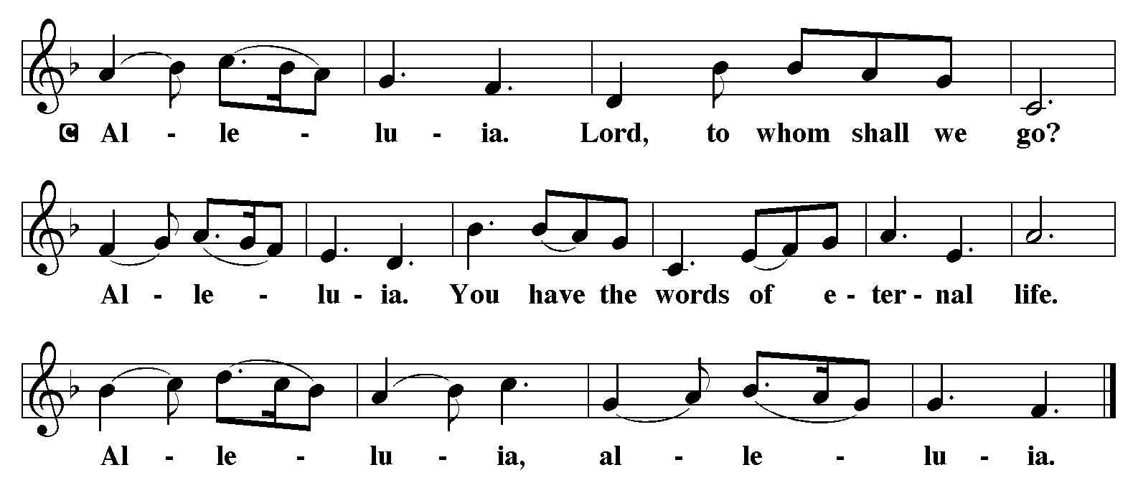

Gospel Reading: John 8:31-36 Pew Bible Page #867

C Glory to you, O Lord
³¹Jesus said to the Jews who had believed in him, “If you continue in my word, you are truly my disciples; ³²and you will know the truth, and the truth will make you free.” ³³They answered him, “We are descendants of Abraham and have never been slaves to anyone. What do you mean by saying, ‘You will be made free’?”
³⁴Jesus answered them, “Very truly, I tell you, everyone who commits sin is a slave to sin. ³⁵The slave does not have a permanent place in the household; the son has a place there forever. ³⁶So if the Son makes you free, you will be free indeed.”

The Gospel of the Lord
C Praise to you, O Christ

Sermon by Pastor John Rothfusz

Sermon Hymn: “The Church of Christ, in Every Age” Red Book #729

Apostles’ Creed
C: I believe in God, the Father almighty,
creator of heaven and earth.
I believe in Jesus Christ, God's only Son, our Lord,
who was conceived by the Holy Spirit,
born of the virgin Mary,
suffered under Pontius Pilate,
was crucified, died, and was buried;
he descended to the dead.
On the third day he rose again;
he ascended into heaven,
he is seated at the right hand of the Father,
and he will come to judge the living and the dead.
I believe in the Holy Spirit,
the holy catholic church, the communion of saints,
the forgiveness of sins, the resurrection of the body,
and the life everlasting. Amen.
Prayers: After each portion of the prayers finishes with “Lord in your mercy,” please respond, “Hear our prayer.”

Offering: Jesus is Lord, and leads us in the ways of life and salvation. Let us offer ourselves to the Lord and joyfully lift our tithes and offerings to God.

Please take a moment now to make an electronic offering to the church on the website, with the Tithe.ly app on your phone, or drop an envelope in the plate at communion time.
Faith Lutheran website link www.shareourfaith.org

Offering Prayer

Great Thanksgiving
P The Lord be with you.
C And also with you.
P Lift up your hearts.
C We lift them to the Lord.
P Let us give thanks to the Lord our God.
C It is right to give God thanks and praise.

P It is indeed right, our duty and our joy… with the church on earth and the hosts of heaven, we praise your name and join their unending hymn:
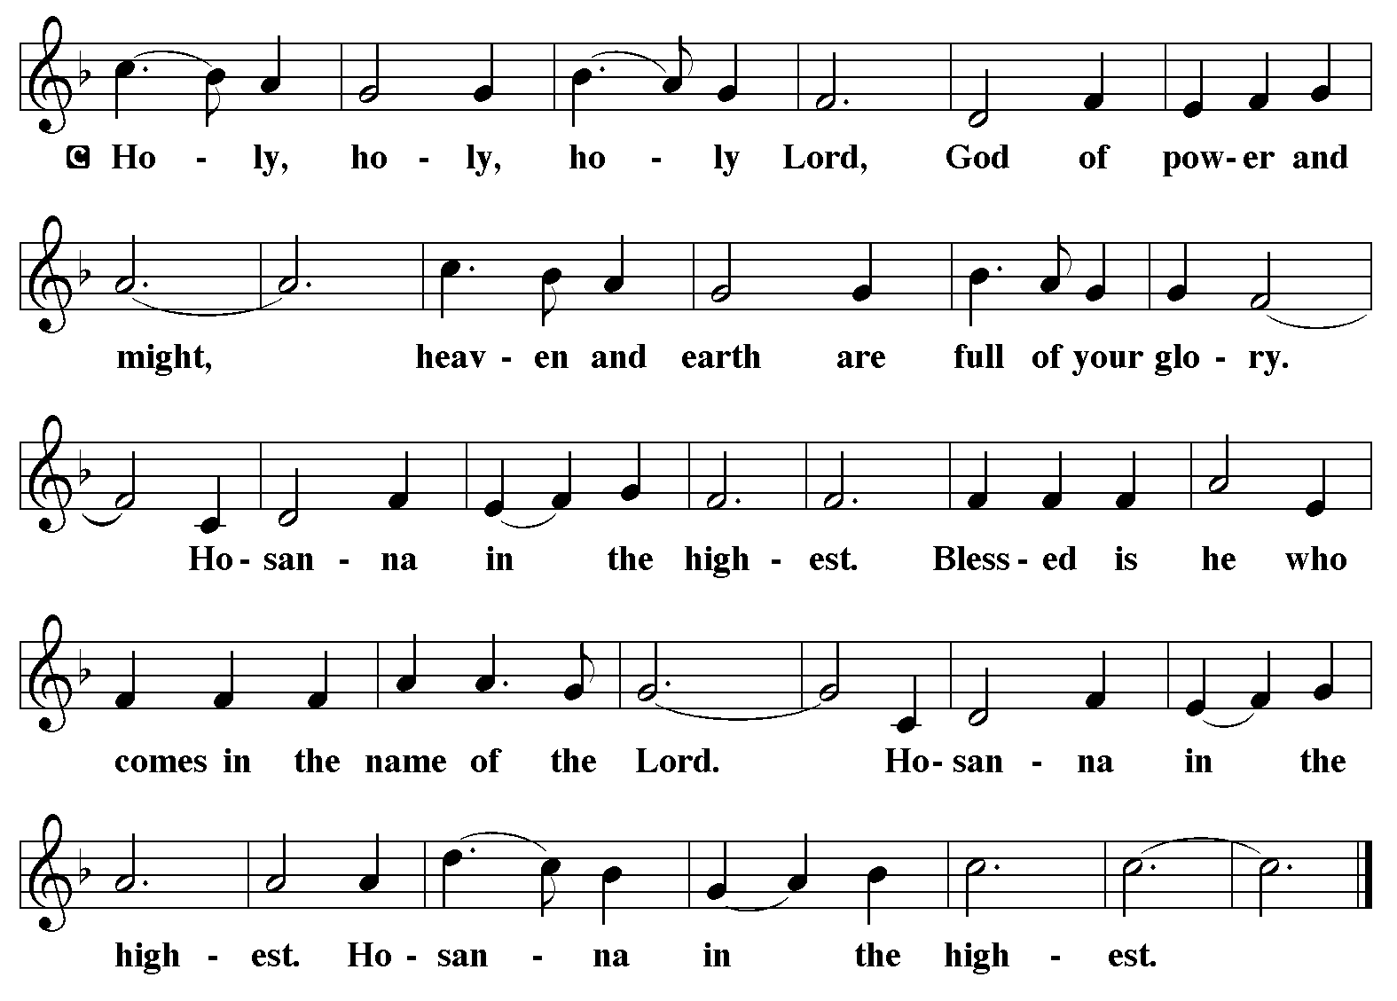

Holy Communion Preface pp. 108-111 or other Eucharistic prayer
In the night in which he was betrayed,
our Lord Jesus took bread, and gave thanks;
broke it, and gave it to his disciples, saying:
Take and eat; this is my body, given for you.
Do this for the remembrance of me.
Again, after supper, he took the cup, gave thanks,
and gave it for all to drink, saying:
This cup is the new covenant in my blood,
shed for you and for all people for the forgiveness of sin.
Do this for the remembrance of me.

C The Lord's Prayer
Our Father, who art in heaven, hallowed be thy name,
thy kingdom come, thy will be done, on earth as it is in heaven.
Give us this day our daily bread; and forgive us our trespasses,
as we forgive those who trespass against us;
and lead us not into temptation, but deliver us from evil.
For thine is the kingdom, and the power, and the glory,
forever and ever. Amen
Communion Distribution
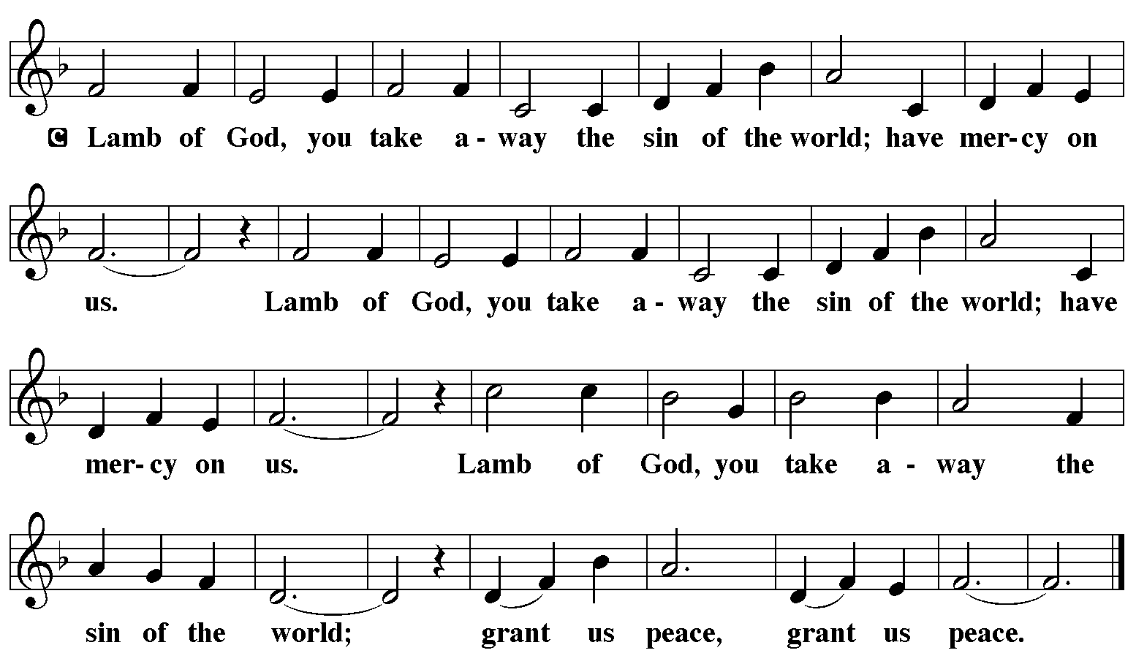

Communion Hymn: “O God, Our Help in Ages Past” Red Book #632

Communion Prayer

Announcements

Blessing
P The Lord bless you and keep you. The Lord make his face shine on you and be gracious to you. The Lord look upon you with favor and + give you peace. In the name of the Father, and of the Son and of the Holy Spirit.
C Amen

Hymn: “A Mighty Fortress Is Our God” Red Book #504

Text: Martin Luther, 1483-1546; tr. Lutheran Book of Worship, 1978
Music: EIN FESTE BURG, Martin Luther, 1483-1546
Text © 1978 Lutheran Book of Worship, admin. Augsburg Fortress
Reprinted under OneLicense.net#A-711151

Dismissal
A Go in peace. Serve the Lord.
C Thanks be to God!

Postlude
Liturgy and texts from Sundays and Seasons.com. Copyright 2022 Augsburg Fortress. All rights reserved.
Reprinted by permission under Augsburg Fortress Liturgies Annual License #23628.

