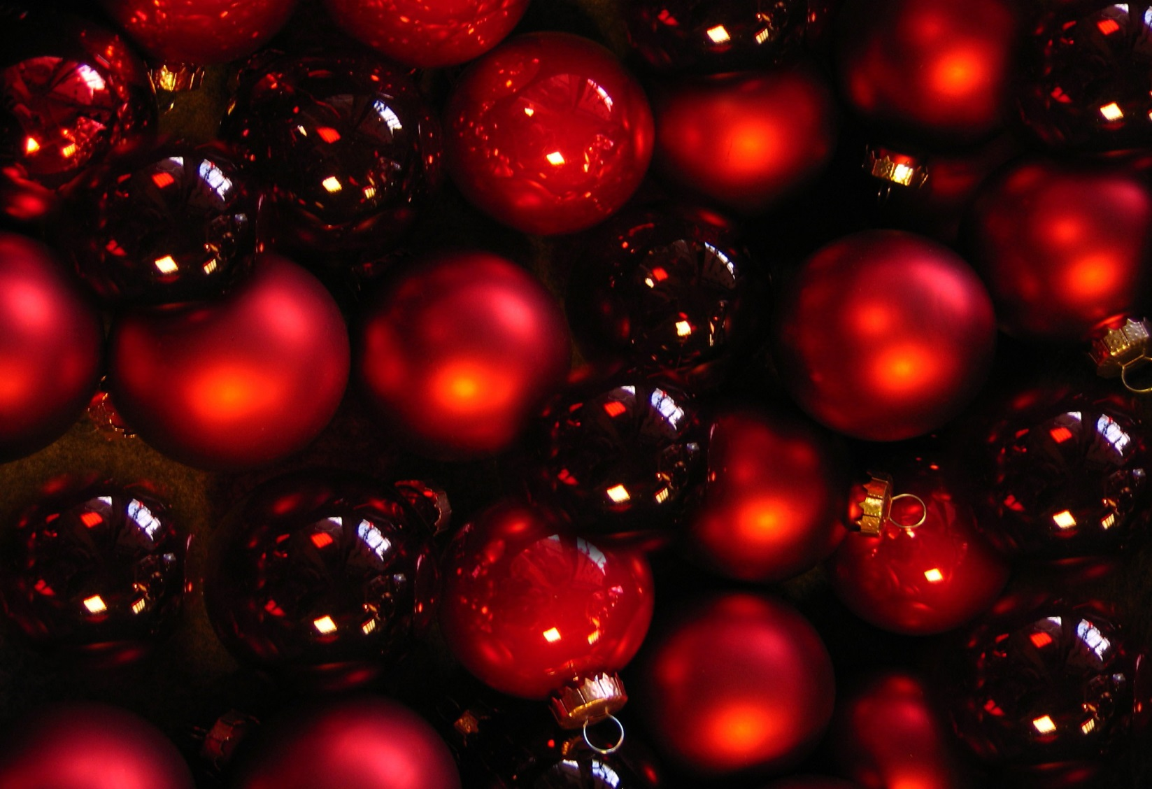
St. Mary Anglican church 2022
Christmas
FaIR
50%OF PROFIT DONATED TO LOCAL UKRAINAIN REFUGEE FAMILIES

Saturday, November 26
9:30am – 2:00pm
2600 Powder Point Road
Nanoose Bay

Great Gifts for all Ages!

Silent Auction
Full-Service Cafe
Bake Sale
Attic Treasures
FREE Admission & Parking
www.stmarynb.ca

