Faith Evangelical Lutheran Church, Washington, IL
Sixteenth Sunday after Pentecost
September 25, 2022

Welcome
Confession and Forgiveness

P: In the name of the Father, and of the + Son, and of the Holy Spirit.
C: Amen.
You may make the sign of the cross as a reminder of your baptism.
P: Almighty God, to whom all hearts are open, all desires known, and from whom no secrets are hid: cleanse the thoughts of our hearts by the inspiration of your Holy Spirit, that we may perfectly love you and worthily magnify your holy name, through Jesus Christ our Lord.
C: Amen.
P: Let us confess our sin in the presence of God and of one another.
Please keep silence for reflection
P: Most merciful God,
C: we confess that we are captive to sin and cannot free ourselves. We have sinned against you in thought, word, and deed, by what we have done and by what we have left undone. We have not loved you with our whole heart; we have not loved our neighbors as ourselves. For the sake of your Son, Jesus Christ, have mercy on us. Forgive us, renew us, and lead us, so that we may delight in your will and walk in your ways, to the glory of your holy name. Amen.
P: In the mercy of almighty God, Jesus Christ was given to die for us, and for his sake God forgives us all our sins. As a called and ordained minister of the church of Christ, and by his authority, I therefore declare to you the entire forgiveness of all your sins, in the name of the Father, and of the + Son, and of the Holy Spirit.
C: Amen.
Faith Lutheran Church
2206 Washington Rd,
Washington, IL 61571
Website and online worship:
www.shareourfaith.org
Church: 309-745-9306
faithlth@shareourfaith.org
Pastor John Rothfusz
Home: 309-745-9282
pastor@shareourfaith.org
Peace: As forgiven children of God, we have peace
with God, and peace with one another.
P The peace of the Lord be with you always.
C And also with you.
P Let us share that peace with one another.

*Hymn: “Gather Us In” Red Book #532

Text: Marty Haugen, b. 1950 Music: GATHER US IN, Marty Haugen Text and music © 1982 GIA Publications Inc., 7404 S. Mason Ave., Chicago, IL 60638. www.giamusic.com. 800.442.3358. All rights reserved. Used by permission. Reprinted under OneLicense.net#A-711151
P The grace of our Lord Jesus Christ, the love of God,
and the communion of the Holy Spirit be with you all.
C And also with you.

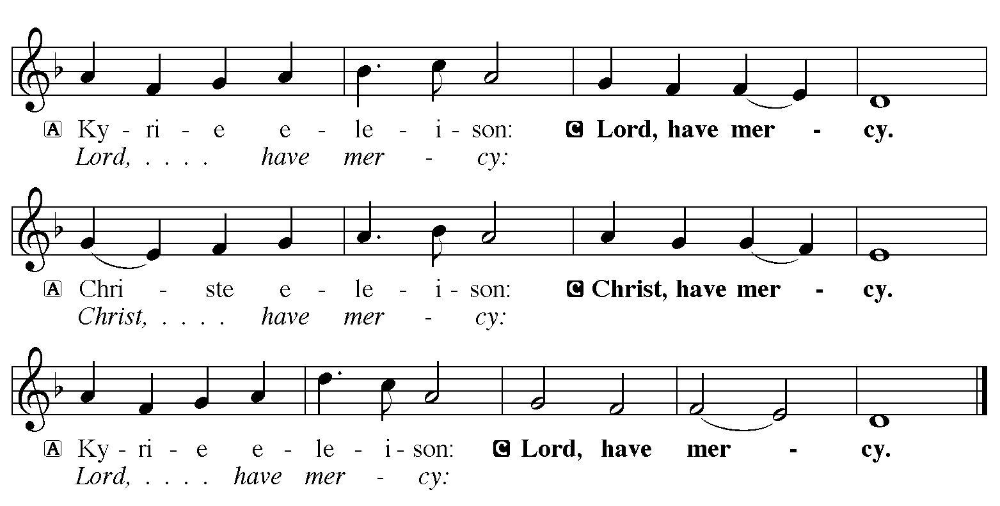

Hymn of Praise
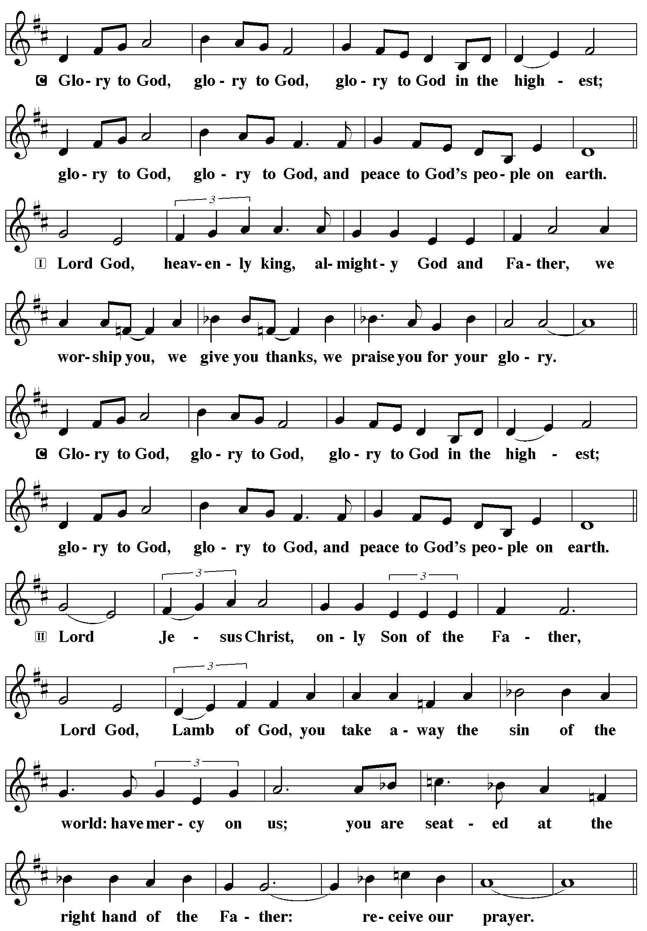
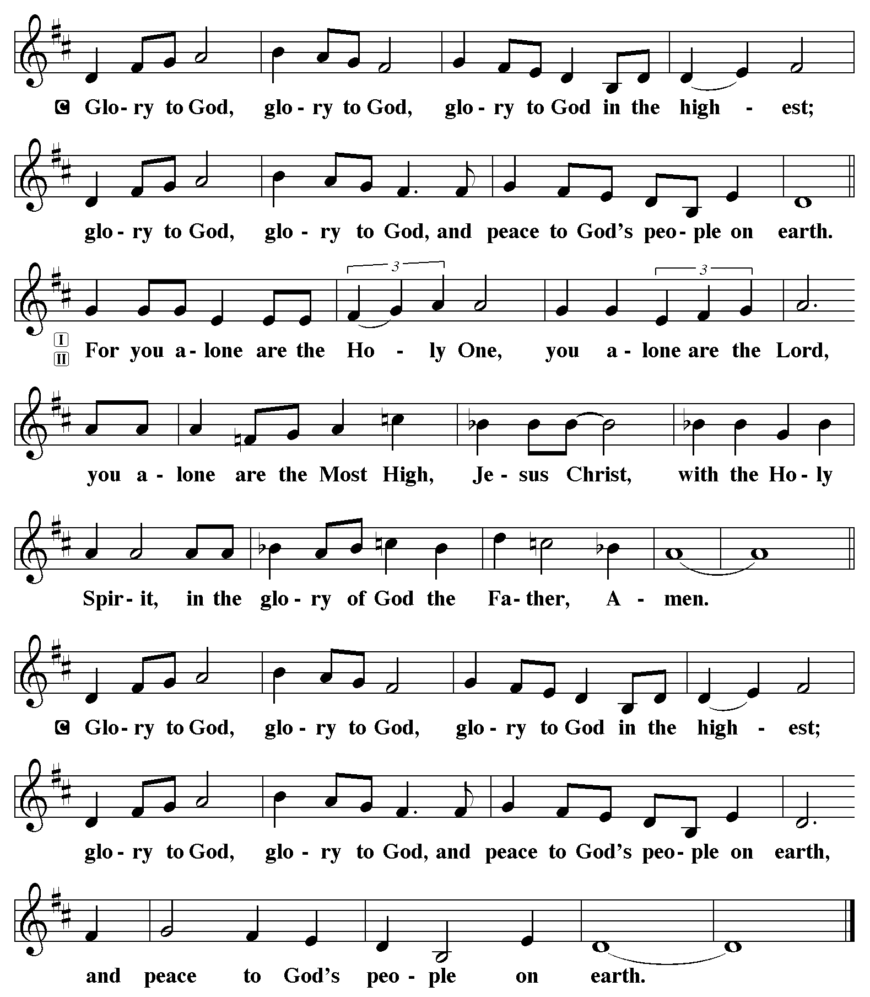

P The Lord be with you
C And also with you.
Let us pray together the Prayer of the Day.
O God, rich in mercy, you look with compassion on this troubled world. Feed us with your grace, and grant us the treasure that comes only from you, through Jesus Christ, our Savior and Lord. Amen.

Children’s Message

First Reading: Amos 6:1a, 4-7 Pew Bible Page #739
^{1a}Alas for those who are at ease in Zion,
and for those who feel secure on Mount Samaria,
⁴Alas for those who lie on beds of ivory,
and lounge on their couches,
and eat lambs from the flock,
and calves from the stall;
⁵who sing idle songs to the sound of the harp,
and like David improvise on instruments of music;
⁶who drink wine from bowls,
and anoint themselves with the finest oils,
but are not grieved over the ruin of Joseph!
⁷Therefore they shall now be the first to go into exile,
and the revelry of the loungers shall pass away.

R The Word of the Lord
C Thanks be to God

Psalm 146 Read responsively by whole verse
¹Hallelujah!
Praise the Lord, O my soul!
²I will praise the Lord as long as I live;
I will sing praises to my God while I have my being.
³Put not your trust in rulers,
in mortals in whom there is no help.
⁴When they breathe their last, they return to earth,
and in that day their thoughts perish.
⁵Happy are they who have the God of Jacob for their help,
whose hope is in the Lord their God;
⁶who made heaven and earth, the seas, and all that is in them;
who keeps promises forever;
⁷who gives justice to those who are oppressed, and food to those who hunger.
The Lord sets the captive free.
⁸The Lord opens the eyes of the blind; the Lord lifts up those who are bowed down; the Lord loves the righteous.
⁹The Lord cares or the stranger;
the Lord sustains the orphan and widow, but frustrates the way of the wicked.
¹⁰The Lord shall reign forever,
your God, O Zion, throughout all generations. Hallelujah!

Second Reading: 1 Timothy 6:6-19 Pew Bible Page #965
⁶Of course, there is great gain in godliness combined with contentment; ⁷for we brought nothing into the world, so that we can take nothing out of it; ⁸but if we have food and clothing, we will be content with these. ⁹But those who want to be rich fall into temptation and are trapped by many senseless and harmful desires that plunge people into ruin and destruction. ¹⁰For the love of money is a root of all kinds of evil, and in their eagerness to be rich some have wandered away from the faith and pierced themselves with many pains.
¹¹But as for you, man of God, shun all this; pursue righteousness, godliness, faith, love, endurance, gentleness. ¹²Fight the good fight of the faith; take hold of the eternal life, to which you were called and for which you made the good confession in the presence of many witnesses. ¹³In the presence of God, who gives life to all things, and of Christ Jesus, who in his testimony before Pontius Pilate made the good confession, I charge you ¹⁴to keep the commandment without spot or blame until the manifestation of our Lord Jesus Christ, ¹⁵which he will bring about at the right time—he who is the blessed and only Sovereign, the King of kings and Lord of lords. ¹⁶It is he alone who has immortality and dwells in unapproachable light, whom no one has ever seen or can see; to him be honor and eternal dominion. Amen.
¹⁷As for those who in the present age are rich, command them not to be haughty, or to set their hopes on the uncertainty of riches, but rather on God who richly provides us with everything for our enjoyment. ¹⁸They are to do good, to be rich in good works, generous, and ready to share, ¹⁹thus storing up for themselves the treasure of a good foundation for the future, so that they may take hold of the life that really is life.

R The Word of the Lord
C Thanks be to God

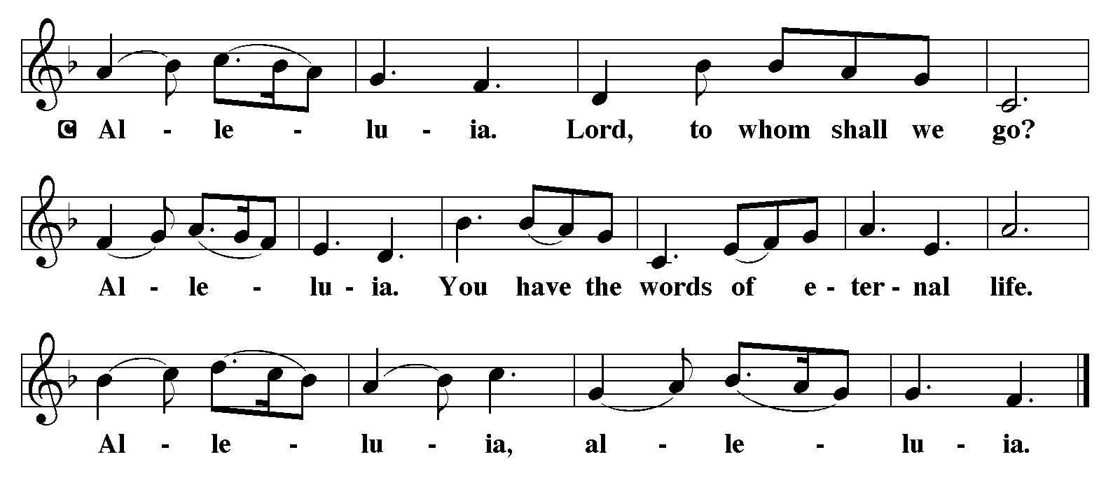

Gospel Reading: Luke 16:19-31 Pew Bible Page #846

C Glory to you, O Lord

[Jesus said:] ¹⁹“There was a rich man who was dressed in purple and fine linen and who feasted sumptuously every day. ²⁰And at his gate lay a poor man named Lazarus, covered with sores, ²¹who longed to satisfy his hunger with what fell from the rich man’s table; even the dogs would come and lick his sores. ²²The poor man died and was carried away by the angels to be with Abraham. The rich man also died and was buried. ²³In Hades, where he was being tormented, he looked up and saw Abraham far away with Lazarus by his side. ²⁴He called out, ‘Father Abraham, have mercy on me, and send Lazarus to dip the tip of his finger in water and cool my tongue; for I am in agony in these flames.’ ²⁵But Abraham said, ‘Child, remember that during your lifetime you received your good things, and Lazarus in like manner evil things; but now he is comforted here, and you are in agony. ²⁶Besides all this, between you and us a great chasm has been fixed, so that those who might want to pass from here to you cannot do so, and no one can cross from there to us.’ ²⁷He said, ‘Then, father, I beg you to send him to my father’s house—²⁸for I have five brothers—that he may warn them, so that they will not also come into this place of torment.’ ²⁹Abraham replied, ‘They have Moses and the prophets; they should listen to them.’ ³⁰He said, ‘No, father Abraham; but if someone goes to them from the dead, they will repent.’ ³¹He said to him, ‘If they do not listen to Moses and the prophets, neither will they be convinced even if someone rises from the dead.’ ”

The Gospel of the Lord
C Praise to you, O Christ

Sermon by Pastor John Rothfusz

Sermon Hymn: “Lord, Whose Love In Humble Service” Red Book #712

Text: Albert F. Bayly, 1901-1984
Music: BEACH SPRING, The Sacred Harp, Philadelphia, 1844
Text © Oxford University Press Reprinted under OneLicense.net#A-711151

Apostles’ Creed
C: I believe in God, the Father almighty,
creator of heaven and earth.
I believe in Jesus Christ, God's only Son, our Lord,
who was conceived by the Holy Spirit,
born of the virgin Mary,
suffered under Pontius Pilate,
was crucified, died, and was buried;
he descended to the dead.
On the third day he rose again;
he ascended into heaven,
he is seated at the right hand of the Father,
and he will come to judge the living and the dead.
I believe in the Holy Spirit,
the holy catholic church, the communion of saints,
the forgiveness of sins, the resurrection of the body,
and the life everlasting. Amen.

Prayers: After each portion of the prayers finishes with “Lord in your mercy,” please respond, “Hear our prayer.”

Offering: Jesus is Lord, and leads us in the ways of life and salvation. Let us offer ourselves to the Lord and joyfully lift our tithes and offerings to God.

Please take a moment now to make an electronic offering to the church on the website, with the Tithe.ly app on your phone, or drop an envelope in the plate at communion time.
Faith Lutheran website link www.shareourfaith.org

Offering Prayer

Great Thanksgiving
P The Lord be with you.
C And also with you.
P Lift up your hearts.
C We lift them to the Lord.
P Let us give thanks to the Lord our God.
C It is right to give God thanks and praise.

P It is indeed right, our duty and our joy… with the church on earth and the hosts of heaven, we praise your name and join their unending hymn:
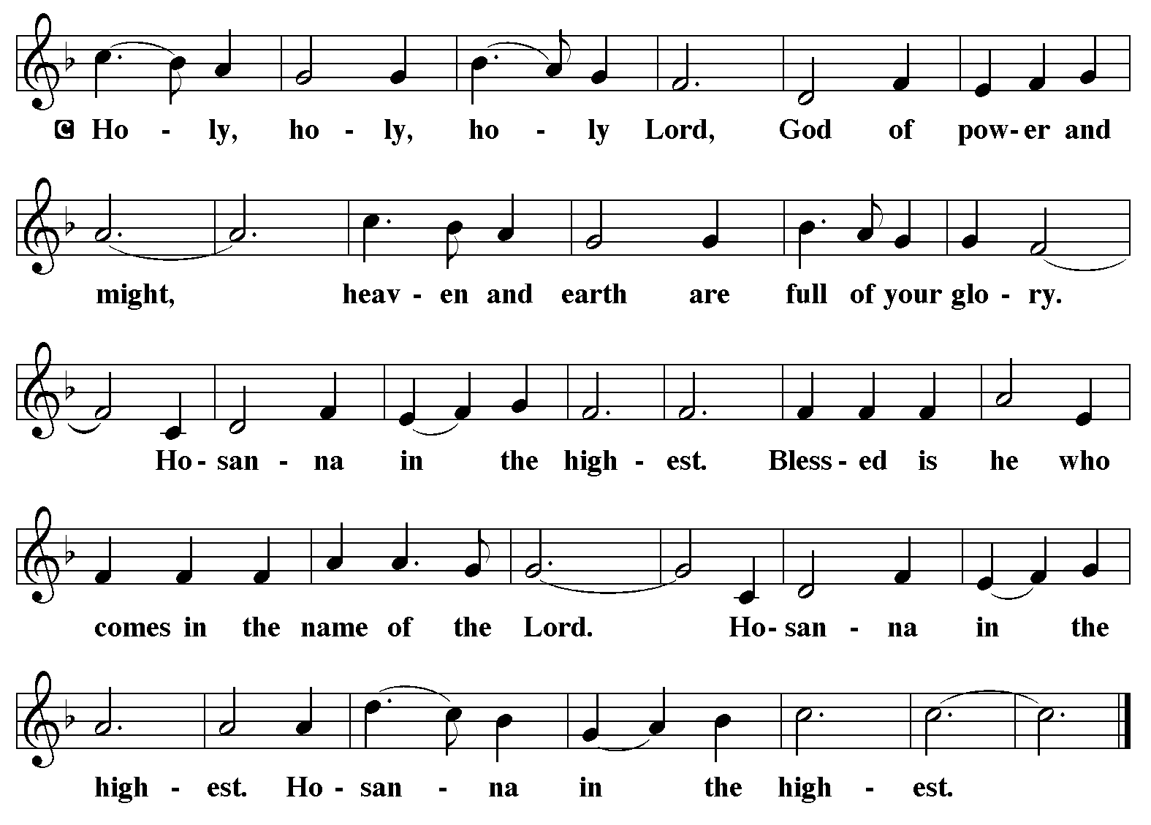

Holy Communion Preface pp. 108-111 or other Eucharistic prayer
In the night in which he was betrayed,
our Lord Jesus took bread, and gave thanks;
broke it, and gave it to his disciples, saying:
Take and eat; this is my body, given for you.
Do this for the remembrance of me.
Again, after supper, he took the cup, gave thanks,
and gave it for all to drink, saying:
This cup is the new covenant in my blood,
shed for you and for all people for the forgiveness of sin.
Do this for the remembrance of me.

C The Lord's Prayer
Our Father, who art in heaven, hallowed be thy name,
thy kingdom come, thy will be done, on earth as it is in heaven.
Give us this day our daily bread; and forgive us our trespasses,
as we forgive those who trespass against us;
and lead us not into temptation, but deliver us from evil.
For thine is the kingdom, and the power, and the glory,
forever and ever. Amen
Communion Distribution
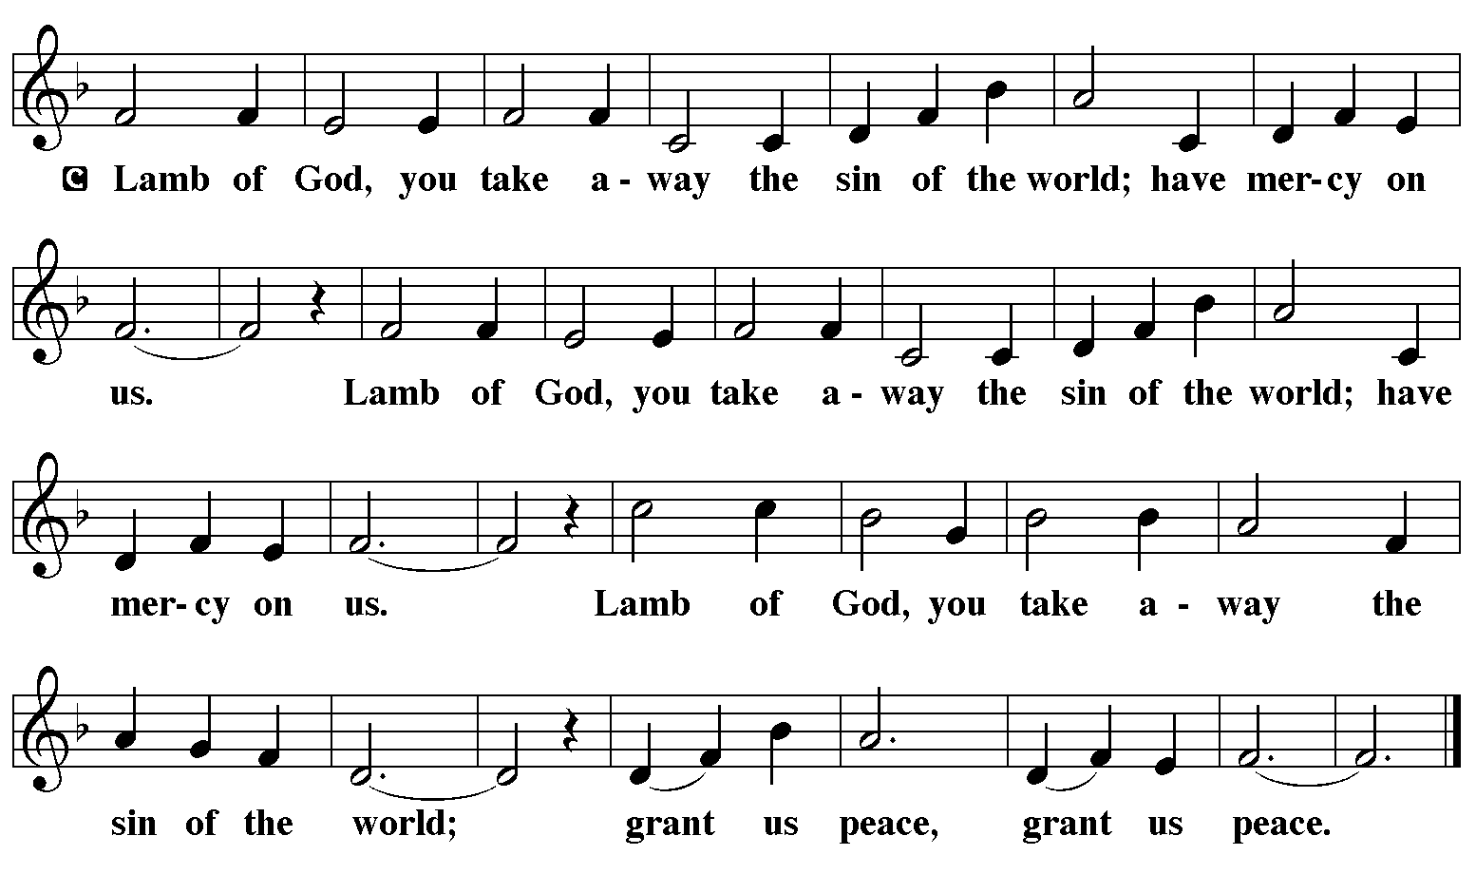

Communion Hymn: “As the Grains of Wheat” Red Book #465

Text: Didache, 2nd cent.; Marty Haugen, b. 1950
Music: AS THE GRAINS, Marty Haugen
Text and music © 1990 GIA Publications, Inc., 7404 S. Mason Ave., Chicago, IL 60638. www.giamusic.com. 800.442.3358. All rights reserved. Used by permission Reprinted under OneLicense.net#A-711151

Communion Prayer

Announcements

Blessing
P The Lord bless you and keep you. The Lord make his face shine on you and be gracious to you. The Lord look upon you with favor and + give you peace. In the name of the Father, and of the Son and of the Holy Spirit.
C Amen

Hymn: “Christ Be Our Light” Red Book #715
Text: Bernadette Farre;;. b/ 1058 Music: CHRIST BE OUR LIGHT, Bernadette Farrell
Text and music © 1993 Bernadette Farrell. Published by OCP Publications, 5536 NE Hassalo, Portland, OR 97213
All rights reserved. Used by permission. Reprinted under OneLicense.net#A-711151
Dismissal
A Go in peace. Serve the Lord. C Thanks be to God!
Postlude
Liturgy and texts from Sundays and Seasons.com. Copyright 2022 Augsburg Fortress. All rights reserved.
Reprinted by permission under Augsburg Fortress Liturgies Annual License #23628.

