2023 Canadian Church Calendar ORDER FORM
We are pleased to offer the Anglican Church Calendar for 2023.

The Theme for the 2023 Canadian Anglican Church Calendar is Peaks & Valleys
and as has been the custom, includes a range of photos of our beloved churches from across our country.

The funds raised will assist the Anglican Church Women to continue with their many outreach programs. We appreciate your help with these commitments.
Make cheques payable to the ACW Diocese of New Westminster, noting your parish name on the cheque.
Name of Parish______________________________________________
Calendar Order Contact Person______________________________________
Phone #____________________ email___________________________
Delivery Address and phone number:

____________________________________________________________
Number of calendars ordered_______ x Cost $6.00 each = $_________
PLEASE have order and payment in before September 30, 2022 to
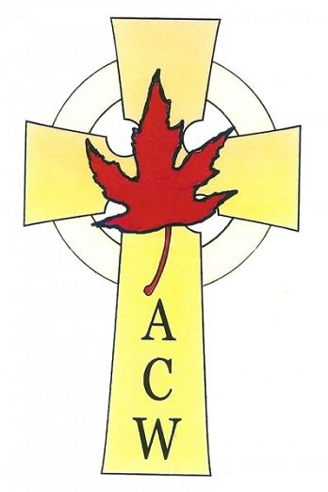
ACW Calendar Secretary, c/o ACW Place, Unit B, 7012 Merritt Avenue, Burnaby B. C. V5J 4R6

Orders can be mailed with the payment or emailed to the

Thank you for your support

Anglican Church Women

Diocese of New Westminster
Calendar Secretary: sylviaanneenga@gmail.com.

