MESSAGE NOTES
What Makes A Church? – Part 2 of 5

Different
Matthew 5:1-6

Today we are continuing a new message series where we are asking the question What Makes A Church? To answer that we are looking at Jesus’ most well-known sermon which we call The Sermon On The Mount. During the next months, we are going to do a deep dive into Jesus’s words in Matthew 5-7 and divide his teaching into three message series.

Read Matthew 5:1-6… A disciple is different from the crowd —

THE GOAL OF A DISCIPLE:

1. To learn God’s Word from their Rabbi, and how to apply God’s word to their life

2. To become like their Rabbi

Jesus came to minister God’s love to people and make disciples, and he wants us to join him in that. But what is necessary if we are going to be like Jesus and do what he did, is we need to be willing to reach the next generation. Think about it, who does Jesus call and mentor as his disciples? They were young people, not 45-year-old men with beards…. Will we sacrifice the next generation on the altar of our preferences for how we like to worship and how we like to “do Church”?....

A disciple of Jesus is one who is becoming like Jesus, not as an individual, but TOGETHER within a community. In Matthew 4:19 and Mark 1:19 where the Bible says: Jesus called out to them, “Come, follow me, and I will show you how to fish for people!”, what we do not see in the English translation is that the word “Come”, in the language the Bible was written in has a plural subject. The idea is that in Jesus’ day, Rabbis called disciples as individuals into a community. It was not about individualism.

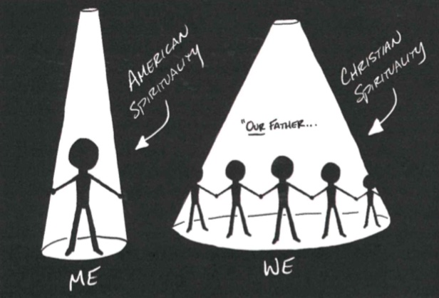

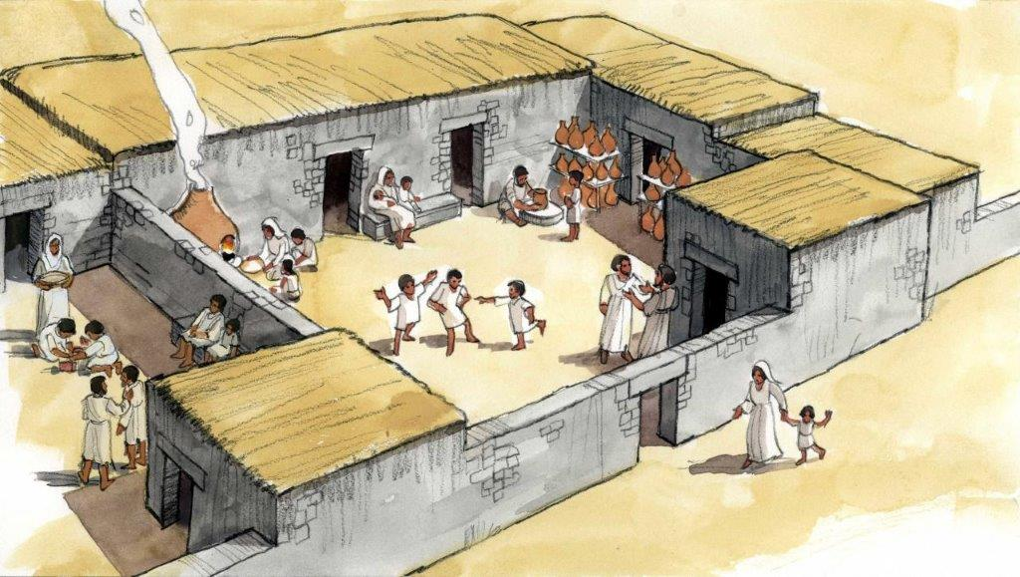

Jesus’ disciples in that day understood this because the context of the homes they were from (Insulas) where extended family all lived together and depended on each other. As they lived together in community, they would build one another up in their faith and help each other live the word of God. They became a COMMUNITY, and spiritually, that’s the kind of community God is calling us to as a church. This is a community we do not simply walk away from when we are upset about something or someone, but we continue to work at life and faith together and help each other Become Like Jesus Together.

³ “Blessed are the poor in spirit, for theirs is the kingdom of heaven. Matthew 5:3

⁴ Blessed are those who mourn, for they will be comforted. Matthew 5:4

⁵ Blessed are the meek, for they will inherit the earth. Matthew 5:5

⁶ Blessed are those who hunger and thirst for righteousness, for they will be filled. Matthew 5:6

