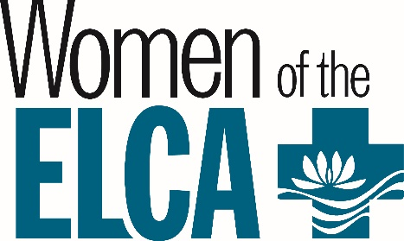

First Timer’s GRANT APPLICATION
FOR THE NW MN SWO OF THE ELCA
ANNUAL CONVENTION

Selection Criteria:
- The woman has never attended a SWO Convention.
- Why the woman would like to attend the convention
- Each congregational unit can have only one applicant. More can apply, but we are limited to only 10 scholarships.
- The woman may not serve as a delegate and grant recipient at the same time.

Selection Procedure:
- All applications should be sent to the address below and a committee appointed by the SWO President comprised of board members will review each application.
- All applications are due one month prior to the convention.
- The applicants who are chosen, based on the above criteria will receive a phone call and letter informing her of the scholarship.

Please Print: Name __________________________________________________Phone__________________________

Address ________________________________________E-Mail Address_______________________________________

City ______________________________________________________ State _________ Zip ______________________

Congregational Unit and Town _________________________________________________________________________

Occupation ________________________________________________________________________________________

Interests __________________________________________________________________________________________

Why you would like to attend the Convention __________________________________________________________________________________________________

Deadline is August 1, 2022

Return to: Diane Teigland
Box 267
Bertha, MN 56437
218—639-5610

rev 5/30/2022

