September 4, 2022
Taken Captive Through Different Philosophies


Welcome, Welcome, Welcome

Taken Captive Through Different Philosophies

Is it possible for followers of Jesus to be tricked, duped, taken captive?
Good sincere people can be taken captive!!! Adam and Eve
2 Timothy 2:25-26
Ephesians 6:12
Fortunately, we are not the first ones to deal with this issue
How to avoid being “taken captive”
First & foremost, take everything to GOD and HIS WORD.
What does God have to say?
What does Scripture say? (How to read the Bible for all that it is worth)
Illustration – News Paper (Genre)
Personal ways I’ve learned related to not being duped
Do not take things personally!
When we overreact or take things personally, we give control to others!
Crossing Guard – Standing on the corner
Eleanor Roosevelt “No one can make you feel inferior without your consent.”

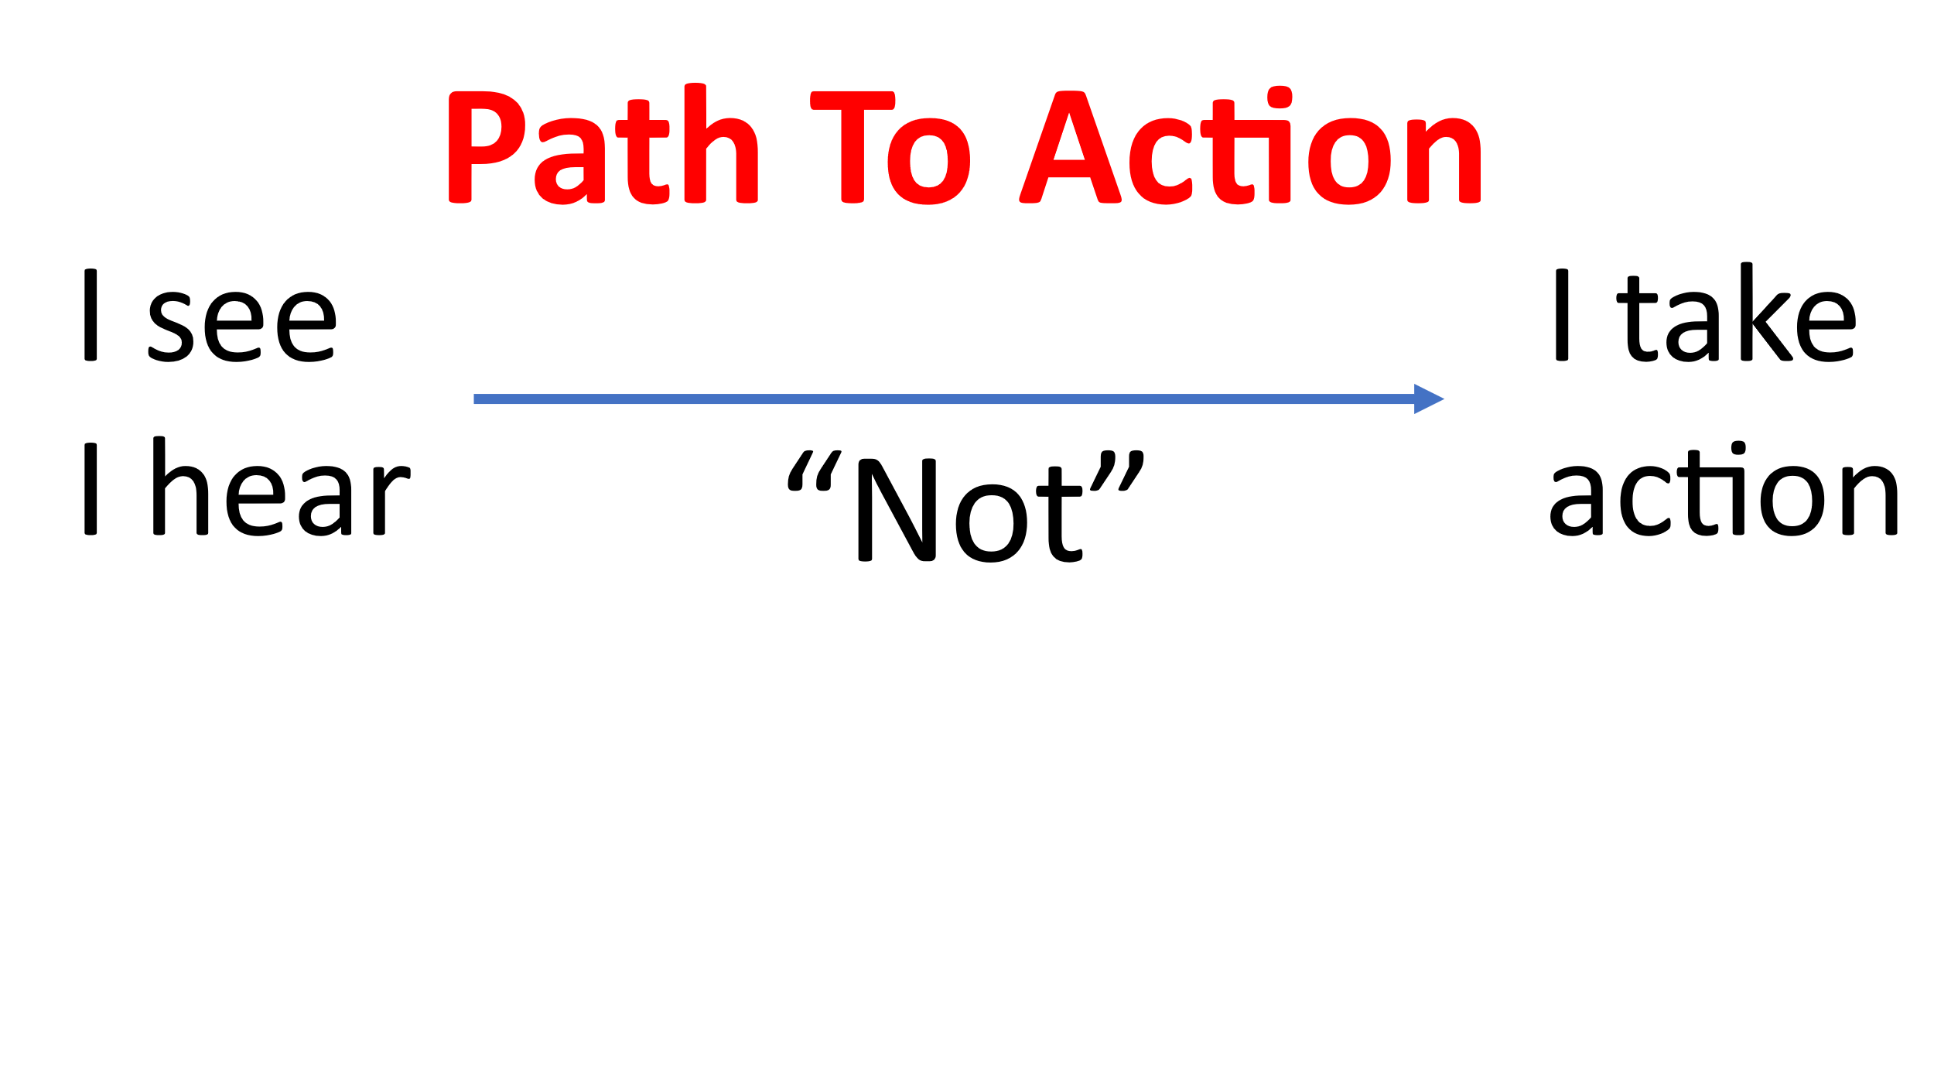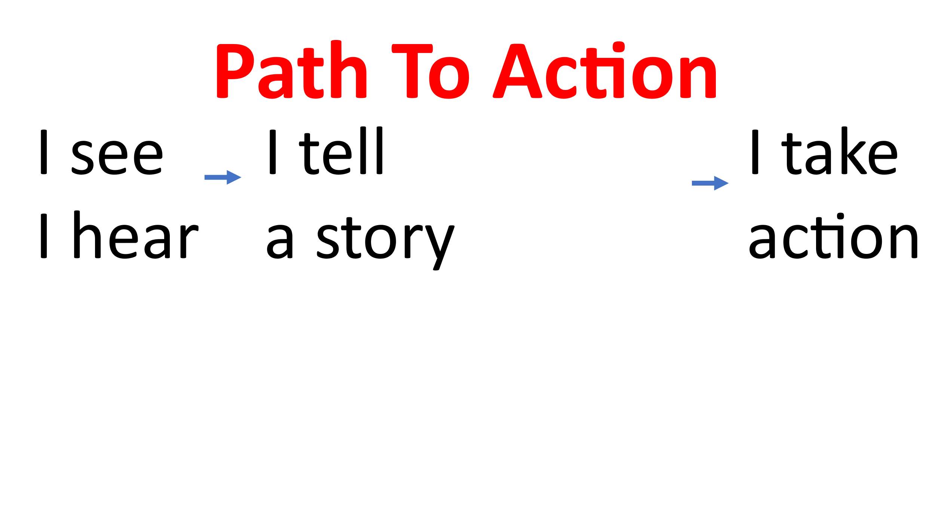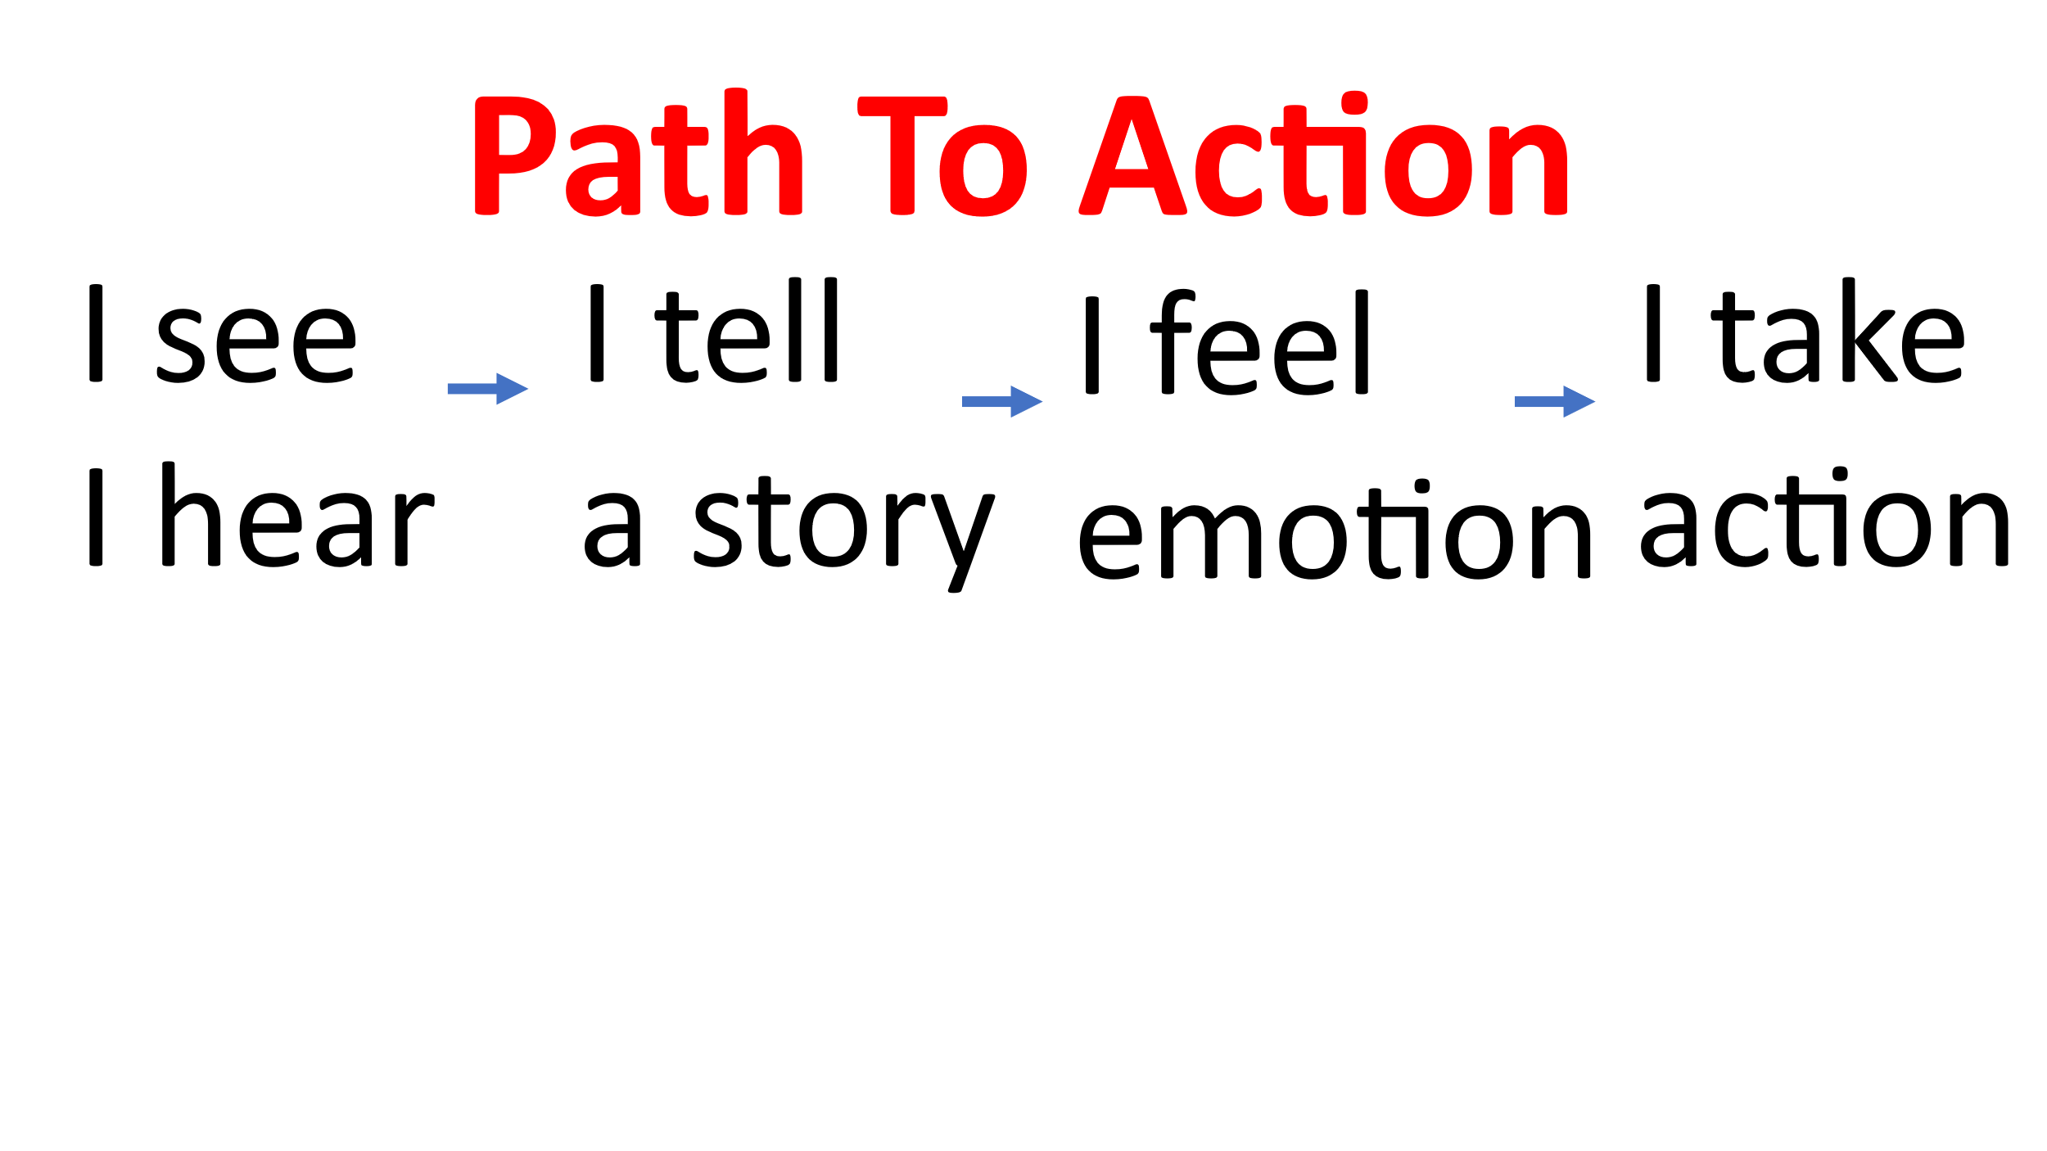
If you can imagine any valid story that explains heir behavior, it will typically lead to empathy

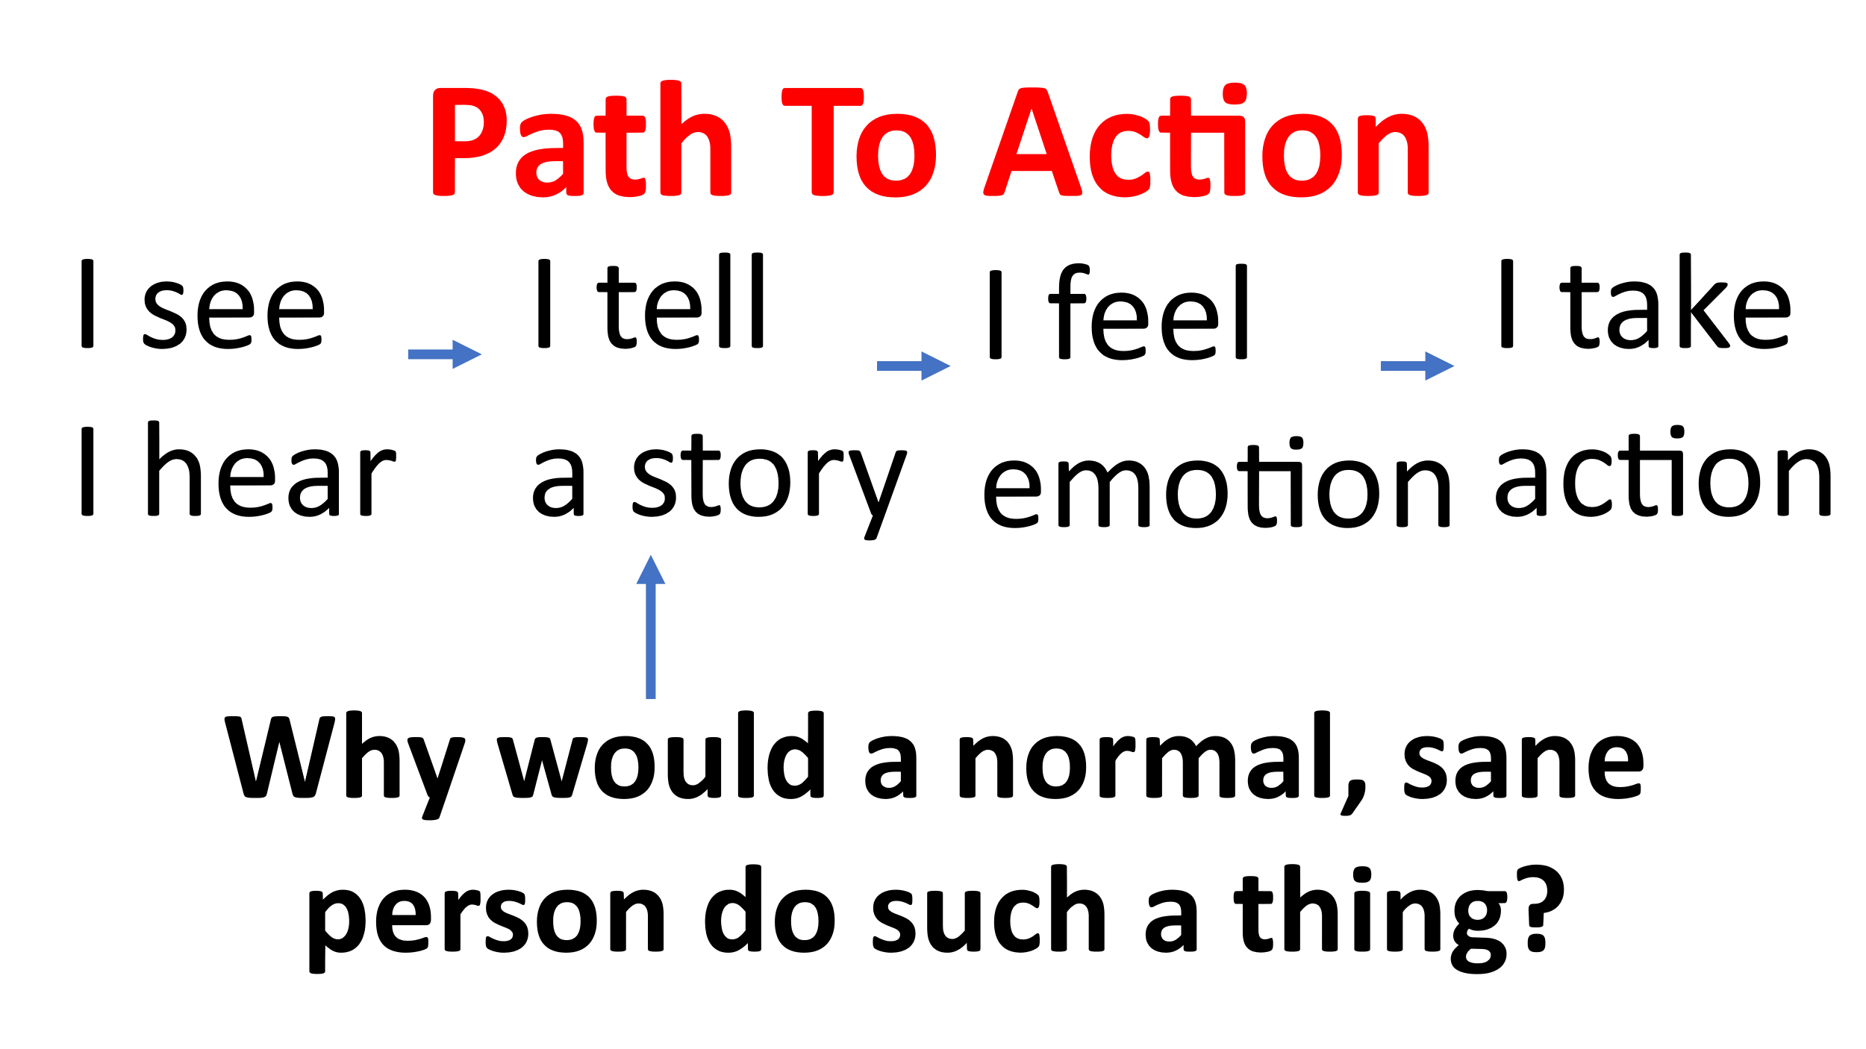
What story are you telling yourself? The story you are telling says a lot about you!
Another way to avoid being duped is to run things through various tests for truth.
ALL THRUTH is from GOD!!!
Tests for Truth
- Scripture
- Alignment with God’s Character
- Law of Non-Contradiction
- If it seems too good to be true, it probably is!
- What is the Holy Spirit saying?

Please remember Dr. H. Blackaby
I don’t doubt that you’ve heard from God, but I reserve the right to question your interpretation.”
Over all these things, put on love. (Theological Humility)

Colossians 2:20-23 “Since you died with Christ to the elemental spiritual forces of this world, why, as though you still belonged to the world, do you submit to its rules; “Do not handle! Do not taste! Do not touch!”? These rules, which have to do with things that are all destined to perish with use are based on merely human commands and teachings. Such regulations indeed have an appearance of wisdom, with their self-imposed worship, their false humility and their harsh treatment of the body, but they lack any value in restraining sensual indulgence.”
Died with Christ through Baptism (Romans 6)
Based on mere human commands & teachings
Appearance of wisdom (Satan typically comes as an angel of light 2 Corinthians 11:14)
Lack any value in restraining sexual indulgences
Let us not be duped rather let’s focus on JESUS
An old illustration from the Treasury Department, one can’t possibly know every counterfeit scheme, so study & know the real thing!
With that in mind, Let u
Be people who spend time with Jesus (Acts 4:13)
Be people who rightly handle the Word of God (2 Timothy 2:15)

Prayer

Sing a song unto the Lord

Benediction

Table Talk (Discussion Points)
Please Consider Sharing:
- What do you think about the possibility that Believers can be duped?
- What do you think about the Apostle Paul’s concept of people being taken captive to do his will (2 Timothy 2:26)?
- How do you typically not take things personally?
- What are your thoughts on the Path to Action? In what way does the story you tell say more about you?
- What tests for truth do you use to assess validity? Are they similar to Pastor Jeff’s tests for truth?
- Ultimately why does the Apostle Paul say that the “do nots” fail?
- (OVERALL) Sharing what the Holy Spirit impressed upon you personally, during our time together.

