Faith Evangelical Lutheran Church, Washington, IL
Twelfth Sunday after Pentecost
August 28, 2022

Welcome
Confession and Forgiveness

P: In the name of the Father, and of the + Son, and of the Holy Spirit.
C: Amen.
You may make the sign of the cross as a reminder of your baptism.
P: Almighty God, to whom all hearts are open, all desires known, and from whom no secrets are hid: cleanse the thoughts of our hearts by the inspiration of your Holy Spirit, that we may perfectly love you and worthily magnify your holy name, through Jesus Christ our Lord.
C: Amen.
P: Let us confess our sin in the presence of God and of one another.
Please keep silence for reflection
P: Most merciful God,
C: we confess that we are captive to sin and cannot free ourselves. We have sinned against you in thought, word, and deed, by what we have done and by what we have left undone. We have not loved you with our whole heart; we have not loved our neighbors as ourselves. For the sake of your Son, Jesus Christ, have mercy on us. Forgive us, renew us, and lead us, so that we may delight in your will and walk in your ways, to the glory of your holy name. Amen.
P: In the mercy of almighty God, Jesus Christ was given to die for us, and for his sake God forgives us all our sins. As a called and ordained minister of the church of Christ, and by his authority, I therefore declare to you the entire forgiveness of all your sins, in the name of the Father, and of the + Son, and of the Holy Spirit.
C: Amen.
Faith Lutheran Church
2206 Washington Rd,
Washington, IL 61571
Website and online worship:
www.shareourfaith.org
Church: 309-745-9306
faithlth@shareourfaith.org
Pastor John Rothfusz
Home: 309-745-9282
pastor@shareourfaith.org
Peace: As forgiven children of God, we have peace
with God, and peace with one another.
P The peace of the Lord be with you always.
C And also with you.
P Let us share that peace with one another.

*Hymn: “Gather Us In” Red Book #532

Text: Marty Haugen , b. 1950 Music: GATHER US IN, Marty Haugen
Text and music © 1982 GIA Publications Inc., 7404 S. Mason Ave., Chicago, IL 60638. www.giamusic.com. 800.442.3358. All rights reserved. Used by permission. Reprinted under OneLicense.net#A-711151
P The grace of our Lord Jesus Christ, the love of God,
and the communion of the Holy Spirit be with you all.
C And also with you.

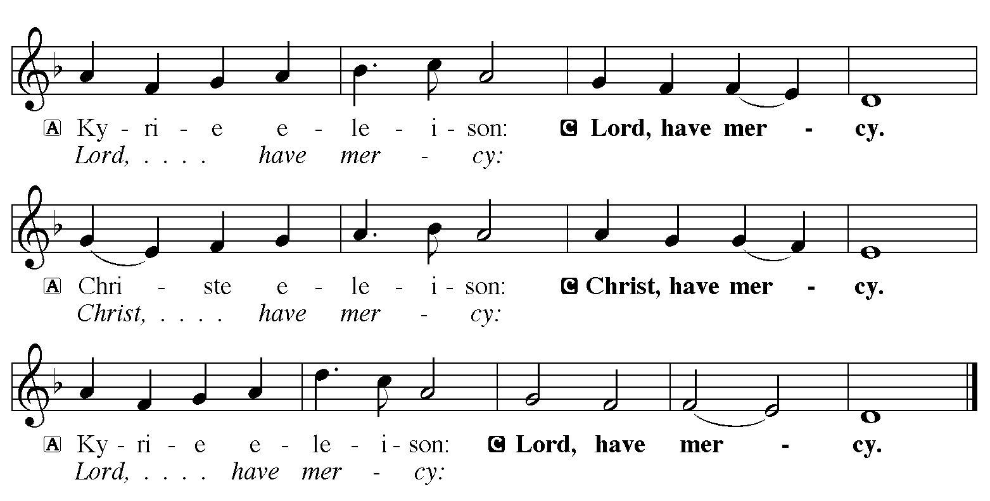

Hymn of Praise
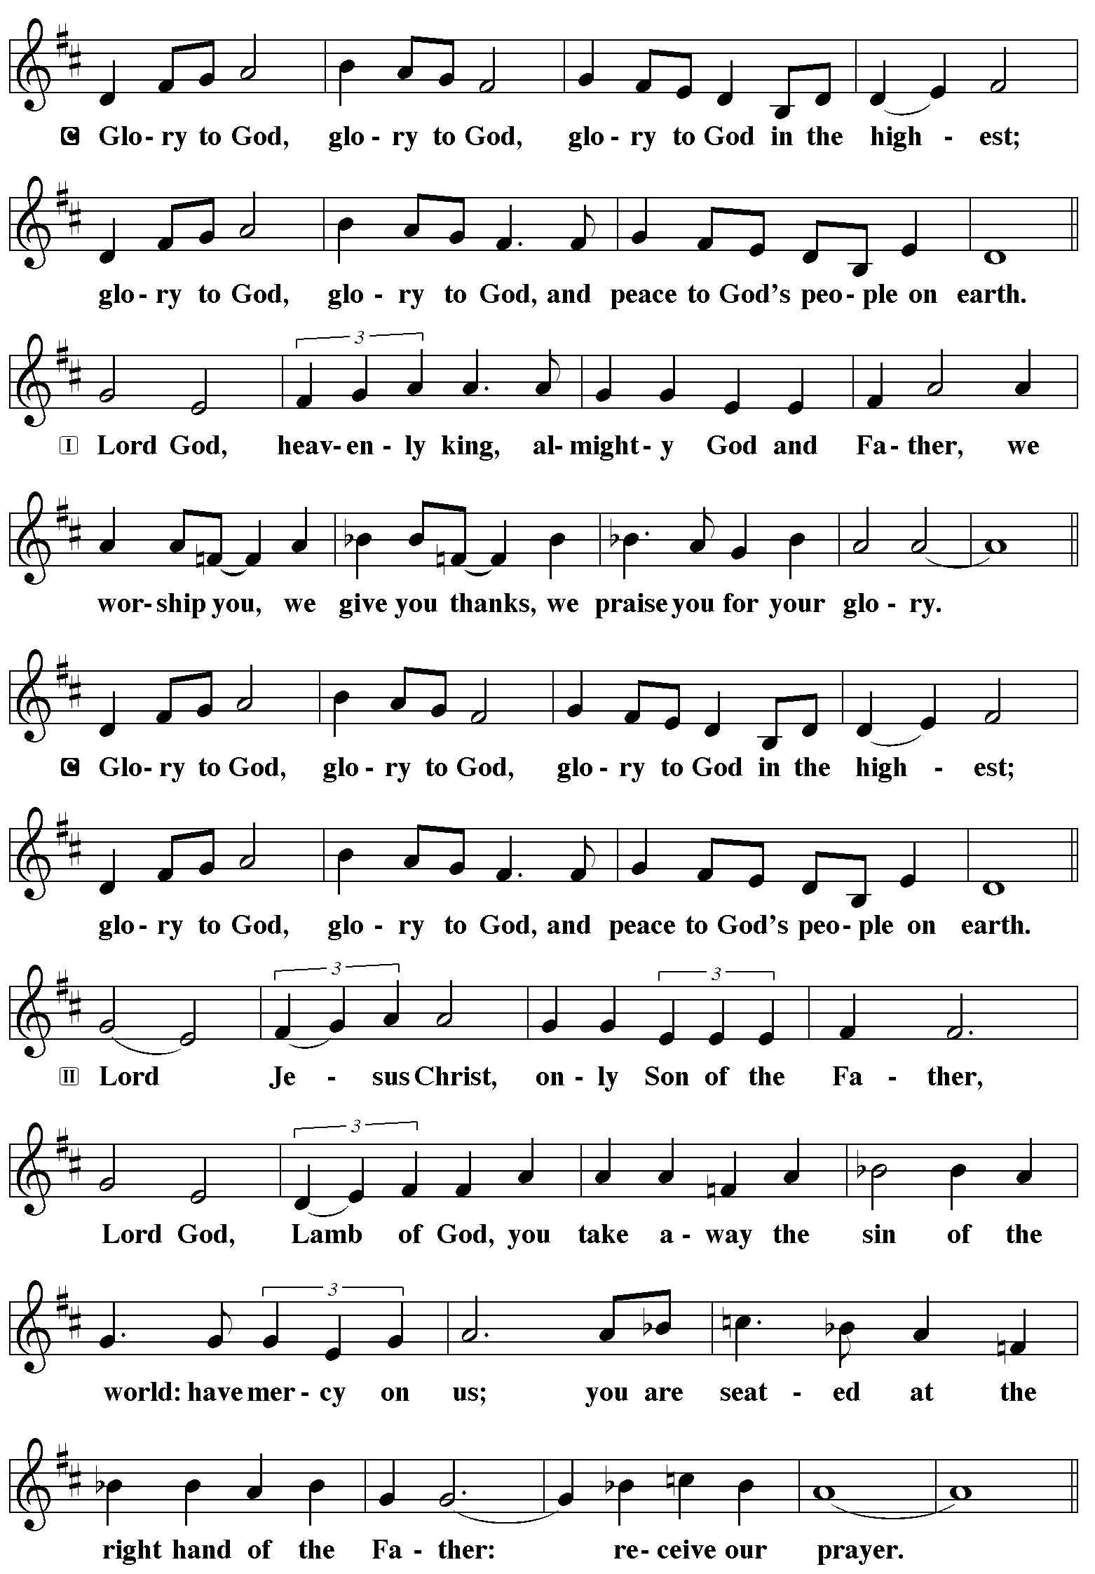
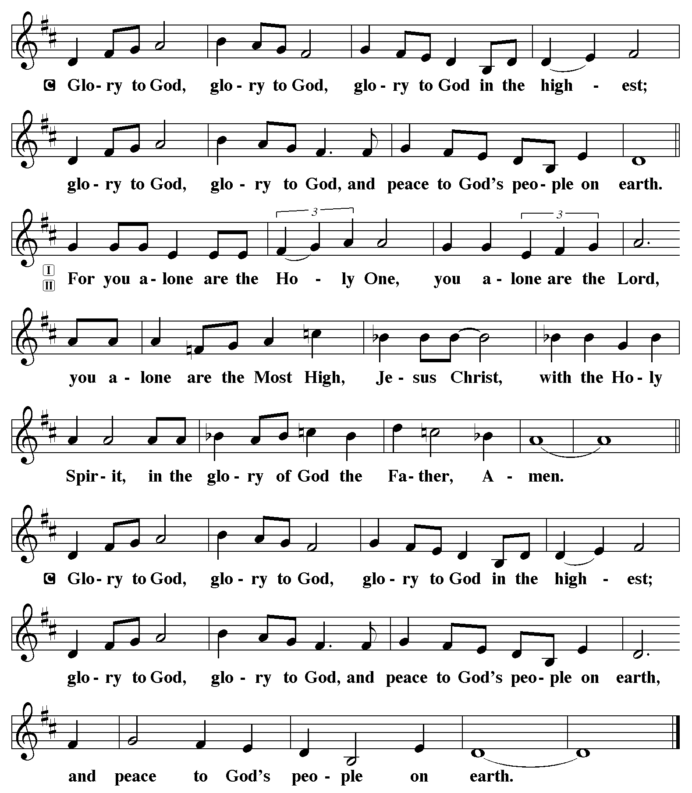

P The Lord be with you
C And also with you.
Let us pray together the Prayer of the Day.
O God, you resist those who are proud and give grace to those who are humble. Give us the humility of your Son, that we may embody the generosity of Jesus Christ, our Savior and Lord.
Amen.

Children’s Message

First Reading: Proverbs 25:6-7 Pew Bible Page #528
⁶Do not put yourself forward in the king’s presence or stand in the place of the great; ⁷for it is better to be told, “Come up here,” than to be put lower in the presence of a noble.
R The Word of the Lord
C Thanks be to God

Psalm 112 Read responsively by whole verse
¹Hallelujah! Happy are they who fear the Lord
and have great delight in God’s commandments!
²Their descendants will be mighty in the land;
the generation of the upright will be blessed.
³Wealth and riches will be in their house,
and their righteousness will last forever.
⁴Light shines in the darkness for the upright;
the righteous are merciful and full of compassion.
⁵It is good for them to be generous in lending
and to manage their affairs with justice.
⁶For they will never be shaken;
the righteous will be kept in everlasting remembrance.
⁷They will not be afraid of any evil rumors;
their heart is steadfast, trusting in the Lord.
⁸Their heart is established and will not shrink,
until they see their desire upon their enemies.
⁹They have given freely to the poor, and their righteousness stands fast forever;
they will hold up their head with honor.
¹⁰The wicked will see it and be angry; they will gnash their teeth and | pine away; the desires of the wicked will perish.
Second Reading: Hebrews 13:1-8, 15-16 Pew Bible Page #981
¹Let mutual love continue. ²Do not neglect to show hospitality to strangers, for by doing that some have entertained angels without knowing it. ³Remember those who are in prison, as though you were in prison with them; those who are being tortured, as though you yourselves were being tortured. ⁴Let marriage be held in honor by all, and let the marriage bed be kept undefiled; for God will judge fornicators and adulterers. ⁵Keep your lives free from the love of money, and be content with what you have; for he has said, “I will never leave you or forsake you.” ⁶So we can say with confidence, “The Lord is my helper; I will not be afraid.
What can anyone do to me?” ⁷Remember your leaders, those who spoke the word of God to you; consider the outcome of their way of life, and imitate their faith. ⁸Jesus Christ is the same yesterday and today and forever. ¹⁵Through him, then, let us continually offer a sacrifice of praise to God, that is, the fruit of lips that confess his name. ¹⁶Do not neglect to do good and to share what you have, for such sacrifices are pleasing to God.

R The Word of the Lord
C Thanks be to God
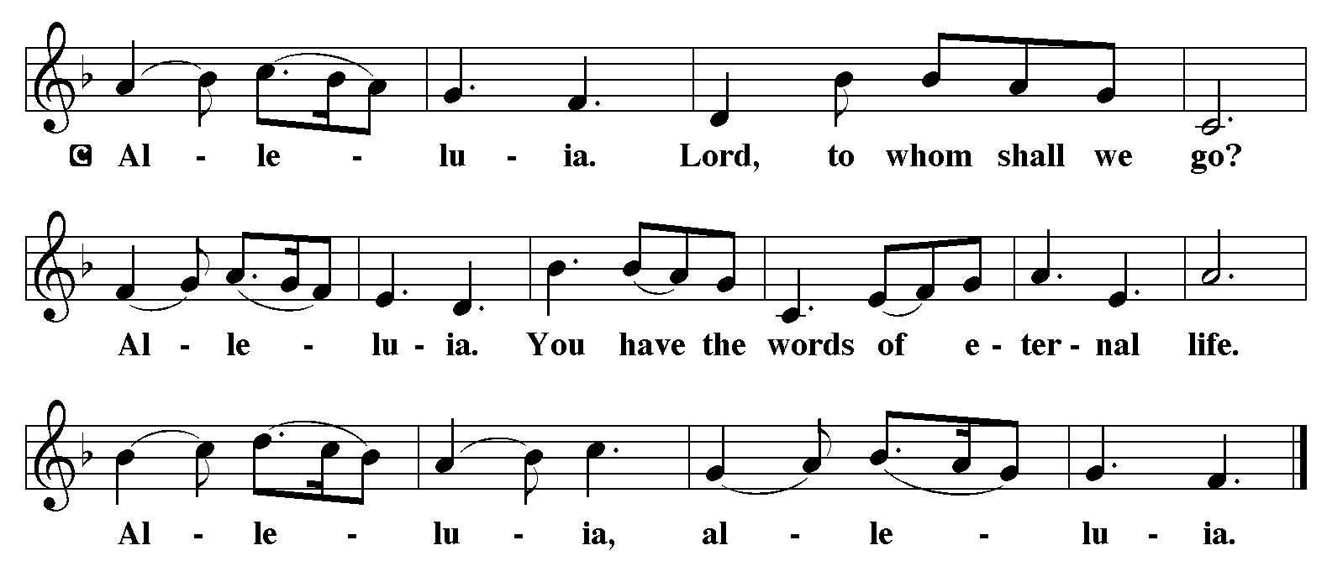

Gospel Reading: Luke 14:1, 7-14 Pew Bible Page #844

C Glory to you, O Lord
¹On one occasion when Jesus was going to the house of a leader of the Pharisees to eat a meal on the sabbath, they were watching him closely.
⁷When he noticed how the guests chose the places of honor, he told them a parable. ⁸“When you are invited by someone to a wedding banquet, do not sit down at the place of honor, in case someone more distinguished than you has been invited by your host; ⁹and the host who invited both of you may come and say to you, ‘Give this person your place,’ and then in disgrace you would start to take the lowest place. ¹⁰But when you are invited, go and sit down at the lowest place, so that when your host comes, he may say to you, ‘Friend, move up higher’; then you will be honored in the presence of all who sit at the table with you. ¹¹For all who exalt themselves will be humbled, and those who humble themselves will be exalted.”
¹²He said also to the one who had invited him, “When you give a luncheon or a dinner, do not invite your friends or your brothers or your relatives or rich neighbors, in case they may invite you in return, and you would be repaid. ¹³But when you give a banquet, invite the poor, the crippled, the lame, and the blind. ¹⁴And you will be blessed, because they cannot repay you, for you will be repaid at the resurrection of the righteous.”
The Gospel of the Lord C Praise to you, O Christ
Sermon by Pastor John Rothfusz
Sermon Hymn: “All Are Welcome” Red Book #641
Text: Marty Haugen, b. 1950 Music: TWO OAKS, Marty Haugen
Text and music © 1994 GIA Publications, Inc., 7404 S. mason Ave., Chicago, IL 60638. www.giamusic.com. 800.442.3358. All rights reserved. Used by permission. Reprinted under OneLicense.net#A-711151
Apostles’ Creed
C: I believe in God, the Father almighty,
creator of heaven and earth.
I believe in Jesus Christ, God's only Son, our Lord,
who was conceived by the Holy Spirit,
born of the virgin Mary,
suffered under Pontius Pilate,
was crucified, died, and was buried;
he descended to the dead.
On the third day he rose again;
he ascended into heaven,
he is seated at the right hand of the Father,
and he will come to judge the living and the dead.
I believe in the Holy Spirit,
the holy catholic church, the communion of saints,
the forgiveness of sins, the resurrection of the body,
and the life everlasting. Amen.

Prayers: After each portion of the prayers finishes with “Lord in your mercy,” please respond, “Hear our prayer.”

Offering: Jesus is Lord, and leads us in the ways of life and salvation. Let us offer ourselves to the Lord and joyfully lift our tithes and offerings to God.
Please take a moment now to make an electronic offering to the church on the website, with the Tithe.ly app on your phone, or drop and envelope in the plate at communion time.
Faith Lutheran website link www.shareourfaith.org

Offering Prayer

Great Thanksgiving
P The Lord be with you.
C And also with you.
P Lift up your hearts.
C We lift them to the Lord.
P Let us give thanks to the Lord our God.
C It is right to give God thanks and praise.

P It is indeed right, our duty and our joy… with the church on earth and the hosts of heaven, we praise your name and join their unending hymn:
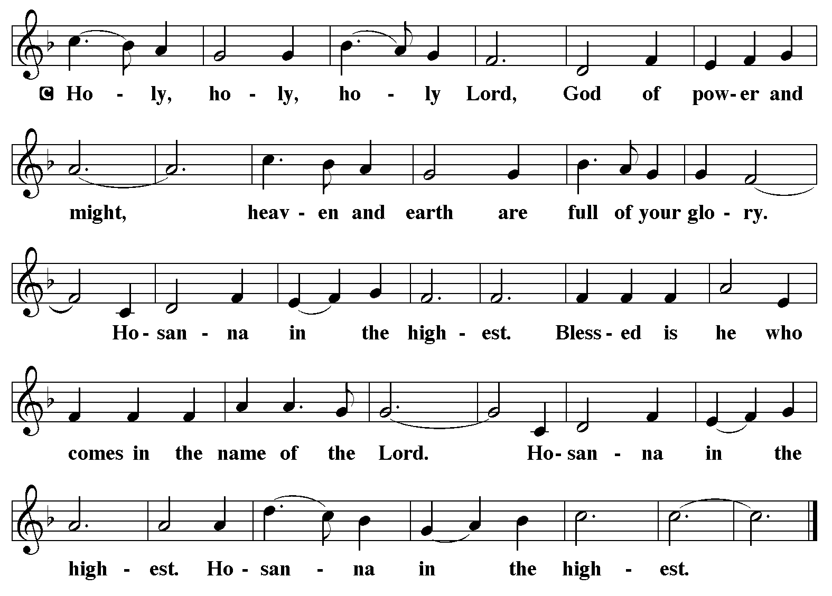

Holy Communion Preface pp. 108-111 or other Eucharistic prayer
In the night in which he was betrayed,
our Lord Jesus took bread, and gave thanks;
broke it, and gave it to his disciples, saying:
Take and eat; this is my body, given for you.
Do this for the remembrance of me.
Again, after supper, he took the cup, gave thanks,
and gave it for all to drink, saying:
This cup is the new covenant in my blood,
shed for you and for all people for the forgiveness of sin.
Do this for the remembrance of me.

C The Lord's Prayer
Our Father, who art in heaven, hallowed be thy name,
thy kingdom come, thy will be done, on earth as it is in heaven.
Give us this day our daily bread; and forgive us our trespasses,
as we forgive those who trespass against us;
and lead us not into temptation, but deliver us from evil.
For thine is the kingdom, and the power, and the glory,
forever and ever. Amen
Communion Distribution
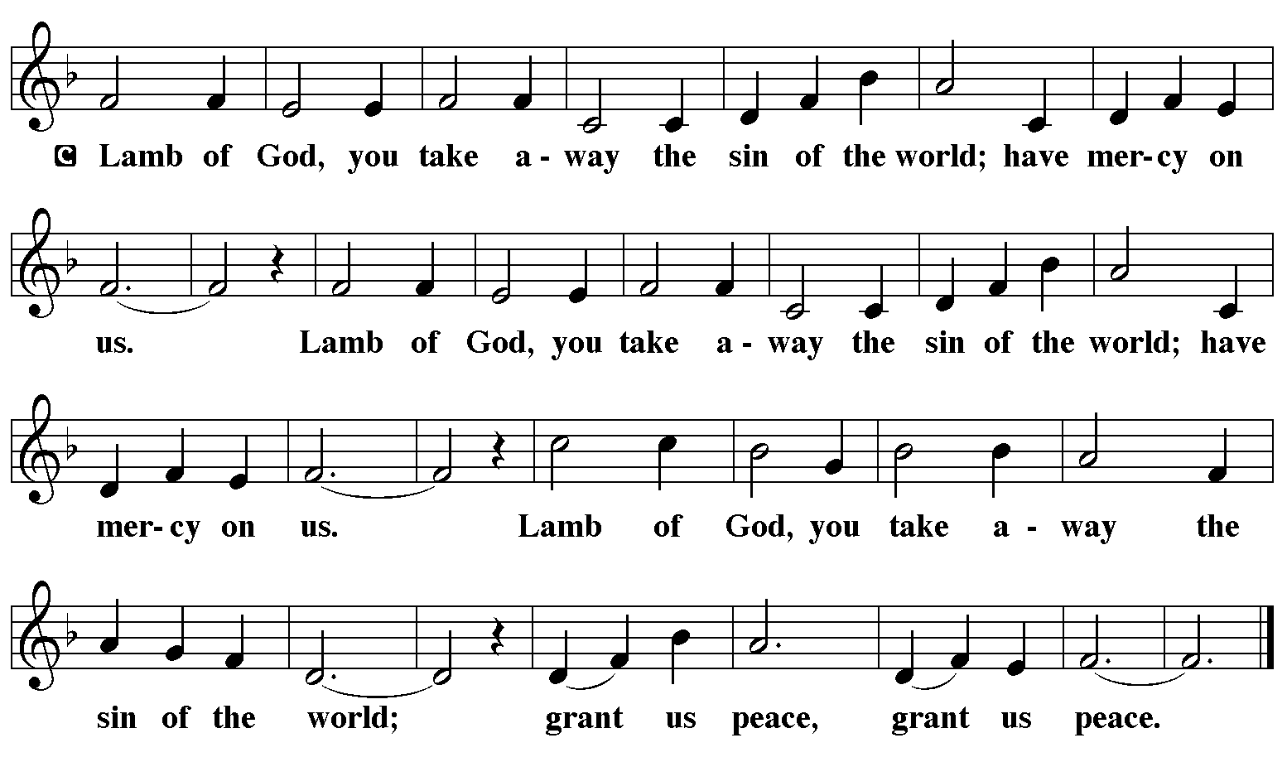

Communion Hymn: “We Come to the Hungry Feast” Red Book #479

Text: Ray Makeever, b. 1943
Music: HUNGRY FEAST, Ray Makeever
Text and music © 1982 Ray Makeever, admin. Augsburg Fortress
Reprinted under OneLicense.net#A-711151

Communion Prayer

Announcements

Blessing
P The Lord bless you and keep you. The Lord make his face shine on you and be gracious to you. The Lord look upon you with favor and + give you peace. In the name of the Father, and of the Son and of the Holy Spirit.
C Amen

Hymn: “The Spirit Sends Us Forth to Serve” Red Book #551
Dismissal
A Go in peace. Serve the Lord.
C Thanks be to God!
Postlude

Liturgy and texts from Sundays and Seasons.com. Copyright 2022 Augsburg Fortress. All rights reserved.
Reprinted by permission under Augsburg Fortress Liturgies Annual License #23628.

