Sunday, Aug. 21, 2022
Greeters: Isobel McLeish, Stewart Crerar
Coffee: Debra Monk, Marilyn Bourne
Service Leader: Wayne Hughes
Reflection on scripture: Bent Over
Power Point: Sue Newman
Scripture Reader: Adrian Franck
Scripture: Psalm 71:1-6, Luke 13:10-17
To read the scripture follow the link below then
type in the scripture verse http://bible.oremus.org

Comox United Church worship services are available in three ways.
1) Attend worship in-person at the church on Sundays at 10:00 am.
2) Watch live on-line by going to our YouTube channel. Just click on this link at 10:00 am on Sunday morning:
https://www.youtube.com/channel/UCJIaxG_quMwagK5WeiQwXPA
3) Watch the service at another time from the "Virtual Services" page on our website:
https://www.comoxunitedchurch.com/pages/online-sunday-services

Check out the CxU Blog
https://www.comoxunitedchurch.com/blog

FANTASTIC NEWS! Camp Homewood is a GO from September 30th to October 2nd. Registration forms will soon be going out to those who have signed up.
Would you like to join us? Come and enjoy fun and fellowship, rest and relaxation in a beautiful setting on Quadra Island. Questions? Contact Ruth Giles gilesr@shaw.ca. Or phone 250-339-5609

Hearing Assist Devices
We are looking for a volunteer
to maintain the hearing assist
devices.
Please contact the office. admin@comoxunitedchurch.com

Volunteer needed to take Garbage cans out on Sunday and to bring in on Monday starting September 11. Please contact the the office

How to live Our Values:
Care for the Common Good
Could CxU be a refuge for family and friends of those in the new Dementia Village, being built at St. Joseph’s? Could we provide a quiet place and maybe a listening ear, for people to process their experience with their loved ones in the Village?

This week’s Tip:
1. To learn about the dance/exercise classes starting in September, go to the church website
by googling Comox United Church.
2. From the menu at the top of the page, click on Events.
3. Scroll to Dance Classes.
4. Consider participating!
Questions? Comments? Concerns?
Submissions? Photos?
NB: This is YOUR website! If you’d like to add any articles or photos to this or any page, please email Joyce Wagland at websiteadmin@comoxunitedchurch.com or phone 250-207-5650.

Join The Grand Parade to benefit Glacier View Lodge! Saturday, September 17, 2022 Comox Marina Park 10 – 1:00. Proceeds from this fundraising walk will go towards the Music Therapy Program. Gather friends and family to form a team to fundraise and walk, or donate to an existing team. More information at:
https://thegrandparade.org/location/comoxvalley

Grief Workshop and Support Group
- An 8 week program beginning on Tuesday, September 6 at 2:00
led by Wayne Hughes
- This is an opportunity to normalize the grief process, explore feelings, receive emotional and spiritual support in a safe, nonjudgmental environment, and learn new ways to approach and cope with problems.
- Contact the office or Wayne directly to register for this workshop.
- Enrollment limited to 12 people.

Knox United Indoor Fall Fair
Sat. Sep. 10
345 Pym St. Parksville
8:00 am – 2:00 pm
Clothing, Books, Baking silent auction.
Kids playroom
Free admission

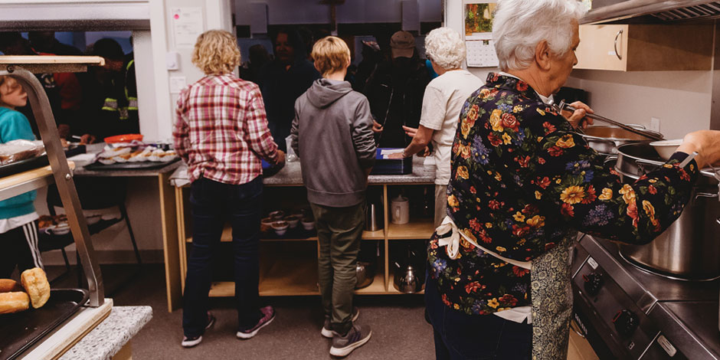

Would you like to help your needy neighbour?

Good news for our clients at the Sonshine Lunch Club serving meals to needy people - lunches will start serving meals 5 days a week inside at St George’s United church, Courtenay at the beginning of September.

This will mean more volunteers will be required and the Wednesday group of United church members (mostly from St George’s) would welcome your help from 9am to 12.30 -1.00 pm. This could be on a regular or an on-call basis.

For more info call Wayne or Louise Smiley of St George’s, home 250-334-7708 or Ruth Giles from Comox, home 250-339-5609. Thank you.

Comox United Church (250 Beach Drive) is STARTING A DANCE PROGRAM TO PROMOTE:
MOBILITY - FLEXIBILITY - BALANCE
Free introductory classes
NO dance experience necessary
please bring a friend
Questions: contact Wendy trinitydance@shaw.ca
STRETCH and STRENGTH
TUES. September 6 9:45-11:15 room T2
THURS. September 8 9:45 -11:15 room T2
Bring your Yoga mat!
Space is limited to 12 participants – extra classes will be added if required.
CHAIR DANCE
Suitable for those with limited mobility
WED. September 7 9:45- 11:15 room L1 lower level
The Right to Learn: Meshack’s Story

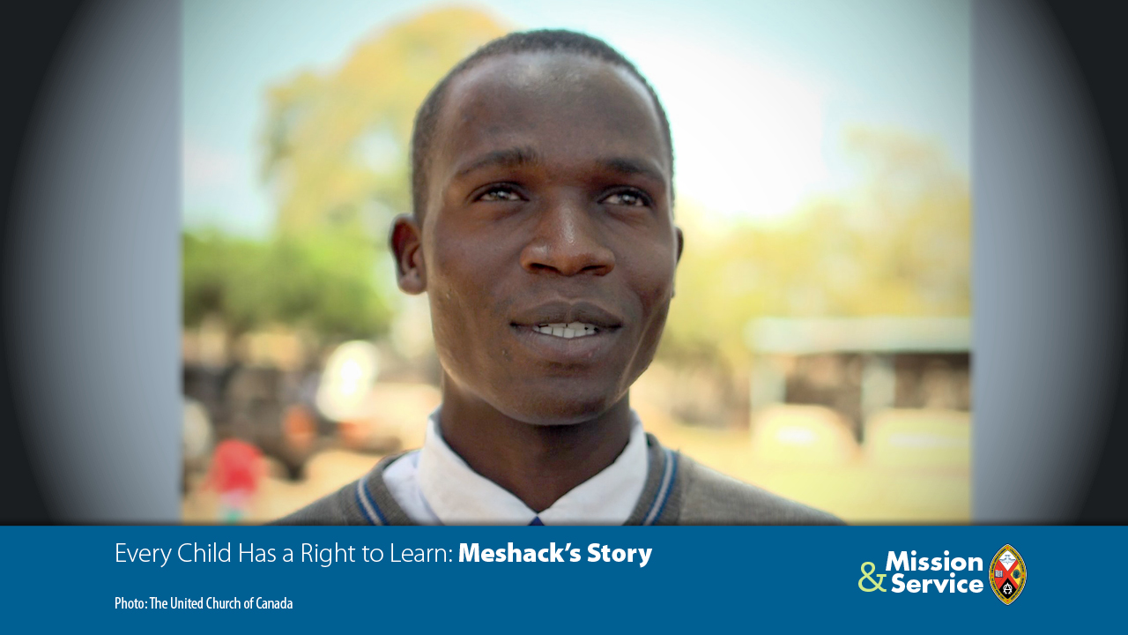

Every child has the right to learn.

Donations to the Mission and Service Fund of the United Church helps children around the world to go to school thanks to partnerships with organizations like the Kenya Alliance for Advancement of Children (KAARC).

School fees, violence, child labour, and discrimination mean that too many children can’t go to or stay in school. KAARC brings together child rights organizations to share information about child protection and safeguarding and to support children in schools.

KAARC has established over 300 child rights clubs in schools. One of these clubs helped Meshack through primary school. A bursary program helps him pay his high school fees, and the child rights club at his school is teaching him how to be a positive role model.

“Going to school was a problem for me. KAARC has helped me. They encouraged me a lot. They enabled me to start my primary school. Now I’m in high school,” Meshack says. “The club is helping us a lot, too. They give us role models to teach us what is bad and help us be confident in whatever we are doing. I’m very happy.”

Our congregation gives a designated amount of our annual offerings to the Mission and Service Fund so part of your offering this week will help to break down barriers so children can go to school regardless of where they live and how much money they have.

