
Faith Evangelical Lutheran Church, Washington, IL
Ninth Sunday after Pentecost
August 7, 2022

Welcome
Confession and Forgiveness

P: In the name of the Father, and of the + Son, and of the Holy Spirit.
C: Amen.
You may make the sign of the cross as a reminder of your baptism.
P: Almighty God, to whom all hearts are open, all desires known, and from whom no secrets are hid: cleanse the thoughts of our hearts by the inspiration of your Holy Spirit, that we may perfectly love you and worthily magnify your holy name, through Jesus Christ our Lord.
C: Amen.
P: Let us confess our sin in the presence of God and of one another.
Please keep silence for reflection
P: Most merciful God,
C: we confess that we are captive to sin and cannot free ourselves. We have sinned against you in thought, word, and deed, by what we have done and by what we have left undone. We have not loved you with our whole heart; we have not loved our neighbors as ourselves. For the sake of your Son, Jesus Christ, have mercy on us. Forgive us, renew us, and lead us, so that we may delight in your will and walk in your ways, to the glory of your holy name. Amen.
P: In the mercy of almighty God, Jesus Christ was given to die for us, and for his sake God forgives us all our sins. As a called and ordained minister of the church of Christ, and by his authority, I therefore declare to you the entire forgiveness of all your sins, in the name of the Father, and of the + Son, and of the Holy Spirit.
C: Amen.
Faith Lutheran Church
2206 Washington Rd,
Washington, IL 61571
Website and online worship:
www.shareourfaith.org
Church: 309-745-9306
faithlth@shareourfaith.org
Pastor John Rothfusz
Home: 309-745-9282
pastor@shareourfaith.org
Peace: As forgiven children of God, we have peace
with God, and peace with one another.
P The peace of the Lord be with you always.
C And also with you.
P Let us share that peace with one another.

*Hymn: “You Have Come Down to the Lakeshore” Red Book #817

Text: Cesáreo Gabaráin, 1936-1991; tr. Madeleine Forell Marshall, b. 1946
Music: PESCADOR DE HOMBRES, Cesáreo Gabaráin
Spanish text and music © 1979 Cesáreo Gabaráin, OCP Publications. All rights reserved. Tr. © Editorial Avance Luterano Reprinted under OneLicense.net#A-711151
P The grace of our Lord Jesus Christ, the love of God,
and the communion of the Holy Spirit be with you all.
C And also with you.

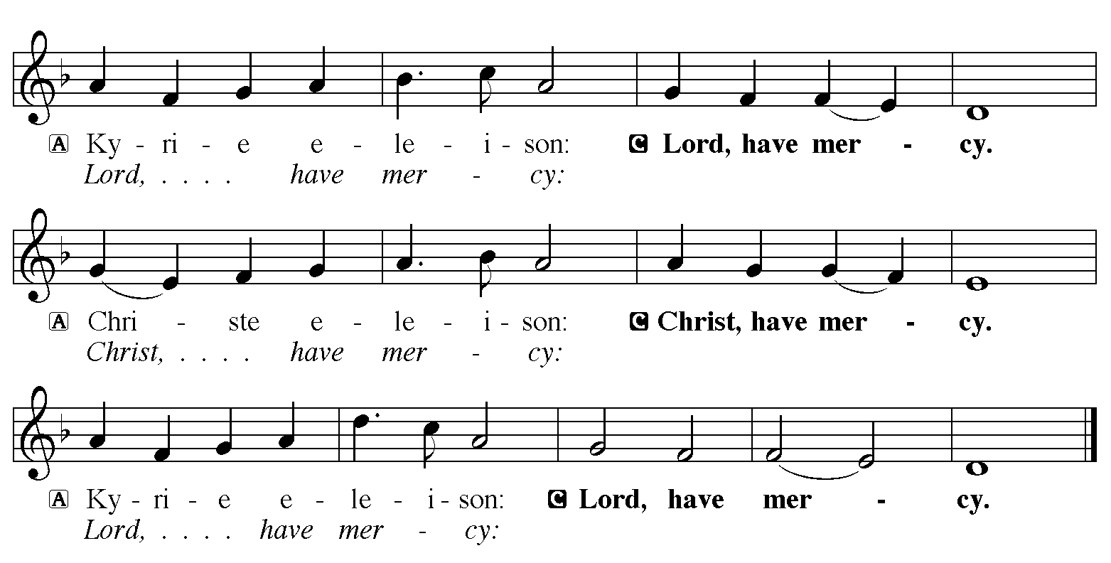

Hymn of Praise
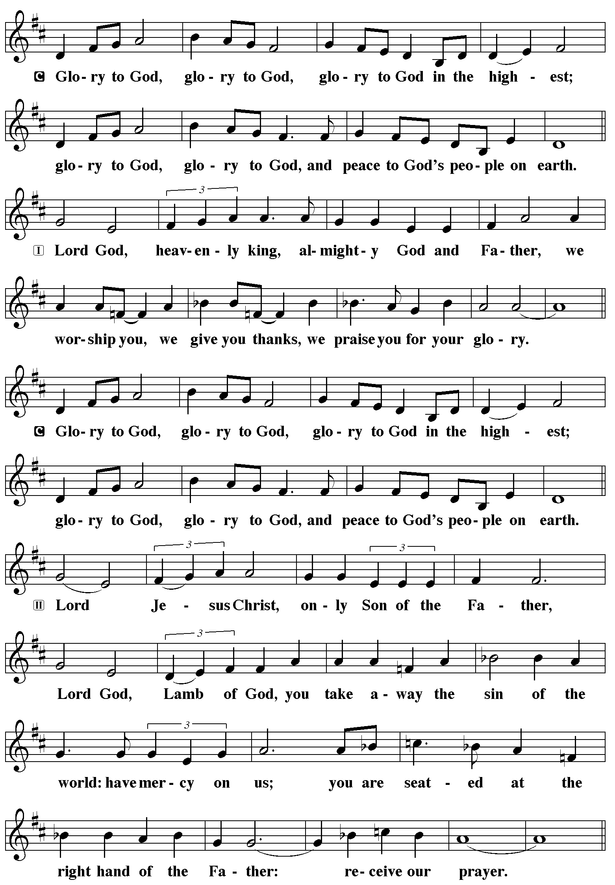
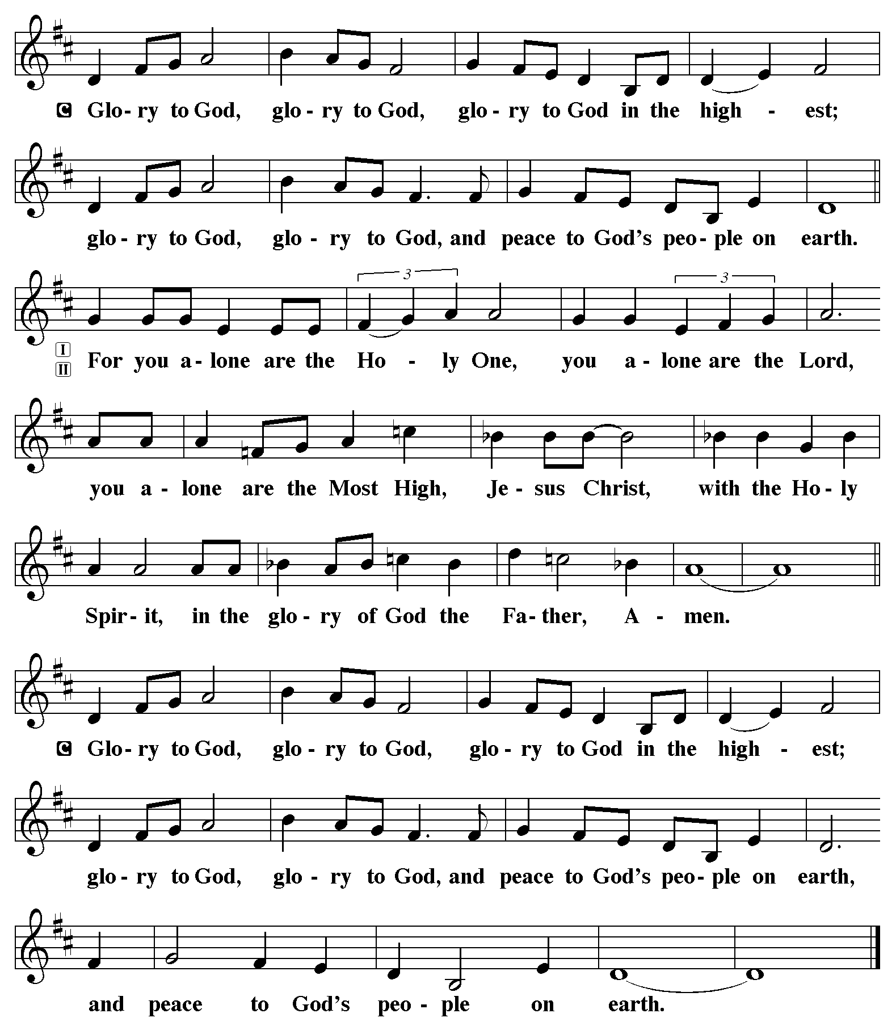

P The Lord be with you
C And also with you.
Let us pray together the Prayer of the Day.
Almighty God, you sent your Holy Spirit to be the life and light of your church. Open our hearts to the riches of your grace, that we may be ready to receive you wherever you appear, through Jesus Christ, our Savior and Lord.
Amen.

Children’s Message

First Reading: Genesis 15:1-6 Pew Bible Page #10
¹After these things the word of the Lord came to Abram in a vision, “Do not be afraid, Abram, I am your shield; your reward shall be very great.” ²But Abram said, “O Lord God, what will you give me, for I continue childless, and the heir of my house is Eliezer of Damascus?” ³And Abram said, “You have given me no offspring, and so a slave born in my house is to be my heir.” ⁴But the word of the Lord came to him, “This man shall not be your heir; no one but your very own issue shall be your heir.” ⁵He brought him outside and said, “Look toward heaven and count the stars, if you are able to count them.” Then he said to him, “So shall your descendants be.” ⁶And he believed the Lord; and the Lord reckoned it to him as righteousness.
R The Word of the Lord
C Thanks be to God

Psalm 33:12-22 Read responsively by whole verse
¹²Happy is the nation whose God is the Lord!
Happy the people chosen to be God’s heritage!
¹³The Lord looks down from heaven,
and sees all humankind.
¹⁴God sits firmly enthroned and watches
all who dwell on the earth.
¹⁵God fashions all their hearts
and observes all their deeds.
¹⁶A king is not saved by the size of the army,
nor are warriors rescued by their great strength.
¹⁷The horse gives vain hope for victory;
despite its great strength it cannot save.
¹⁸Truly, your eye is upon those who fear you, O Lord,
upon those who wait for your steadfast love,
¹⁹to deliver their lives from death,
and to keep them alive in time of famine.
²⁰Our innermost being waits for you, O Lord,
our helper and our shield.
²¹Surely, our heart rejoices in you,
for in your holy name we put our trust.
²²Let your lovingkindness, O Lord, be upon us,
even as we place our hope in you.

Second Reading: Hebrews 11:1-3, 8-16 Pew Bible Page #979
¹Now faith is the assurance of things hoped for, the conviction of things not seen. ²Indeed, by faith our ancestors received approval. ³By faith we understand that the worlds were prepared by the word of God, so that what is seen was made from things that are not visible.
⁸By faith Abraham obeyed when he was called to set out for a place that he was to receive as an inheritance; and he set out, not knowing where he was going. ⁹By faith he stayed for a time in the land he had been promised, as in a foreign land, living in tents, as did Isaac and Jacob, who were heirs with him of the same promise. ¹⁰For he looked forward to the city that has foundations, whose architect and builder is God. ¹¹By faith he received power of procreation, even though he was too old—and Sarah herself was barren—because he considered him faithful who had promised. ¹²Therefore from one person, and this one as good as dead, descendants were born, “as many as the stars of heaven and as the innumerable grains of sand by the seashore.”
¹³All of these died in faith without having received the promises, but from a distance they saw and greeted them. They confessed that they were strangers and foreigners on the earth, ¹⁴for people who speak in this way make it clear that they are seeking a homeland. ¹⁵If they had been thinking of the land that they had left behind, they would have had opportunity to return. ¹⁶But as it is, they desire a better country, that is, a heavenly one. Therefore God is not ashamed to be called their God; indeed, he has prepared a city for them.

R The Word of the Lord
C Thanks be to God
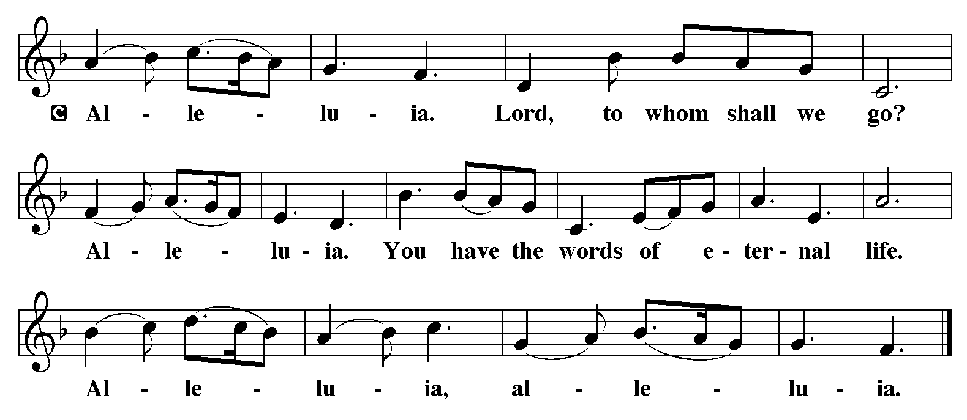

Gospel Reading: Luke 12:32-40 Pew Bible Page #842

C Glory to you, O Lord
[Jesus said:] ³²“Do not be afraid, little flock, for it is your Father’s good pleasure to give you the kingdom. ³³Sell your possessions, and give alms. Make purses for yourselves that do not wear out, an unfailing treasure in heaven, where no thief comes near and no moth destroys. ³⁴For where your treasure is, there your heart will be also.
³⁵“Be dressed for action and have your lamps lit; ³⁶be like those who are waiting for their master to return from the wedding banquet, so that they may open the door for him as soon as he comes and knocks. ³⁷Blessed are those slaves whom the master finds alert when he comes; truly I tell you, he will fasten his belt and have them sit down to eat, and he will come and serve them. ³⁸If he comes during the middle of the night, or near dawn, and finds them so, blessed are those slaves.
³⁹“But know this: if the owner of the house had known at what hour the thief was coming, he would not have let his house be broken into. ⁴⁰You also must be ready, for the Son of Man is coming at an unexpected hour.”
The Gospel of the Lord C Praise to you, O Christ
Sermon by Pastor John Rothfusz
Sermon Hymn: “Have No Fear, Little Flock” Red Book #764

Text: Luke 12:32, st. 1; Marjorie Jilson, b. 1931, sts. 2-4
Music: LITTLE FLOCK, Heinz Werner Zimmermann, b. 1930
Text and music © 1973 Concordia Publishing House Reprinted under OneLicense.net#A-711151
Apostles’ Creed
C: I believe in God, the Father almighty,
creator of heaven and earth.
I believe in Jesus Christ, God's only Son, our Lord,
who was conceived by the Holy Spirit,
born of the virgin Mary,
suffered under Pontius Pilate,
was crucified, died, and was buried;
he descended to the dead.
On the third day he rose again;
he ascended into heaven,
he is seated at the right hand of the Father,
and he will come to judge the living and the dead.
I believe in the Holy Spirit,
the holy catholic church, the communion of saints,
the forgiveness of sins, the resurrection of the body,
and the life everlasting. Amen.


Prayers: After each portion of the prayers finishes with “Lord in your mercy,” please respond, “Hear our prayer.”

Offering: Jesus is Lord, and leads us in the ways of life and salvation. Let us offer ourselves to the Lord and joyfully lift our tithes and offerings to God.
Please take a moment now to make an electronic offering to the church on the website, with the Tithe.ly app on your phone, or drop and envelope in the plate at communion time.
Faith Lutheran website link www.shareourfaith.org

Offering Prayer

Great Thanksgiving
P The Lord be with you.
C And also with you.
P Lift up your hearts.
C We lift them to the Lord.
P Let us give thanks to the Lord our God.
C It is right to give God thanks and praise.

P It is indeed right, our duty and our joy… with the church on earth and the hosts of heaven, we praise your name and join their unending hymn:
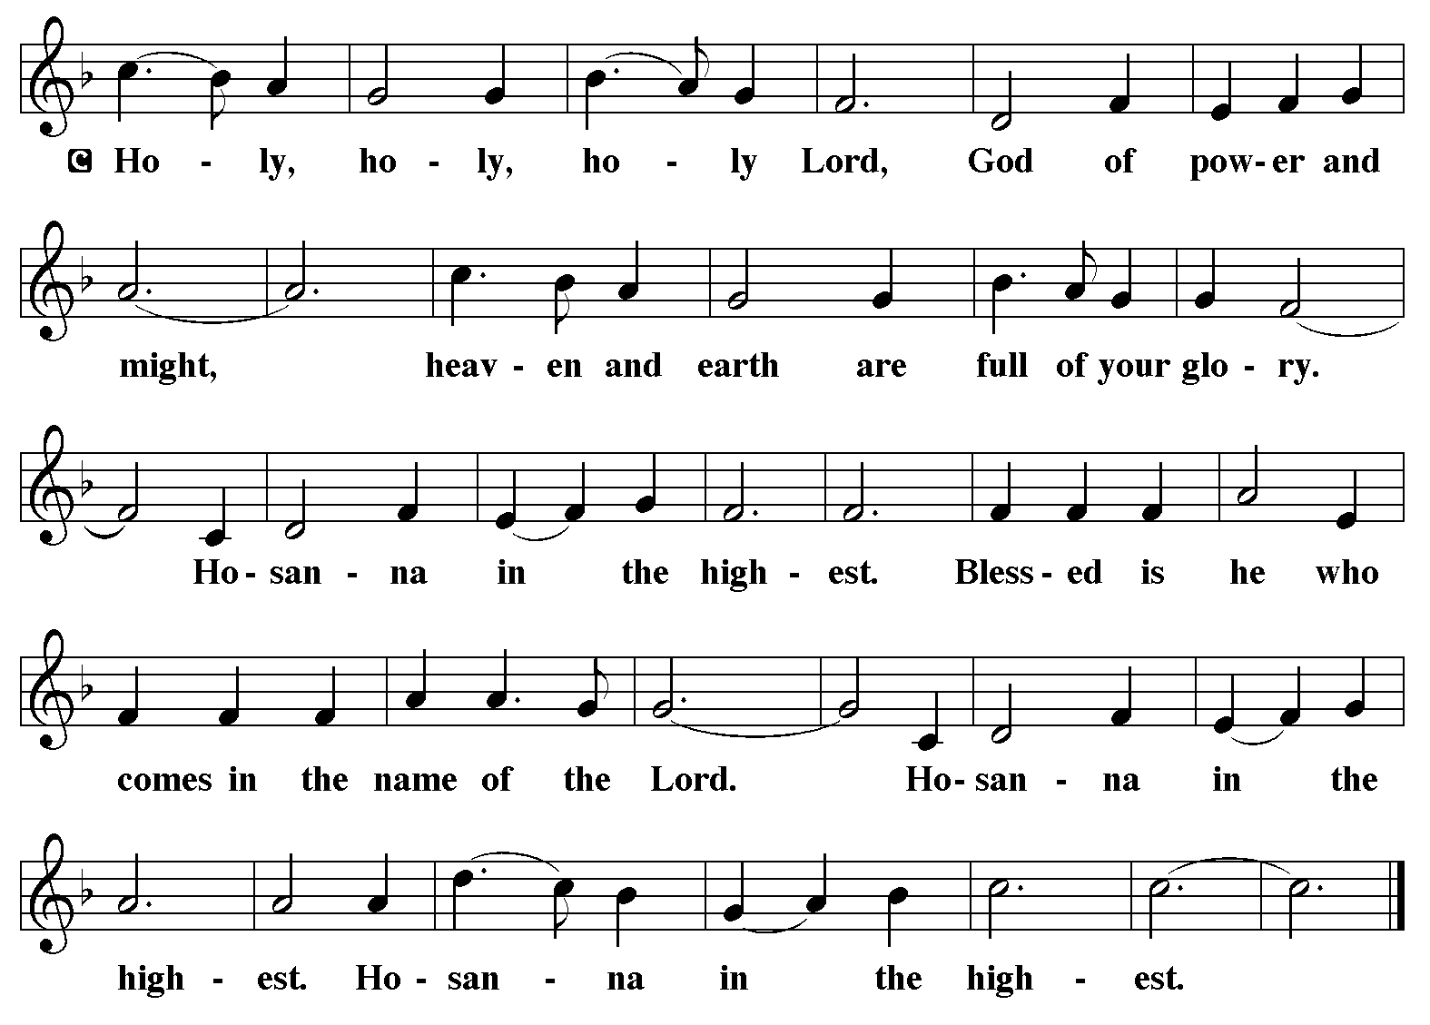

Holy Communion Preface pp. 108-111 or other Eucharistic prayer

In the night in which he was betrayed,
our Lord Jesus took bread, and gave thanks;
broke it, and gave it to his disciples, saying:
Take and eat; this is my body, given for you.
Do this for the remembrance of me.
Again, after supper, he took the cup, gave thanks,
and gave it for all to drink, saying:
This cup is the new covenant in my blood,
shed for you and for all people for the forgiveness of sin.
Do this for the remembrance of me.

C The Lord's Prayer
Our Father, who art in heaven, hallowed be thy name,
thy kingdom come, thy will be done, on earth as it is in heaven.
Give us this day our daily bread; and forgive us our trespasses,
as we forgive those who trespass against us;
and lead us not into temptation, but deliver us from evil.
For thine is the kingdom, and the power, and the glory,
forever and ever. Amen
Communion Distribution
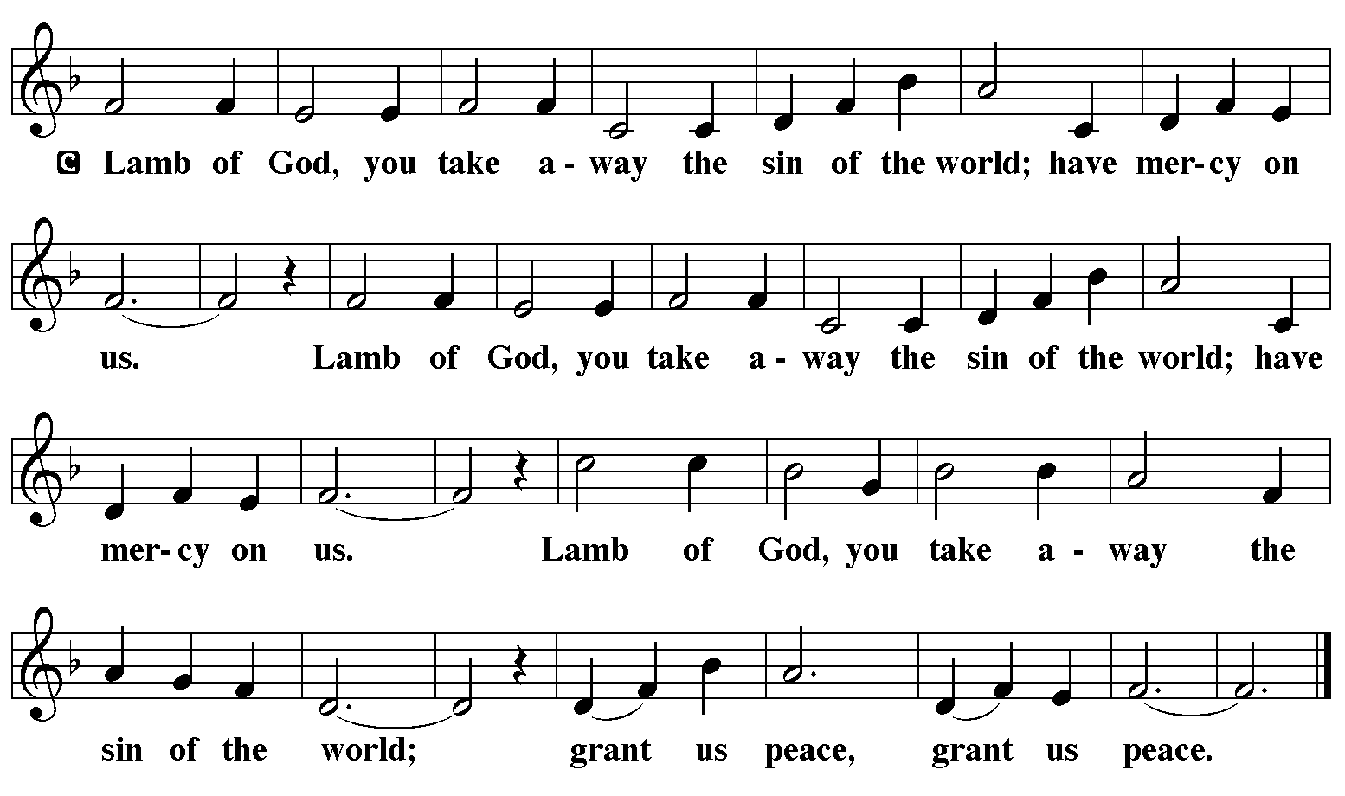

Communion Hymn: “How Great Thou Art” Blue Book #856

Text: Carl g. Boberg, 1859-1940; tr. And adapt. Stuart K. Hine, 1899-1989
Music: O STORE GUD, Swedish folk tune; adapt. Stuart K. HineText and music © 1953 S. K. Hine, assigned to Manna Music, Inc., 35255 Brooten Road,Pacific City, OR 97135 (ASCAP). Renewed 1981. All rights reserved. Reprinted under OneLicense.net#A-711151

Communion Prayer
Announcements
Blessing
P The Lord bless you and keep you. The Lord make his face shine on you and be gracious to you. The Lord look upon you with favor and + give you peace. In the name of the Father, and of the Son and of the Holy Spirit.
C Amen
Hymn: “Lord Jesus, You Shall Be My Song” Red Book #808

Text: Les Petites Soeurs de Jésus and L’Arche community; tr. Stephen Somerville, b. 1931
Music: LES PETITES SOEURS, Les Petites Soeurs de Jeésus and L’Archie Community
Text and music © 1987 Les Petites Soeurs de Jésus
Tr. © 1970 Stephen Somerville Reprinted under OneLicense.net#A-711151

Dismissal
A Go in peace. Serve the Lord.
C Thanks be to God!
Postlude

Liturgy and texts from Sundays and Seasons.com. Copyright 2022 Augsburg Fortress. All rights reserved.
Reprinted by permission under Augsburg Fortress Liturgies Annual License #23628.

