Sunday, July 31, 2022
Greeters: Merrilee Cameron, Marg Silman
Coffee: Jan Bjarnason, Peter Senior
Service Leader: Rev. Brenda Riley
Sermon: A New Spirituality
Power Point: Barb Page
Scripture Reader: Julie Whitman
Scripture: Luke 12:13-21
To read the scripture follow the link below then
type in the scripture verse http://bible.oremus.org

Please note: Church office is closed Tuesday Aug. 2

Comox United Church worship services are available in three ways.
1) Attend worship in-person at the church on Sundays at 10:00 am.
2) Watch live on-line by going to our YouTube channel. Just click on this link at 10:00 am on Sunday morning:
https://www.youtube.com/channel/UCJIaxG_quMwagK5WeiQwXPA
3) Watch the service at another time from the "Virtual Services" page on our website:
https://www.comoxunitedchurch.com/pages/online-sunday-services

Check out the CxU Blog
https://www.comoxunitedchurch.com/blog

SCAM emails: If you receive an email from Pastor Wayne Hughes this is a scam
DO NOT open it or respond to it.

We truly appreciate the kindness and patience you, our administrators and your congregation had with our construction team and our subcontractors.
The project is now 95% complete and with any luck it will be completely finished this week with the exception of some additional work that is being added.
This project went well. We came in under budget (good for us and the Town) and on schedule! It truly takes a community to make a project like this a success.
Best regards, Raymond Henderson
Edgett Excavating

Our dates are September 30-October 2, 2022 and we would encourage you to consider coming - for fun, fellowship, rest and recreation at the beautiful site on Quadra Island. Please email gilesr@shaw.ca if you plan on coming but have not already notified Joanne Wiens. We need a minimum number of 30 to attend.
Any photos from previous visits would be welcomed; send to gilesr@shaw.ca

Thank you for your generous support for our Sundaes on Sunday Camp Homewood Retreat (Sept 30-Oct 2) fundraiser. Together we raised $300 for craft supplies and for those who may need assistance in attending. Please let Ruth Giles, Marg Adams or Fiona Curry know if you’d like to attend. We need 30 enthusiastic campers in order for this weekend to go ahead.

This week’s Tip:

1. To read about the Congregational Retreat coming up in September, go to the church
website by googling Comox United Church.
2. From the menu at the top of the page, click on Events.
3. Scroll to Camp Homewood!
4. Consider reserving a spot for yourself!

NB: This is YOUR website! If you’d like to add any articles or photos to this or please email Joyce Wagland at websiteadmin@comoxunitedchurch.com or phone 250-207- 5650.

Free topsoil -courtesy of Edgett Contracting - is available to any in the congregation
- first come, first served, but must do the loading and transport yourself.

Thank You!
You will notice that the lines in the parking lot have been freshly painted. This happened because one of our congregation skillfully negotiated with Edgett Contracting. In exchange for letting Edgett use our parking lot to store their trucks and excavators during the sidewalk construction project Edgett arranged for the lines to be repainted. No money changed hands. Just old-fashioned bartering and trust.

Thank you to Edgett and their partners.
Thank you to Andrew Black for handling this on our behalf.

Join The Grand Parade to benefit Glacier View Lodge! Saturday, September 17, 2022 Comox Marina Park 10 – 1:00. Proceeds from this fundraising walk will go towards the Music Therapy Program. Gather friends and family to form a team to fundraise and walk, or donate to an existing team. More information at:
https://thegrandparade.org/location/comoxvalley

How to live Our Values
Spirituality

Daily Reflections hosted by the Christian Seasons Calendar offer encouragement in our common ministry as disciples of Christ Jesus, for the glory of God and the sake of God’s beloved world.
https://christiancalendar.squarespace.com/daily

How to live Our Values:
Openness
“Though “out of the world,” we are in the same world as everybody else, the world of the bomb, the world of race hatred, the world of technology, the world of mass media, big business, revolution, and all the rest. We take a different attitude to all these things, for we belong to God. Yet so does everybody else belong to God. We just happen to be conscious of it, and to make a profession out of this consciousness.”
Thomas Merton

How to live Our Values:
Care for the Common Good
(Space for your idea here. Send a note to admin@comoxunitedchurch.com.)

How to live Our Values:
Radical Love
Consider a role on the Refugee Support team that is helping dozens of Ukrainian people settle in the Comox Valley.
Ruth G. offered her vacant suite and now has a young family living there.

What role will you take?
To offer you gift of time or talent, contact Cathie Talbot at 250-339-1021 or cgtalbot@shaw.ca.

General Council 44: The Rev. Dr. Carmen Lansdowne Elected 44th Moderator
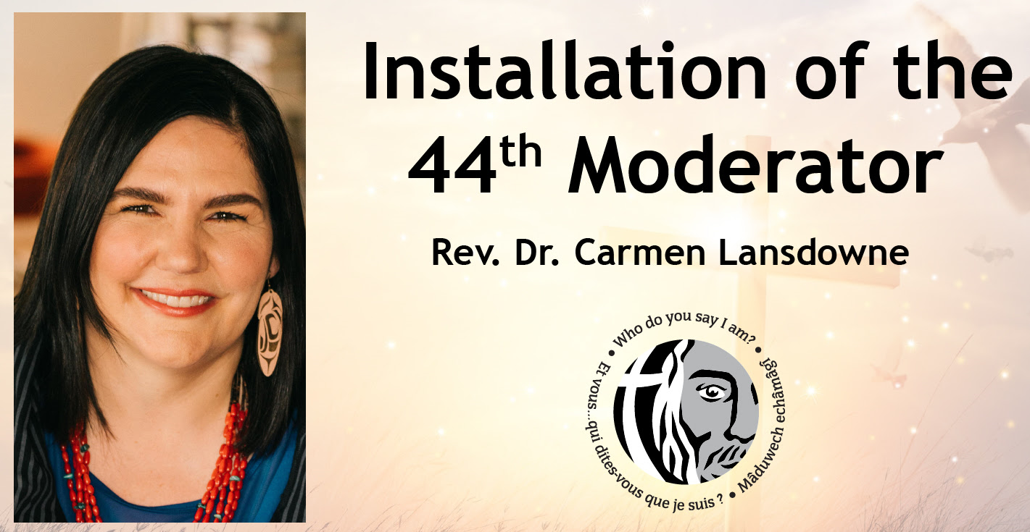
[Photo credit: Courtesy of Rev. Dr. Carmen Lansdowne]

The United Church of Canada has elected the Rev. Dr. Carmen Lansdowne, Kwisa’lakw, 47, as its 44th Moderator. She will be the church’s spiritual leader for the next three years.
In articulating her vision for The United Church of Canada, the Rev. Dr. Lansdowne speaks of a church committed: “To build new connections and rebuild old ones. To work towards social change that sees a world cared for, and human dignity honoured. To walk together every day in repentance and reconciliation. To march and fight and change unjust systems together. To pray together. To sing together. To discern together.”
Get to know the 44th Moderator by reading her full biography and statement of vision, watching her message on YouTube, and following her on Facebook.
You are invited to the installation of the new Moderator on Sunday, August 7, 2022, at 1:00 p.m. PDT/ 4:00 p.m. EDT/ 5:30 p.m. NDT. Attend in person, or watch online on YouTube Livestream.

