All Saints Anglican Church, Agassiz
6904 Lougheed Highway, BC, V0M 1A0

Bulletin July 11– July 17, 2022
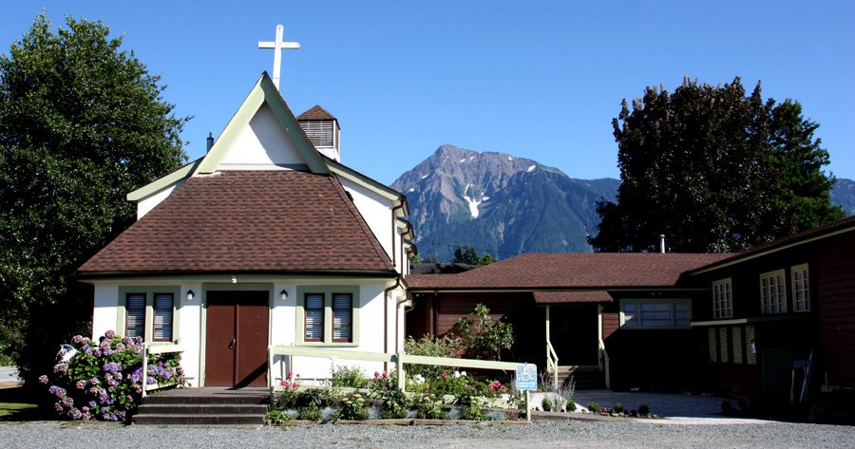

‘The ground we walk does not belong to us; for thousands of years it has been - and remains - the territory of the Stó:lō.’ We are grateful for their sharing.

Phone: 604-796-3553
Website: www.allsaints-agassiz.ca
https://www.facebook.com/groups/AllSaintsFamily
OUR DOOR IS OPEN AND ALL ARE WELCOME
17th July 2022, 6th Sunday after Pentecost
Priest-in-Charge: The Reverend Philip Barker
Hosts: Graham Featherstone/Jennifer Pinlac
Intercessor: Karol Henrotte
Lay Administrator: Karol Henrotte
Announcer: Ginny Jennings
Piano: Fran Froehlich

PLEASE NOTE:
Zoom service will still be available and a link sent out around 09:45 by Graham. Email him at gfeatherstone@shaw.ca if you don’t think you’re on his list.
Vicar’s cell phone: Rev’d Philip Barker. 778-867-2461
Vicar’s Warden: Ginny Jennings. 604-796-2206
People’s Warden: Lynn Laughlin. 604-799-5131
Parish email: www.allsaints-agassiz.ca
Please contact either warden if you have an issue that needs to be brought to the attention of the Vicar - or contact the Vicar direct (see above for details).

WARDENS’ PITCH
- Bible Study with Karol is every Saturday at 8:30 a.m. on Zoom.
- Book Club meets Wednesday at 4:00 p.m. on Zoom.
- July 20th will be the last meeting for the current book. See below for further information regarding the next book club.
- Evening Prayer with Valerie is at 7:00 p.m. Sun, Wed, Fri on our webpage.
- Prayer Requests can be given on a piece of paper to either of the Wardens or the Vicar or entered in the Prayer Request Book on the piano in the church or you may contact Anthea Lewis at antheamlewis@shaw.ca for Pray First Prayer Circle, which is a confidential online prayer circle.
- Music Requests may be given to the Wardens or the Vicar.
- AA meets in the hall every Tuesday at noon.
- Games for 55’s + every Thursday in the hall 10:00-12:00.
- Coffee Hosts rotation has begun after our Sunday service. We will need two more people to sign up so that everyone has been partnered up. Please contact Anthea or Lynn if you are willing to fill a spot.
- 5th Sunday of each month will be a potluck lunch after the service.

PLEASE NOTE: If anyone has any inclusions for the Bulletin, please contact the Wardens. Thank you.

All Saints Book Club will be taking a break after July 20th and will restart on Wednesday, September 7th at 4.00pm on Zoom. The new book will be 'The Book of Joy: Lasting Happiness in a Changing World" by the Dalai Lama, Desmond Tutu and others. It is the result of a 7-day meeting between the Dalai Lama and Archbishop Tutu discussing how we find joy in the face of suffering. The hardback is currently available on Amazon for $25.00. New book club members are always welcome. Please tell Sheila if you would like to be added to the Zoom invitation list and please make sure you have a copy of the book.

Agassiz Churches together are sponsoring another refugee family and have asked if we would include the information below in our bulletin for the forsee-able future. I have joined the refugee committee because I will likely be involved in teaching the family English. All Saints has not been committed to anything.

Refugee Sponsorship
The Agassiz Group of Churches is sponsoring another family, a young family (father, mother, and 2 young boys) who fled Sudan. We would appreciate your support in the following ways:
1. Housing--we have urgent need for a 2-bedroom rental place, preferably within walking distance of services in Agassiz. We've been told this family may arrive in 2-4 months from now. Contact Alfred VanderBrink on 604 793 8681.
2. Household items--if you have donations towards setting up a home for this family, please contact the Feenstra's, Sophia 604-819-5929, or Auke 604-819-1689.
3. Finances--We presently have $8000 in our account. We need $17,000 more by September. Cheques can be made out to Riverside CRC Refugee Fund (charitable tax receipts are available).

Chuckles
Never buy flowers from a monk. Only you can prevent florist friars.

Birthdays This Month
Fred Watson was on the 18th.

Ministerial Meandering
Does Size Matter?
Now before you ladies start tittering behind your fans, I want to tell you that I am writing about towns, not todgers. Also, I am trying to address functionality in relation to size, which, I suppose, could elicit another small giggle.

I am no economist, even though I read the magazine, but in a recent edition there was an article on the growth or otherwise of British towns and cities. I don’t pretend to understand all the arguments that were being put forward, but it had me wondering - in my meandering way - about the theological implications of town growth (urban development) and its societal implications.

There are few now, I would venture, that have spent their entire lives within one village or town in Britain; population growth demands that people move, either into or away from towns. There are restrictions on building too; Green Belt areas make building contracts very hard to come by (legally), and so horizontal growth is restricted. Vertical growth is also limited in most towns too. If a town is then to be a centre of commerce, it will require that domestic housing is also restricted or even reduced.
Demographic change must follow, and it is evident in most major British cities, that those of middle age and upwards are moving out to quieter and more spacious living areas.

What does all this movement mean for us as a society? Obviously, I cannot give the answers here - even if I knew them (which I don’t) - but I ask the question as to whether this is a healthy move for us as sociable human beings?

Endless growth does not equate with increasing ‘success’, even in the market place. Towns close up at night, apart from the clubs, pubs, and restaurants, and with travel either expensive or risky, there is less incentive to mingle where you cannot stay.
I am not saying ‘bring back the horse and cart’ - though I sometimes think it wouldn’t be such a bad idea - but I think that urban growth or sprawl is detrimental to a cohesive sense of community.

Looking closer to home than Britain, when I did a locum in Fort St John, the town had an average age of 25, and it was at the time the fastest growing town in Canada. Does this make it a success in societal terms?
It might make it a financial success, and a good place to find a job, but as it creeps ever outwards, insidiously invading the surrounding country, and separating family from family by ever increasing distances, I fear for the sense of community that we still treasure here in Agassiz.

So, ladies, bigger is not necessarily better, I fear; and whilst smaller is not necessarily perfect either, it may be more satisfying for community and sense of belonging. And it is a lack of that sense of belonging that stops us from recognising our neighbours as fellow human beings, and increases our sense of alienation, bringing loneliness, isolation, and depression in its wake.

If Jesus emphasised one thing, it was that we are all ‘children of God, - and, as such, we are part of a family. In order to maintain that sense of family, we should curb the tendency to ever increase the size of our towns and cities. Perhaps, to do so, we should also curb the tendency to increase the size of our families too - but that would be to open a whole new can of worms that I am not going to address today!

Philip+

Sunday Cycle of Prayer
St. Thomas, Chilliwack The Revd Allen Doerksen
The Revd David Koe
The Thomas, Vancouver The Revd Michael Batten
The Revd Brynn Craffey
The Anglican Church Women-Gail Revitt President

Monthly Cycle of Prayer
Synod Office Synod Office Staff
Salal and Cedar The Revd Laurel Dykstra

Anglican Cycle of Prayer
Our Primate, Archbishop, Linda Nicolls. For National Indigenous Interim Bishop Sidney Black and for the Anglican Council of Indigenous People. We also pray for the Coordinator for Indigenous Justice, Kerry Baisley.
In our parish we pray for our priest, Philip; retired priests Mike, Jack, and Paul. Amen

Collect
Almighty God, your Son as opened for us a new and living way into your presence. Give us pure hearts and constant wills to worship you in spirit and in truth; through Jesus Christ our Lord, who reigns with you and the Holy Spirit, one God, now and forever.

Amos 8: 1-12 Graham Featherstone

Introduction: In the fourth vision of his planned devastation, God threatens to punish the Israelites for fraudulent business practices which particularly affect the poor and needy. There is a word-play on “summer fruit” and “end”: in Hebrew the words sound alike.

Reading:
This is what the Lord GOD showed me--a basket of summer fruit.
He said, "Amos, what do you see?" And I said, "A basket of summer fruit." Then the LORD said to me, "The end has come upon my people Israel; I will never again pass them by.
The songs of the temple shall become wailings in that day," says the Lord GOD; "the dead bodies shall be many, cast out in every place. Be silent!"
Hear this, you that trample on the needy, and bring to ruin the poor of the land,
saying, "When will the new moon be over so that we may sell grain; and the sabbath, so that we may offer wheat for sale? We will make the ephah small and the shekel great, and practice deceit with false balances,
buying the poor for silver and the needy for a pair of sandals, and selling the sweepings of the wheat."
The LORD has sworn by the pride of Jacob: Surely I will never forget any of their deeds.
Shall not the land tremble on this account, and everyone mourn who lives in it, and all of it rise like the Nile, and be tossed about and sink again, like the Nile of Egypt?
On that day, says the Lord GOD, I will make the sun go down at noon, and darken the earth in broad daylight.
I will turn your feasts into mourning, and all your songs into lamentation; I will bring sackcloth on all loins, and baldness on every head; I will make it like the mourning for an only son, and the end of it like a bitter day.
The time is surely coming, says the Lord GOD, when I will send a famine on the land; not a famine of bread, or a thirst for water, but of hearing the words of the LORD.
They shall wander from sea to sea, and from north to east; they shall run to and fro, seeking the word of the LORD, but they shall not find it.

Hear what the Spirit is saying to the Church. Thanks be to God

Psalm 52
Why do you boast, O mighty one, of mischief done against the godly? All day long
you are plotting destruction. Your tongue is like a sharp razor, you worker of treachery.
You love evil more than good, and lying more than speaking the truth.
You love all words that devour, O deceitful tongue.
But God will break you down forever; he will snatch and tear you from your tent; he will uproot you from the land of the living.
The righteous will see, and fear, and will laugh at the evildoer, saying,
"See the one who would not take refuge in God, but trusted in abundant riches, and sought refuge in wealth!"
But I am like a green olive tree in the house of God. I trust in the steadfast love of God forever and ever.
I will thank you forever, because of what you have done. In the presence of the faithful I will proclaim your name, for it is good.

Colossians 1:15-28 Lynn Laughlin

Introduction: The Christians of Colossae hear of Christ, in whom the entirety of God resides, who draws all things together, and who is the head of all created-ness.
Reading:
He is the image of the invisible God, the firstborn of all creation;
for in him all things in heaven and on earth were created, things visible and invisible, whether thrones or dominions or rulers or powers--all things have been created through him and for him.
He himself is before all things, and in him all things hold together.
He is the head of the body, the church; he is the beginning, the firstborn from the dead, so that he might come to have first place in everything.
For in him all the fullness of God was pleased to dwell,
and through him God was pleased to reconcile to himself all things, whether on earth or in heaven, by making peace through the blood of his cross.
And you who were once estranged and hostile in mind, doing evil deeds,
he has now reconciled in his fleshly body through death, so as to present you holy and blameless and irreproachable before him--
provided that you continue securely established and steadfast in the faith, without shifting from the hope promised by the gospel that you heard, which has been proclaimed to every creature under heaven. I, Paul, became a servant of this gospel.
I am now rejoicing in my sufferings for your sake, and in my flesh I am completing what is lacking in Christ's afflictions for the sake of his body, that is, the church.
I became its servant according to God's commission that was given to me for you, to make the word of God fully known,
the mystery that has been hidden throughout the ages and generations but has now been revealed to his saints.
To them God chose to make known how great among the Gentiles are the riches of the glory of this mystery, which is Christ in you, the hope of glory.
It is he whom we proclaim, warning everyone and teaching everyone in all wisdom, so that we may present everyone mature in Christ.

Hear what the Spirit is saying to the Church. Thanks be to God

Luke 10: 38-42

Introduction: In Jesus’ day, to sit at someone’s feet was to be his disciple. Jesus praises Mary’s discipleship. Her role is exemplary but Jesus also values Martha’s role.
Reading:
Now as they went on their way, he entered a certain village, where a woman named Martha welcomed him into her home.
She had a sister named Mary, who sat at the Lord's feet and listened to what he was saying.
But Martha was distracted by her many tasks; so she came to him and asked, "Lord, do you not care that my sister has left me to do all the work by myself? Tell her then to help me."
But the Lord answered her, "Martha, Martha, you are worried and distracted by many things;
there is need of only one thing. Mary has chosen the better part, which will not be taken away from her."

