Holy Eucharist on the Sixth Sunday after Pentecost
Proper 16

The Gathering of the Community
Presider The grace of our Lord Jesus Christ,
and the love of God,
and the fellowship of the Holy Spirit
be with you all.
People And also with you.

Act of Praise
Blessed Jesus, at Your Word (CP 559)

The Collect for the Sixth Sunday after Pentecost (ACRCL Proper 16C)
Presider Let us pray.
Eternal God,
you draw near to us in Christ
and make yourself our guest:
amid the cares of our daily lives,
alert us to your presence
and make us attentive to your voice,
so that we may treasure your word above all else.
We ask this through Jesus Christ, your Son.
People Amen.

Children’s Message

The Proclamation of the Word

The First Reading (Amos 8.1-12)
Reader A reading from the book of Amos:
This is what the Lord God showed me - a basket of summer fruit. He said, "Amos, what do you see?" And I said, "A basket of summer fruit." Then the Lord said to me, "The end has come upon my people Israel; I will never again pass them by. The songs of the temple shall become wailings in that day," says the Lord God; "the dead bodies shall be many, cast out in every place. Be silent!" Hear this, you that trample on the needy, and bring to ruin the poor of the land, saying, "When will the new moon be over so that we may sell grain; and the sabbath, so that we may offer wheat for sale? We will make the ephah small and the shekel great, and practise deceit with false balances, buying the poor for silver and the needy for a pair of sandals, and selling the sweepings of the wheat." The Lord has sworn by the pride of Jacob: Surely I will never forget any of their deeds. Shall not the land tremble on this account, and everyone mourn who lives in it, and all of it rise like the Nile, and be tossed about and sink again, like the Nile of Egypt? On that day, says the Lord God, I will make the sun go down at noon, and darken the earth in broad daylight. I will turn your feasts into mourning, and all your songs into lamentation; I will bring sackcloth on all loins, and baldness on every head; I will make it like the mourning for an only son, and the end of it like a bitter day. The time is surely coming, says the Lord God, when I will send a famine on the land; not a famine of bread, or a thirst for water, but of hearing the words of the Lord. They shall wander from sea to sea, and from north to east; they shall run to and fro, seeking the word of the Lord, but they shall not find it.
Hear what the Spirit is saying to the Church.
People Thanks be to God.

The Psalms (52)
Cantor sings the refrain once. Everyone sings the refrain together.
Cantor sings the verses. Everyone sings the refrains.
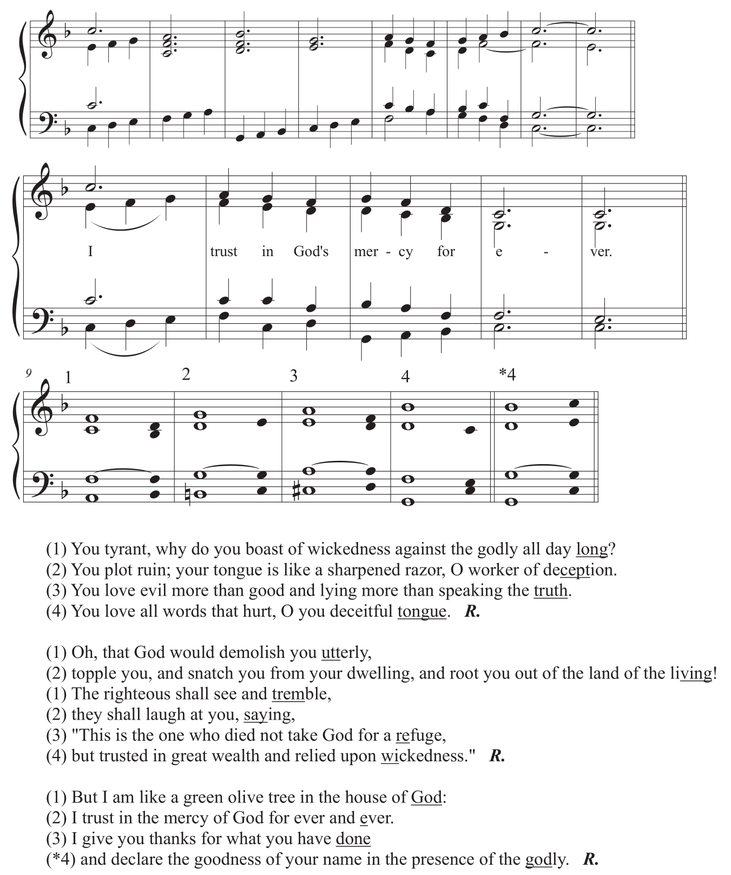

The Second Reading (Colossians 1.15-28)
Reader A reading from Paul’s letter to the Colossians:
He is the image of the invisible God, the firstborn of all creation; for in him all things in heaven and on earth were created, things visible and invisible, whether thrones or dominions or rulers or powers all things have been created through him and for him. He himself is before all things, and in him all things hold together. He is the head of the body, the church; he is the beginning, the firstborn from the dead, so that he might come to have first place in everything. For in him all the fullness of God was pleased to dwell, and through him God was pleased to reconcile to himself all things, whether on earth or in heaven, by making peace through the blood of his cross. And you who were once estranged and hostile in mind, doing evil deeds, he has now reconciled in his fleshly body through death, so as to present you holy and blameless and irreproachable before him provided that you continue securely established and steadfast in the faith, without shifting from the hope promised by the gospel that you heard, which has been proclaimed to every creature under heaven. I, Paul, became a servant of this gospel. I am now rejoicing in my sufferings for your sake, and in my flesh I am completing what is lacking in Christ's afflictions for the sake of his body, that is, the church. I became its servant according to God's commission that was given to me for you, to make the word of God fully known, the mystery that has been hidden throughout the ages and generations but has now been revealed to his saints. To them God chose to make known how great among the Gentiles are the riches of the glory of this mystery, which is Christ in you, the hope of glory. It is he whom we proclaim, warning everyone and teaching everyone in all wisdom, so that we may present everyone mature in Christ.
Hear what the Spirit is saying to the Church.
People Thanks be to God.

Gospel Acclamation (CP 708)
Cantor Alleluia, alleluia, alleluia!
All Alleluia, alleluia, alleluia!
Cantor Blessed are they who hold the word fast in an honest and good heart,
and bring forth fruit with patience.
All Alleluia, alleluia, alleluia!

Gospel Reading (Luke 10.38-42)
Reader The Lord be with you.
People And also with you.

Reader The holy Gospel of our Lord Jesus Christ according to Saint Luke.
People Glory to you, Lord Jesus Christ.
Now as they went on their way, Jesus entered a certain village, where a woman named Martha welcomed him into her home. She had a sister named Mary, who sat at the Lord's feet and listened to what he was saying. But Martha was distracted by her many tasks; so she came to him and asked, "Lord, do you not care that my sister has left me to do all the work by myself? Tell her then to help me." But the Lord answered her, "Martha, Martha, you are worried and distracted by many things; there is need of only one thing. Mary has chosen the better part, which will not be taken away from her."
The Gospel of Christ.
People Praise to you, Lord Jesus Christ.

Sermon
The Rev. Fitz Griffith

Musical Reflection

The Apostles’ Creed
Presider Let us confess our faith, as we say,
All I believe in God,
the Father almighty,
creator of heaven and earth.
I believe in Jesus Christ, his only Son, our Lord.
He was conceived by the power of the Holy Spirit
and born of the Virgin Mary.
He suffered under Pontius Pilate,
was crucified, died, and was buried.
He descended to the dead.
On the third day he rose again.
He ascended into heaven,
and is seated at the right hand of the Father.
He will come again
to judge the living and the dead.
I believe in the Holy Spirit,
the holy catholic Church,
the communion of saints,
the forgiveness of sins,
the resurrection of the body,
and the life everlasting. Amen.

The Prayers of the People

Confession and Absolution
Presider Let us confess our sins to God.

Silence is kept.

Presider Merciful Creator God,
People You have searched us out and known us;
the hopes we hold and regrets and sins that cling to us.
The hurts we absorb and ferment;
the tears we both cause and shed.
We stand before you: all that we have been and all that we are,
knowing that only in you are we truly known
as the ones you would have us be.
Forgive us and guide us to face ourselves
and respect each other with dignity,
that we might welcome with you
the gifts and challenges that your new creation brings,
through Jesus Christ, who lives and reigns with you
and the Holy Spirit, one God now and forever.
Amen.

Presider May God our Great Creator
cleanse your hearts of all stain from sin and brokenness,
that you may walk with Jesus along the good road, his holy way.
May God purify your minds, that you may be guided by the holy word.
May God, our Great Creator clear your eyes
that you may see the goodness God has created.
May God, our Great Creator open your ears
that you may hear God’s voice.
May God, make your souls one with the Trinity,
so that you may worship in spirit and in truth,
and love God, God’s Peoples and God’s creation with all your hearts, minds, bodies and souls. Amen.
The Peace
Presider The peace of the Lord be always with you.
People And also with you.

Let us greet one another with a sign of peace.

The Celebration of the Eucharist

Offertory Hymn
Myrrh-Bearing Mary (CP 235)

Prayer over the Gifts (ACRCL General 2)
Presider Let us pray.
Merciful God,
as grains of wheat scattered upon the hills
were gathered together to become one bread,
so let your church be gathered together
from the ends of the earth into your kingdom,
for yours is the glory through Jesus Christ,
now and for ever.
People Amen.

The Eucharistic Prayer (5)
Presider The Lord be with you.
People And also with you.

Lift up your hearts.
We lift them to the Lord.

Let us give thanks to the Lord our God.
It is right to give our thanks and praise.

We give you thanks and praise, almighty God,
for the gift of a world full of wonder,
and for our life which comes from you.
By your power you sustain the universe.
People Glory to you for ever and ever.

Presider You created us to love you with all our heart,
and to love each other as ourselves,
but we rebel against you by the evil that we do.
In Jesus, your Son,
you bring healing to our world
and gather us into one great family.
Therefore, with all who serve you
on earth and in heaven,
we praise your wonderful name, as we sing,
All Holy, holy, holy Lord, (CP 726)
God of power and might,
heaven and earth are full of your glory.
Hosanna in the highest.
Blessed is he who comes in the name of the Lord.
Hosanna in the highest.

Presider We give you thanks and praise, loving God,
because in sending Jesus, your Son, to us
you showed us how much you love us.
He cares for the poor and the hungry.
He suffers with the sick and the rejected.
Betrayed and forsaken, he did not strike back
but overcame hatred with love.
On the cross
he defeated the power of sin and death.
By raising him from the dead
you show us the power of your love
to bring new life to all your people.
People Glory to you for ever and ever.

Presider On the night before he gave up his life for us,
Jesus, at supper with his friends,
took bread, gave thanks to you,
broke it, and gave it to them,
saying, “Take this, all of you, and eat it:
this is my body which is given for you.”
After supper, Jesus took the cup of wine,
said the blessing, gave it to his friends,
and said, “Drink this, all of you:
this is the cup of my blood,
the blood of the new and eternal covenant,
which is shed for you and for many,
so that sins may be forgiven.
Do this in memory of me.”
People Glory to you for ever and ever.

Presider Gracious God,
with this bread and wine
we celebrate the death and resurrection of Jesus,
and we offer ourselves to you in him.
Send your Holy Spirit on us and on these gifts,
that we may know the presence of Jesus
in the breaking of bread,
and share in the life
of the family of your children.
People Glory to you for ever and ever.

Presider Holy God, you call us to be your servants;
fill us with the courage and love of Jesus,
that all the world may gather in joy
at the table of your kingdom.
We sing your praise, almighty Father,
through Jesus, our Lord,
in the power of the Holy Spirit,
now and for ever.
People Glory to you for ever and ever. Amen.

The Lord’s Prayer
Presider As our Saviour taught us, let us pray,
All Our Father in heaven,
hallowed be your name,
your kingdom come,
your will be done,
on earth as in heaven.
Give us today our daily bread.
Forgive us our sins
as we forgive those who sin against us.
Save us from the time of trial,
and deliver us from evil.
For the kingdom, the power,
and the glory are yours,
now and for ever. Amen.

The Breaking of the Bread (4)
Presider Creator of all, you gave us golden fields of wheat,
whose many grains we have gathered and made into this one bread.
People So may your Church be gathered
from the ends of the earth into your kingdom

The Communion
Presider The gifts of God for the People of God.
People Thanks be to God.

Music During Communion
The Tree of Life My Soul Hath Seen (CP 488)

Prayer after Communion
Presider All your works praise you, O Lord.
All And your faithful servants bless you.
Gracious God
we thank you for feeding us
with the body and blood of your Son
Jesus Christ.
May we, who share his body,
live his risen life;
we, who drink his cup,
bring life to others;
we, whom the Spirit lights,
give light to the world.
Keep us firm in the hope you have set before us,
so that we and all your children shall be free,
and the whole earth live to praise your name;
through Christ our Lord. Amen.

The Blessing
Presider May the Spirit of God lead you into all truth, giving you grace to confess that Jesus Christ is Lord, and to proclaim the wonderful works of God;
and the blessing of God, Source of all being, Eternal Word, and Holy Spirit be upon you now and always.
People Amen.

Sending Hymn
What a Friend We Have in Jesus (CP 532)

Dismissal
Presider Go forth in the name of Christ. Alleluia.
People Thanks be to God. Alleluia..

