Faith Evangelical Lutheran Church, Washington, IL
Fifth Sunday after Pentecost
July 10, 2022

Welcome
Confession and Forgiveness

P: In the name of the Father, and of the + Son, and of the Holy Spirit.
C: Amen.
You may make the sign of the cross as a reminder of your baptism.
P: Almighty God, to whom all hearts are open, all desires known, and from whom no secrets are hid: cleanse the thoughts of our hearts by the inspiration of your Holy Spirit, that we may perfectly love you and worthily magnify your holy name, through Jesus Christ our Lord.
C: Amen.
P: Let us confess our sin in the presence of God and of one another.
Please keep silence for reflection
P: Most merciful God,
C: we confess that we are captive to sin and cannot free ourselves. We have sinned against you in thought, word, and deed, by what we have done and by what we have left undone. We have not loved you with our whole heart; we have not loved our neighbors as ourselves. For the sake of your Son, Jesus Christ, have mercy on us. Forgive us, renew us, and lead us, so that we may delight in your will and walk in your ways, to the glory of your holy name. Amen.
P: In the mercy of almighty God, Jesus Christ was given to die for us, and for his sake God forgives us all our sins. As a called and ordained minister of the church of Christ, and by his authority, I therefore declare to you the entire forgiveness of all your sins, in the name of the Father, and of the + Son, and of the Holy Spirit.
C: Amen.
Faith Lutheran Church
2206 Washington Rd,
Washington, IL 61571
Website and online worship:
www.shareourfaith.org
Church: 309-745-9306
faithlth@shareourfaith.org
Pastor John Rothfusz
Home: 309-745-9282
pastor@shareourfaith.org
Peace: As forgiven children of God, we have peace
with God, and peace with one another.
P The peace of the Lord be with you always.
C And also with you.
P Let us share that peace with one another.

*Hymn: “When the Poor Ones” Red Book #725

Text: José Antonio Olivar, b. 1939; tr. Martin A. Seltz, b. 1951
Music: EL CAMINO, Miquel Manzano, b. 1934
Text and music © 1971, 1996 J.A. Olivar, Miquel Manzano, and San Pablo International – SSP, admin. OCP Publications, 5536 NE Hassalo, Portland, OR 97213. All rights reserved. Used by permission. Reprinted under OneLicense.net#A-711151

P The grace of our Lord Jesus Christ, the love of God,
and the communion of the Holy Spirit be with you all.
C And also with you.

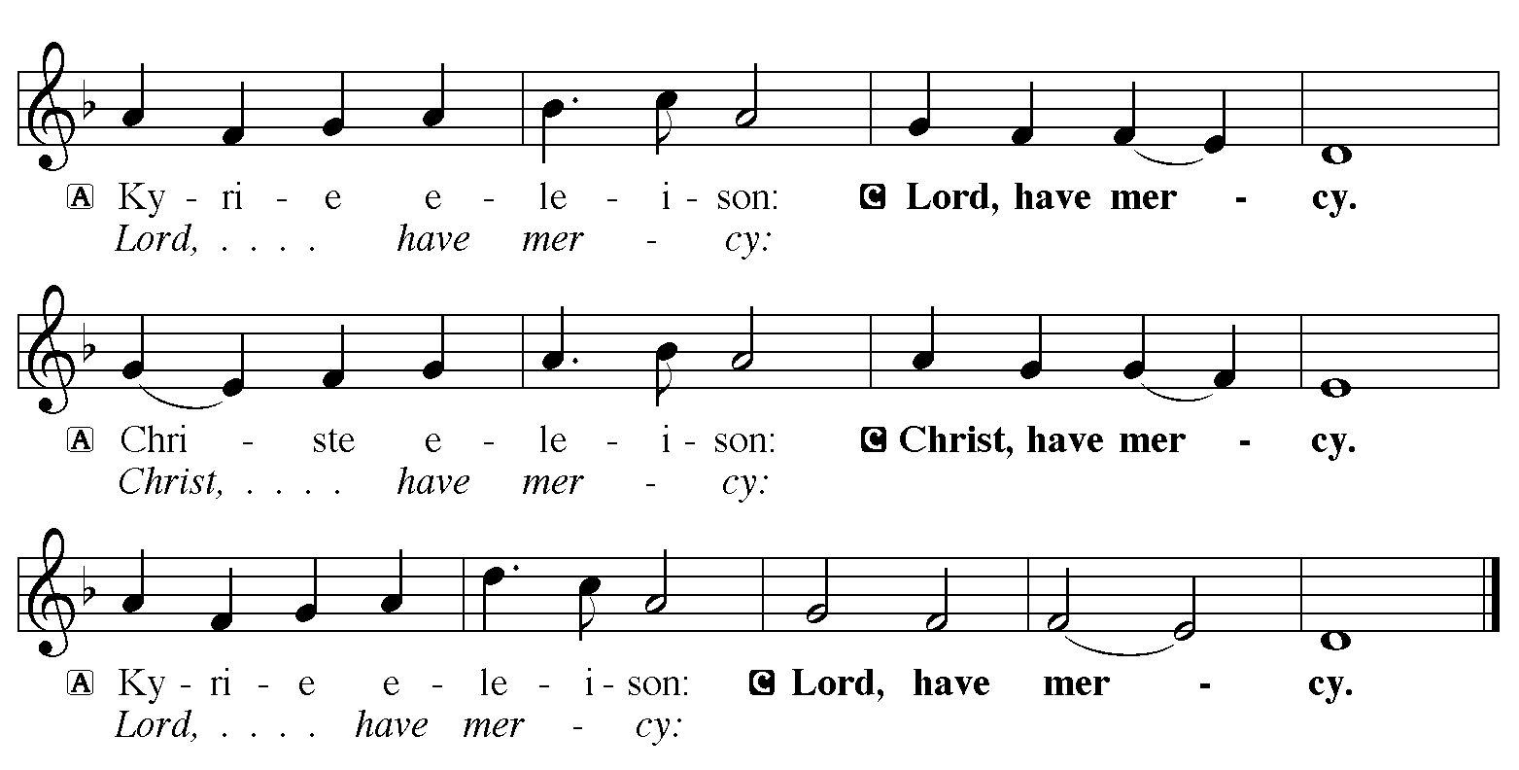

Hymn of Praise
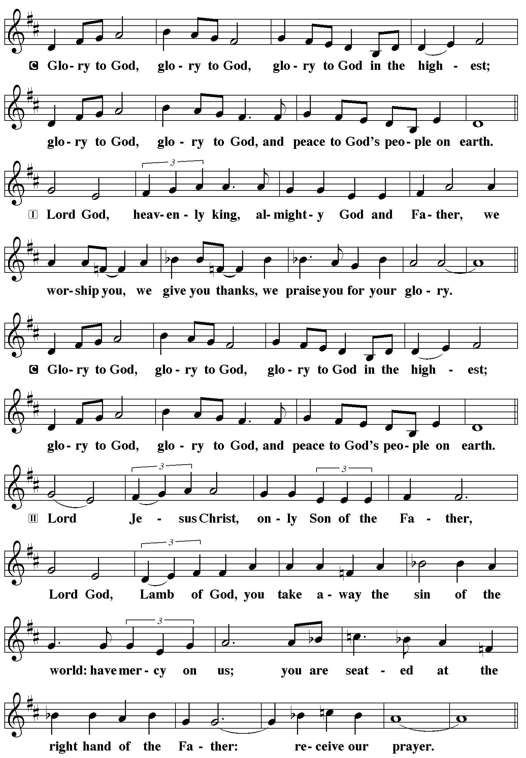
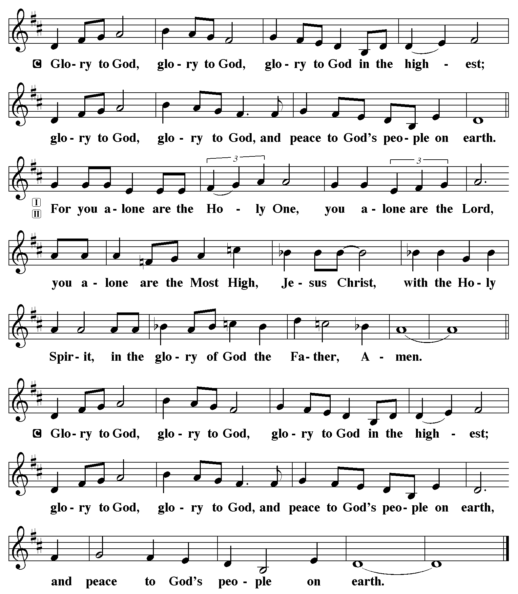

P The Lord be with you
C And also with you.
Let us pray together the Prayer of the Day.
O Lord God, your mercy delights us, and the world longs for your loving care. Hear the cries of everyone in need, and turn our hearts to love our neighbors with the love of your Son, Jesus Christ, our Savior and Lord.
Amen.

Children’s Message

First Reading: Deuteronomy 30:9-14 Pew Bible Page #167
⁹The Lord your God will make you abundantly prosperous in all your undertakings, in the fruit of your body, in the fruit of your livestock, and in the fruit of your soil. For the Lord will again take delight in prospering you, just as he delighted in prospering your ancestors, ¹⁰when you obey the Lord your God by observing his commandments and decrees that are written in this book of the law, because you turn to the Lord your God with all your heart and with all your soul.
¹¹Surely, this commandment that I am commanding you today is not too hard for you, nor is it too far away. ¹²It is not in heaven, that you should say, “Who will go up to heaven for us, and get it for us so that we may hear it and observe it?” ¹³Neither is it beyond the sea, that you should say, “Who will cross to the other side of the sea for us, and get it for us so that we may hear it and observe it?” ¹⁴No, the word is very near to you; it is in your mouth and in your heart for you to observe.

R The Word of the Lord
C Thanks be to God

Psalm 25:1-10 Read responsively by whole verse
¹To you, O Lord,
I lift up my soul.
²My God, I put my trust in you; let me not be put to shame,
nor let my enemies triumph over me.
³Let none who look to you be put to shame;
rather let those be put to shame who are treacherous.
⁴Show me your ways, O Lord,
and teach me your paths.
⁵Lead me in your truth and teach me,
for you are the God of my salvation; in you have I trusted all the day long.
⁶Remember, O Lord, your compassion and love,
for they are from everlasting.
⁷Remember not the sins of my youth and my transgressions;
remember me according to your steadfast love and for the sake of your
goodness, O Lord.
⁸You are gracious and upright, O Lord;
therefore you teach sinners in your way.
⁹You lead the lowly in justice
and teach the lowly your way.
¹⁰All your paths, O Lord, are steadfast love and faithfulness
to those who keep your covenant and your testimonies.

Second Reading: Colossians 1:1-14 Pew Bible Page #955
¹Paul, an apostle of Christ Jesus by the will of God, and Timothy our brother,
²To the saints and faithful brothers and sisters in Christ in Colossae:
Grace to you and peace from God our Father.
³In our prayers for you we always thank God, the Father of our Lord Jesus Christ, ⁴for we have heard of your faith in Christ Jesus and of the love that you have for all the saints, ⁵because of the hope laid up for you in heaven. You have heard of this hope before in the word of the truth, the gospel ⁶that has come to you. Just as it is bearing fruit and growing in the whole world, so it has been bearing fruit among yourselves from the day you heard it and truly comprehended the grace of God. ⁷This you learned from Epaphras, our beloved fellow servant. He is a faithful minister of Christ on your behalf, ⁸and he has made known to us your love in the Spirit.
⁹For this reason, since the day we heard it, we have not ceased praying for you and asking that you may be filled with the knowledge of God’s will in all spiritual wisdom and understanding, ¹⁰so that you may lead lives worthy of the Lord, fully pleasing to him, as you bear fruit in every good work and as you grow in the knowledge of God. ¹¹May you be made strong with all the strength that comes from his glorious power, and may you be prepared to endure everything with patience, while joyfully ¹²giving thanks to the Father, who has enabled you to share in the inheritance of the saints in the light. ¹³He has rescued us from the power of darkness and transferred us into the kingdom of his beloved Son, ¹⁴in whom we have redemption, the forgiveness of sins.

R The Word of the Lord
C Thanks be to God

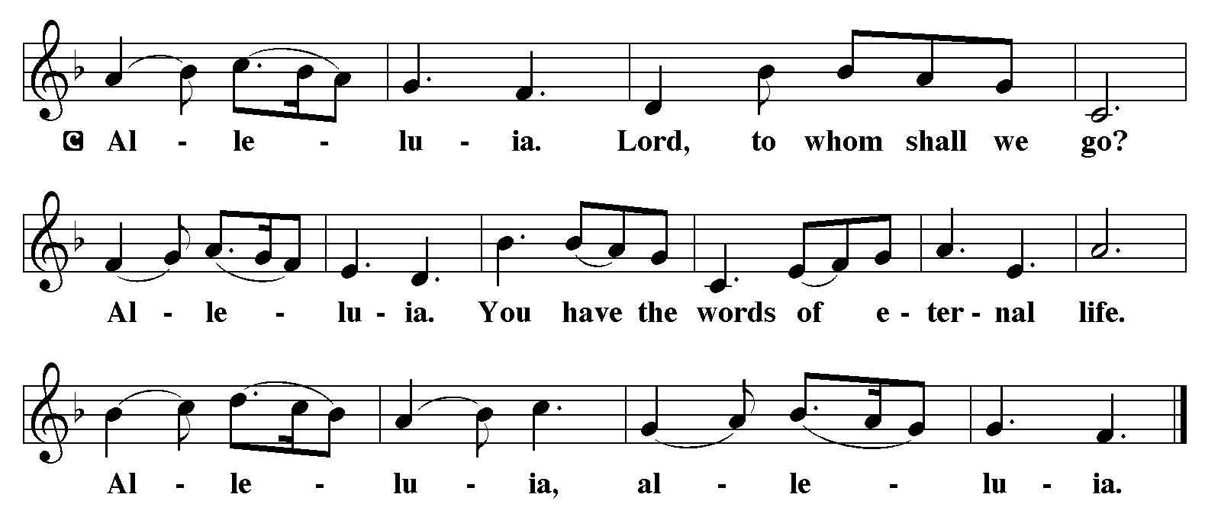

Gospel Reading: Luke 10:25-37 Pew Bible Page #839

C Glory to you, O Lord
²⁵Just then a lawyer stood up to test Jesus. “Teacher,” he said, “what must I do to inherit eternal life?” ²⁶He said to him, “What is written in the law? What do you read there?” ²⁷He answered, “You shall love the Lord your God with all your heart, and with all your soul, and with all your strength, and with all your mind; and your neighbor as yourself.” ²⁸And he said to him, “You have given the right answer; do this, and you will live.”
²⁹But wanting to justify himself, he asked Jesus, “And who is my neighbor?” ³⁰Jesus replied, “A man was going down from Jerusalem to Jericho, and fell into the hands of robbers, who stripped him, beat him, and went away, leaving him half dead. ³¹Now by chance a priest was going down that road; and when he saw him, he passed by on the other side. ³²So likewise a Levite, when he came to the place and saw him, passed by on the other side. ³³But a Samaritan while traveling came near him; and when he saw him, he was moved with pity. ³⁴He went to him and bandaged his wounds, having poured oil and wine on them. Then he put him on his own animal, brought him to an inn, and took care of him. ³⁵The next day he took out two denarii, gave them to the innkeeper, and said, ‘Take care of him; and when I come back, I will repay you whatever more you spend.’ ³⁶Which of these three, do you think, was a neighbor to the man who fell into the hands of the robbers?” ³⁷He said, “The one who showed him mercy.” Jesus said to him, “Go and do likewise.”

The Gospel of the Lord
C Praise to you, O Christ

Sermon by Pastor John Rothfusz

Sermon Hymn: “Lord, Whose Love in Humble Service” Red Book #712

Text: Albert F. Bayly, 1901-1984
Music: BEACH SPRING, The Sacred Harp, Philadelphia, 1844
Text © Oxford University Press Reprinted under OneLicense.net#A-711151

Apostles’ Creed
C: I believe in God, the Father almighty,
creator of heaven and earth.
I believe in Jesus Christ, God's only Son, our Lord,
who was conceived by the Holy Spirit,
born of the virgin Mary,
suffered under Pontius Pilate,
was crucified, died, and was buried;
he descended to the dead.
On the third day he rose again;
he ascended into heaven,
he is seated at the right hand of the Father,
and he will come to judge the living and the dead.
I believe in the Holy Spirit,
the holy catholic church, the communion of saints,
the forgiveness of sins, the resurrection of the body,
and the life everlasting. Amen.

Prayers: After each portion of the prayers finishes with “Lord in your mercy,” please respond, “Hear our prayer.”

Offering: Jesus is Lord, and leads us in the ways of life and salvation. Let us offer ourselves to the Lord and joyfully lift our tithes and offerings to God.
Please take a moment now to make an electronic offering to the church on the website, with the Tithe.ly app on your phone, or drop and envelope in the plate at communion time.
Faith Lutheran website link www.shareourfaith.org

Offering Prayer

Great Thanksgiving
P The Lord be with you.
C And also with you.
P Lift up your hearts.
C We lift them to the Lord.
P Let us give thanks to the Lord our God.
C It is right to give God thanks and praise.

P It is indeed right, our duty and our joy… with the church on earth and the hosts of heaven, we praise your name and join their unending hymn:
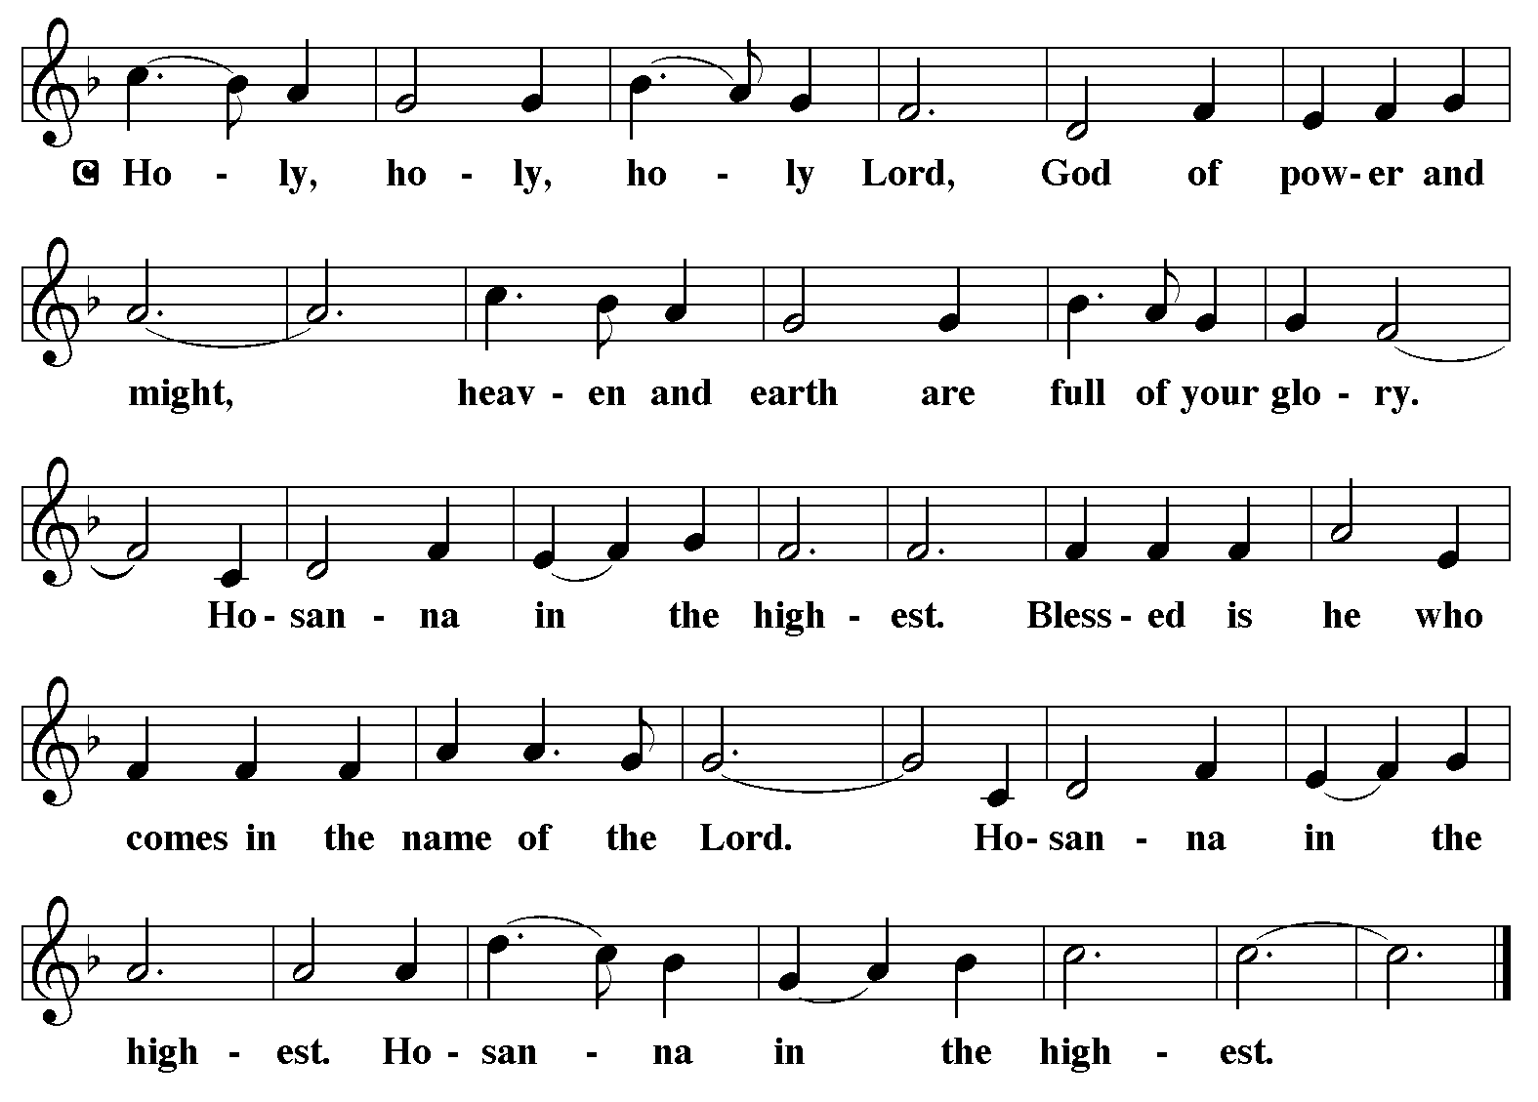
Holy Communion Preface pp. 108-111 or other Eucharistic prayer
In the night in which he was betrayed,
our Lord Jesus took bread, and gave thanks;
broke it, and gave it to his disciples, saying:
Take and eat; this is my body, given for you.
Do this for the remembrance of me.
Again, after supper, he took the cup, gave thanks,
and gave it for all to drink, saying:
This cup is the new covenant in my blood,
shed for you and for all people for the forgiveness of sin.
Do this for the remembrance of me.

C The Lord's Prayer
Our Father, who art in heaven, hallowed be thy name,
thy kingdom come, thy will be done, on earth as it is in heaven.
Give us this day our daily bread; and forgive us our trespasses,
as we forgive those who trespass against us;
and lead us not into temptation, but deliver us from evil.
For thine is the kingdom, and the power, and the glory,
forever and ever. Amen
Communion Distribution
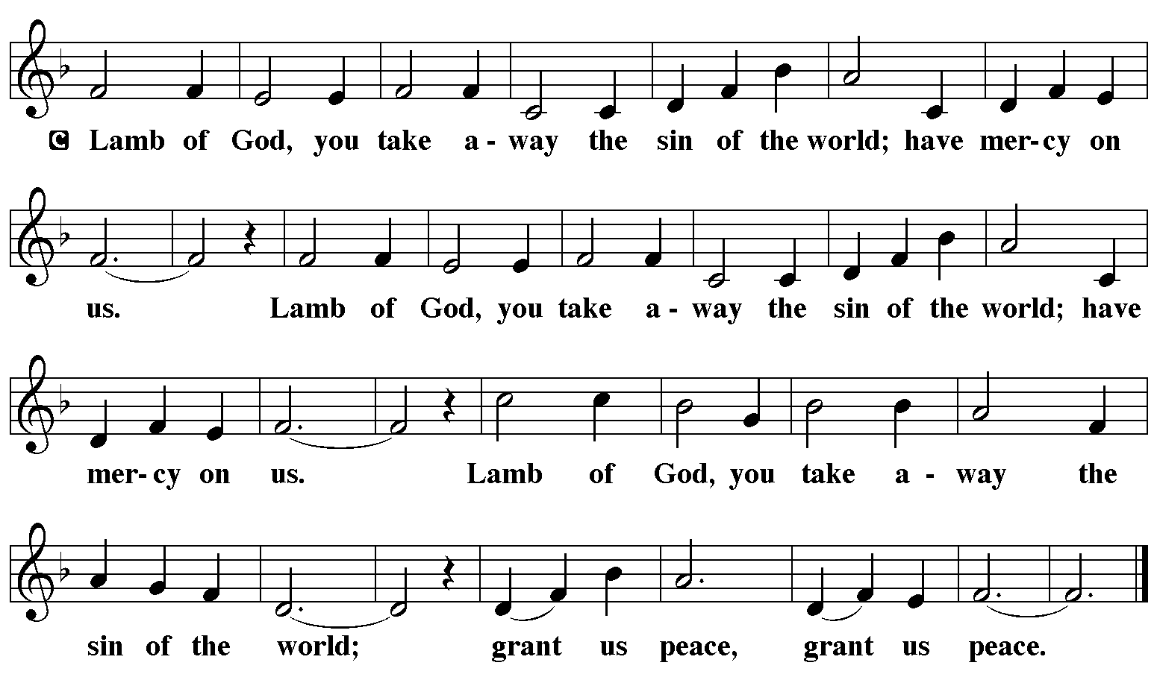

Communion Hymn: “Jesu, Jesu, Fill Us with Your Love” Red Book #708

Text: Tom Colvin, 1925-2000, alt.
Music: CHEREPONI, Ghanaian folk tune, adapt. Tom Colvin
Text and music © 1969 Hope Publishing Company, Carol Stream, IL 60188. All rights reserved. Used by permission Reprinted under OneLicense.net#A-711151

Communion Prayer

Announcements

Blessing
P The Lord bless you and keep you.
The Lord make his face shine on you and be gracious to you.
The Lord look upon you with favor and + give you peace.
In the name of the Father, and of the Son and of the Holy Spirit.

C Amen

Hymn: “The Spirit Sends Us Forth to Serve” Red Book #551
Text: Delores Dufner, OSB, b. 1939
Music: CHESTERFIELD, attr. Thomas Haweis, 1734-1820
Text © 1993 Delores Dufner, admin. OCP Publications. All rights reserved. Reprinted under OneLicense.net#A-711151

Dismissal
A Go in peace. Serve the Lord.
C Thanks be to God!
Postlude
Liturgy and texts from Sundays and Seasons.com. Copyright 2022 Augsburg Fortress. All rights reserved.
Reprinted by permission under Augsburg Fortress Liturgies Annual License #23628.

