All Saints Anglican Church, Agassiz
6904 Lougheed Highway, BC, V0M 1A0

Bulletin June 13 – June 19, 2022
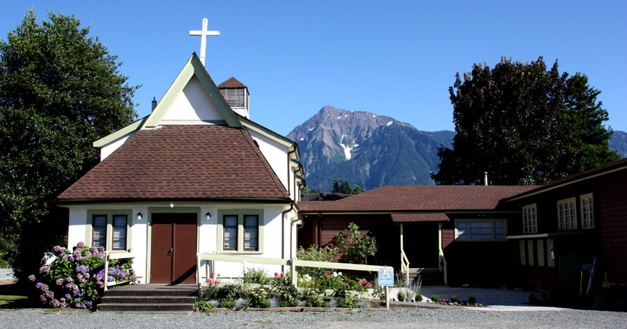

‘The ground we walk does not belong to us; for thousands of years it has been - and remains - the territory of the Stó:lō.’ We are grateful for their sharing.

Phone: 604-796-3553
Website: www.allsaints-agassiz.ca
https://www.facebook.com/groups/AllSaintsFamily
OUR DOOR IS OPEN AND ALL ARE WELCOME
19thJune 2022, 2nd Sunday after Pentecost
Priest-in-Charge: The Reverend Philip Barker
Hosts: Graham Featherstone/Jennifer Pinlac
Intercessor: Karol Henrotte
Lay Administrator: Karol Henrotte
Announcer: Ginny Jennings
Piano: Fran Froehlich

PLEASE NOTE:
Zoom service will still be available and a link sent out around 09:45 by Graham. Email him at gfeatherstone@shaw.ca if you don’t think you’re on his list.
Vicar’s cell phone: Rev’d Philip Barker. 778-867-2461
Vicar’s Warden: Ginny Jennings. 604-796-2206
People’s Warden: Lynn Laughlin. 604-799-5131
Parish email: www.allsaints-agassiz.ca
Please contact either warden if you have an issue that needs to be brought to the attention of the Vicar - or contact the Vicar direct (see above for details).

WARDENS’ PITCH
- Bible Study with Karol is every Saturday at 8:30 a.m. on Zoom.
- Book Club meets Wednesday at 4:00 p.m. on Zoom.
- Evening Prayer with Valerie is at 7:00 p.m. Sun, Wed, Fri on our webpage.
- Prayer Requests can be given on a piece of paper to either of the Wardens or the Vicar or entered in the Prayer Request Book on the piano in the church or you may contact Anthea Lewis at antheamlewis@shaw.ca for Pray First Prayer Circle, which is a confidential online prayer circle.
- Music Requests may be given to the Wardens or the Vicar.
- AA meets in the hall every Tuesday at noon.
- Games for 55’s + every Thursday in the hall 10:00-12:00.
- Coffee Time after our service will continue as is until June when we will start our schedule again. We need 4 more hosts and you will always be teamed up.
- 5th Sunday of each month will be a potluck lunch after the service.
PLEASE NOTE: If anyone has any inclusions for the Bulletin, please contact the Wardens. Thank you.

Equipment in Basement to be sold by July 1st. The equipment is not being used and we need it removed to seal the cracks in the flooring where the water is coming in.
Coffee hosting has begun, so please ensure that you know when it is your turn to provide goodies. We are still in need of four more hosts—2 for the 1st Sunday in Odd Months and 2 for the 1st Sunday in Even Months.

Chuckles
In the 1980's I fell off my bike and skinned my knee. I'm telling you this now because we didn't have social media then.

Birthdays This Month
None that we know of this week.

Sunday Cycle of Prayer
St Augustine, Marpole The Revd Datherine Hough
The Revd Christine Magrega
St. Mary the Virgin, South Hill The Revd Espedito Farinas
St. Mary the Virgin, Sapperton The Revd Arvin Amayag

Monthly Cycle of Prayer
Holy Trinity Cathedral, The Venerable Richard Leggett
New Westminster The Revd Carole Neilson
The Revd Montegomery Tugwete
St. Barnabas, New Westminster The Revd Emilie Smith

Anglican Cycle of Prayer
Our Primate, Archbishop, Linda Nicolls. For National Indigenous Interim Bishop Sidney Black and for the Anglican Council of Indigenous People. We also pray for the Coordinator for Indigenous Justice, Kerry Baisley.
In our parish we pray for our priest, Philip; retired priests Mike, Jack, and Paul. Amen

Collect – June 19, 2022
Almighty God, your Son revealed in signs and miracles the wonder of your saving love. Renew your people with your heavenly grace, and in all our weakness sustain us by your mighty power; through Jesus Christ our Lord, who is alive and reigns with you and the Holy Spirit, one God, now and for ever.

Psalm 66 David Hamilton

Praise God with shouts of joy, all people!
Sing to the glory of his name; offer him glorious praise!
Say to God, “How wonderful are the things you do! Your power is so great that your enemies bow down in fear before you.
Everyone on earth worships you; they sing praises to you, they sing praises to your name.”
Come and see what God has done, his wonderful acts among people.
He changed the sea into dry land; our ancestors crossed the river on foot. There we rejoiced because of what he did.
He rules forever by his might and keeps his eyes on the nations. Let no rebels rise against him.
Praise our God, all nations; let your praise be heard.
He has kept us alive and has not allowed us to fall.
You have put us to the test, God; as silver is purified by fire, so you have tested us.
You let us fall into a trap and placed heavy burdens on our backs.
You let our enemies trample us; we went through fire and flood, but now you have brought us to a place of safety.[b]
I will bring burnt offerings to your house; I will offer you what I promised.
I will give you what I said I would when I was in trouble.
I will offer sheep to be burned on the altar; I will sacrifice bulls and goats, and the smoke will go up to the sky.
Come and listen, all who honor God, and I will tell you what he has done for me.
I cried to him for help; I praised him with songs.
If I had ignored my sins, the Lord would not have listened to me.
But God has indeed heard me; he has listened to my prayer.
I praise God, because he did not reject my prayer or keep back his constant love from me.

Psalm 67

God, be merciful to us and bless us; look on us with kindness,
so that the whole world may know your will; so that all nations may know your salvation.
May the peoples praise you, O God; may all the peoples praise you!
May the nations be glad and sing for joy, because you judge the peoples with justice and guide every nation on earth.
May the peoples praise you, O God; may all the peoples praise you!
The land has produced its harvest; God, our God, has blessed us.
God has blessed us; may all people everywhere honor him.

Numbers 14: 26-45

The Lord Punishes the People for Complaining

The Lord said to Moses and Aaron,
“How much longer are these wicked people going to complain against me? I have heard enough of these complaints!
Now give them this answer: ‘I swear that as surely as I live, I will do to you just what you have asked. I, the Lord, have spoken.
You will die and your corpses will be scattered across this wilderness. Because you have complained against me, none of you over twenty years of age will enter that land.
I promised to let you live there, but not one of you will, except Caleb and Joshua.
You said that your children would be captured, but I will bring them into the land that you rejected, and it will be their home.
You will die here in this wilderness.
Your children will wander in the wilderness for forty years, suffering for your unfaithfulness, until the last one of you dies.
You will suffer the consequences of your sin for forty years, one year for each of the forty days you spent exploring the land. You will know what it means to have me against you!
I swear that I will do this to you wicked people who have gathered together against me. Here in the wilderness every one of you will die. I, the Lord, have spoken.’”
The men Moses had sent to explore the land brought back a false report which caused the people to complain against the Lord. And so the Lord struck them with a disease, and they died.
Of the twelve spies only Joshua and Caleb survived.
When Moses told the Israelites what the Lord had said, they mourned bitterly.
Early the next morning they started out to invade the hill country, saying, “Now we are ready to go to the place which the Lord told us about. We admit that we have sinned.”
But Moses said, “Then why are you disobeying the Lord now? You will not succeed!
Don't go. The Lord is not with you, and your enemies will defeat you.
When you face the Amalekites and the Canaanites, you will die in battle; the Lord will not be with you, because you have refused to follow him.”
Yet they still dared to go up into the hill country, even though neither the Lord's Covenant Box nor Moses left the camp.
Then the Amalekites and the Canaanites who lived there attacked and defeated them, and pursued them as far as Hormah.

Here what the Spirit is saying to the Church. Thanks be to God.

Acts 15: 1-12 Valerie Hamilton

The Meeting at Jerusalem

Some men came from Judea to Antioch and started teaching the believers, “You cannot be saved unless you are circumcised as the Law of Moses requires.”
Paul and Barnabas got into a fierce argument with them about this, so it was decided that Paul and Barnabas and some of the others in Antioch should go to Jerusalem and see the apostles and elders about this matter.
They were sent on their way by the church; and as they went through Phoenicia and Samaria, they reported how the Gentiles had turned to God; this news brought great joy to all the believers.
When they arrived in Jerusalem, they were welcomed by the church, the apostles, and the elders, to whom they told all that God had done through them.
But some of the believers who belonged to the party of the Pharisees stood up and said, “The Gentiles must be circumcised and told to obey the Law of Moses.”
The apostles and the elders met together to consider this question.
After a long debate Peter stood up and said, “My friends, you know that a long time ago God chose me from among you to preach the Good News to the Gentiles, so that they could hear and believe.
And God, who knows the thoughts of everyone, showed his approval of the Gentiles by giving the Holy Spirit to them, just as he had to us.
He made no difference between us and them; he forgave their sins because they believed.
So then, why do you now want to put God to the test by laying a load on the backs of the believers which neither our ancestors nor we ourselves were able to carry?
No! We believe and are saved by the grace of the Lord Jesus, just as they are.”
The whole group was silent as they heard Barnabas and Paul report all the miracles and wonders that God had performed through them among the Gentiles.

Here what the Spirit is saying to the Church. Thanks be to God.

