Faith Evangelical Lutheran Church, Washington, Illinois

75th Anniversary Celebration
Holy Trinity Sunday
June 12, 2022
10 a.m.

Jesus Christ is the same yesterday and today and forever.
Hebrews 13:8

History of Faith Evangelical Lutheran Church

Faith Lutheran Church was planted in 1947 as a mission church in Beverly Manor. It was first called Beverly Manor Lutheran Church. The Peoria Area Brotherhood worked with the American Lutheran Church Mission Board to start a congregation in this growing area after a survey showed the need.
On January 5, 1947, a Sunday School was organized and the first worship service was held in the basement of Jim and Theda Hohenbary’s home on Wagner Street. Pastor H. C. Haferman of Zion Lutheran Church in Peoria led the service. He also instructed the first class of six charter members: Mr. and Mrs. Al Morse, Mr. and Mrs. Jim Hohenbary, Mrs. Helen Bratcher, and Mr. Joe Bratcher.
The Peoria Area Brotherhood was able to obtain a loan to build a church. Two lots were purchased on Vohland St. in Beverly Manor, and ground was broken on September 28, 1947. The construction was done by volunteer labor of the Area Brotherhood and the men of the congregation. The church building was dedicated in November, 1948.
From 1948-1951 the Rev. Harold Knappe served as advisory pastor, and a number of interns from Wartburg and Capital Seminaries served the congregation until a full-time pastor was called in 1955. The interns were Theodore Schroeder, George Saffran, Irvin Briese, Roy Timaeus, Russell Comnick, and Harry Feistner. The congregation grew, and the Peoria Area Brotherhood helped by assuming the balance of the debt on the church building so that a parsonage could be built.
Pastor Russell Comnick was called as the first full-time pastor, beginning in 1955. As the congregation grew it was clear that a new, larger church building would be needed. 7.5 acres were purchased at the current location. Groundbreaking was on April 24, 1960, and the cornerstone was laid on September 25, 1960. The first worship at the current site was held on October 16, 1960, with the building only partially completed. The current church building was completed and dedicated April 23, 1961. The congregation also built a new parsonage on the same site. Much of this work was done with volunteer labor from the congregation.
In 1963 Pastor Lee Leubke came to serve the congregation. He was able to make the mission congregation self-supporting.
In 1965 Pastor George Schlueter was called to Faith Lutheran. In 1974, the congregation began the Faith Lutheran Child Care Center in the basement, with a director and teacher. More women were working outside the home, and the church was convinced that it was essential to serve the working families in the area by providing a safe place for children to learn and grow. That ministry has grown steadily through the years, and has been a blessing to many children and families in the community.

In 1979, Pastor Karl Otto was called to serve. As the church and Child Care continued to grow, there was a need to expand the church building. In 1992, an addition was built onto the church. It expanded the worship space and added restrooms, a fellowship hall and kitchen upstairs. In the basement, it gave significantly more room for the growing Child Care ministry.
In 1995 the church called Pastor Mark Boster to serve. Many people took part in the Via de Cristo, a spiritual renewal ministry. The Youth Ministry program became very active, with regular trips and service programs. The Mission team also had lots of energy to support trips to share the gospel.
In 2006, Pastor John Rothfusz was called. The congregation took out a $1.43 million loan to build a new facility for the Faith Lutheran Child Care Center, north of the parsonage on the same lot. It was dedicated on June 7, 2009, and has enabled the Child Care to expand significantly and be modern, safe, and secure. The center is now licensed to serve 120 children.
With the newly opened space in the basement, the church is open for new kinds of ministry. Several scouting groups now meet regularly in the church. The Washington Weekend Snackpac group uses our basement to store food and pack weekend food bags for kids in the Washington schools who are food insecure. The Buddy Bag program provides the same kinds of weekend food bags for our Child Care kids in need. And the Widow’s Jar Pantry by the road provides food and personal care items every day to the many people who stop by to check.
The large tornado that hit Washington in 2013 did not affect the church buildings directly, but we hosted numerous groups of volunteers that came to help with the cleanup. The Covid pandemic has also impacted our ministry over the past few years, and challenged us to offer more ministry online.
Just as we have received faithful pastors to lead our congregation, we have also sent out pastors to serve in other places. Three sons of the congregation have been ordained as pastors. They are Rev. Wayne Mesecher, Rev. Dennis Pettyjohn, and Rev. Michael Jones. As God gives generously to us, we strive to give generously to bless the world that God loves.
In every season, we give thanks to God who is faithful. Our hope for the future is in the Lord who is always steadfast. Our Lord Jesus is the constant center of our faith and our service as we bear witness to his saving work among us and for all the world.

Prelude
Welcome

Confession and Forgiveness

P: In the name of the Father, and of the + Son, and of the Holy Spirit.
C: Amen.
You may make the sign of the cross as a reminder of your baptism.
P: Almighty God, to whom all hearts are open, all desires known, and from whom no secrets are hid: cleanse the thoughts of our hearts by the inspiration of your Holy Spirit, that we may perfectly love you and worthily magnify your holy name, through Jesus Christ our Lord.
C: Amen.
P: Let us confess our sin in the presence of God and of one another.
Please keep silence for reflection
P: Most merciful God,
C: we confess that we are captive to sin and cannot free ourselves. We have sinned against you in thought, word, and deed, by what we have done and by what we have left undone. We have not loved you with our whole heart; we have not loved our neighbors as ourselves. For the sake of your Son, Jesus Christ, have mercy on us. Forgive us, renew us, and lead us, so that we may delight in your will and walk in your ways, to the glory of your holy name. Amen.
P: In the mercy of almighty God, Jesus Christ was given to die for us, and for his sake God forgives us all our sins. As a called and ordained minister of the church of Christ, and by his authority, I therefore declare to you the entire forgiveness of all your sins, in the name of the Father, and of the + Son, and of the Holy Spirit.
C: Amen.

Faith Lutheran Church
2206 Washington Rd,
Washington, IL 61571
Website and online worship:
www.shareourfaith.org
Church: 309-745-9306
faithlth@shareourfaith.org
Pastor John Rothfusz
Home: 309-745-9282
pastor@shareourfaith.org

*Processional Hymn: “Holy, Holy, Holy” Red Book #413
Text:Reginald Heber, 1783-1826, alt.
Music: NICAEA John B. Dykes, 1823-1876 Public Domain

P The grace of our Lord Jesus Christ, the love of God,
and the communion of the Holy Spirit be with you all.
C And also with you.

Kyrie

Hymn of Praise
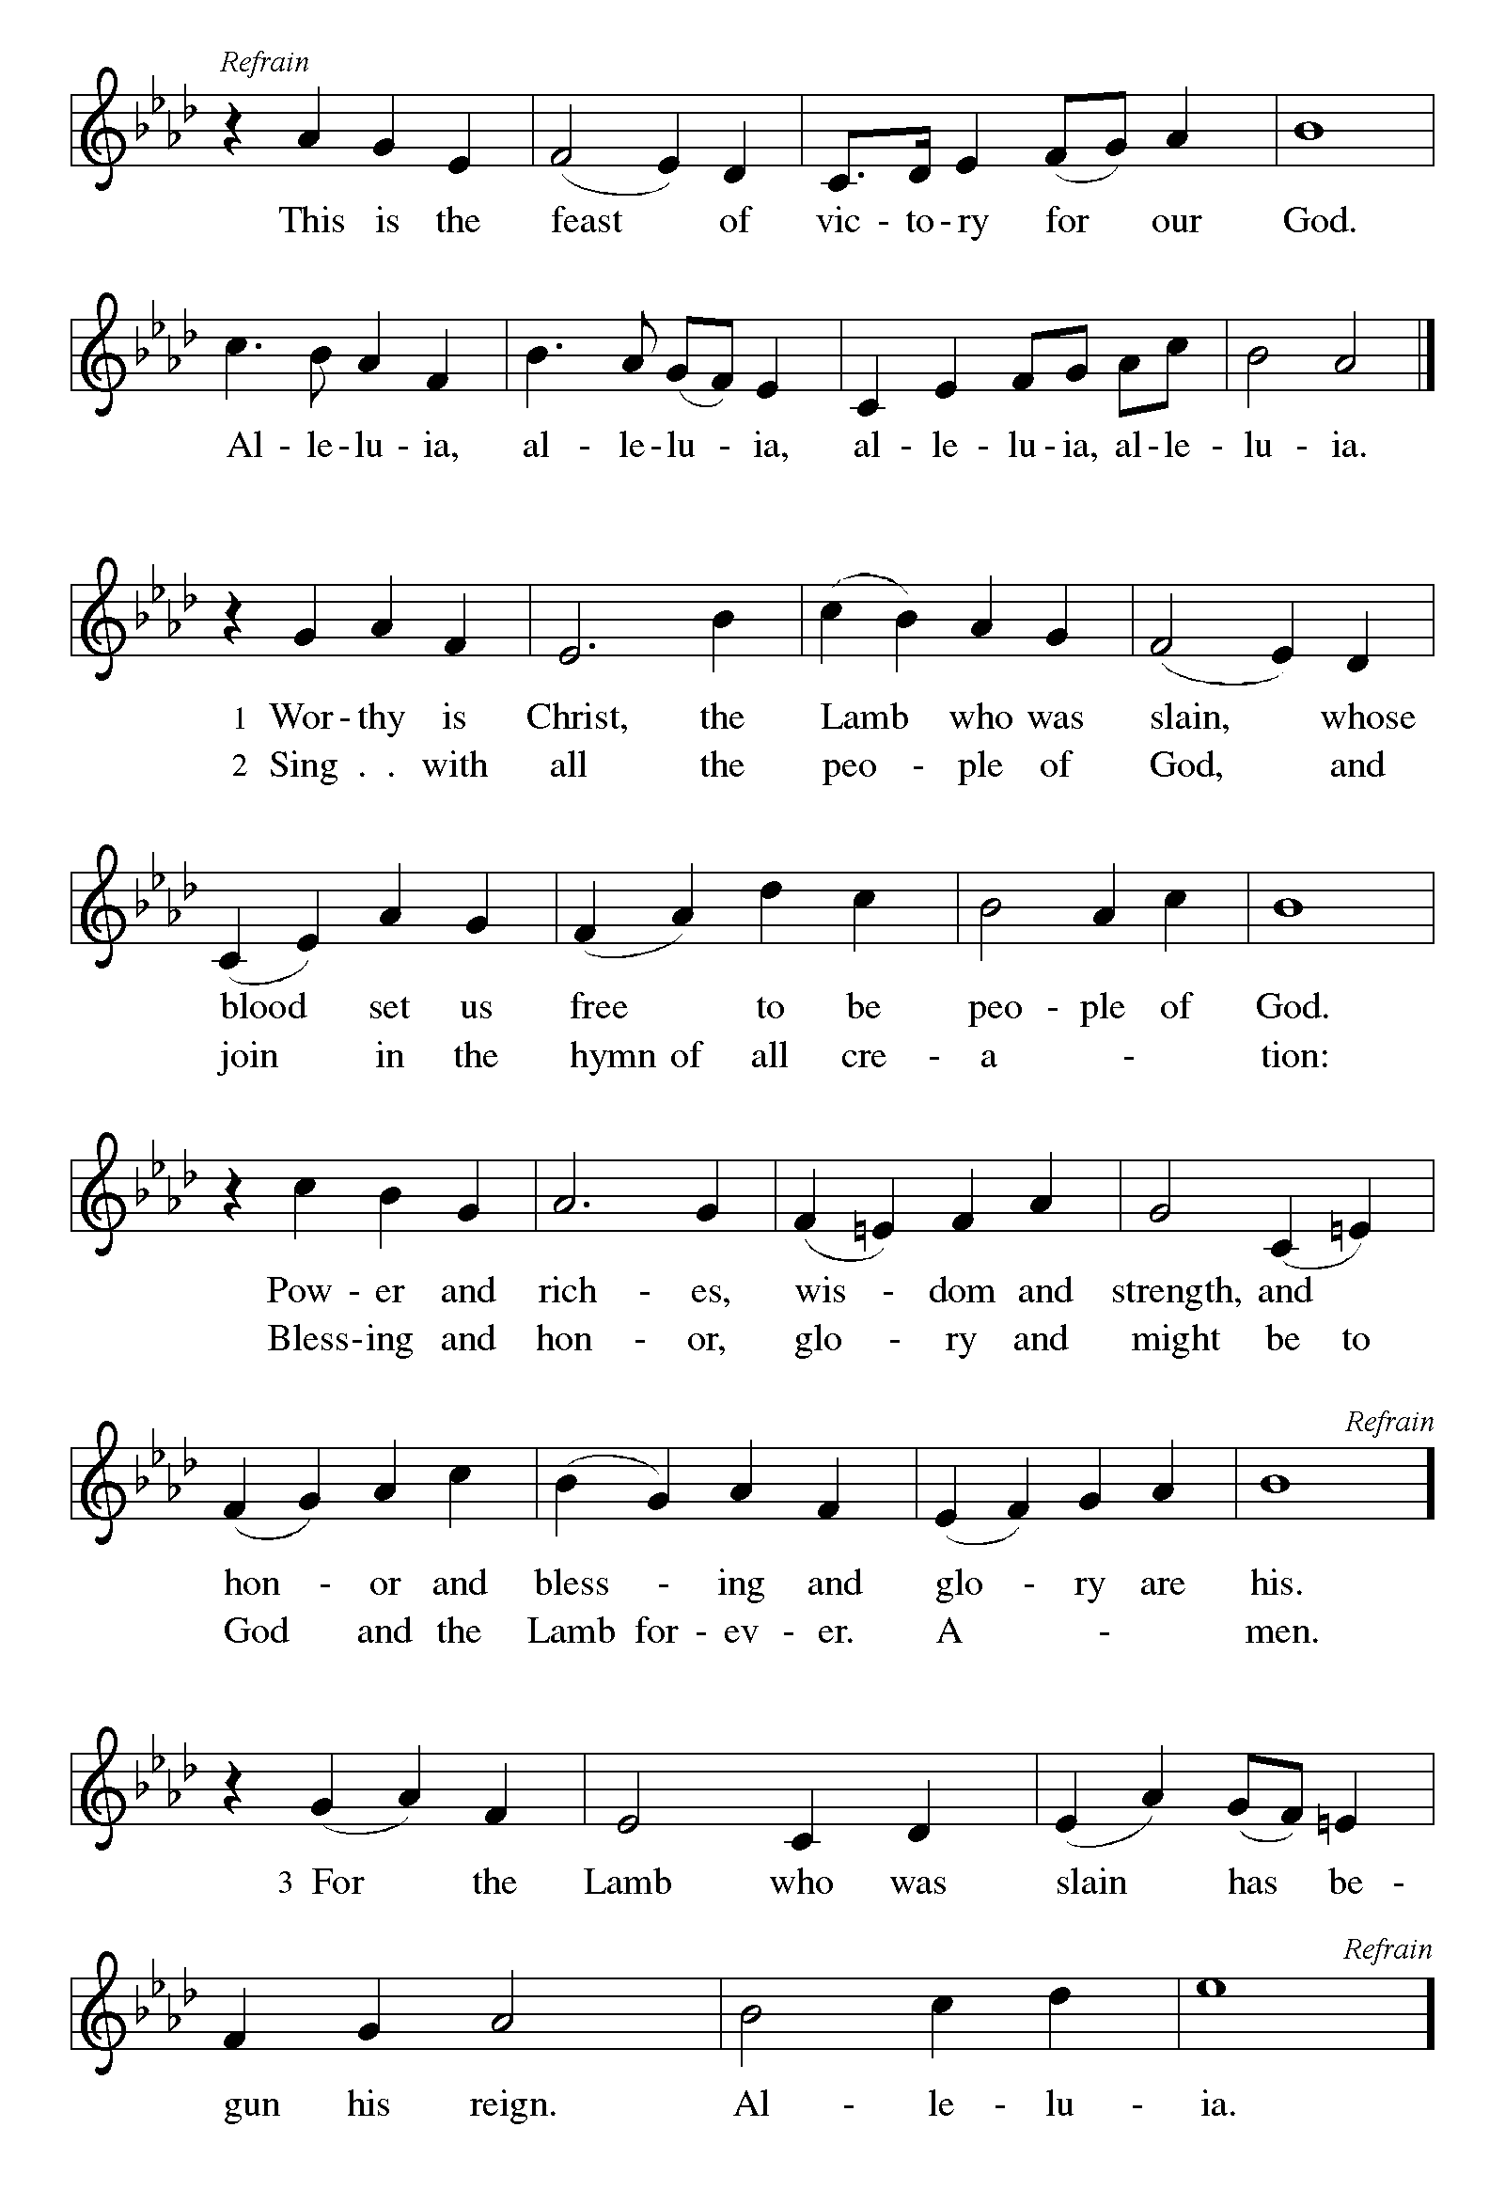

P The Lord be with you
C And also with you.
Let us pray together the Prayer of the Day
O God, you have promised through your Son to be with your church forever. We give you thanks for your faithfulness to those who founded Faith Evangelical Lutheran Church and for the signs of your presence in this community of believers. Increase in us the spirit of faith and love, and make our fellowship an example to all believers and to all nations. We pray through Jesus Christ, our Savior and Lord, who lives and reigns with you and the Holy Spirit, one God, now and forever.
Amen.

Children’s Message

First Reading: 1 Kings 8:22-30 Pew Bible Page #278
²²Then Solomon stood before the altar of the LORD in the presence of all the assembly of Israel, and spread out his hands to heaven. ²³He said, "O LORD, God of Israel, there is no God like you in heaven above or on earth beneath, keeping covenant and steadfast love for your servants who walk before you with all their heart, ²⁴the covenant that you kept for your servant my father David as you declared to him; you promised with your mouth and have this day fulfilled with your hand. ²⁵Therefore, O LORD, God of Israel, keep for your servant my father David that which you promised him, saying, 'There shall never fail you a successor before me to sit on the throne of Israel, if only your children look to their way, to walk before me as you have walked before me.' ²⁶Therefore, O God of Israel, let your word be confirmed, which you promised to your servant my father David.
²⁷But will God indeed dwell on the earth? Even heaven and the highest heaven cannot contain you, much less this house that I have built! ²⁸Regard your servant's prayer and his plea, O LORD my God, heeding the cry and the prayer that your servant prays to you today; ²⁹that your eyes may be open night and day toward this house, the place of which you said, 'My name shall be there,' that you may heed the prayer that your servant prays toward this place. ³⁰Hear the plea of your servant and of your people Israel when they pray toward this place; O hear in heaven your dwelling place; heed and forgive.
R The Word of the Lord
C Thanks be to God

Psalm 8 sing in unison
¹O | Lord our Lord,
how exalted is your name in | all the world!
²Out of the mouths of in- | fants and children
your majesty is praised a- | bove the heavens.
³You have set up a stronghold against your | adversaries,
to quell the enemy and | the avenger.
⁴When I consider your heavens, the work | of your fingers,
the moon and the stars you have set | in their courses,
⁵what is man that you should be mind- | ful of him,
the son of man that you should | seek him out?
⁶You have made him but little lower | than the angels;
you adorn him with glo- | ry and honor;
⁷you give him mastery over the works | of your hands;
you put all things un- | der his feet:
⁸all | sheep and oxen,
even the wild beasts | of the field,
⁹the birds of the air, the fish | of the sea,
and whatsoever walks in the paths | of the sea.
¹⁰O | Lord our Lord,
how exalted is your name in | all the world!

Second Reading: Hebrews 13:1-8 Pew Bible Page #981
¹Let mutual love continue. ²Do not neglect to show hospitality to strangers, for by doing that some have entertained angels without knowing it. ³Remember those who are in prison, as though you were in prison with them; those who are being tortured, as though you yourselves were being tortured. ⁴Let marriage be held in honor by all, and let the marriage bed be kept undefiled; for God will judge fornicators and adulterers. ⁵Keep your lives free from the love of money, and be content with what you have; for he has said, "I will never leave you or forsake you." ⁶So we can say with confidence,
"The Lord is my helper;
I will not be afraid.
What can anyone do to me?"
⁷Remember your leaders, those who spoke the word of God to you; consider the outcome of their way of life, and imitate their faith. ⁸Jesus Christ is the same yesterday and today and forever.
R The Word of the Lord
C Thanks be to God

Gospel Reading: Matthew 28:16-20 Pew Bible Page #806

C Glory to you, O Lord
¹⁶Now the eleven disciples went to Galilee, to the mountain to which Jesus had directed them. ¹⁷When they saw him, they worshiped him; but some doubted. ¹⁸And Jesus came and said to them, "All authority in heaven and on earth has been given to me. ¹⁹Go therefore and make disciples of all nations, baptizing them in the name of the Father and of the Son and of the Holy Spirit, ²⁰and teaching them to obey everything that I have commanded you. And remember, I am with you always, to the end of the age."
The Gospel of the Lord
C Praise to you, O Christ
Sermon by The Rev. S. John Roth,
Bishop, Central/Southern IL Synod - ELCA

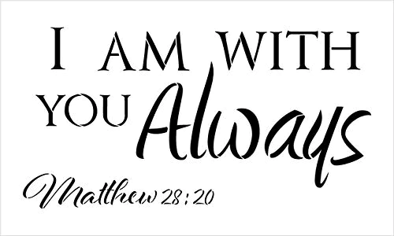

Hymn of the Day: The Church’s One Foundation Red Book #654
Text: Samuel J. Stone, 1839-1900
Music: AURELIA Samuel S. Wesley, 1810-1876
Nicene Creed
We believe in one God,
the Father, the Almighty,
maker of heaven and earth,
of all that is, seen and unseen.
We believe in one Lord, Jesus Christ,
the only Son of God,
eternally begotten of the Father,
God from God, Light from Light,
true God from true God,
begotten, not made,
of one Being with the Father;
through him all things were made.
For us and for our salvation
he came down from heaven,
was incarnate of the Holy Spirit and the virgin Mary
and became truly human.
For our sake he was crucified under Pontius Pilate;
he suffered death and was buried.
On the third day he rose again
in accordance with the scriptures;
he ascended into heaven
and is seated at the right hand of the Father.
He will come again in glory to judge the living and the dead,
and his kingdom will have no end.
We believe in the Holy Spirit, the Lord, the giver of life,
who proceeds from the Father and the Son,*
who with the Father and the Son is worshiped and glorified,
who has spoken through the prophets.
We believe in one holy catholic and apostolic church.
We acknowledge one baptism for the forgiveness of sins.
We look for the resurrection of the dead,
and the life of the world to come. Amen.
*Or, "who proceeds from the Father." The phrase "and the Son" is a later addition to the creed.

Prayers: After each portion of the prayers finishes with “Lord in your mercy,” please respond, “Hear our prayer.”

Peace: As forgiven children of God, we have peace with God, and peace with one another. The peace of the Lord be with you always.
C And also with you.
P Let us share that peace with one another.
Offering: Jesus calls us as his people in baptism and we are united as one in the church. Let us show our thanks and praise as we lift our tithes and offerings to the Lord.
We welcome your regular offerings to support the ministry of Faith Lutheran Church. We also invite you to make special 75th Anniversary offerings using the envelopes included. These offerings will be sent to Madagascar where we have companion synods, to help rebuild schools and churches after some major cyclones caused widespread damage.
Please take a moment now to make an electronic offering to the church on the website, with the Tithe.ly app on your phone, or drop an offering in the plate.
Faith Lutheran website link www.shareourfaith.org
Offering Prayer

Great Thanksgiving

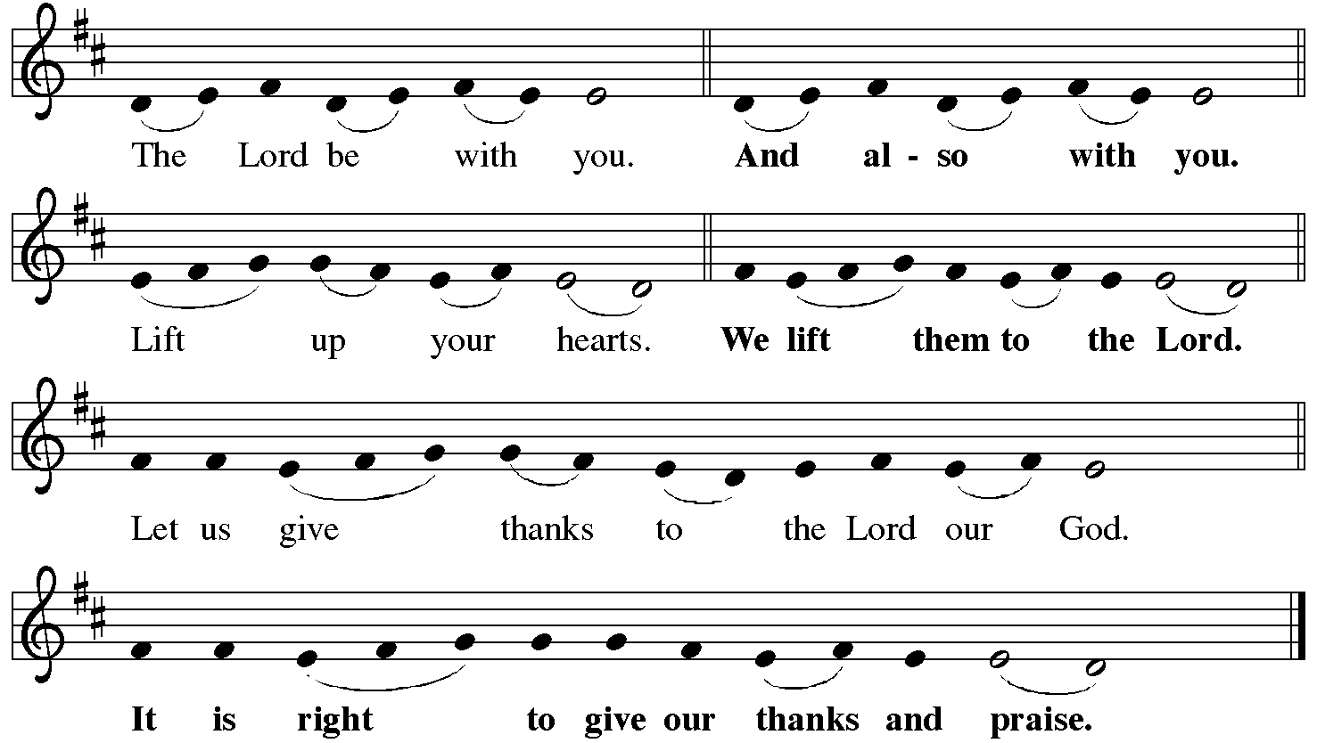

P It is indeed right, our duty and our joy, that we should at all times and in all places give thanks and praise to you, almighty and merciful God.
You reveal your glory as the glory of the Father, the Son and the Holy Spirit:
equal in majesty, undivided in splendor, one Lord, one God,
ever to be adored in your eternal glory.
And so with all the choirs of angels, with the church on earth and the hosts of heaven, we praise your name and join their unending hymn.

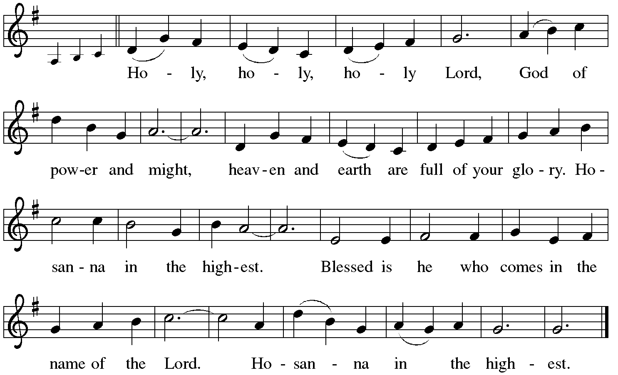
Holy Communion: Eucharistic Prayer and Words of Institution
We praise you, holy God, our maker, our lover, our keeper,
nurturing our past, our present, our future; for the universe beyond our knowing,
for seas and forests and fields, for rivers and prairies and hills,
for creatures seen and unseen, for animals both wild and tame,
and for the places we humans call home, for cities and churches and schools,
for the gift of Faith Evangelical Lutheran Church.
We praise you for your covenant people, for Moses and Miriam and Aaron,
for traditions of prayer and praise; and for centuries of faithful Christians,
for Mary Magdalene, Peter and Paul,
for our bishops, pastors, and all those called to ministry,
for teachers and all servants of the church.
We praise you for your Son, Jesus, who saves us from sin and from evil,
who continues to lead us into new life.
In the night in which he was betrayed,
our Lord Jesus took bread, and gave thanks;
broke it, and gave it to his disciples, saying:
Take and eat; this is my body, given for you.
Do this for the remembrance of me.
Again, after supper, he took the cup, gave thanks,
and gave it for all to drink, saying:
This cup is the new covenant in my blood,
shed for you and for all people for the forgiveness of sin.
Do this for the remembrance of me.
And so we remember your Son, his life, his death, and his glorious resurrection,
his word, and his presence in this meal, and we proclaim the mystery of faith:
Christ has died. Christ is risen. Christ will come again.
We pray that you send your Spirit, your breath, your fire, your wisdom,
your guidance everywhere in the church.
Send your Spirit upon this bread and cup; inspire your people for service,
always making us new; and renew the world with your mercy,
with your healing, your justice and your peace,
reconciling us with you and our neighbors.
We praise you, holy God, the Father, the Son, the Holy Spirit,
one God, yesterday, today and forever.
Amen.
C The Lord's Prayer
Our Father, who art in heaven, hallowed be thy name,
thy kingdom come, thy will be done, on earth as it is in heaven.
Give us this day our daily bread; and forgive us our trespasses,
as we forgive those who trespass against us;
and lead us not into temptation, but deliver us from evil.
For thine is the kingdom, and the power, and the glory,
forever and ever. Amen
Communion Distribution: Please come forward by the center aisle and stand before the rail. Kneel when indicated. Please receive the bread and take the red wine or white grape juice from the tray. The pastor will dismiss the table together. You can return by the side aisle. All who are baptized and believe that Christ is present in the meal are welcome to share with us.
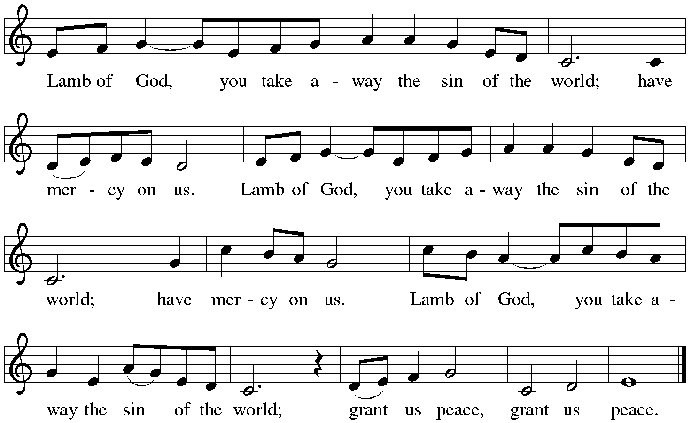
Communion Hymns
Red Book # 532 Gather Us In
Red Book # 631 Love Divine, All Loves Excelling
Red Book # 632 O God, Our Help in Ages Past
Red Book # 661 I Love to Tell the Story
Post Communion Prayer
Almighty God, we give you thanks that you have fed us with this heavenly food.
In your grace and by your Spirit, help us to be what we celebrate,
the body of Christ in the world. Send us out, renewed by this life-giving meal,
to do the work you have given us to do: to witness for Christ,
to love you with singleness of heart, and to serve you with clarity of purpose;
through Jesus Christ, our Savior and Lord.
Amen.

Announcements: Recognition, Appreciation and Gratitude

Blessing
Go forth in peace and with the courage of faith.
Love God with all your heart, with all your soul, and with all your mind,
and love your neighbor as yourself.
Amen.
Whatever you do in word or deed,
do everything in the name of the Lord Jesus,
giving thanks to God through him.
Amen.
The God of hope fill you with joy and peace in believing,
so that you may abound in hope by the power of the Holy Spirit.
Amen.
Almighty God, Father, ☩ Son, and Holy Spirit,
bless you now and forever.
Amen.

Recessional Hymn: “My Hope is Built on Nothing Less” Red Book #597
Text: Edward Mote, 1797-1874, alt
Music: MELITA, John B Dykes, 1823-1876

Dismissal
Go in peace. Serve the Lord.
Thanks be to God!
Postlude

Liturgy and texts from Sundays and Seasons.com. Copyright 2022 Augsburg Fortress. All rights reserved.
Reprinted by permission under Augsburg Fortress Liturgies Annual License #23628.

+ + +
Participants in this Service
Presiding Minister Pastor John Rothfusz
Proclaimer Bishop S. John Roth
Central/Southern Illinois Synod, Evangelical Lutheran Church in America
Crucifer Miles Johnson
Bible Bearer Julia Johnson
Banner Bearer Connor Watson
Reader Karen Pettyjohn
Ushers Jim and Laurie Busch
Communion Assistant Bob Cullen
Acolyte Joci Ballard
Organist Sharon Riggins

75th Anniversary Committee Laurie Busch
Sharon Gates
Karen Ghighi
Karen Pettyjohn

Jesus Christ is the same yesterday and today and forever.
Hebrews 13:8

