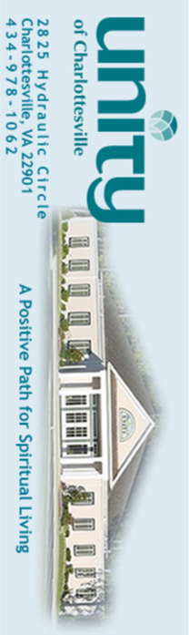

(June 15 – August 31, 2022)

Are You Ready to Accept the Challenge?

Unexpected
Income
Program

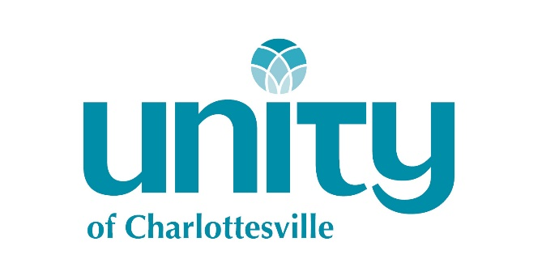

2825 Hydraulic Circle
Charlottesville, VA 22901
www.unitycharlottesville.org
unityofcharlottesville@gmail.com
(434) 978-1062
The Law of
Giving and Receiving
By Charles Fillmore

The law of giving and receiving is the
law of substance that equalizes all things. To realize and maintain divine order, substance must have both an inlet and an outlet in consciousness and must be kept moving.

To demonstrate substance as supply, the law governing it must be recognized and kept. Those who, from pride or ignorance, do not open themselves to the inflow of substance do not demonstrate supply, and all who by selfishness refuse it an outlet, also fail. Everyone must receive freely and give as freely as he receives. Disregard of the basic principle of supply frequently hinders one’s realization of the divine good. Readiness to give and readiness to receive are equally essential.

Tithing is giving a tenth of one’s supply to God and God’s work. Tithing, which is based on a law that cannot fail, establishes method in giving. It brings into consciousness a sense of divine order that is manifested in one’s outer life and affairs as increased efficiency and greater prosperity. It is the surest way ever found to demonstrate plenty, for it is God’s own law and way of giving.

“Freely ye received, freely give.”
—Matthew 10:8

Here's How It Works

Would you be willing to generously give 10% of any unexpected income you receive from June 15-August 31?
We’re talking about “found” money that you weren’t expecting; like winning the lottery, receiving an inheritance, getting an unexpected bonus, finding a penny on the sidewalk, or collecting on a debt that you had forgotten about.

Unity’s Unexpected Income Program is about practicing a conscious and deliberate approach to affirmative prayer, being willing and open to receive your good, and generously giving 10% of any unexpected income that you receive from June 15 until August 31 to Unity of Charlottesville.
If you’re willing to accept the challenge, we’re inviting you to make the pledge on the “Count Me In” panel and begin and end your day with the “My Prayer for Prosperity” affirmation.

Join us in setting the laws of prosperity in motion for your increased good, and the financial support of Unity of Charlottesville.
My Prayer for
Prosperity

I affirm that God of my understanding is the source of all supply, including any money or unexpected income that comes to me. I affirm that my good is now flowing to me so richly and so fully that I have an abundance of money to spare and to share, today and always. I affirm that true prosperity includes perfect health, perfect wealth, and perfect happiness.

These words which I now speak in faith, activate the law of Universal Good and I gratefully accept the results.

I bless all the good that is coming to me now; I bless the increase. I bless all of the others in the Unexpected Income Program, and I know that we now prosper together in every way. I give thanks for this good.

So it is! And so I let it be.

Do this affirmative prayer every morning and evening throughout for the duration of this program.

Unity of Charlottesville Unexpected Income Program
Count Me In!

I want to be included in the Affirmative Prayer for Unexpected Income and for the general demonstration of increased good in my life. I will share the increase that comes to me in the form of a gift of 10% OFF THE TOP to Unity of Charlottesville for any unexpected income I receive from June 15 through August 31, 2022. I understand "Unexpected Income" to mean any increase of money over and above my current normal income.

Signed
__________________________________ _____________________________ ___________________
(Please Print) Email Phone

Please email your signed agreement to: unityofcharlottesville@gmail.com, mail to Unity of Charlottesville, or drop in the collection basket. For more information, please speak with your minister or any member of the UOC board of trustees.

