Equip Conference
SESSION: CARING WORSHIP
Nov 13, 2021

Christian Worship - A Definition
Our response of faith, thanksgiving and praise, obedience, and service to God the Father for the relationship we have with him through the sacrificial work of Christ and the grace given to us by the Holy Spirit.

- Christian worship’s foundation is God - not us. Our reflection should begin with who God is and what he’s done, and not what we want to receive from Him.
- Christian worship is informed by the Bible. God has revealed himself, his works, and his expectations for his people through the scriptures.
- Christian worship should be Christ-Centered. Jesus Christ is the mediator between God and his people. We are saved through the resurrected Christ. It is the life and light of Christ that we imitate to the world.

Four-fold Order of Worship

Order of Worship |  | The Plan of Salvation
The Gathering | --> | God desires to be in fellowship with us. God comes to us and initiates a relationship with us through the power of the Holy Spirit
The Word | --> | Because of sin our relationship with God is broken. So God sends his Son- the living Word of God to restore the relationship through his life, death, & resurrection
The Table | --> | We are invited to repent of our sins and believe the Gospel. We say yes to Christ in faith, lay our sins on Christ, receive forgiveness and follow him.
The Sending | --> | As followers of Christ, God sends us out into the world as his representatives.

Worship Planning at Tabernacle Community Church

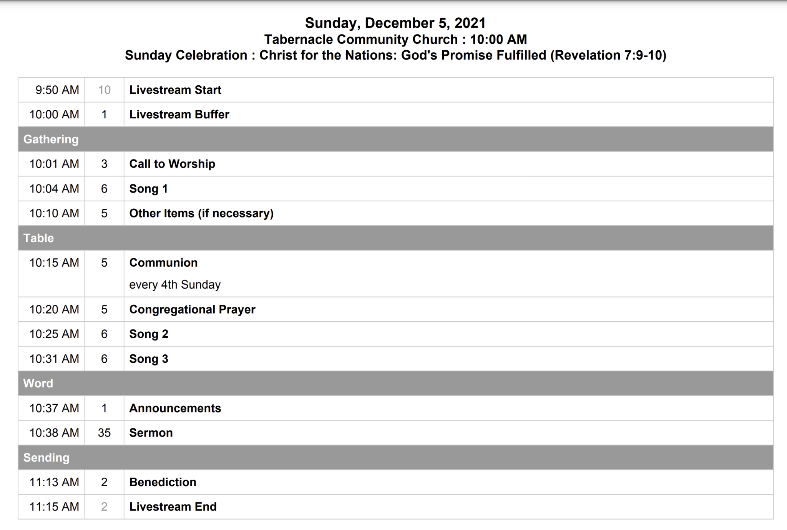

The following is Included in the TCC worship planning process:
- Sermon title and text received by the pastors
- Weekly Worship planning meetings
  - Themes in texts
  - Songs
  - Bible Readings
  - Schedule worship team and band
- Weekly worship service debriefs with pastors and worship team
- Worship director looks ahead into the year and beyond for functional and relational needs

What does caring worship look like?

Caring worship breaks down barriers to welcome all worshipers, including persons from different cultures, ages, abilities, both seekers and lifelong Christians.

Let’s Explore together
What can caring worship look like at Tabernacle Community Church in the following area?

- Culture

- Age

- Abilities

- Seekers

- Lifelong Chrisitans

