Faith Evangelical Lutheran Church, Washington, IL
Sixth Sunday of Easter
May 22, 2022

Welcome

Hymn: “Borning Cry” Red Book #732
Text: John C. Ylvisaker, b. 1937
Music: WATERLIFE, John C. Ylvisaker
Text and music © 1985 John Ylvisaker
Reprinted under OneLicense.net#A-711151
Service of Holy Baptism
P In baptism our gracious heavenly Father frees us from sin and death by joining us to the death and resurrection of our Lord Jesus Christ. We are born children of a fallen humanity; by water and the Holy Spirit we are reborn children of God and made members of the church, the body of Christ. Living with Christ and in the communion of saints, we grow in faith, love, and obedience to the will of God.
Parents and Sponsors: We present Charlotte Kathleen Rissman for baptism.
P Called by the Holy Spirit, trusting in the grace and love of God, do you desire to have your child baptized into Christ?
Parents and Sponsors: I do
P As you bring Charlotte to receive the gift of baptism, you are entrusted with responsibilities:
to live with her among God's faithful people,
bring her to the word of God and the holy supper,
teach her the Lord's Prayer, the Creed, and the Ten Commandments,
place in her hands the holy scriptures,
and nurture her in faith and prayer,
so that your child may learn to trust God, proclaim Christ through word and deed, care for others and the world God made, and work for justice and peace.
Do you promise to help Charlotte grow in the Christian faith and life?
R I do.
P Sponsors, do you promise to nurture Charlotte in the Christian faith as you are empowered by God's Spirit, and to help her live in the covenant of baptism and in communion with the church?
R I do.
P People of God, do you promise to support Charlotte and pray for her in her new life in Christ?
C We do.
P I ask you to profess your faith in Christ Jesus, reject sin, and confess the faith of the church.
Do you renounce the devil and all the forces that defy God?
R I renounce them.
P Do you renounce the powers of this world that rebel against God?
R I renounce them.

P Do you renounce the ways of sin that draw you from God?
R I renounce them.
P The congregation may join us in our confession of faith.
Do you believe in God the Father?
I believe in God, the Father almighty,
creator of heaven and earth.
Do you believe in Jesus Christ, the Son of God?
I believe in Jesus Christ, God's only Son, our Lord,
who was conceived by the Holy Spirit,
born of the virgin Mary,
suffered under Pontius Pilate,
was crucified, died, and was buried;
he descended to the dead.*
On the third day he rose again;
he ascended into heaven,
he is seated at the right hand of the Father,
and he will come to judge the living and the dead.
Do you believe in God the Holy Spirit?
I believe in the Holy Spirit,
the holy catholic church,
the communion of saints,
the forgiveness of sins,
the resurrection of the body,
and the life everlasting.
Thanksgiving at the Font
P The Lord be with you.
C And also with you.
P Let us give thanks to the Lord our God.
C It is right to give God thanks and praise.
P Blessed are you, O God, maker and ruler of all things. Your voice thundered over the waters at creation. You water the mountains and send springs into the valleys to refresh and satisfy all living things.
Through the waters of the flood you carried those in the ark to safety. Through the sea you led your people Israel from slavery to freedom. In the wilderness you nourished them with water from the rock, and you brought them across the river Jordan to the promised land.
By the baptism of his death and resurrection, your Son Jesus has carried us to safety and freedom. The floods shall not overwhelm us, and the deep shall not swallow us up, for Christ has brought us over to the land of promise. He sends us to make disciples, baptizing in the name of the Father, and of the Son, and of the Holy Spirit.
Pour out your Holy Spirit; wash away sin in this cleansing water; clothe the baptized with Christ; and claim your daughters and sons, no longer slave and free, no longer male and female, but one with all the baptized in Christ Jesus, who lives and reigns with you in the unity of the Holy Spirit, one God, now and forever.
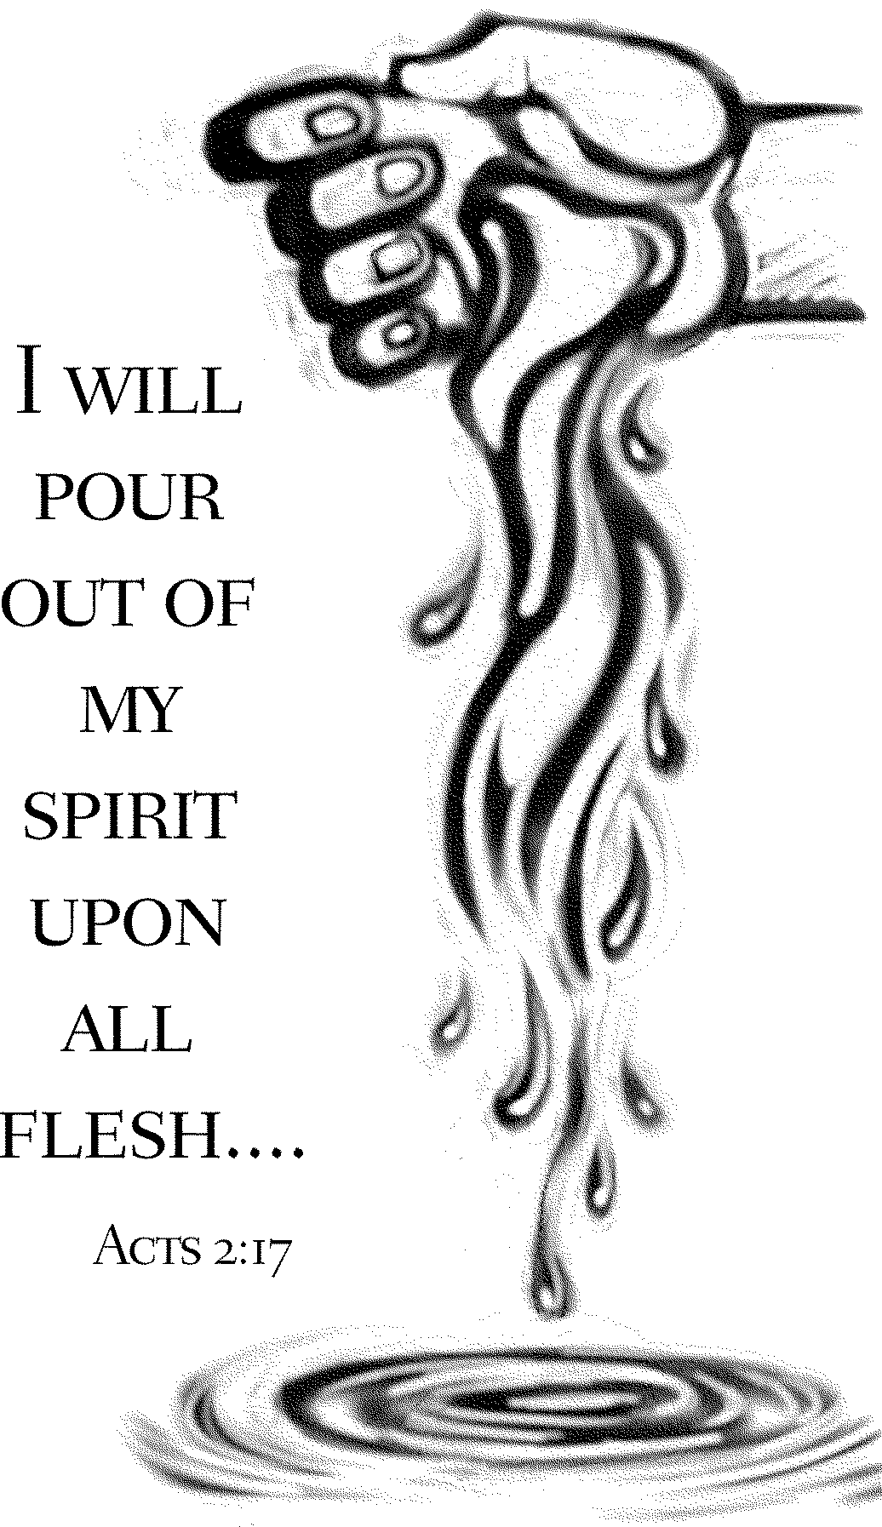
C Amen.
Baptism of Charlotte Kathleen Rissman
Charlotte, I baptize you in the name of the Father,
and of the Son,
and of the Holy Spirit.
Amen.
P Let us pray. We give you thanks, O God, that through water and the Holy Spirit you give your daughters and sons new birth, cleanse them from sin, and raise them to eternal life.
Sustain Charlotte with the gift of your Holy Spirit: the spirit of wisdom and understanding, the spirit of counsel and might, the spirit of knowledge and the fear of the Lord, the spirit of joy in your presence, both now and forever.
C Amen.
Marking the sign of the cross on the forehead and anointing with oil.
P Charlotte, child of God, you have been sealed by the Holy Spirit and marked with the cross of Christ forever.
C Amen.
Presenting a lighted baptismal candle to the baptized.
“Let your light so shine before others that they may see your good works and give glory to your Father in heaven.”
Presenting a Faith Chest to the baptized.
P Let us welcome the newly baptized.
C We welcome you into the body of Christ and into the mission we share: join us in giving thanks and praise to God and bearing God's creative and redeeming word to all the world.

P I would like to present to you the newest member of our Faith family, Charlotte Rissman. Please repeat after me, “Charlotte, Jesus loves you, and so do we.”
C “Charlotte, Jesus loves you, and so do we”
The Peace: May the peace of the Lord be with you always.
C And also with you (Please share a sign of God’s peace)
Hymn: “I Want to Walk as a Child of the Light” Red Book #815
Text: Kathleen Thomerson, b. 1934 Music: HOUSTON, Kathleen Thomerson Text and music © 1970, 1975 Celebration
Reprinted under OneLicense.net#A-711151
P The Lord be with you
C And also with you.
Let us pray together the Prayer of the Day
Bountiful God, you gather your people into your realm, and you promise us food from your tree of life. Nourish us with your word, that empowered by your Spirit we may love one another and the world you have made, through Jesus Christ, our Savior and Lord, who lives and reigns with you and the Holy Spirit, one God, now and forever. Amen.
Children’s Message

First Reading: Acts 16:9-15 Pew Bible Page #896
⁹During the night Paul had a vision: there stood a man of Macedonia pleading with him and saying, “Come over to Macedonia and help us.” ¹⁰When he had seen the vision, we immediately tried to cross over to Macedonia, being convinced that God had called us to proclaim the good news to them.
¹¹We set sail from Troas and took a straight course to Samothrace, the following day to Neapolis, ¹²and from there to Philippi, which is a leading city of the district of Macedonia and a Roman colony. We remained in this city for some days. ¹³On the sabbath day we went outside the gate by the river, where we supposed there was a place of prayer; and we sat down and spoke to the women who had gathered there. ¹⁴A certain woman named Lydia, a worshiper of God, was listening to us; she was from the city of Thyatira and a dealer in purple cloth. The Lord opened her heart to listen eagerly to what was said by Paul. ¹⁵When she and her household were baptized, she urged us, saying, “If you have judged me to be faithful to the Lord, come and stay at my home.” And she prevailed upon us.
R The Word of the Lord C Thanks be to God
Psalm 67 We sing the psalm in unison with Psalm Tone 4
¹May God be merciful to | us and bless us;
may the light of God’s face | shine upon us.
²Let your way be known | upon earth,
your saving health a- | mong all nations.
³Let the peoples praise | you, O God;
let all the | peoples praise you
⁴Let the nations be glad and | sing for joy,
for you judge the peoples with equity and guide all the na- | tions on earth.
⁵Let the peoples | praise you, O God;
let all the | peoples praise you.
⁶The earth has brought | forth its increase;
God, our own | God, has blessed us.
⁷May God | give us blessing,
and may all the ends of the earth | stand in awe.

Second Reading: Revelation 21:10, 22-22:5 Pew Bible Page #1014
¹⁰And in the spirit [one of the angels] carried me away to a great, high mountain and showed me the holy city Jerusalem coming down out of heaven from God.
²²I saw no temple in the city, for its temple is the Lord God the Almighty and the Lamb. ²³And the city has no need of sun or moon to shine on it, for the glory of God is its light, and its lamp is the Lamb. ²⁴The nations will walk by its light, and the kings of the earth will bring their glory into it. ²⁵Its gates will never be shut by day—and there will be no night there. ²⁶People will bring into it the glory and the honor of the nations. ²⁷But nothing unclean will enter it, nor anyone who practices abomination or falsehood, but only those who are written in the Lamb’s book of life.
^{22:1}Then the angel showed me the river of the water of life, bright as crystal, flowing from the throne of God and of the Lamb ²through the middle of the street of the city. On either side of the river is the tree of life with its twelve kinds of fruit, producing its fruit each month; and the leaves of the tree are for the healing of the nations. ³Nothing accursed will be found there any more. But the throne of God and of the Lamb will be in it, and his servants will worship him; ⁴they will see his face, and his name will be on their foreheads. ⁵And there will be no more night; they need no light of lamp or sun, for the Lord God will be their light, and they will reign forever and ever.

R The Word of the Lord
C Thanks be to God

Gospel Reading: John 14:23-29 Pew Bible Page #873

C Glory to you, O Lord
²³Jesus answered [Judas (not Iscariot),] “Those who love me will keep my word, and my Father will love them, and we will come to them and make our home with them. ²⁴Whoever does not love me does not keep my words; and the word that you hear is not mine, but is from the Father who sent me.
²⁵“I have said these things to you while I am still with you. ²⁶But the Advocate, the Holy Spirit, whom the Father will send in my name, will teach you everything, and remind you of all that I have said to you. ²⁷Peace I leave with you; my peace I give to you. I do not give to you as the world gives. Do not let your hearts be troubled, and do not let them be afraid. ²⁸You heard me say to you, ‘I am going away, and I am coming to you.’ If you loved me, you would rejoice that I am going to the Father, because the Father is greater than I. ²⁹And now I have told you this before it occurs, so that when it does occur, you may believe.”
The Gospel of the Lord
C Praise to you, O Christ
Sermon by Pastor John Rothfusz
Sermon Hymn: “Love Divine, All Loves Excelling” Red Book #631
Text: Charles Wesley, 1707-1788
Music: HYFRYDOL, Rowland H. Prichard, 1811-1887

Prayers: After each portion of the prayers finishes with “Lord in your mercy,” please respond, “Hear our prayer.”

Offering: Jesus is risen and fills us with new life and hope. Let us offer ourselves to the Lord and joyfully lift our tithes and offerings to the Lord.

I Am Thanking Jesus
I am thanking Jesus, I am thanking Jesus, I am thanking Jesus from my heart.
I am thanking Jesus, I am thanking Jesus, I am thanking Jesus from my heart.

Please take a moment now to make an electronic offering to the church on the website, with the Tithe.ly app on your phone, or drop and envelope in the plate at communion time.

Faith Lutheran website link www.shareourfaith.org

Offering Prayer

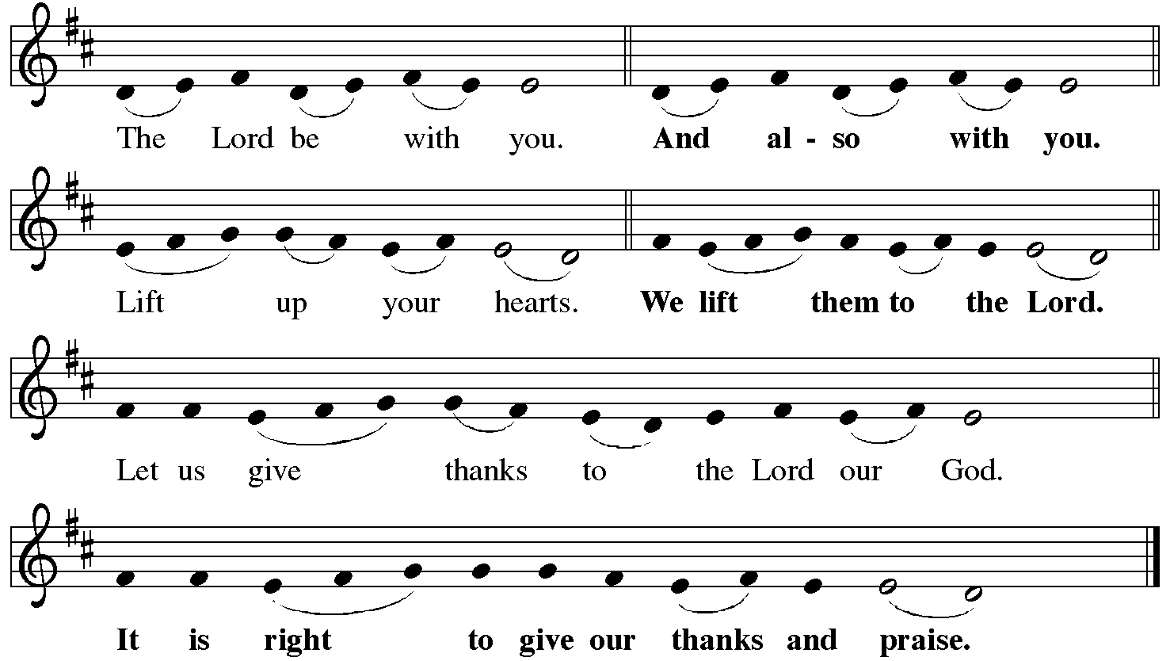

P It is indeed right, our duty and our joy… with the church on earth and the hosts of heaven, we praise your name and join their unending hymn:
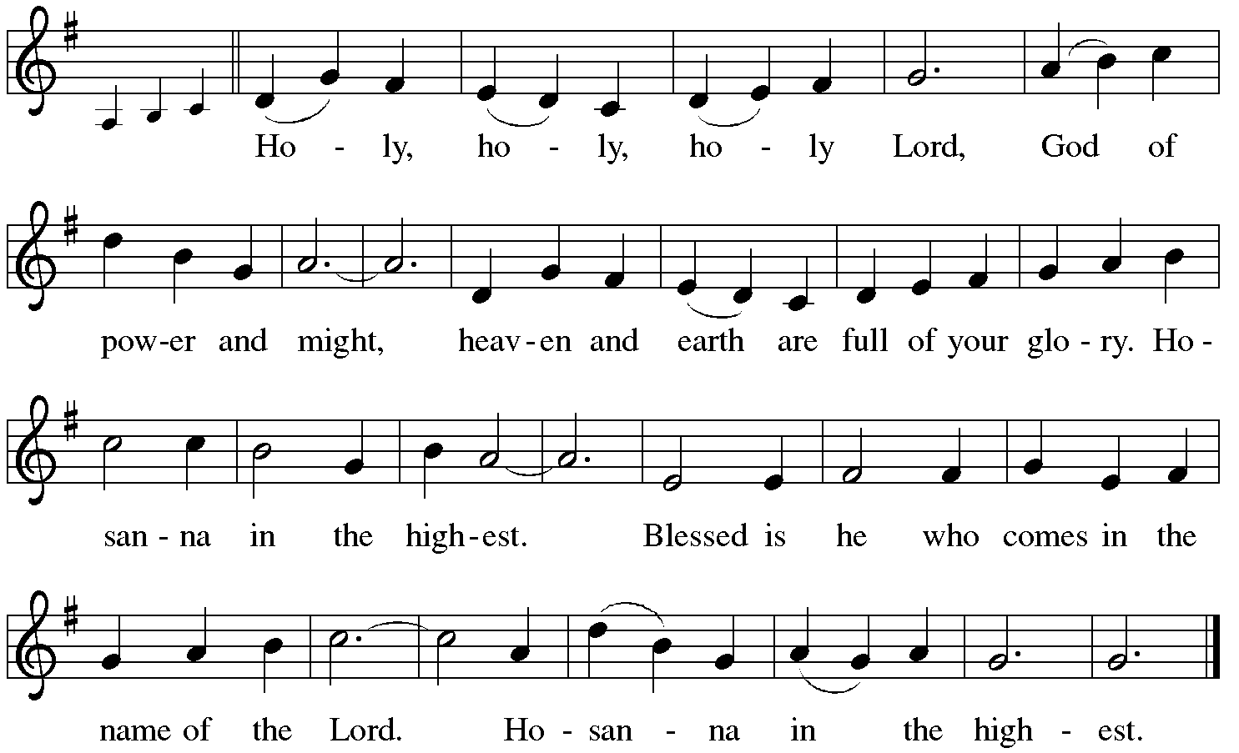

*Eucharistic Prayer/Words of Institution
In the night in which he was betrayed, our Lord Jesus took bread, and gave thanks; broke it, and gave it to his disciples, saying: Take and eat; this is my body, given for you. Do this for the remembrance of me.
Again, after supper, he took the cup, gave thanks, and gave it for all to drink, saying: This cup is the new covenant in my blood, shed for you and for all people for the forgiveness of sin. Do this for the remembrance of me.
For as often as we eat of this bread and drink from this cup,
we proclaim the Lord’s death until he comes.
Christ has died.
Christ is risen.
Christ will come again….
to share with us the great and promised feast.
Amen. Come, Lord Jesus….
and receive our inheritance with all your saints in light.
Amen. Come, Holy Spirit.

C The Lord's Prayer
Our Father, who art in heaven, hallowed be thy name,
thy kingdom come, thy will be done, on earth as it is in heaven.
Give us this day our daily bread; and forgive us our trespasses,
as we forgive those who trespass against us;
and lead us not into temptation, but deliver us from evil.
For thine is the kingdom, and the power, and the glory,
forever and ever. Amen
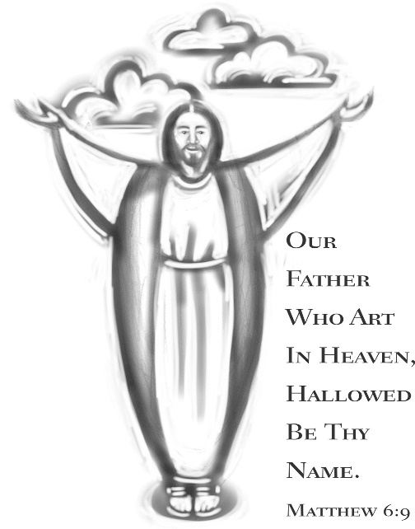

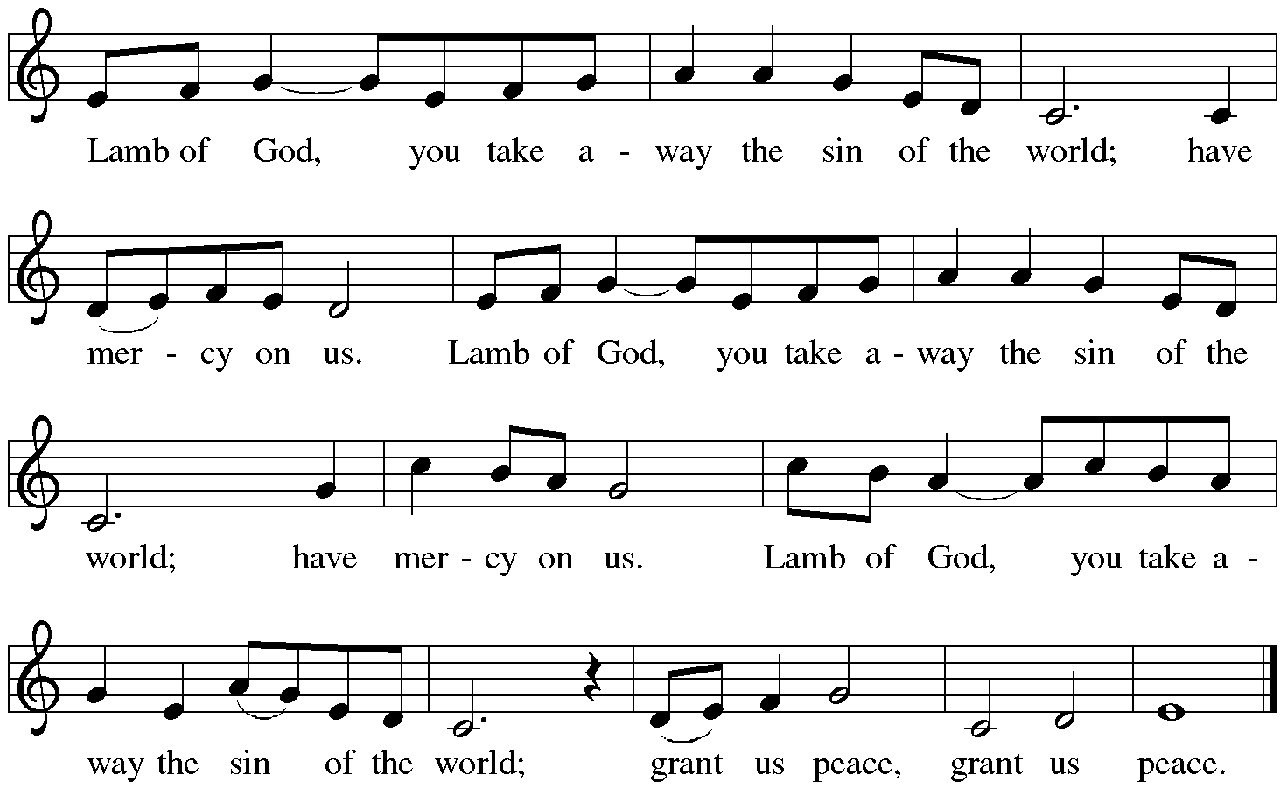

Communion Distribution

Communion Hymn: “When Peace like a River” Red Book #785
Text: Horatio G. Spafford, 1828-1888
Music: VILLE DU HAVRE, Philip P. Bliss, 1838-1876

Communion Prayer

Announcements

Blessing
P The Lord bless you and keep you.
The Lord make his face shine on you and be gracious to you.
The Lord look upon you with favor and + give you peace.
In the name of the Father, and of the Son and of the Holy Spirit.
C Amen

Hymn: “My Life Flows On in Endless Song” Red Book #763

Text: Robert Lowry, 1826-1899
Music: HOW CAN I KEEP FROM SINGING, Robert Lowry, 1826-1899, alt.

Dismissal
A Go in peace. Serve the Lord.
C Thanks be to God!
Postlude
Liturgy and texts from Sundays and Seasons.com. Copyright 2022 Augsburg Fortress. All rights reserved.
Reprinted by permission under Augsburg Fortress Liturgies Annual License #23628.

