All Saints Anglican Church, Agassiz
6904 Lougheed Highway, BC, V0M 1A0

Bulletin May 9 – May 15, 2022
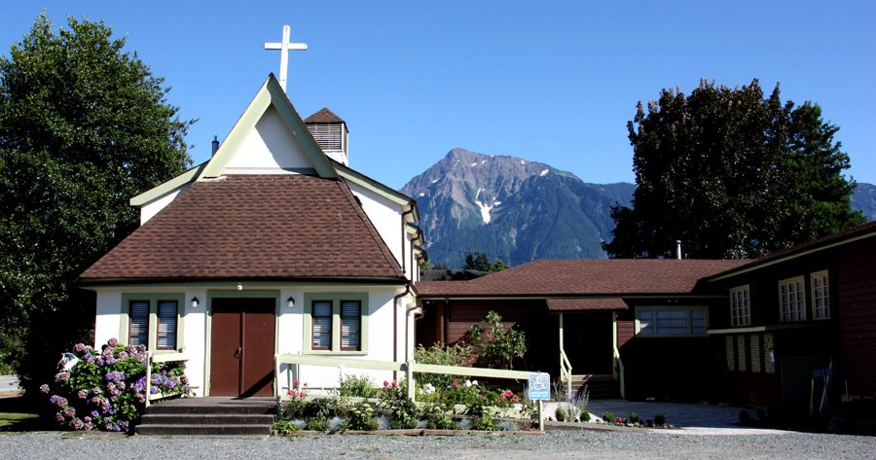

‘The ground we walk does not belong to us; for thousands of years it has been - and remains - the territory of the Stó:lō.’ We are grateful for their sharing.

Phone: 604-796-3553
Website: www.allsaints-agassiz.ca
https://www.facebook.com/groups/AllSaintsFamily
OUR DOOR IS OPEN AND ALL ARE WELCOME
15th May, 2022 Fifth Sunday of Easter
Priest-in-Charge: The Reverend Philip Barker
Hosts: Graham Featherstone/Jennifer Pinlac
Intercessor: Lynn Laughlin
Lay Administrator: Wil Watchorn
Announcer: Ginny Jennings
Piano: Fran Froehlich

PLEASE NOTE:
Zoom service will still be available and a link sent out around 09:45 by Graham. Email him at gfeatherstone@shaw.ca if you don’t think you’re on his list.
Vicar’s cell phone: Rev’d Philip Barker. 778-867-2461
Vicar’s Warden: Ginny Jennings. 604-796-2206
People’s Warden: Lynn Laughlin. 604-799-5131
Parish email: www.allsaints-agassiz.ca
Please contact either warden if you have an issue that needs to be brought to the attention of the Vicar - or contact the Vicar direct (see above for details).

WARDENS’ PITCH
- Bible Study with Karol is every Saturday at 8:30 a.m. on Zoom.
- Book Club meets Wednesday at 4:00 p.m. on Zoom.
- Evening Prayer with Valerie is at 7:00 p.m. Sun, Wed, Fri on our webpage.
- Prayer Requests can be given on a piece of paper to either of the Wardens or the Vicar or entered in the Prayer Request Book on the piano in the church or you may contact Anthea Lewis at antheamlewis@shaw.ca for Pray First Prayer Circle, which is a confidential online prayer circle.
- Music Requests may be given to the Wardens or the Vicar.
- AA meets in the hall every Tuesday at noon.
- Games for 55’s + every Thursday in the hall 10:00-12:00.
- Coffee Time after our service will continue as is until June when we will start our schedule again. We need 4 more hosts and you will always be teamed up.
- 5th Sunday of each month will be a potluck lunch after the service.
PLEASE NOTE: If anyone has any inclusions for the Bulletin, please contact the Wardens. Thank you.

Equipment in Basement to be sold by July 1st. The equipment is not being used and we need it removed to seal the cracks in the flooring where the water is coming in.

The O'Driscoll Forum
On Tuesday May 31, 2022 at 4:00 p.m. will be the on line introduction of The O'Driscoll Forum. Click on https://vst.edu/event/online-launch-of-the-odriscoll-forum/ to join in.
Many will remember Herbert O'Driscoll and his spouse Paula from Herb's time at Christ Church Cathedral in Vancouver, from his radio work, from his books, from Paula's musical contributions and perhaps from participating in one of the pilgrimage trips they lead. Wendy Young remembers vividly her pilgrimage to the Holy Land lead by Herb.
The O'Driscoll Forum has been set up at Vancouver School of Theology to carry on the work of Herb and Paula in fostering excellence in preaching, teaching and the liturgical arts. And yes, there will be an invitation to make a financial contribution to The O'Driscoll Forum! Go to https://vst.edu/odriscollforum/ to find the Donate Online button.

Ministerial Meanderings

There is something rather comforting about being thousands of miles away from a place where cruelty and hatred seem to rule the day, and kindness and compassion have fled the scene.

I mention this to remind myself and you that we are incredibly lucky to be living in a country where there is peace, and war and conflict of the sort being experienced daily in the Ukraine is so alien to us that we really cannot comprehend it.

I do not bring this up to dwell unnecessarily on sad and depressing issues, but rather to emphasize our good fortune.
Yes - I am aware that not all is well with our government, and there are still many unresolved problems that require our attention and effort, but on the whole, most of us don’t have too much to bitch about when we look at what our brothers and sisters are enduring just across the ocean.

Perhaps another reason that I raise the topic is that we tend to see only those bits of the war that we want to, or can understand. Although we read about the abuse and rape of women in war, and the gratuitous savagery that accompanies soldiers in every field of conflict, we give it lip-service at best - most of the time.

Just the other day, Sheila and I were watching a programme in which the thorny issue of justification for torture was raised. Our immediate, knee-jerk response is likely to be, ‘Of course it is not justified - it is never justified!’
But then you have to think about why it is done in certain circumstances.

If you are aware that the fate of hundreds of innocent civilians rests with intelligence that your prisoner has - or is likely to have, then are you going to be satisfied with an answer that is essentially, ‘I’m not going to tell you,’ or ‘I don’t know’? How are you going to ensure that they are telling you the truth, if time is of the essence, and there is little time to shift the target or neutralize the threat?

This may seem to be the stuff of TV drama, but for those soldiers in Ukraine, it a real and present danger - and affects not only them and their comrades in arms, but probably also their families and homes.
When I was in deployed forces ashore, (in various conflicts), we were given pre-deployment training in resisting interrogation, should we be captured. As medics, we were a sought-after target, as to reduce the medical capability of one side is to demoralize and lower the morale of the fighting men, who depend on being removed from the battlefield promptly, then rapidly and competently put back together by surgical teams.

My resistance to interrogation training was never (thankfully) put to the test, but I have no doubt whatsoever that it would not have been a civilized question and answer session over a cup of coffee.

Dwell on what these men and women have to face on a daily basis - either for real, or as an imminent threat - and don’t be too swift to condemn those for whom the result of intelligence is truly a matter of life and death.

Philip+

Chuckles•
My train of thought derailed……There were no survivors.

Birthdays This Month
Paula Holm on the 23rd and John Van Laerhoven on the 26th.

Sunday Cycle of Prayer
St. James, Vancouver The Venerable Kevin Hunt
The Revd Matthew Johnson
The Revd Joyce Locht
The Revd Amanda Ruston
Standing committee on Finance
And Property Bob Hardy, ODNW, Treasurer and
Chair;
Shailene Caparas, Staff

Monthly Cycle of Prayer
St. Christopher, West Vancouver The Revd Karen Urquhart
St. Stephen, West Vancouver The Revd Kenneth Vinal
St. Francis-in-the-Wood, The Venerable Stephanie
West Vancouver Shepard

Anglican Cycle of Prayer
Our Primate, Archbishop, Linda Nicolls. For National Indigenous Interim Bishop Sidney Black and for the Anglican Council of Indigenous People. We also pray for the Coordinator for Indigenous Justice, Kerry Baisley.
In our parish we pray for our priest, Philip; retired priests Mike, Jack, and Paul. Amen

Collect – May 15, 2022
Almighty God, your Son Jesus Christ is the way, the truth, and the life. Give us grace to love one another and walk in the way of his commandments, who lives and reigns with you and the Holy Spirit, one God, now and for ever.

Acts 11: 1-18 Helene Atkinson
Introduction: Peter has been instrumental in the conversion of a Gentile to Christianity. Cornelius, an officer in the Roman army, has received the Holy Spirit and has been baptised – as have members of his household. Peter has now returned to Judea where members of the Christian community who are of Jewish origin seek an explanation as to why Gentiles have become Christians.
Reading: Now the apostles and the believers who were in Judea heard that the Gentiles had also accepted the word of God.
So when Peter went up to Jerusalem, the circumcised believers criticized him,
saying, "Why did you go to uncircumcised men and eat with them?"
Then Peter began to explain it to them, step by step, saying,
"I was in the city of Joppa praying, and in a trance I saw a vision. There was something like a large sheet coming down from heaven, being lowered by its four corners; and it came close to me.
As I looked at it closely I saw four-footed animals, beasts of prey, reptiles, and birds of the air.
I also heard a voice saying to me, 'Get up, Peter; kill and eat.'
But I replied, 'By no means, Lord; for nothing profane or unclean has ever entered my mouth.'
But a second time the voice answered from heaven, 'What God has made clean, you must not call profane.'
This happened three times; then everything was pulled up again to heaven.
At that very moment three men, sent to me from Caesarea, arrived at the house where we were.
The Spirit told me to go with them and not to make a distinction between them and us. These six brothers also accompanied me, and we entered the man's house.
He told us how he had seen the angel standing in his house and saying, 'Send to Joppa and bring Simon, who is called Peter;
he will give you a message by which you and your entire household will be saved.'
And as I began to speak, the Holy Spirit fell upon them just as it had upon us at the beginning.
And I remembered the word of the Lord, how he had said, 'John baptized with water, but you will be baptized with the Holy Spirit.'
If then God gave them the same gift that he gave us when we believed in the Lord Jesus Christ, who was I that I could hinder God?"
When they heard this, they were silenced. And they praised God, saying, "Then God has given even to the Gentiles the repentance that leads to life."
Hear what the Spirit is saying to the Church. Thanks be to God
Psalm 148
Praise the LORD! Praise the LORD from the heavens; praise him in the heights!
Praise him, all his angels; praise him, all his host!
Praise him, sun and moon; praise him, all you shining stars!
Praise him, you highest heavens, and you waters above the heavens!
Let them praise the name of the LORD, for he commanded and they were created.
He established them forever and ever; he fixed their bounds, which cannot be passed.
Praise the LORD from the earth, you sea monsters and all deeps,
fire and hail, snow and frost, stormy wind fulfilling his command!
Mountains and all hills, fruit trees and all cedars!
Wild animals and all cattle, creeping things and flying birds!
Kings of the earth and all peoples, princes and all rulers of the earth!
Young men and women alike, old and young together!
Let them praise the name of the LORD, for his name alone is exalted; his glory is above earth and heaven.
He has raised up a horn for his people, praise for all his faithful, for the people of Israel who are close to him. Praise the LORD!

Revelations 21: 1-6 Wendy Young
Introduction: The book of Revelation is “the revelation of Christ” made through John. It is prophecy which reveals secrets of heaven and earth. In a vision, John has seen the destruction of the old city, and of the old heaven and earth. Now he sees the new creation, of divine origin and free of evil forces – for ultimately God’s love will prevail.
Reading: Then I saw a new heaven and a new earth; for the first heaven and the first earth had passed away, and the sea was no more.
And I saw the holy city, the new Jerusalem, coming down out of heaven from God, prepared as a bride adorned for her husband.
And I heard a loud voice from the throne saying, "See, the home of God is among mortals. He will dwell with them as their God; they will be his peoples, and God himself will be with them;
he will wipe every tear from their eyes. Death will be no more; mourning and crying and pain will be no more, for the first things have passed away."
And the one who was seated on the throne said, "See, I am making all things new." Also he said, "Write this, for these words are trustworthy and true."
Then he said to me, "It is done! I am the Alpha and the Omega, the beginning and the end. To the thirsty I will give water as a gift from the spring of the water of life.

Hear what the Spirit is saying to the Church. Thanks be to God

The Gospel
John 13: 31-35
Introduction: Jesus is preparing his followers for his departure. After the Last Supper, he has washed the feet of his disciples, a symbol of servanthood. He has predicted his betrayal. Judas Iscariot has gone out into the night – a symbol of the dark deed he is about to commit.
Reading: When he had gone out, Jesus said, "Now the Son of Man has been glorified, and God has been glorified in him.
If God has been glorified in him, God will also glorify him in himself and will glorify him at once.
Little children, I am with you only a little longer. You will look for me; and as I said to the Jews so now I say to you, 'Where I am going, you cannot come.'
I give you a new commandment, that you love one another. Just as I have loved you, you also should love one another.
By this everyone will know that you are my disciples, if you have love for one another."

