All Saints Anglican Church, Agassiz
6904 Lougheed Highway, BC, V0M 1A0

Bulletin May 2 – May 8, 2022
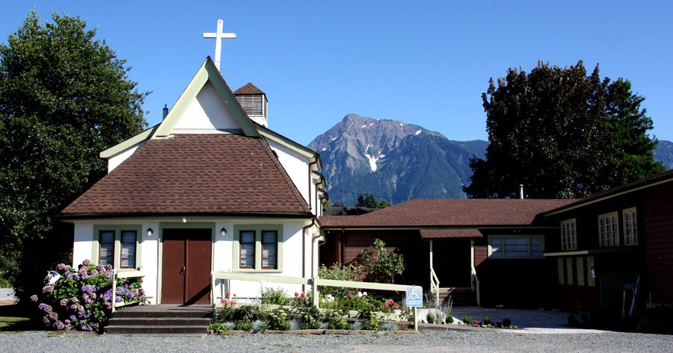

‘The ground we walk does not belong to us; for thousands of years it has been - and remains - the territory of the Stó:lō.’ We are grateful for their sharing.

Phone: 604-796-3553
Website: www.allsaints-agassiz.ca
https://www.facebook.com/groups/AllSaintsFamily
OUR DOOR IS OPEN AND ALL ARE WELCOME
8th May, 2022 Fourth Sunday of Easter
Priest-in-Charge: The Reverend Philip Barker
Hosts: Graham Featherstone/Jennifer Pinlac
Intercessor: Karol Henrotte
Lay Administrator: Gail Thomson
Announcer: Ginny Jennings
Piano: Fran Froehlich

PLEASE NOTE:
Zoom service will still be available and a link sent out around 09:45 by Graham. Email him at gfeatherstone@shaw.ca if you don’t think you’re on his list.
Vicar’s cell phone: Rev’d Philip Barker. 778-867-2461
Vicar’s Warden: Ginny Jennings. 604-796-2206
People’s Warden: Lynn Laughlin. 604-799-5131
Parish email: www.allsaints-agassiz.ca
Please contact either warden if you have an issue that needs to be brought to the attention of the Vicar - or contact the Vicar direct (see above for details).

WARDENS’ PITCH
- Bible Study with Karol is every Saturday at 8:30 a.m. on Zoom.
- Book Club meets Wednesday at 4:00 p.m. on Zoom.
- Evening Prayer with Valerie is at 7:00 p.m. Sun, Wed, Fri on our webpage.
- Prayer Requests can be given on a piece of paper to either of the Wardens or the Vicar or entered in the Prayer Request Book on the piano in the church or you may contact Anthea Lewis at antheamlewis@shaw.ca for Pray First Prayer Circle, which is a confidential online prayer circle.
- Music Requests may be given to the Wardens or the Vicar.
- AA meets in the hall every Tuesday at noon.
- Games for 55’s + every Thursday in the hall 10:00-12:00.
- Coffee Time after our service will continue as is until June when we will start our schedule again. We need 4 more hosts and you will always be teamed up.
- 5th Sunday of each month will be a potluck lunch after the service.
PLEASE NOTE: If anyone has any inclusions for the Bulletin, please contact the Wardens. Thank you.

Ministerial Meanderings
Last night I was looking at the sky when I was taking Gracie out for her last bathroom break before bed. It has become somewhat of a routine of late, as when she goes out, she likes to greet any other dogs who may be sharing their news on the block, and if there aren’t any, then she will greet the stars and moon - and any low-flying aircraft in the night sky. If there are none of the above, she will complain loudly that there are objects missing from her evening perambulation.
Sheila, being infinitely more socially conscious than I, and actually worrying about ‘what people might think’, has encouraged me to go out with Gracie, so as to avert her proclivity to vocalize at bedtime.

Accordingly, Gracie and I were out in the yard, and I was looking at the night sky…only I wasn’t - as there wasn’t a star to be seen, and a blanket of cloud had shut off the heavens. I felt cheated, and would have totally agreed with Gracie had she chosen at that moment to ask (in her peremptory way) why her celestial bodies had been covered up. Nevertheless, in deference to Sheila, and for the sake of domestic harmony, neither Gracie nor I broke into a mournful howl - though the desire was there.

I was left with a sense of loneliness, abandonment, and sadness - akin to despair, but not so marked. I also had a profound sense of my smallness and insignificance in the world.
It is hard at such times to go back into the house and appear ‘normal’ - whatever that is - and I looked for a distraction in order not to have to talk about how I felt.

Sharing such thoughts of worthlessness is not easy at the best of times, and I think we need to have some kind of release valve that we can activate, to allow these feelings to vent and dissipate. For some, sharing with a partner or close friend may be the answer; for me, it is not - most of the time. The problem is that your partner or friend will ask you how you are feeling and why - and it’s likely that you have no answer to either question. Depression is a lonely place.

Are you expecting miracle cures from me? Because if you are, you will be sadly disappointed.
My solace is in three places. First - as always - music; second - the psalms, which have raw emotions in them that I can relate to; and third - Gethsemane.
If Jesus felt the way I think he felt in Garden of Gethsemane, then he knows how I feel at times - and how you do too.

That gives me hope when I see and feel none - and I know that eventually, my clouds will clear.

Philip+

Chuckles•
Vegetarians live up to nine years longer than meat-eaters. Nine horrible, worthless, bacon-less years.

Birthdays This Month
Karol Henrotte on the 2nd, Paula Holm on the 23rd and John Van Laerhoven on the 26th.

Sunday Cycle of Prayer
The Deanery of Tri-Cities/North Burnaby - The Revd Eric Mason, Regional Dean
The Archdeaconry of Burrard - The Venerable Kevin Hunt, Regional Archdeacon

Monthly Cycle of Prayer
Holy Cross, Vancouver - The Revd Alecia Greenfield
St. Mary the Virgin, South Hill - The Revd Expedito Farinas

Anglican Cycle of Prayer
Our Primate, Archbishop, Linda Nicolls. For National Indigenous Interim Bishop Sidney Black and for the Anglican Council of Indigenous People. We also pray for the Coordinator for Indigenous Justice, Kerry Baisley.
In our parish we pray for our priest, Philip; retired priests Mike, Jack, and Paul. Amen

Collect – May 8, 2022
O God of peace, who brought again from the dead our Lord Jesus Christ, that great shepherd of the sheep, by the blood of the eternal covenant, make us perfect in every good work to do your will, and work in us that which is well-pleasing in your sight; through Jesus Christ our lord.

Acts 9: 36-43 Hilary Routley
Introduction: Peter is visiting the coastal region to the northwest of Jerusalem. He is near modern Tel Aviv. There he meets people who are already Christians. In Lydda, he has been instrumental in healing a paralyzed man. He has said to him, “Aeneas, Jesus Christ heals you!”.
Reading: Now in Joppa there was a disciple whose name was Tabitha, which in Greek is Dorcas. She was devoted to good works and acts of charity.
At that time she became ill and died. When they had washed her, they laid her in a room upstairs.
Since Lydda was near Joppa, the disciples, who heard that Peter was there, sent two men to him with the request, "Please come to us without delay."
So Peter got up and went with them; and when he arrived, they took him to the room upstairs. All the widows stood beside him, weeping and showing tunics and other clothing that Dorcas had made while she was with them.
Peter put all of them outside, and then he knelt down and prayed. He turned to the body and said, "Tabitha, get up." Then she opened her eyes, and seeing Peter, she sat up.
He gave her his hand and helped her up. Then calling the saints and widows, he showed her to be alive.
This became known throughout Joppa, and many believed in the Lord.
Meanwhile he stayed in Joppa for some time with a certain Simon, a tanner
Hear what the Spirit is saying to the Church. Thanks be to God
Psalm 23 The LORD is my shepherd, I shall not want.
He makes me lie down in green pastures; he leads me beside still waters;
he restores my soul. He leads me in right paths for his name's sake.
Even though I walk through the darkest valley, I fear no evil; for you are with me; your rod and your staff-- they comfort me.
You prepare a table before me in the presence of my enemies; you anoint my head with oil; my cup overflows.
Surely goodness and mercy shall follow me all the days of my life, and I shall dwell in the house of the LORD my whole life long.

Revelations 7: 9-17 Pamela Evans
Introduction: The Lamb, whom we recognize as Christ, has, in opening six of the seven seals on the scroll, revealed events in God’s plan for the end-times. Our reading is a vision of the fate of the faithful. While they will suffer during the final events of this era, they will survive; in fact, God will give them eternal life.
Reading: After this I looked, and there was a great multitude that no one could count, from every nation, from all tribes and peoples and languages, standing before the throne and before the Lamb, robed in white, with palm branches in their hands.
They cried out in a loud voice, saying, "Salvation belongs to our God who is seated on the throne, and to the Lamb!"
And all the angels stood around the throne and around the elders and the four living creatures, and they fell on their faces before the throne and worshiped God,
singing, "Amen! Blessing and glory and wisdom and thanksgiving and honor and power and might be to our God forever and ever! Amen."
Then one of the elders addressed me, saying, "Who are these, robed in white, and where have they come from?"
I said to him, "Sir, you are the one that knows." Then he said to me, "These are they who have come out of the great ordeal; they have washed their robes and made them white in the blood of the Lamb.
For this reason they are before the throne of God, and worship him day and night within his temple, and the one who is seated on the throne will shelter them.
They will hunger no more, and thirst no more; the sun will not strike them, nor any scorching heat;
for the Lamb at the center of the throne will be their shepherd, and he will guide them to springs of the water of life, and God will wipe away every tear from their eyes."

Hear what the Spirit is saying to the Church. Thanks be to God

The Gospel
John 10: 22-30
Introduction: It is the time of Hanukkah, when Jews commemorate the rededication of the Temple after it had been desecrated. Jesus has earlier told people that he is divine and that he existed before Abraham. While what he does witnesses to his oneness with God, only those who believe can understand his Messiahship.
Reading: At that time the festival of the Dedication took place in Jerusalem. It was winter,
and Jesus was walking in the temple, in the portico of Solomon.
So the Jews gathered around him and said to him, "How long will you keep us in suspense? If you are the Messiah, tell us plainly."
Jesus answered, "I have told you, and you do not believe. The works that I do in my Father's name testify to me;
but you do not believe, because you do not belong to my sheep.
My sheep hear my voice. I know them, and they follow me.
I give them eternal life, and they will never perish. No one will snatch them out of my hand.
What my Father has given me is greater than all else, and no one can snatch it out of the Father's hand.
The Father and I are one."

