Faith Evangelical Lutheran Church, Washington, IL
Third Sunday of Easter – Baptismal Anniversary
May 1, 2022

Prelude
Welcome
Remembering our Baptism
We believe that our baptism is the most important day of our lives, because on that day God called us each by name and claimed us as his own forever. The Lord adopts us into his family, and makes us a part of the Body of Christ in the church.
So it is good and important to remember and celebrate that day when our baptism happened. We gather in baptism dates, to try to recognize each of our members.
Today we are recognizing those whom we know were baptized in the first four months of the year. I will read the names of those who are listed with a baptismal anniversary from January through April, so we can recognize them today.
Whenever you give thanks for your baptism, you can dip your finger in water and make the sign of the cross on your forehead as a remembrance of your baptism. We invite each of you to return to the baptismal font and mark that cross for yourself.
You can also light a candle to celebrate the light of faith. We give a lighted candle to each person as they are baptized, saying, “Let your light so shine before others that they may see your good works and give glory to your Father in heaven.”
A reading from Galatians: “In Christ Jesus you are all children of God through faith. As many of you as were baptized into Christ have clothed yourselves with Christ. There is no longer Jew or Greek, there is no longer slave or free, there is no longer male or female; for all of you are one in Christ Jesus.”
When you were baptized you were claimed by God, and marked with the cross of Christ forever. You can remember your baptism with thanksgiving and joy.
Today we affirm that baptism and its ongoing power in our lives. Baptism makes us children of God and followers of Jesus as long as we live and in heaven forever.
Together with all the people of God, I ask you to profess your faith in Christ Jesus, reject sin, and confess the faith of the church.
Faith Lutheran Church
2206 Washington Rd,
Washington, IL 61571
Website and online worship:
www.shareourfaith.org
Church: 309-745-9306
faithlth@shareourfaith.org
Pastor John Rothfusz
Home: 309-745-9282
pastor@shareourfaith.org
Do you renounce the devil and all the forces that defy
God, the powers of this world that rebel against God,
and the ways of sin that draw you from God?

Response:
I renounce them.
Do you believe in God the Father?
I believe in God, the Father almighty,
creator of heaven and earth.
Do you believe in Jesus Christ, the Son of God?
I believe in Jesus Christ, God’s only Son, our Lord,
who was conceived by the Holy Spirit,
born of the virgin Mary,
suffered under Pontius Pilate,
was crucified, died, and was buried;
he descended to the dead.*
On the third day he rose again; he ascended into heaven,
he is seated at the right hand of the Father,
and he will come to judge the living and the dead.
Do you believe in God the Holy Spirit?
I believe in the Holy Spirit,
the holy catholic church, the communion of saints,
the forgiveness of sins, the resurrection of the body,
and the life everlasting.
You have made public profession of your faith. Do you intend to continue in the covenant God made with you in holy baptism:
to live among God’s faithful people,
to hear the word of God and share in the Lord’s supper,
to proclaim the good news of God in Christ through word and deed,
to serve all people, following the example of Jesus,
and to strive for justice and peace in all the earth?
The group makes affirmation:
I do, and I ask God to help and guide me.
The minister addresses the assembly.
I ask all the people of God, do you promise to support and pray for these baptized and for one another in your life in Christ?
We do, and we ask God to help and guide us.
The presiding minister prays for God’s blessing.
Let us pray. Gracious God we thank you for the new life you give us through Holy Baptism. Bless each person here as they mark the anniversary of their baptism. We give you thanks, that through water and the Holy Spirit you give us new birth, cleanse us from sin, and raise us to eternal life. Stir up in all your people the gift of your Holy Spirit: the spirit of wisdom and understanding, the spirit of counsel and might, the spirit of knowledge and the fear of the Lord, the spirit of joy in your presence both now and forever. Make us faithful to follow you as long as we live. In Jesus’ name we pray. Amen.
May you live in God’s peace and follow Jesus as you live out your baptism. The Peace of the Lord be with you always.
C And also with you
Let us share that peace with one another.

*Hymn: “Christ Is Alive! Let Christians Sing” Red Book #389

Text: Brian A. Wren, b. 1936
Music: TRURO, T. Williams, Psalmodia Evangelica, 1789
Text © 1975, rev. 1995 Hope Publishing Company, Carol Stream, IL 60188. All rights reserved. Used by permission. Reprinted under OneLicense.net#A-711151

P The grace of our Lord Jesus Christ, the love of God,
and the communion of the Holy Spirit be with you all.
C And also with you.

Hymn of Praise
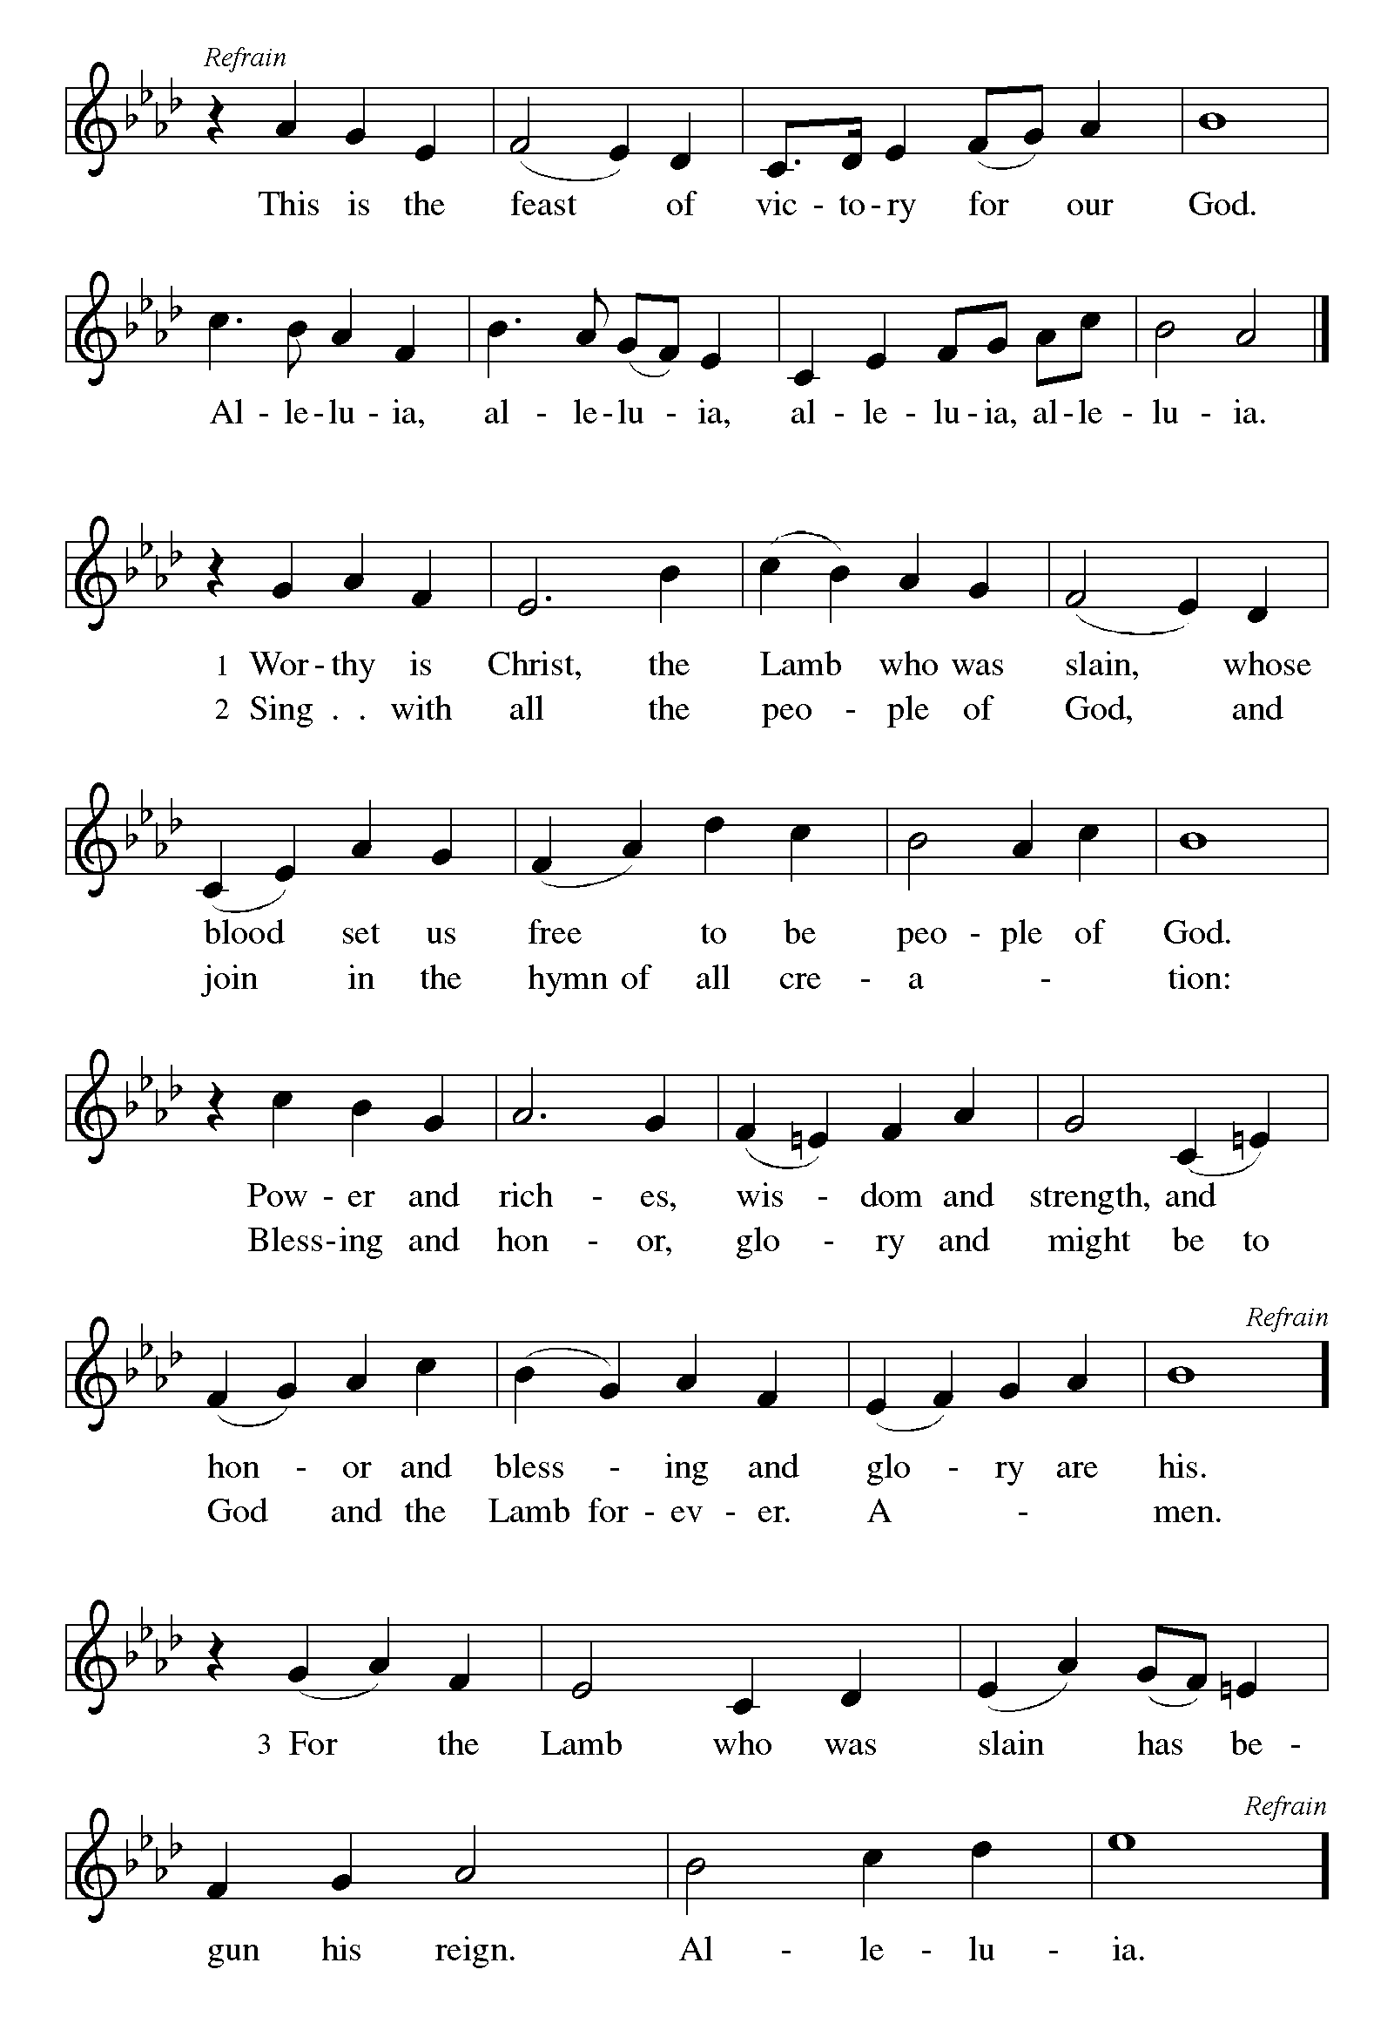

P The Lord be with you
C And also with you.
Let us pray together the Prayer of the Day
Eternal and all-merciful God, with all the angels and all the saints we laud your majesty and might. By the resurrection of your Son, show yourself to us and inspire us to follow Jesus Christ, our Savior and Lord, who lives and reigns with you and the Holy Spirit, one God, now and forever.
Amen.

Children’s Message
First Reading: Acts 9:1-20 Pew Bible Page #889
¹Saul, still breathing threats and murder against the disciples of the Lord, went to the high priest ²and asked him for letters to the synagogues at Damascus, so that if he found any who belonged to the Way, men or women, he might bring them bound to Jerusalem. ³Now as he was going along and approaching Damascus, suddenly a light from heaven flashed around him. ⁴He fell to the ground and heard a voice saying to him, “Saul, Saul, why do you persecute me?” ⁵He asked, “Who are you, Lord?” The reply came, “I am Jesus, whom you are persecuting. ⁶But get up and enter the city, and you will be told what you are to do.” ⁷The men who were traveling with him stood speechless because they heard the voice but saw no one. ⁸Saul got up from the ground, and though his eyes were open, he could see nothing; so they led him by the hand and brought him into Damascus. ⁹For three days he was without sight, and neither ate nor drank.
¹⁰Now there was a discip le in Damascus named Ananias. The Lord said to him in a vision, “Ananias.” He answered, “Here I am, Lord.” ¹¹The Lord said to him, “Get up and go to the street called Straight, and at the house of Judas look for a man of Tarsus named Saul. At this moment he is praying, ¹²and he has seen in a vision a man named Ananias come in and lay his hands on him so that he might regain his sight.” ¹³But Ananias answered, “Lord, I have heard from many about this man, how much evil he has done to your saints in Jerusalem; ¹⁴and here he has authority from the chief priests to bind all who invoke your name.” ¹⁵But the Lord said to him, “Go, for he is an instrument whom I have chosen to bring my name before Gentiles and kings and before the people of Israel; ¹⁶I myself will show him how much he must suffer for the sake of my name.” ¹⁷So Ananias went and entered the house. He laid his hands on Saul and said, “Brother Saul, the Lord Jesus, who appeared to you on your way here, has sent me so that you may regain your sight and be filled with the Holy Spirit.” ¹⁸And immediately something like scales fell from his eyes, and his sight was restored. Then he got up and was baptized, ¹⁹and after taking some food, he regained his strength.
For several days he was with the disciples in Damascus, ²⁰and immediately he began to proclaim Jesus in the synagogues, saying, “He is the Son of God.”

R The Word of the Lord
C Thanks be to God
Psalm 30 We sing the psalm in unison with Psalm Tone 4

¹I will exalt you, O Lord, because you have lift- | ed me up
and have not let my enemies triumph | over me.
²O Lord my God, I cried | out to you,
and you restored | me to health.
³You brought me up, O Lord, | from the dead;
you restored my life as I was going down | to the grave.
⁴Sing praise to the Lord, | all you faithful;
give thanks in ho- | ly remembrance.
⁵God’s wrath is short; God’s favor | lasts a lifetime.
Weeping spends the night, but joy comes | in the morning.
⁶While I felt se- | cure, I said,
“I shall never | be disturbed.
⁷You, Lord, with your favor, made me as strong | as the mountains.”
Then you hid your face, and I was | filled with fear.
⁸I cried to | you, O Lord;
I pleaded with | my Lord, saying,
⁹“What profit is there in my blood, if I go down | to the pit?
Will the dust praise you or de- | clare your faithfulness?
¹⁰Hear, O Lord, and have mer- | cy upon me;
O Lord, | be my helper.”
¹¹You have turned my wailing | into dancing;
you have put off my sackcloth and clothed | me with joy.
¹²Therefore my heart sings to you | without ceasing;
O Lord my God, I will give you | thanks forever.

Second Reading: Revelation 5:11-14 Pew Bible Page #1004
¹¹Then I looked, and I heard the voice of many angels surrounding the throne and the living creatures and the elders; they numbered myriads of myriads and thousands of thousands, ¹²singing with full voice,
“Worthy is the Lamb that was slaughtered
to receive power and wealth and wisdom and might
and honor and glory and blessing!”
¹³Then I heard every creature in heaven and on earth and under the earth and in the sea, and all that is in them, singing, “
To the one seated on the throne and to the Lamb
be blessing and honor and glory and might
forever and ever!”
¹⁴And the four living creatures said, “Amen!” And the elders fell down and worshiped.

R The Word of the Lord
C Thanks be to God

Gospel Reading: John 21:1-19 Pew Bible Page #

C Glory to you, O Lord
¹After [he appeared to his followers in Jerusalem,] Jesus showed himself again to the disciples by the Sea of Tiberias; and he showed himself in this way. ²Gathered there together were Simon Peter, Thomas called the Twin, Nathanael of Cana in Galilee, the sons of Zebedee, and two others of his disciples. ³Simon Peter said to them, “I am going fishing.” They said to him, “We will go with you.” They went out and got into the boat, but that night they caught nothing.
⁴Just after daybreak, Jesus stood on the beach; but the disciples did not know that it was Jesus. ⁵Jesus said to them, “Children, you have no fish, have you?” They answered him, “No.” ⁶He said to them, “Cast the net to the right side of the boat, and you will find some.” So they cast it, and now they were not able to haul it in because there were so many fish. ⁷That disciple whom Jesus loved said to Peter, “It is the Lord!” When Simon Peter heard that it was the Lord, he put on some clothes, for he was naked, and jumped into the sea. ⁸But the other disciples came in the boat, dragging the net full of fish, for they were not far from the land, only about a hundred yards off.
⁹When they had gone ashore, they saw a charcoal fire there, with fish on it, and bread. ¹⁰Jesus said to them, “Bring some of the fish that you have just caught.” ¹¹So Simon Peter went aboard and hauled the net ashore, full of large fish, a hundred fifty-three of them; and though there were so many, the net was not torn. ¹²Jesus said to them, “Come and have breakfast.” Now none of the disciples dared to ask him, “Who are you?” because they knew it was the Lord. ¹³Jesus came and took the bread and gave it to them, and did the same with the fish. ¹⁴This was now the third time that Jesus appeared to the disciples after he was raised from the dead.
¹⁵When they had finished breakfast, Jesus said to Simon Peter, “Simon son of John, do you love me more than these?” He said to him, “Yes, Lord; you know that I love you.” Jesus said to him, “Feed my lambs.” ¹⁶A second time he said to him, “Simon son of John, do you love me?” He said to him, “Yes, Lord; you know that I love you.” Jesus said to him, “Tend my sheep.” ¹⁷He said to him the third time, “Simon son of John, do you love me?” Peter felt hurt because he said to him the third time, “Do you love me?” And he said to him, “Lord, you know everything; you know that I love you.” Jesus said to him, “Feed my sheep. ¹⁸Very truly, I tell you, when you were younger, you used to fasten your own belt and to go wherever you wished. But when you grow old, you will stretch out your hands, and someone else will fasten a belt around you and take you where you do not wish to go.” ¹⁹(He said this to indicate the kind of death by which he would glorify God.) After this he said to him, “Follow me.”

The Gospel of the Lord
C Praise to you, O Christ

Sermon by Pastor John Rothfusz

Sermon Hymn: “What Wondrous Love Is This” Red Book #666

Text: North America folk hymn, 19th cent., alt.
Music: WONDROUS LOVE, W. Walker, Southern Harmony, 1835
Reprinted under OneLicense.net#A-711151

Apostles’ Creed
C: I believe in God, the Father almighty,
creator of heaven and earth.
I believe in Jesus Christ, God's only Son, our Lord,
who was conceived by the Holy Spirit,
born of the virgin Mary,
suffered under Pontius Pilate,
was crucified, died, and was buried;
he descended to the dead.
On the third day he rose again;
he ascended into heaven,
he is seated at the right hand of the Father,
and he will come to judge the living and the dead.
I believe in the Holy Spirit,
the holy catholic church, the communion of saints,
the forgiveness of sins, the resurrection of the body,
and the life everlasting. Amen.

Prayers: After each portion of the prayers finishes with “Lord in your mercy,” please respond, “Hear our prayer.”

Offering: Jesus is risen and fills us with new life and hope. Let us offer ourselves to the Lord and joyfully lift our tithes and offerings to the Lord.

Please take a moment now to make an electronic offering to the church on the website, with the Tithe.ly app on your phone, or drop and envelope in the plate at communion time.
Faith Lutheran website link www.shareourfaith.org

Offering Prayer

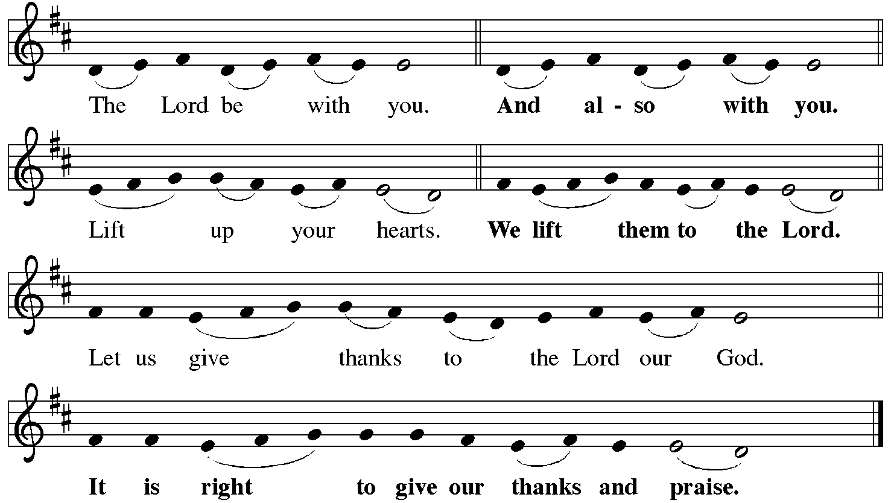

P It is indeed right, our duty and our joy… with the church on earth and the hosts of heaven, we praise your name and join their unending hymn:
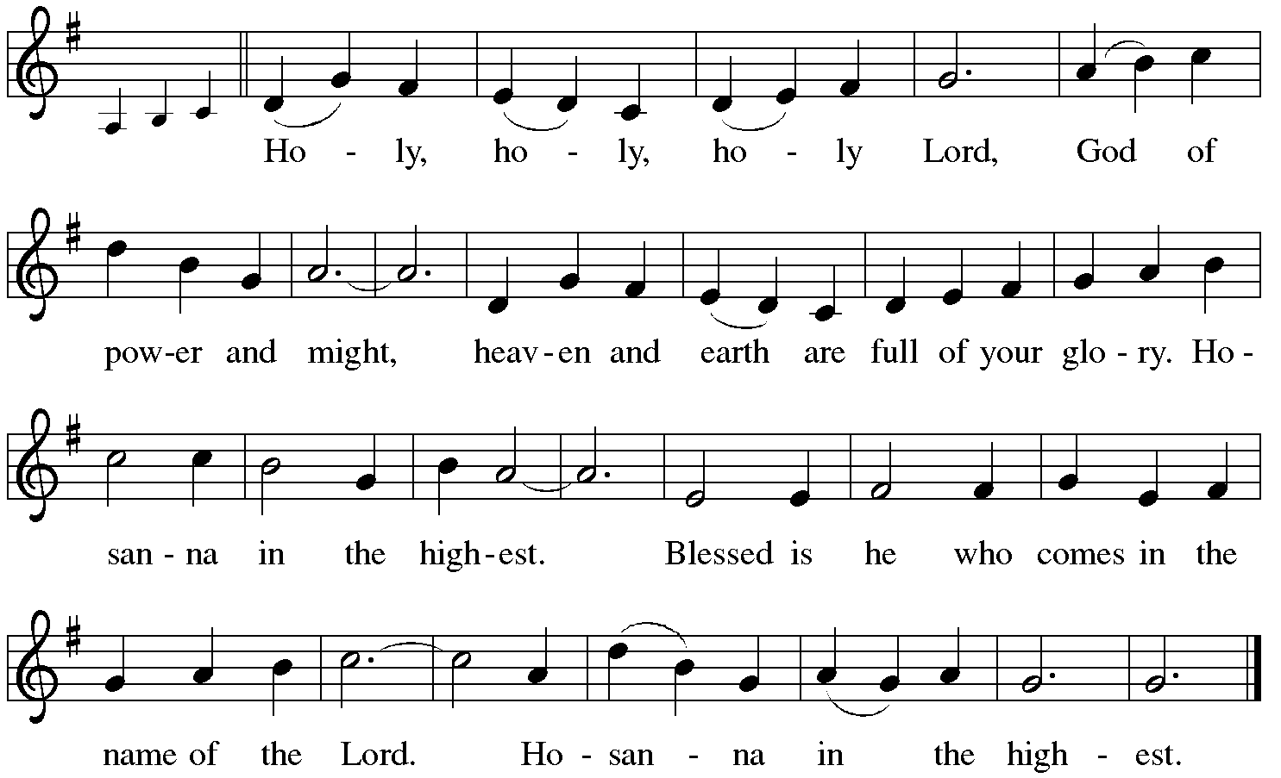

*Eucharistic Prayer/Words of Institution
In the night in which he was betrayed, our Lord Jesus took bread, and gave thanks; broke it, and gave it to his disciples, saying: Take and eat; this is my body, given for you. Do this for the remembrance of me.
Again, after supper, he took the cup, gave thanks, and gave it for all to drink, saying: This cup is the new covenant in my blood, shed for you and for all people for the forgiveness of sin. Do this for the remembrance of me.
For as often as we eat of this bread and drink from this cup,
we proclaim the Lord’s death until he comes.
Christ has died.
Christ is risen.
Christ will come again….
to share with us the great and promised feast.
Amen. Come, Lord Jesus….
and receive our inheritance with all your saints in light.
Amen. Come, Holy Spirit.

C The Lord's Prayer

Our Father, who art in heaven, hallowed be thy name,
thy kingdom come, thy will be done, on earth as it is in heaven.
Give us this day our daily bread; and forgive us our trespasses,
as we forgive those who trespass against us;
and lead us not into temptation, but deliver us from evil.
For thine is the kingdom, and the power, and the glory,
forever and ever. Amen

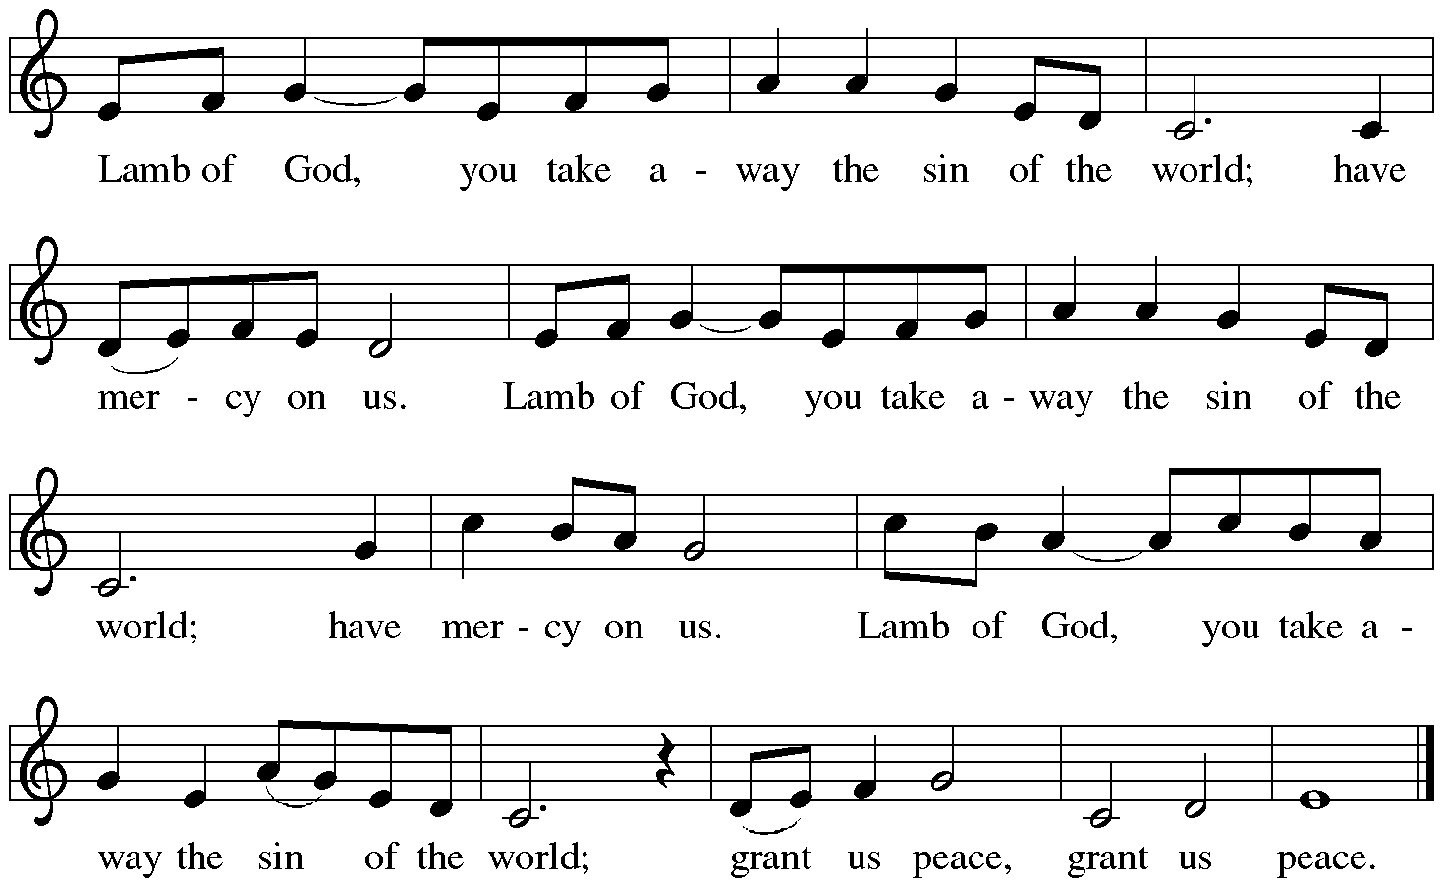

Communion Distribution

Communion Hymn: “I Received the Living God” Red Book #477
Text: Anonymous
Music: LIVING GOD, Anonymous
Reprinted under OneLicense.net#A-711151

Communion Prayer

Announcements

Blessing
P The Lord bless you and keep you.
The Lord make his face shine on you and be gracious to you.
The Lord look upon you with favor and + give you peace.
In the name of the Father, and of the Son and of the Holy Spirit.
C Amen

Hymn: “Up from the Grave He Arose” Back #12
Text: Robert Lowry, 1826-1899
Music: CHRIST AROSE, Robert Lowry, 1826-1899 Public Domain

Dismissal
A Go in peace. Serve the Lord.
C Thanks be to God!
Postlude
Liturgy and texts from Sundays and Seasons.com. Copyright 2022 Augsburg Fortress. All rights reserved.
Reprinted by permission under Augsburg Fortress Liturgies Annual License #23628.

