May 1, 2022
Biblical Reparations
Welcome, Welcome, Welcome
“Living and Loving Like Jesus”
Living and loving like Jesus is only possible if Jesus is abiding in us and us in Him!!!
“It cannot be too strongly emphasized that the Christian life is a Christ-life. It is not an imitation, but an incarnation. We do not copy Christ, we reproduce Him; or, rather He reproduces His own life within us by the indwelling of the Holy Spirit.” G. Pardington Page 323
It has been said, “You do not get more of the Holy Spirit, but He gets more of you”
Biblical Reparation 2 Samuel 21:1-6;14
“During the reign of David, there was a famine for three successive years; so David sought the face of the Lord. The Lord said, "It is on account of Saul and his blood-stained house; it is because he put the Gibeonites to death."
FYI- The Gibeonites deceived the Israelites, yet it seems as though God held the Israelites to their promise. Wow!!! (Joshua 9)
The king summoned the Gibeonites and spoke to them. (Now the Gibeonites were not a part of Israel but were survivors of the Amorites; the Israelites had sworn to [spare] them, but Saul in his zeal for Israel and Judah had tried to annihilate them.) David asked the Gibeonites, "What shall I do for you? How shall I make amends so that you will bless the Lord's inheritance?" The Gibeonites answered him, "We have no right to demand silver or gold from Saul or his family, nor do we have the right to put anyone in Israel to death. ‘What do you want me to do for you?’ David asked. They answered the king, ‘As for the man who destroyed us and plotted against us so that we have been decimated and have no place anywhere in Israel, let seven of his male descendants be given to us to be killed and exposed before the Lord at Gibeah of Saul — the Lord's chosen one.’’” 2 Sam 21:1-6;
“They buried the bones of Saul and his son Jonathan in the tomb of Saul's father Kish, at Zela in Benjamin, and did everything the king commanded. After that, God answered prayer in behalf of the land.” 2 Samuel 12:14
Jeff’s Opinion- Biblical Reparation Is NOT what is being suggested by our current politicians!

Biblical Reparation is not politically based-Biblical Reparation is God Centered
God allowed the Famine-Not about Politics or Finances
God led & God directed
Does God require/use Reparations at times? YES
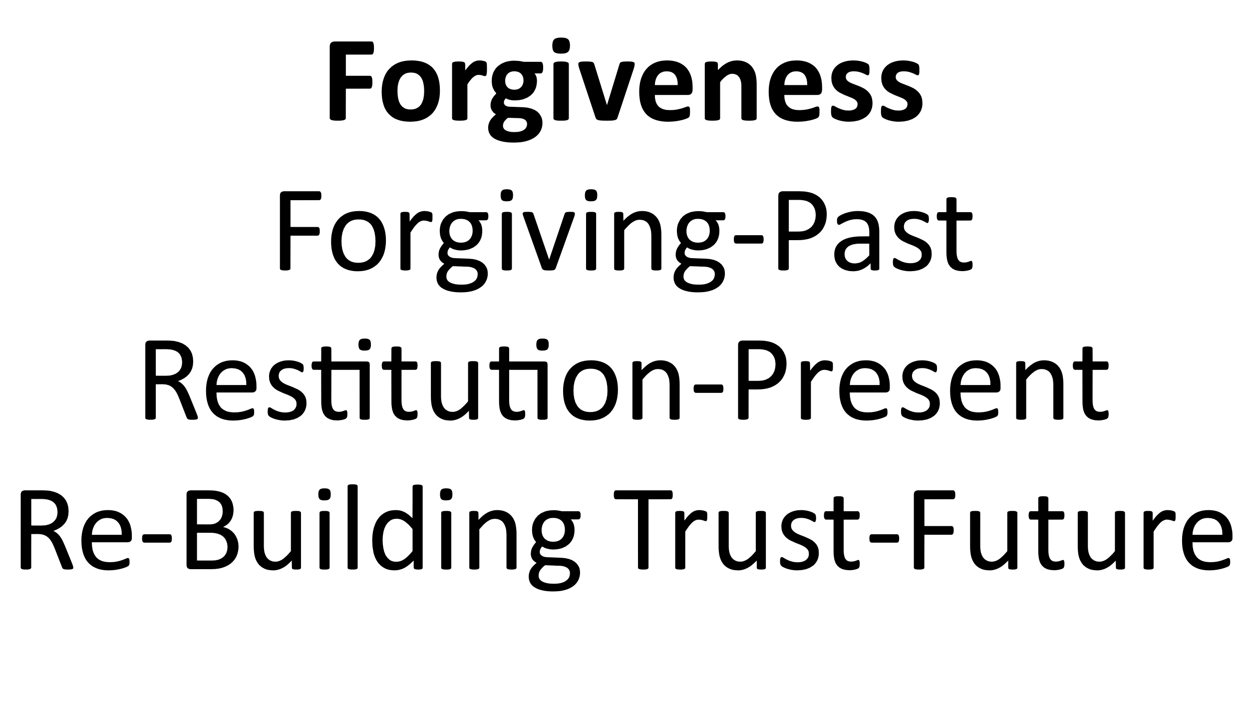
God is the author of Biblical Reparation
Prayer
Remembering through Communion

Table Talk (Discussion Points)
Please Consider Sharing:
What are your thoughts related to the G. Pardington quote? What are the key differences between imitation and incarnation?
In your own words, please describe Biblical Reparations.
How does this Biblical story illustrate the importance of keeping a promise even when a person(s) was deceived into making the promise (The Gibeonites deceived the Israelites, Joshua Chapter 9)?
What are your thoughts on the three tenses of forgiveness?
Who do you know that is close to you and far from God? How can you demonstrate Jesus’s Love to them this week?
What the Holy Spirit impressed upon you personally during our time together.

