SPN Senior Club Fundraiser

“Everything’s Coming Up Gift Cards”
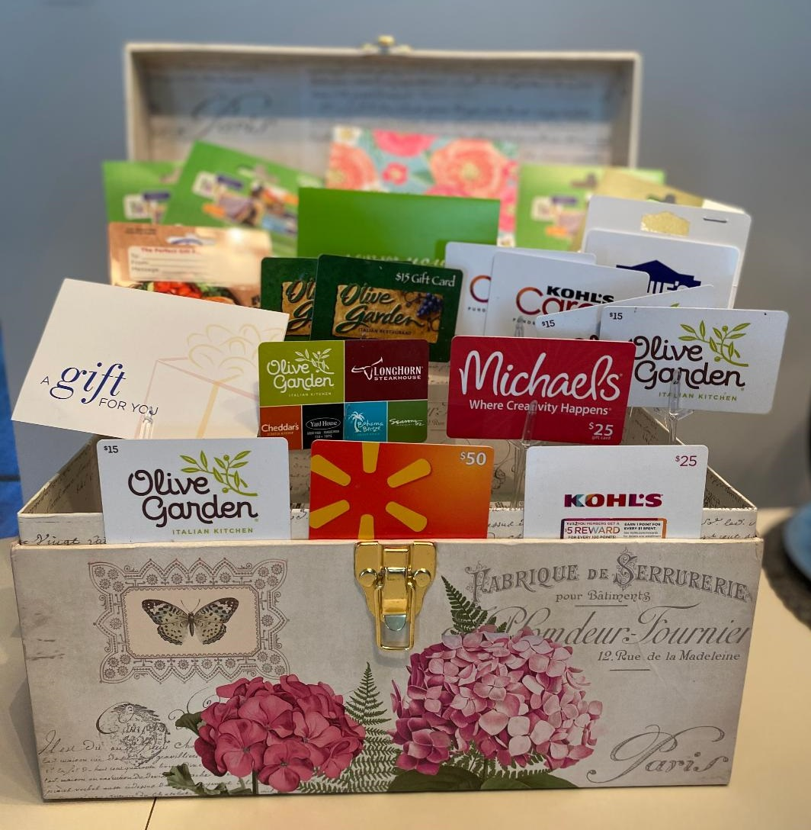
$500.00 in Gift Cards:
$75.00 Boscov’s $75.00 Olive Garden
$75.00 Kohl’s $50.00 Black Sea Jewelers
$50.00 Walmart $25.00 Valley Café
$25.00 Multi Restaurant $25.00 Michael’s
$25.00 Panera Bread $25.00 Lowe’s
$25.00 Redners $25.00 Visa

Chances are $2.00 each OR 3 for $5.00

Tickets can be purchased after each Mass beginning April 30 thru May 22; Bingo (May 1); and the Parish breakfast (May 8)

The Winner will be announced at the Senior Club Luncheon on May 24, 2022

Winner need not be present to win

