Faith Evangelical Lutheran Church, Washington, IL
Second Sunday of Easter
April 24, 2022

Welcome
Thanksgiving for Baptism

Alleluia! Christ is risen.
Christ is risen indeed. Alleluia!
You may make the sign of the cross as a reminder of your baptism.
In the waters of baptism,
we have passed over from death to life with Jesus Christ,
and we are a new creation.
For this saving mystery, and for this water, let us bless God,
who was, who is, and who is to come.
We pour water in the font as we give thanks for our Baptism
We thank you, God, for your river of life,
flowing freely from your throne: through the earth, through the city,
through every living thing.
You rescued Noah and his family from the flood;
You opened wide the sea for the Israelites.
Now in these waters you flood us with mercy, and our sin is drowned forever.
You open the gate of righteousness and we pass safely through.
In Jesus Christ, you calm and trouble the waters.
You nourish us and enclose us in safety. You call us forth and send us out.
In lush and barren places, you are with us. You have become our salvation.
Now breathe upon this water and awaken your church once more.
Claim us again as your beloved and holy people.
Quench our thirst; cleanse our hearts; wipe away every tear.
To you, our Beginning and our End, our Shepherd and Lamb,
be honor, glory, praise, and thanksgiving, now and forever.
Amen.
Faith Lutheran Church
2206 Washington Rd,
Washington, IL 61571
Website and online worship:
www.shareourfaith.org
Church: 309-745-9306
faithlth@shareourfaith.org
Pastor John Rothfusz
Home: 309-745-9282
pastor@shareourfaith.org

Peace: As forgiven children of God, we have peace
with God, and peace with one another.
P The peace of the Lord be with you always.
C And also with you.
P Let us share that peace with one another.
*Hymn: “Christ the Lord Is Risen Today; Alleluia” Red Book #369

Text: attr. Wipo of Burgundy, d. c. 1050; tr. Jane E. Leeson, 1807-1882, alt.
Music: LLANFAIR, Robert Williams, 1781-1821

P The grace of our Lord Jesus Christ, the love of God,
and the communion of the Holy Spirit be with you all.
C And also with you.

Hymn of Praise
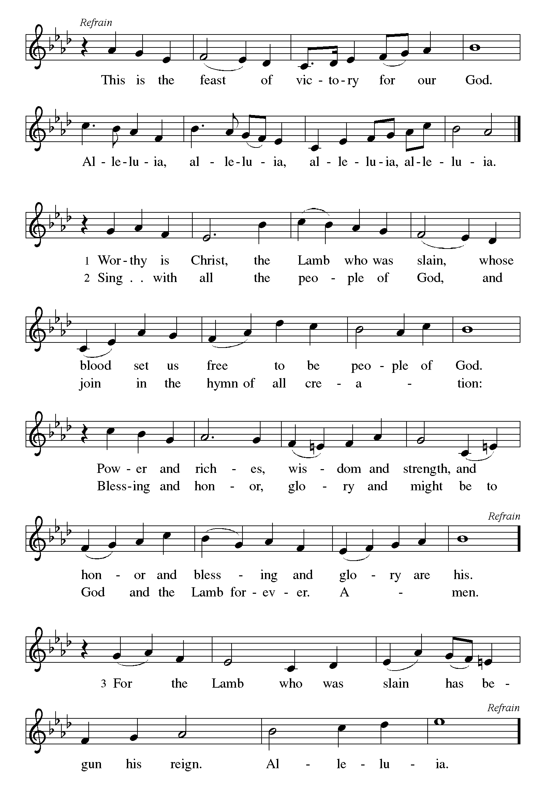

P The Lord be with you
C And also with you.
Let us pray together the Prayer of the Day
O God of life, you reach out to us amid our fears with the wounded hands of your risen Son. By your Spirit’s breath revive our faith in your mercy, and strengthen us to be the body of your Son, Jesus Christ, our Savior and Lord, who lives and reigns with you and the Holy Spirit, one God, now and forever.
Amen.

Children’s Message
First Reading: Acts 5:27-32 Pew Bible Page #885
²⁷When they had brought [the apostles,] they had them stand before the council. The high priest questioned them, ²⁸saying, “We gave you strict orders not to teach in this name, yet here you have filled Jerusalem with your teaching and you are determined to bring this man’s blood on us.” ²⁹But Peter and the apostles answered, “We must obey God rather than any human authority. ³⁰The God of our ancestors raised up Jesus, whom you had killed by hanging him on a tree. ³¹God exalted him at his right hand as Leader and Savior that he might give repentance to Israel and forgiveness of sins. ³²And we are witnesses to these things, and so is the Holy Spirit whom God has given to those who obey him.”

R The Word of the Lord
C Thanks be to God

Psalm 150 We sing the psalm in unison with Psalm Tone 4

Let everything that has breath praise the Lord. (Ps. 150:6)

¹Hallelujah! Praise God in the | holy temple;
praise God in the | mighty firmament.
²Praise God for | mighty acts;
praise God for ex- | ceeding greatness.
³Praise God with | trumpet sound;
praise God with | lyre and harp.
⁴Praise God with tambou- | rine and dance;
praise God with | strings and pipe.
⁵Praise God with re- | sounding cymbals;
praise God with loud | clanging cymbals.
⁶Let everything | that has breath
praise the Lord. | Hallelujah!

Second Reading: Revelation 1:4-8 Pew Bible Page #1001
⁴John to the seven churches that are in Asia:
Grace to you and peace from him who is and who was and who is to come, and from the seven spirits who are before his throne, ⁵and from Jesus Christ, the faithful witness, the firstborn of the dead, and the ruler of the kings of the earth.
To him who loves us and freed us from our sins by his blood, ⁶and made us to be a kingdom, priests serving his God and Father, to him be glory and dominion forever and ever. Amen.
⁷Look! He is coming with the clouds;
every eye will see him,
even those who pierced him;
and on his account all the tribes of the earth will wail.
So it is to be. Amen.
⁸“I am the Alpha and the Omega,” says the Lord God, who is and who was and who is to come, the Almighty.

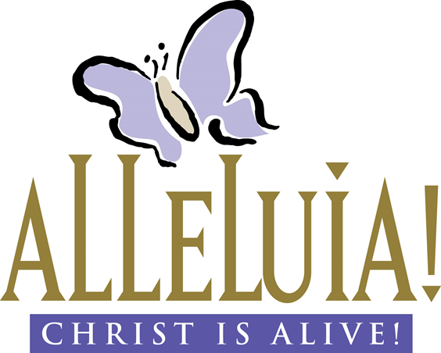
R The Word of the Lord
C Thanks be to God

Gospel Reading: John 20:19-31 Pew Bible Page #879

C Glory to you, O Lord
¹⁹When it was evening on that day, the first day of the week, and the doors of the house where the disciples had met were locked for fear of the Jews, Jesus came and stood among them and said, “Peace be with you.” ²⁰After he said this, he showed them his hands and his side. Then the disciples rejoiced when they saw the Lord. ²¹Jesus said to them again, “Peace be with you. As the Father has sent me, so I send you.” ²²When he had said this, he breathed on them and said to them, “Receive the Holy Spirit. ²³If you forgive the sins of any, they are forgiven them; if you retain the sins of any, they are retained.”
²⁴But Thomas (who was called the Twin), one of the twelve, was not with them when Jesus came. ²⁵So the other disciples told him, “We have seen the Lord.” But he said to them, “Unless I see the mark of the nails in his hands, and put my finger in the mark of the nails and my hand in his side, I will not believe.”
²⁶A week later his disciples were again in the house, and Thomas was with them. Although the doors were shut, Jesus came and stood among them and said, “Peace be with you.” ²⁷Then he said to Thomas, “Put your finger here and see my hands. Reach out your hand and put it in my side. Do not doubt but believe.” ²⁸Thomas answered him, “My Lord and my God!” ²⁹Jesus said to him, “Have you believed because you have seen me? Blessed are those who have not seen and yet have come to believe.”
³⁰Now Jesus did many other signs in the presence of his disciples, which are not written in this book. ³¹But these are written so that you may come to believe that Jesus is the Messiah, the Son of God, and that through believing you may have life in his name.

The Gospel of the Lord
C Praise to you, O Christ

Synod Staff Sermon by Pastor Ken Sandlin, Assistant to the Bishop

Sermon Hymn: “We Walk by Faith” Red Book #635

Text: Henry Alford, 1810-1871, alt.
Music: SHANTI, Marty Haugen, b. 1950
Music © 1984 GIA Publications, Inc., 7404 S. mason Ave., Chicago, IL 60638. www.giamusic.com. 800.442.3358. All rights reserved. Used by permission. Reprinted under OneLicense.net#A-711151

Apostles’ Creed
C: I believe in God, the Father almighty,
creator of heaven and earth.
I believe in Jesus Christ, God's only Son, our Lord,
who was conceived by the Holy Spirit,
born of the virgin Mary,
suffered under Pontius Pilate,
was crucified, died, and was buried;
he descended to the dead.
On the third day he rose again;
he ascended into heaven,
he is seated at the right hand of the Father,
and he will come to judge the living and the dead.

I believe in the Holy Spirit,
the holy catholic church, the communion of saints,
the forgiveness of sins, the resurrection of the body,
and the life everlasting. Amen.

Prayers: After each portion of the prayers finishes with “Lord in your mercy,” please respond, “Hear our prayer.”

Offering: Jesus is risen and fills us with new life and hope. Let us offer ourselves to the Lord and joyfully lift our tithes and offerings to the Lord.

Please take a moment now to make an electronic offering to the church on the website, with the Tithe.ly app on your phone, or drop and envelope in the plate at communion time.
Faith Lutheran website link www.shareourfaith.org

Offering Prayer

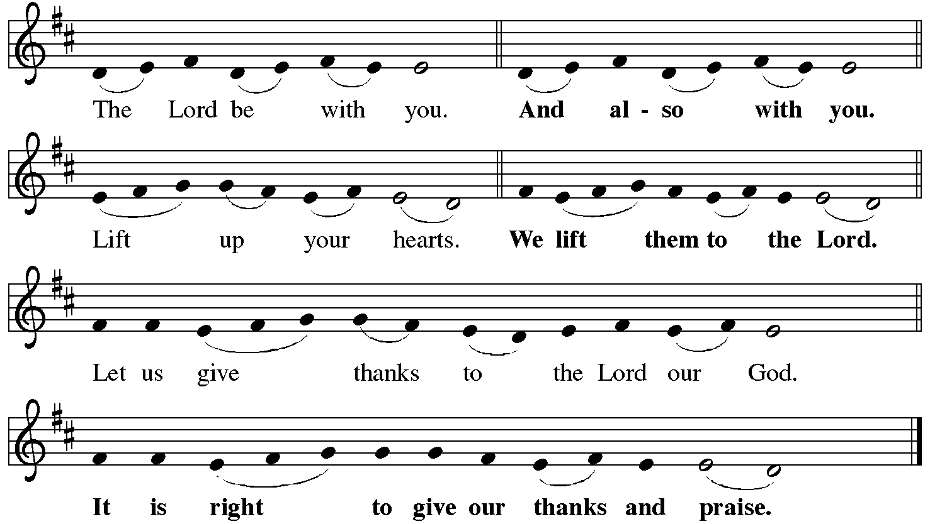

P It is indeed right, our duty and our joy… with the church on earth and the hosts of heaven, we praise your name and join their unending hymn:
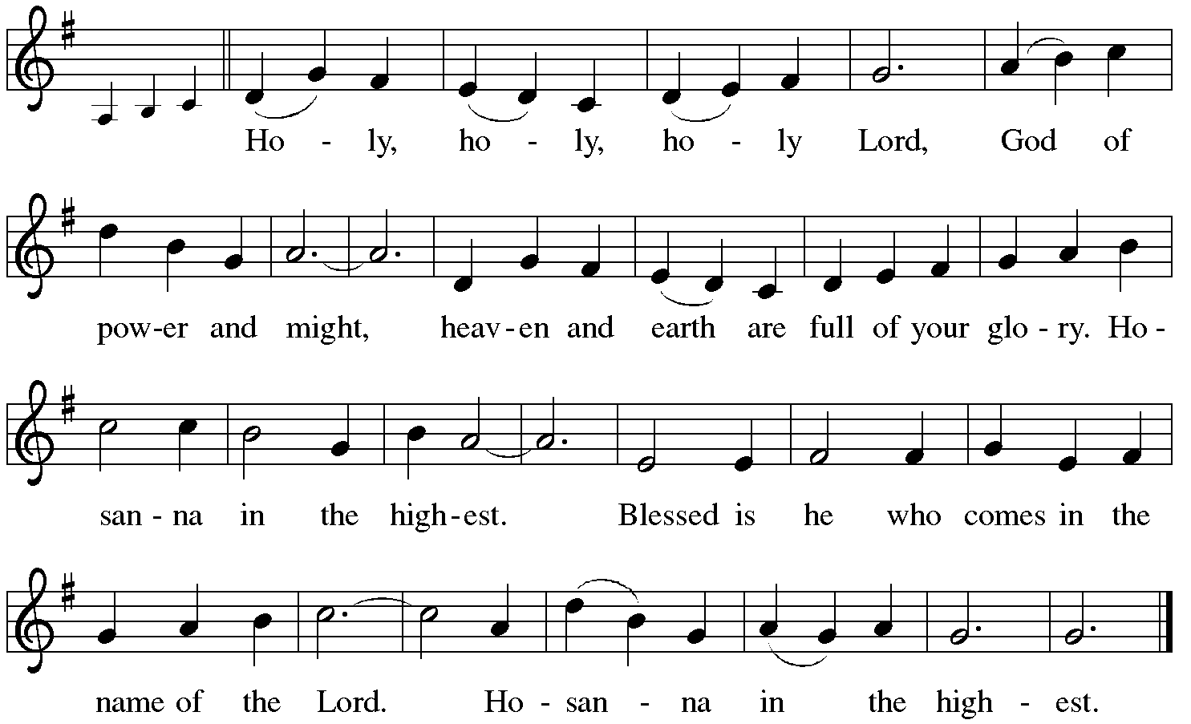

*Eucharistic Prayer/Words of Institution
In the night in which he was betrayed, our Lord Jesus took bread, and gave thanks; broke it, and gave it to his disciples, saying: Take and eat; this is my body, given for you. Do this for the remembrance of me.
Again, after supper, he took the cup, gave thanks, and gave it for all to drink, saying: This cup is the new covenant in my blood, shed for you and for all people for the forgiveness of sin. Do this for the remembrance of me.
For as often as we eat of this bread and drink from this cup,
we proclaim the Lord’s death until he comes.
Christ has died.
Christ is risen.
Christ will come again….
to share with us the great and promised feast.
Amen. Come, Lord Jesus….
and receive our inheritance with all your saints in light.
Amen. Come, Holy Spirit.

C The Lord's Prayer
Our Father, who art in heaven, hallowed be thy name,
thy kingdom come, thy will be done, on earth as it is in heaven.
Give us this day our daily bread; and forgive us our trespasses,
as we forgive those who trespass against us;
and lead us not into temptation, but deliver us from evil.
For thine is the kingdom, and the power, and the glory,
forever and ever. Amen
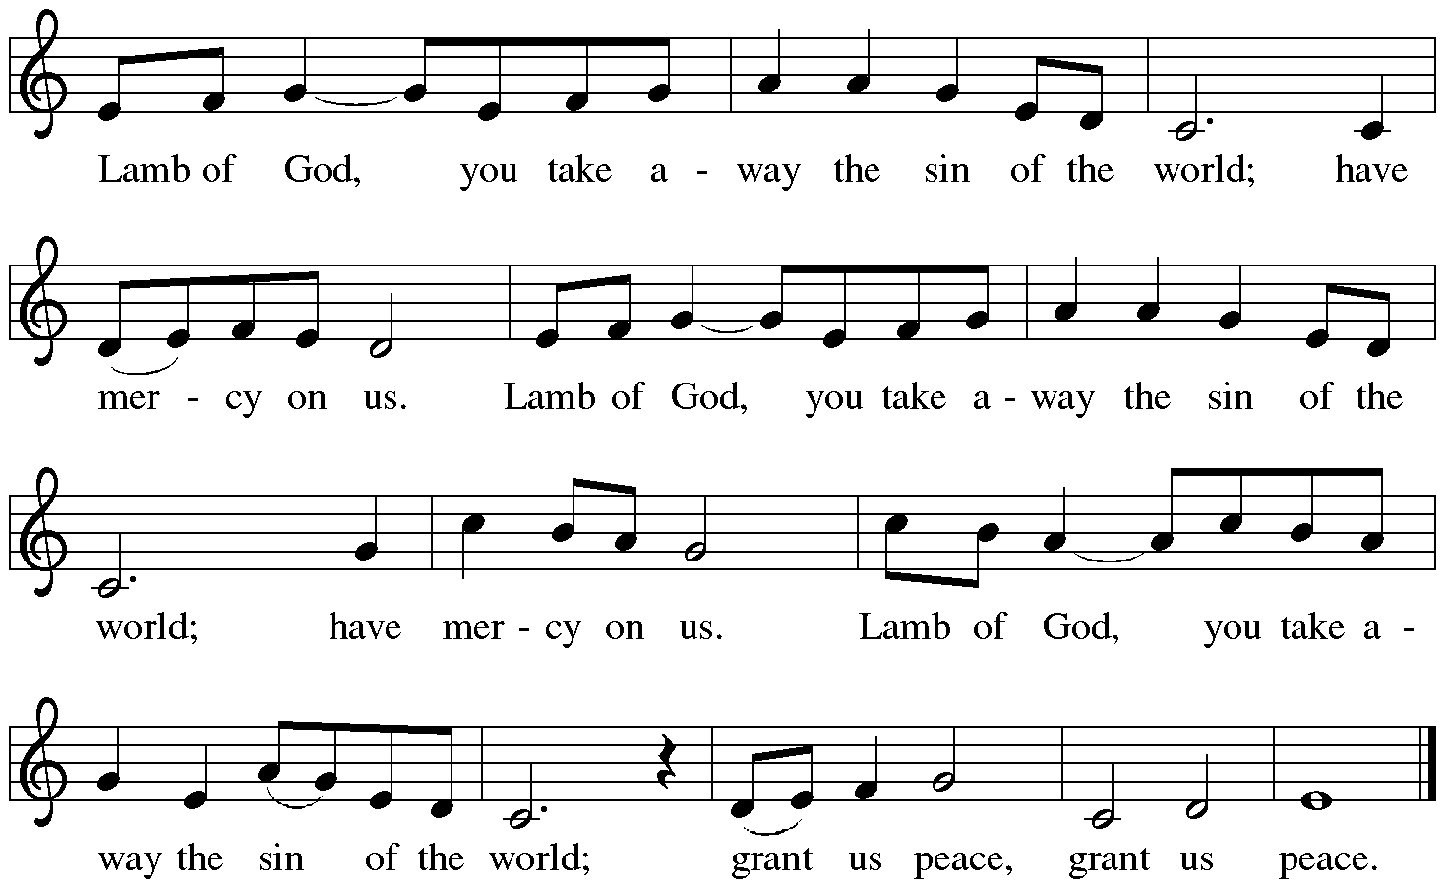

Communion Distribution

Communion Hymn: “One Bread, One Body” Red Book #496

Text: John Eoley, sȷ, b. 1939
Music: ONE BREAD, ONE BODY, John Foley sȷ
Text and music © 1978 John B. Voley, SJ and OCP Publications, 5536 NE Hassalo, Portland, OR 97213. All rights reserved. Used by permission. Reprinted under OneLicense.net#A-711151

Communion Prayer

Announcements

Blessing
P The Lord bless you and keep you.
The Lord make his face shine on you and be gracious to you.
The Lord look upon you with favor and + give you peace.
In the name of the Father, and of the Son and of the Holy Spirit.
C Amen

Hymn: “Alleluia, Alleluia, Give Thanks” Blue Book #671

Text: Donald Fishel, b. 1950
Music: ALLELUIA NO. 1, Donald Fishel, b. 1950
Text and music © 1973 Word of God Music, admin. The Copyright Company. All rights reserved. International © secured. Reprinted under OneLicense.net#A-711151

Dismissal

A Go in peace. Serve the Lord.
C Thanks be to God!
Postlude
Liturgy and texts from Sundays and Seasons.com. Copyright 2022 Augsburg Fortress. All rights reserved.
Reprinted by permission under Augsburg Fortress Liturgies Annual License #23628.

