Calling all singers and wannabe singers
If you like to sing and have been missing it during the pandemic, why not come to St. Cuthbert’s first ever choir camp!

What:

We will be running a week long day camp, for young people 8-18 years of age. Along with the usual day camp activities such as crafts, games, field trips etc., all participants will be in the choir that will be training towards leading the whole Sunday service on July 24, with hymns, anthems and liturgy. We will be learning new music with a guest conductor, who will teach some great church music and make you sound wonderful. We will also encourage individual interests in singing, playing instruments, dancing, etc. for a Friday evening talent show.

Who: Youth – Ages 8-18
All ages will be part of the mass choir. Older teens will be an important part of the choir and can also choose to practise their leadership skills, helping out with activities for younger kids. We encourage all present choir members to come and also those who would like to sing in a choir but have not yet had an opportunity. This is your chance!

Who: Adults – 18 and up
Choir members, parents, and other interested singers are invited to two evening workshops and Saturday morning rehearsal to join in the Sunday Service

Where:
St. Cuthbert’s Anglican Church
11602 – 82nd Ave.
Delta, BC
604-594-8822

Cost:
Children and youth: $100 for the week
Adults: $35 for the week

When:
Youth: Monday – Friday, July 18-24: 9am -5pm
Adults: Tues. July. 19 and Thurs, July 21; 7pm -9pm
All: Friday July 22, 7-9pm Talent Show
All: Saturday July 23: 10:00 – 12:00 followed by a wiener roast or barbecue.
All: Sunday July 24: 9:00am: All sing the Sunday morning service.
Events
Monday to Friday – youth activities
Tuesday evening – Adult workshop and rehearsal
Thursday afternoon – special activity
Thursday evening - Adult workshop and rehearsal
Friday night - Talent show
Saturday – Choir practice for adults and kids
Hot dog roast or barbecue
Sunday – Mass choir leads 10:00 am service.
More information and registration forms are available on the St. Cuthbert webpage: https://www.stcuthbert.ca/events/st-cuthbert-choir-camp/2022-07-18.

Email registration forms to info@stcuthbert.ca, with “Choir camp” in the subject line. if you have questions, call the church office at 604-594-8822.
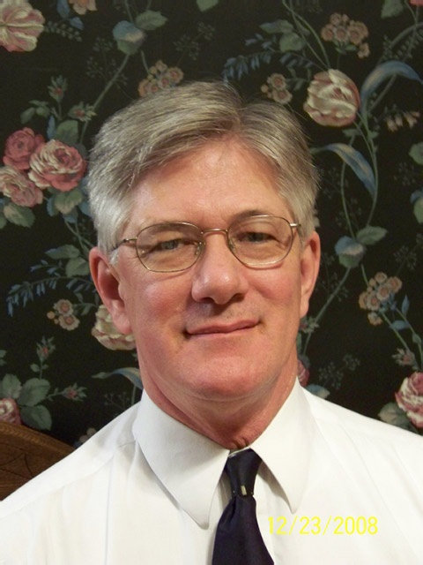
Guest conductor - Murray C. Walker
Murray C. Walker has been the Director of Music at Calvary Episcopal Church, Santa Cruz, California since 1996. A native of Vancouver, British Columbia, Mr. Walker holds music degrees in choral conducting from the University of British Columbia, Vancouver and California State University, Long Beach. He is retired from a forty-year career as a music educator, most recently at the York School in Monterey. His singing career has included the Vancouver Chamber Choir and the choirs of (the former) St. Paul’s Cathedral of Los Angeles, Christ Church Cathedral in Vancouver, Christ Church Cathedral in Montreal and Norwich Cathedral in England. He served as conductor of the Santa Cruz County Youth Symphony from 1988-1993.

St. Cuthbert’s Church
Invites you to
CHOIR CAMP

July 18 – 24, 2022
Sing together
Play together
Learn together
Worship together

