**Maundy Thursday Worship**



## Faith Evangelical Lutheran Church

## 2206 Washington Road

Washington, IL 61571

April 14, 2022

Announcements

Hymn: “Chief of Sinners Though I Be” Red Book #609

Maundy Instruction

P Friends in Christ, in this Lenten season we have heard our Lord's call to struggle against sin, death, and the devil--all that keeps us from loving God and each other. This is the struggle to which we were called at baptism.

Within the community of the church, God never wearies of forgiving sin and giving the peace of reconciliation. In the words of absolution we receive forgiveness as from God himself. We should not doubt this absolution, but firmly believe that in those words our sins are forgiven before God in heaven, for it comes to us in the name and by the command of our Lord Jesus. On this night let us confess our sin against God and our neighbor, and enter the Easter celebration reconciled with God and with one another.

*Confession and Forgiveness

P Let us make our confession to God.

*Silence for reflection and self-examination.*

P Almighty God, merciful Father:

C **I, a troubled and penitent sinner, confess to you all my sins and iniquities with which I have offended you and for which I justly deserve your punishment. But I am sorry for them, and repent of them, and pray for your boundless mercy.**

**For the sake of the suffering and death of your Son, Jesus Christ,**

**be gracious and merciful to me, a poor sinful being;**

**forgive my sins, give me your Holy Spirit for the amendment of my sinful life, and bring me to life everlasting. Amen**

P Almighty God in his mercy has given his Son to die for us and, for his sake, forgives us all our sins. Through his Holy Spirit he cleanses us

and gives us power to proclaim the mighty deeds of God who called us out of darkness into the splendor of his light. As a called and ordained minister of the Church of Christ and by his authority,

I therefore declare to you the entire forgiveness of all your sins,

in the name of the Father, and of the + Son, and of the Holy Spirit.

C **Amen**

Individual Absolution – Declaration of Forgiveness  
*All who wish to come forward to receive an individual absolution may form a line and kneel before the altar along the communion rail. Pastor John will lay his hands on your head and offer God’s own forgiveness with these words: “*In obedience to the command of our Lord Jesus Christ, I forgive you all of your sins. May Almighty God strengthen you in all goodness, and bring you to everlasting life.” *After a moment of reflection, you may return to your seat.*

*Peace: As people forgiven in Christ we have peace with God, and peace with one another. With a word and a touch we can share that peace. May the peace of the Lord be with you always.

**C And also with you.**

P Let us share that peace with one another.

(Greet one another saying “Peace be with you”)

*Let us pray together the Prayer of the Day

Eternal God, **in the sharing of a meal your Son established a new covenant for all people, and in the washing of feet he showed us the dignity of service. Grant that by the power of your Holy Spirit these signs of our life in faith may speak again to our hearts, feed our spirits, and refresh our bodies, through Jesus Christ, our Savior and Lord, who lives and reigns with you and the Holy Spirit, one God, now and forever. Amen.**

First Lesson: Exodus 12:1-14

The LORD said to Moses and Aaron in the land of Egypt: 2This month shall mark for you the beginning of months; it shall be the first month of the year for you. 3Tell the whole congregation of Israel that on the tenth of this month they are to take a lamb for each family, a lamb for each household. 4If a household is too small for a whole lamb, it shall join its closest neighbor in obtaining one; the lamb shall be divided in proportion to the number of people who eat of it. 5Your lamb shall be without blemish, a year-old male; you may take it from the sheep or from the goats. 6You shall keep it until the fourteenth day of this month; then the whole assembled congregation of Israel shall slaughter it at twilight. 7They shall take some of the blood and put it on the two doorposts and the lintel of the houses in which they eat it. 8They shall eat the lamb that same night; they shall eat it roasted over the fire with unleavened bread and bitter herbs. 9Do not eat any of it raw or boiled in water, but roasted over the fire, with its head, legs, and inner organs.

10You shall let none of it remain until the morning; anything that remains until the morning you shall burn. 11This is how you shall eat it: your loins girded, your sandals on your feet, and your staff in your hand; and you shall eat it hurriedly. It is the Passover of the LORD. 12For I will pass through the land of Egypt that night, and I will strike down every firstborn in the land of Egypt, both human beings and animals; on all the gods of Egypt I will execute judgments: I am the LORD. 13The blood shall be a sign for you on the houses where you live: when I see the blood, I will pass over you, and no plague shall destroy you when I strike the land of Egypt.

14This day shall be a day of remembrance for you. You shall celebrate it as a festival to the LORD; throughout your generations you shall observe it as a perpetual ordinance.

The Word of the Lord **C Thanks be to God**

Second Lesson: I Corinthians 11:23-26

For I received from the Lord what I also handed on to you, that the Lord Jesus on the night when he was betrayed took a loaf of bread, 24and when he had given thanks, he broke it and said, "This is my body that is for you. Do this in remembrance of me." 25In the same way he took the cup also, after supper, saying, "This cup is the new covenant in my blood. Do this, as often as you drink it, in remembrance of me." 26For as often as you eat this bread and drink the cup, you proclaim the Lord's death until he comes.

The Word of the Lord **C Thanks be to God**

Sermon by Pastor John Rothfusz

Hymn: “Around You, O Lord Jesus” Red Book # 468

Prayers: After each portion of the prayers finishes with “Lord in your mercy,” please respond, **“Hear our prayer.”**

Offering: In the Lord’s Supper, Jesus gives his own life for you when he offers his body and blood for your salvation. His gift washes you clean from your sins, and unites you in Jesus’ death and resurrection. As a sign of our gratitude for his matchless gift, let us gather our tithes and offerings to the Lord.

P God of glory, **receive these gifts and the offering of our lives. As Jesus offered himself for all people, draw us to serve in the midst of this world, that all creation may be brought from bondage to freedom, from darkness to light, and from death to life; through Jesus Christ our Lord. Amen**

Great Thanksgiving

P The Lord be with you.

**C And also with you.**

P Lift up your hearts.

**C We lift them to the Lord.**

P Let us give thanks to the Lord our God.

**C It is right to give God thanks and praise.**

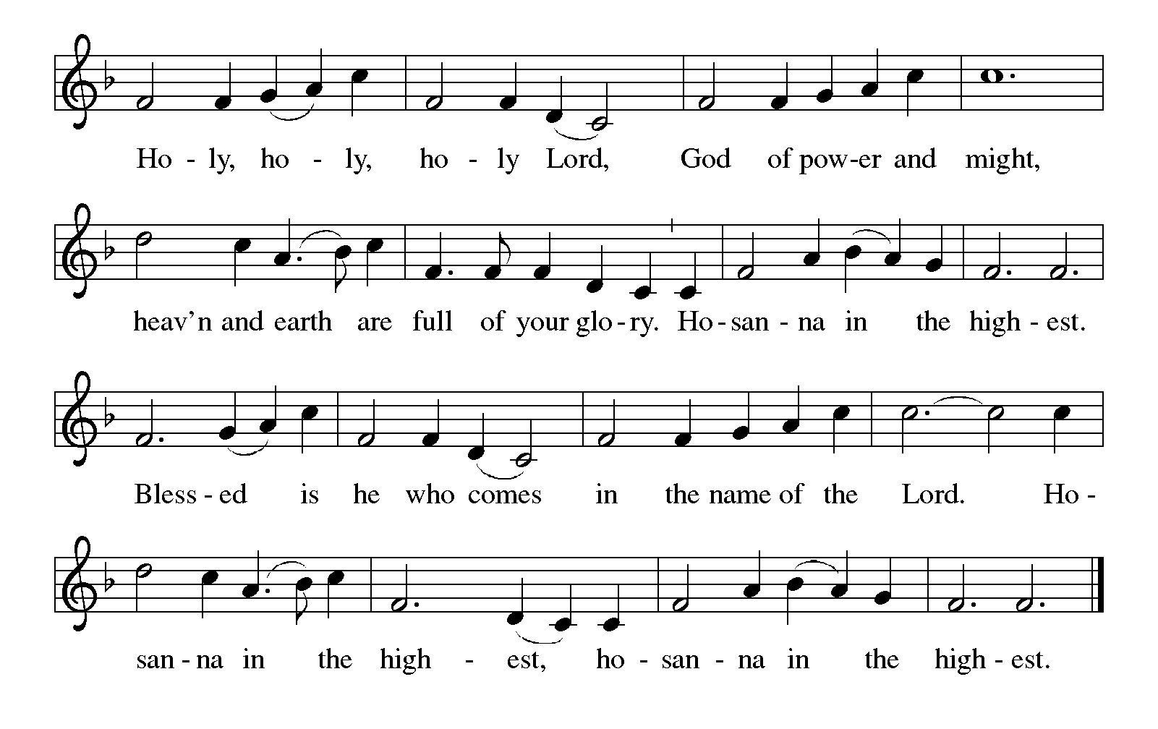P It is indeed right, our duty and our joy… with the church on earth and the hosts of heaven, we praise your name and join their unending hymn:

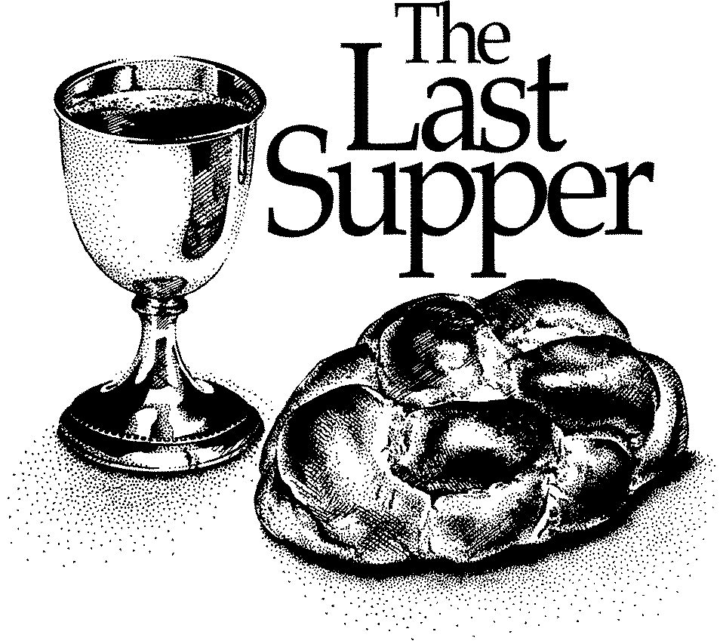

P In the night in which he was betrayed, our Lord Jesus took bread, and gave thanks; broke it, and gave it to his disciples, saying:

Take and eat; this is my body, given for you.

Do this for the remembrance of me.

Again, after supper, he took the cup, gave thanks, and gave it for all to drink, saying: This cup is the new covenant in my blood, shed for you and for all people for the forgiveness of sin.

Do this for the remembrance of me.

The Lord’s Prayer

C **Our Father, who art in heaven, hallowed be thy name,**

**thy kingdom come, thy will be done, on earth as it is in heaven.**

**Give us this day our daily bread; and forgive us our trespasses,**

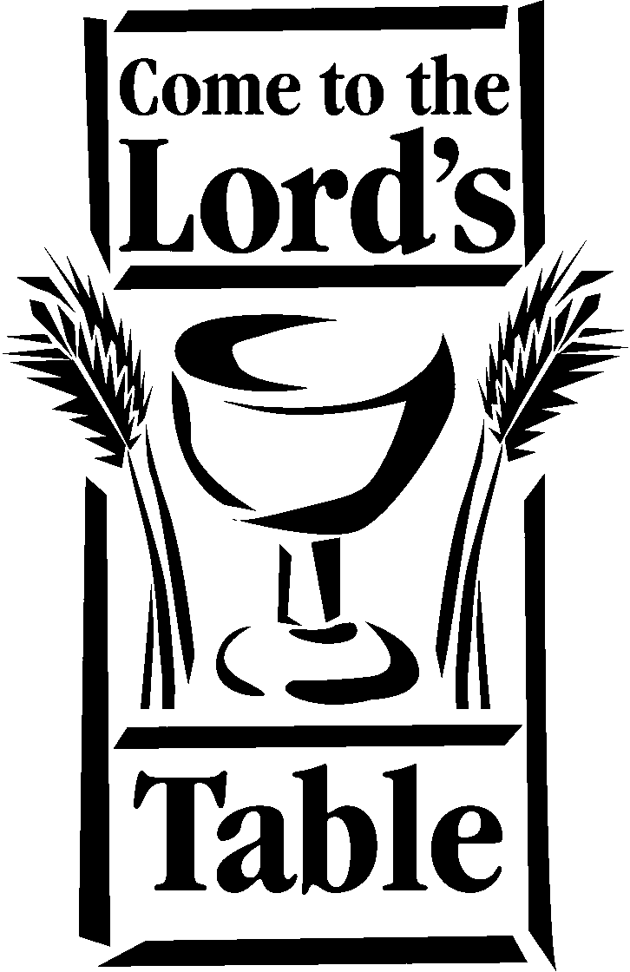**as we forgive those who trespass against us;**

**and lead us not into temptation, but deliver us from evil.**

**For thine is the kingdom, and the power, and the glory,**

**forever and ever. Amen**

P This is the food and drink of salvation:

Let all who hunger for grace come and eat.

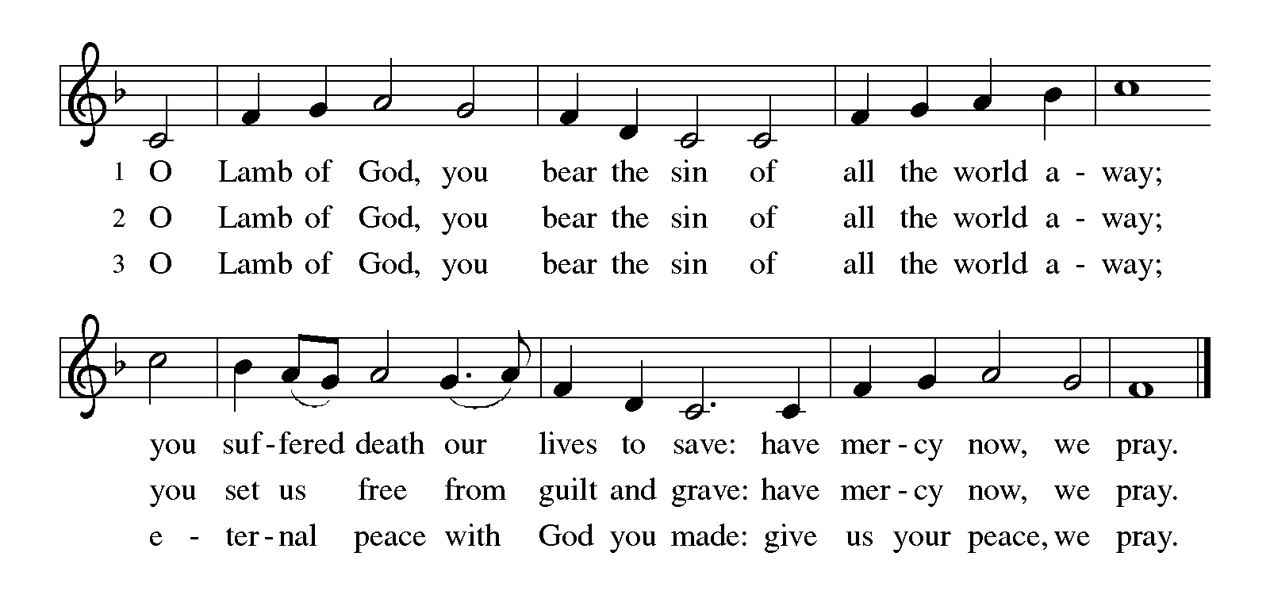Let all who thirst for salvation take the cup.

Distribution of the Lord’s Supper

Communion Hymns

Red Book # 481 “Come to the Table”

Red Book # 360 “Love Consecrates the Humblest Act”

Red Book # 337 “Alas! And Did my Savior Bleed

*Post-Communion Blessing

P Lord God, in a wonderful sacrament you have left us a memorial of your suffering and death. May this sacrament of your body and blood

so work in us that the way we live will proclaim the redemption you have brought; for you live and reign with the Father and the Holy Spirit,

one God, now and forever.

C **Amen**

Stripping of the Altar (Congregation reads Psalm 22 in unison as the altar is stripped. These are words that Jesus likely spoke from the cross.)

**1 My God, my God, why have you forsaken me**

**and are so far from my cry, and from the words of my distress?**

**2 O my God, I cry in the daytime, but you do not answer;**

**by night as well, but I find no rest.**

**3 Yet you are the Holy One,**

**enthroned upon the praises of Israel.**

**4 Our forefathers put their trust in you;**

**they trusted, and you delivered them.**

**5 They cried out to you and were delivered;**

**they trusted in you and were not put to shame.**

**6 But as for me, I am a worm and no man,**

**scorned by all and despised by the people.**

**7 All who see me laugh me to scorn;**

**they curl their lips and wag their heads, saying,**

**8 "He trusted in the Lord; let him deliver him;**

**let him rescue him, if he delights in him."**

**9 Yet you are he who took me out of the womb,**

**and kept me safe upon my mother's breast.**

**10 I have been entrusted to you ever since I was born;**

**you were my God when I was still in my mother's womb.**

**11 Be not far from me, for trouble is near,**

**and there is none to help.**

**12 Many young bulls encircle me;**

**strong bulls of Bashan surround me.**

**13 They open wide their jaws at me,**

**like a ravening and a roaring lion.**

**14 I am poured out like water; all my bones are out of joint;**

**my heart within my breast is melting wax.**

**15 My mouth is dried out like a pot-sherd;**

**my tongue sticks to the roof of my mouth;**

**and you have laid me in the dust of the grave.**

**16 Packs of dogs close me in, and gangs of evildoers circle around me; they pierce my hands and my feet, I can count all my bones.**

**17 They stare and gloat over me; they divide my garments among them; they cast lots for my clothing.**

**18 Be not far away, O Lord;**

**you are my strength; hasten to help me.**

**19 Save me from the sword, my life from the power of the dog.**

**20 Save me from the lion's mouth,**

**my wretched body from the horns of wild bulls.**

**21 I will declare your name to my brethren;**

**in the midst of the congregation I will praise you.**

**22 Praise the Lord, you that fear him; stand in awe of him, O offspring of Israel; all you of Jacob's line, give glory.**

**23 For he does not despise nor abhor the poor in their poverty;**

**neither does he hide his face from them;**

**but when they cry to him he hears them.**

**24 My praise is of him in the great assembly; I will perform my vows in the presence of those who worship him.**

**25 The poor shall eat and be satisfied, and those who seek the Lord shall praise him: "May your heart live forever!"**

**26 All the ends of the earth shall remember and turn to the Lord,**

**and all the families of the nations shall bow before him.**

**27 For kingship belongs to the Lord; he rules over the nations.**

**28 To him alone all who sleep in the earth bow down in worship;**

**all who go down to the dust fall before him.**

**29 My soul shall live for him; my descendants shall serve him;**

**they shall be known as the Lord's forever.**

**30 They shall come and make known to a people yet unborn**

**the saving deeds that he has done.**

**•All Leave the Church in Silence •**



**Worship Notes**:

1. On this day we hear God’s “absolution” or forgiveness for all the sins we confess. Jesus is going to the cross for our sins, bearing their cost and showering us with his love and forgiveness.
2. Maundy -- is an English form of “mandamus,” the Latin word for commandment. The overarching theme for the day is Jesus’ new commandment to “love one another...” Jesus’ love for us is sharply focused by the contrast of his betrayal by Judas after he takes on the role of servant, washing the disciples’ feet, and gives himself for all of us in the Lord’s Supper.
3. Stripping the Altar --This act makes the transition from the celebration of the Lord’s Supper to Jesus’ crucifixion and death. It is symbolic of Jesus’ humiliation at the hands of the soldiers.
4. Silent Dismissal -- There is no benediction on this day. We leave with the words of Psalm 22 that Jesus spoke from the cross. All are asked to leave the church in *silence*, as we contemplate the death of our Lord.

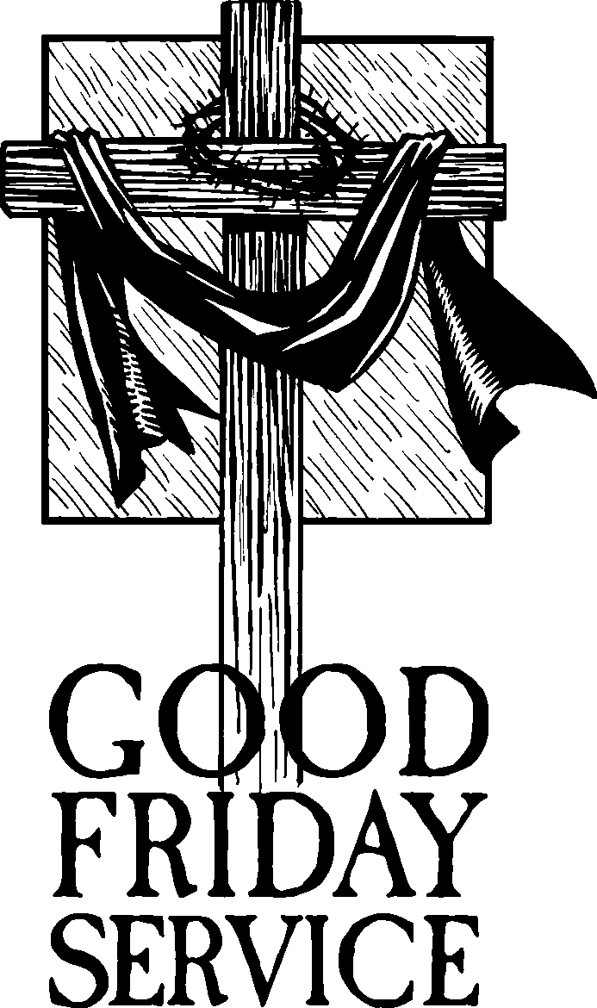**ANNOUNCEMENTS**

**Please join us tomorrow night** at 7 p.m. for our Good Friday Tenebrae Service. We will focus on the great gift that our Lord gives us as he goes to the cross to suffer and die for our sins. As we read the Gospel accounts of the crucifixion and sing Lenten hymns, we will slowly extinguish the lights and descend into darkness as our Lord descends into death.

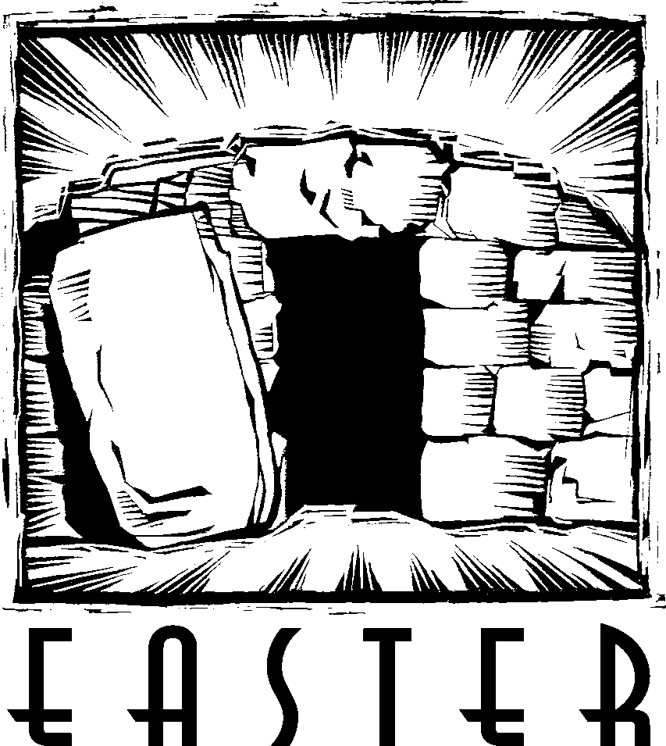There will be no 5 p.m. Saturday Service as we prepare for Easter Sunday Morning.

**We will Arise** on Easter Morning for our Easter Services at 9 a.m. At 10 a.m., the we will serve an Easter Breakfast followed by an Easter Egg Hunt. Please join us to celebrate the resurrection of our Lord who makes all things new.

**HOLY WEEK SCHEDULE**

***MAUNDY THURSDAY:***

7 p.m. Worship with Holy Communion

***GOOD FRIDAY:***

7 p.m. Good Friday Tenebrae Service

***EASTER MORNING:***

9 a.m. Easter Worship with Holy Communion

10 a.m. Easter Breakfast followed by an Easter Egg Hunt

From Sundays and Seasons.com. Copyright 2022 Augsburg Fortress. All rights reserved.

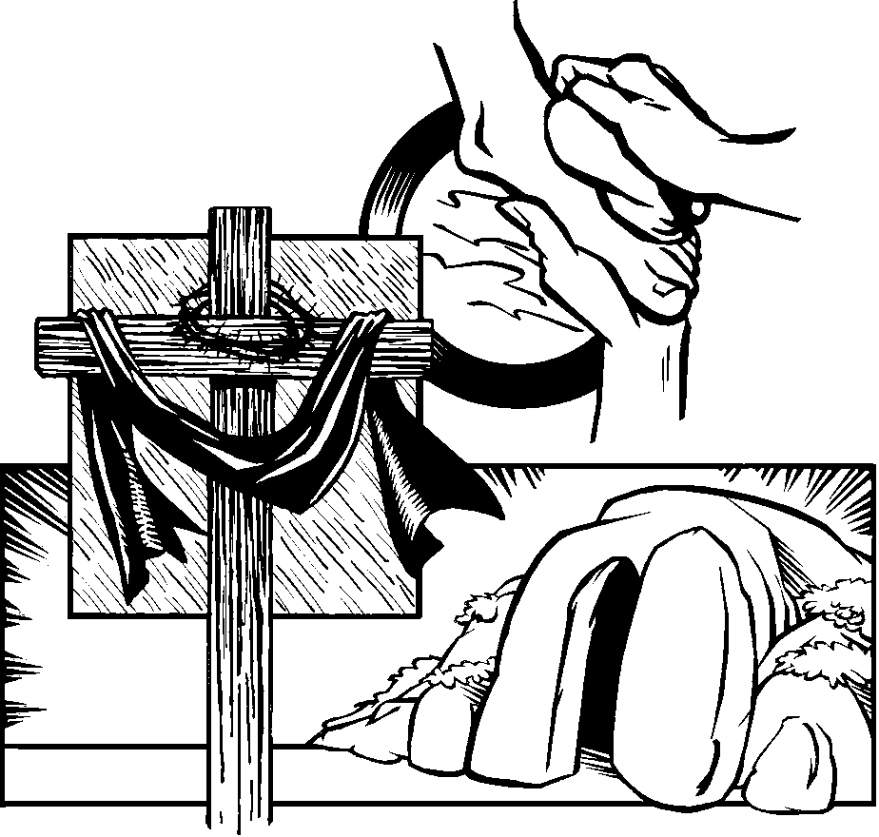Reprinted by permission under Augsburg Fortress Liturgies Annual License #23628.