““Woman, why are you weeping?”

“I have seen the Lord”

Easter Celebration Worship
9 a.m.
April 17, 2022

Faith Evangelical Lutheran Church
2206 Washington Road
Washington, IL 61571
www.shareourfaith.org
(309) 745-9306

Prelude

*Easter Proclamation:

P Alleluia! Christ is risen!
C Christ is risen indeed. Alleluia!

*Hymn: “Jesus Christ is Risen Today” Red Book #365
Public Domain

P The grace of our risen Savior, the love of God,
and the communion of the Holy Spirit be with you all.
C And also with you.
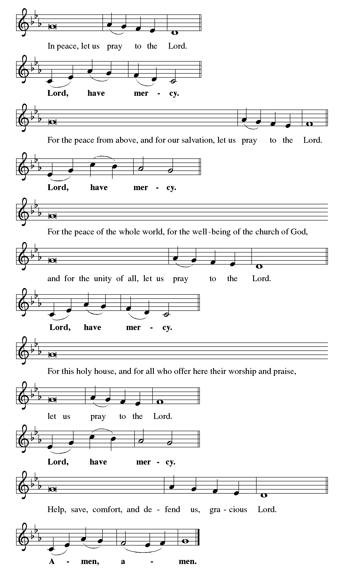

Faith Lutheran Church
2206 Washington Rd,
Washington, IL 61571
Website and online worship:
www.shareourfaith.org
Church: 309-745-9306
faithlth@shareourfaith.org
Pastor John Rothfusz
Home: 309-745-9282
pastor@shareourfaith.org

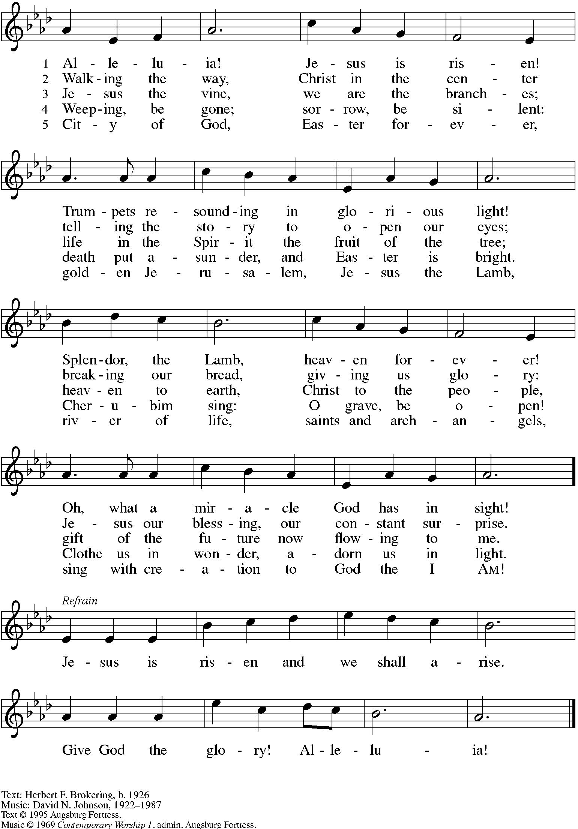
Hymn of Praise: “Alleluia! Jesus is Risen” Red Book #377
All rights reserved. Used by permission. Reprinted under OneLicense.net #A-711151
P The Lord be with you
C And also with you.

Let us pray together the Prayer of the Day
O God, you gave your only Son to suffer death on the cross for our redemption, and by his glorious resurrection you delivered us from the power of death. Make us die every day to sin, so that we may live with him forever in the joy of the resurrection; through Jesus Christ our Lord, who lives and reigns with you and the Holy Spirit, one God, now and forever. Amen

Children’s Message

First Reading: Acts 10:34-43
³⁴Then Peter began to speak to them: "I truly understand that God shows no partiality, ³⁵but in every nation anyone who fears him and does what is right is acceptable to him. ³⁶You know the message he sent to the people of Israel, preaching peace by Jesus Christ — he is Lord of all. ³⁷That message spread throughout Judea, beginning in Galilee after the baptism that John announced: ³⁸how God anointed Jesus of Nazareth with the Holy Spirit and with power; how he went about doing good and healing all who were oppressed by the devil, for God was with him. ³⁹We are witnesses to all that he did both in Judea and in Jerusalem. They put him to death by hanging him on a tree; ⁴⁰but God raised him on the third day and allowed him to appear, ⁴¹not to all the people but to us who were chosen by God as witnesses, and who ate and drank with him after he rose from the dead. ⁴²He commanded us to preach to the people and to testify that he is the one ordained by God as judge of the living and the dead. ⁴³All the prophets testify about him that everyone who believes in him receives forgiveness of sins through his name.".
R The Word of the Lord C Thanks be to God
Psalm 118:1–2, 14–24 Sing Psalm tone in unison (Tone 4 ELW)
¹Give thanks to the Lord, for | he is good;
his mercy en- | dures forever.
²Let Israel | now proclaim,
“His mercy en- | dures forever.”
¹⁴The Lord is my strength | and my song,
and he has become | my salvation.
¹⁵There is a sound of exulta- | tion and victory
in the tents | of the righteous:
¹⁶“The right hand of the | Lord has triumphed!
The right hand of the Lord is exalted!
The right hand of the | Lord has triumphed!”
¹⁷I shall not | die, but live,
and declare the works | of the Lord.
¹⁸The Lord has pun- | ished me sorely,
but he did not hand me o- | ver to death.
¹⁹Open for me the | gates of righteousness;
I will enter them; I will offer thanks | to the Lord.
²⁰“This is the gate | of the Lord;
he who is right- | eous may enter.”
²¹I will give thanks to you, for you | answered me
and have become | my salvation.
²²The same stone which the build- | ers rejected
has become the chief | cornerstone.
²³This is | the Lord’s doing,
and it is marvelous | in our eyes.
²⁴On this day the | Lord has acted;
we will rejoice and be | glad in it.
Second Reading: 1 Corinthians 15:19-26
¹⁹If for this life only we have hoped in Christ, we are of all people most to be pitied.
²⁰But in fact Christ has been raised from the dead, the first fruits of those who have died. ²¹For since death came through a human being, the resurrection of the dead has also come through a human being; ²²for as all die in Adam, so all will be made alive in Christ. ²³But each in his own order: Christ the first fruits, then at his coming those who belong to Christ.
²⁴Then comes the end, when he hands over the kingdom to God the Father, after he has destroyed every ruler and every authority and power.
²⁵For he must reign until he has put all his enemies under his feet. ²⁶The last enemy to be destroyed is death.
R The Word of the Lord C Thanks be to God
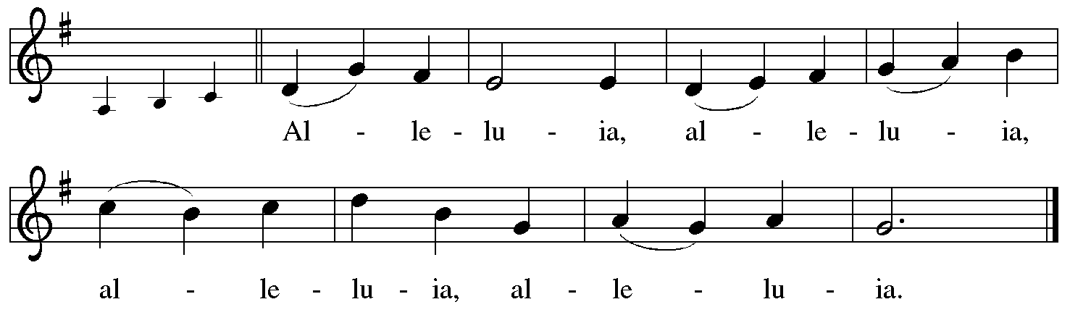
Holy Gospel: John 20:1-18
C Glory to you, O Lord
¹Early on the first day of the week, while it was still dark, Mary Magdalene came to the tomb and saw that the stone had been removed from the tomb. ²So she ran and went to Simon Peter and the other disciple, the one whom Jesus loved, and said to them, “They have taken the Lord out of the tomb, and we do not know where they have laid him.” ³Then Peter and the other disciple set out and went toward the tomb. ⁴The two were running together, but the other disciple outran Peter and reached the tomb first. ⁵He bent down to look in and saw the linen wrappings lying there, but he did not go in. ⁶Then Simon Peter came, following him, and went into the tomb. He saw the linen wrappings lying there, ⁷and the cloth that had been on Jesus’ head, not lying with the linen wrappings but rolled up in a place by itself. ⁸Then the other disciple, who reached the tomb first, also went in, and he saw and believed; ⁹for as yet they did not understand the scripture, that he must rise from the dead. ¹⁰Then the disciples returned to their homes.
¹¹But Mary stood weeping outside the tomb. As she wept, she bent over to look into the tomb; ¹²and she saw two angels in white, sitting where the body of Jesus had been lying, one at the head and the other at the feet. ¹³They said to her, “Woman, why are you weeping?” She said to them, “They have taken away my Lord, and I do not know where they have laid him.” ¹⁴When she had said this, she turned around and saw Jesus standing there, but she did not know that it was Jesus. ¹⁵Jesus said to her, “Woman, why are you weeping? Whom are you looking for?” Supposing him to be the gardener, she said to him, “Sir, if you have carried him away, tell me where you have laid him, and I will take him away.” ¹⁶Jesus said to her, “Mary!” She turned and said to him in Hebrew, “Rabbouni!” (which means Teacher). ¹⁷Jesus said to her, “Do not hold on to me, because I have not yet ascended to the Father. But go to my brothers and say to them, ‘I am ascending to my Father and your Father, to my God and your God.’ ” ¹⁸Mary Magdalene went and announced to the disciples, “I have seen the Lord”; and she told them that he had said these things to her.
P The Gospel of the Lord
C Praise to you, O Christ

Easter Sermon by Pastor John Rothfusz
Hymn: “Thine Is The Glory” Red Bk # 376
Public Domain

Apostles’ Creed
C: I believe in God, the Father almighty,
creator of heaven and earth.
I believe in Jesus Christ, God's only Son, our Lord,
who was conceived by the Holy Spirit,
born of the virgin Mary,
suffered under Pontius Pilate,
was crucified, died, and was buried;

he descended to the dead.*
On the third day he rose again;
he ascended into heaven,
he is seated at the right hand of the Father,
and he will come to judge the living and the dead.
I believe in the Holy Spirit,
the holy catholic church, the communion of saints,
the forgiveness of sins, the resurrection of the body,
and the life everlasting. Amen.
*Or, "he descended into hell," another translation of this text in widespread use.

Prayers: After each portion of the prayers finishes with “Lord in your mercy,” please respond, “Hear our prayer.”
Peace:
P The peace of the risen Lord be with you always.
C And also with you.
P Let us share that peace with one another.
Faith Lutheran website link www.shareourfaith.org
(Greet one another saying “Peace be with you”)

Offering: Jesus is Risen! With his new life, our lives are new forever after. Let us share our joy as we lift up our tithes and offerings to the Lord. Please take a moment now to make an electronic offering to the church on the website, with the Tithe.ly app on your phone, or write a check and drop it in the plate at communion time.

Offering Prayer
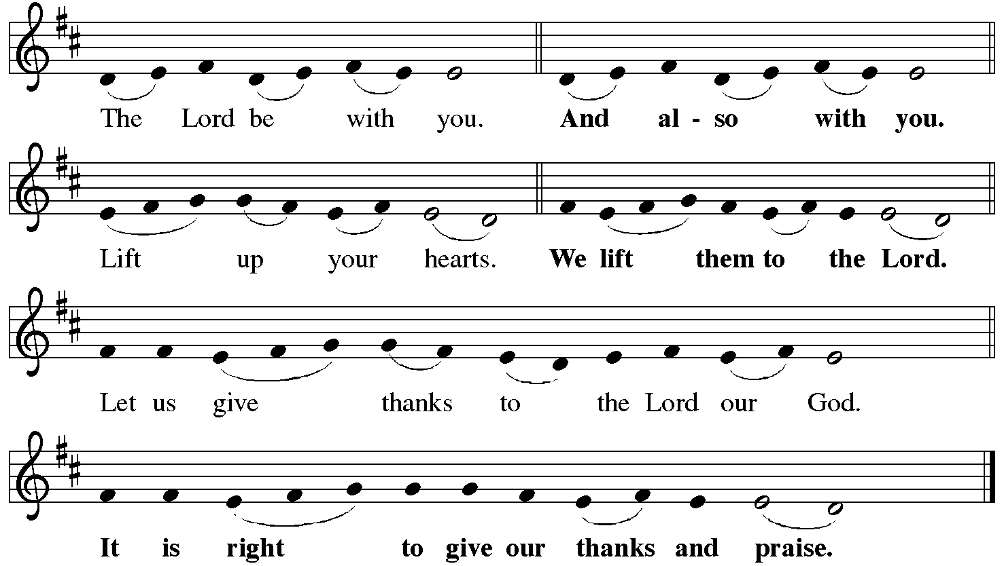
P It is indeed right, our duty and our joy… with the church on earth and the hosts of heaven, we praise your name and join their unending hymn:

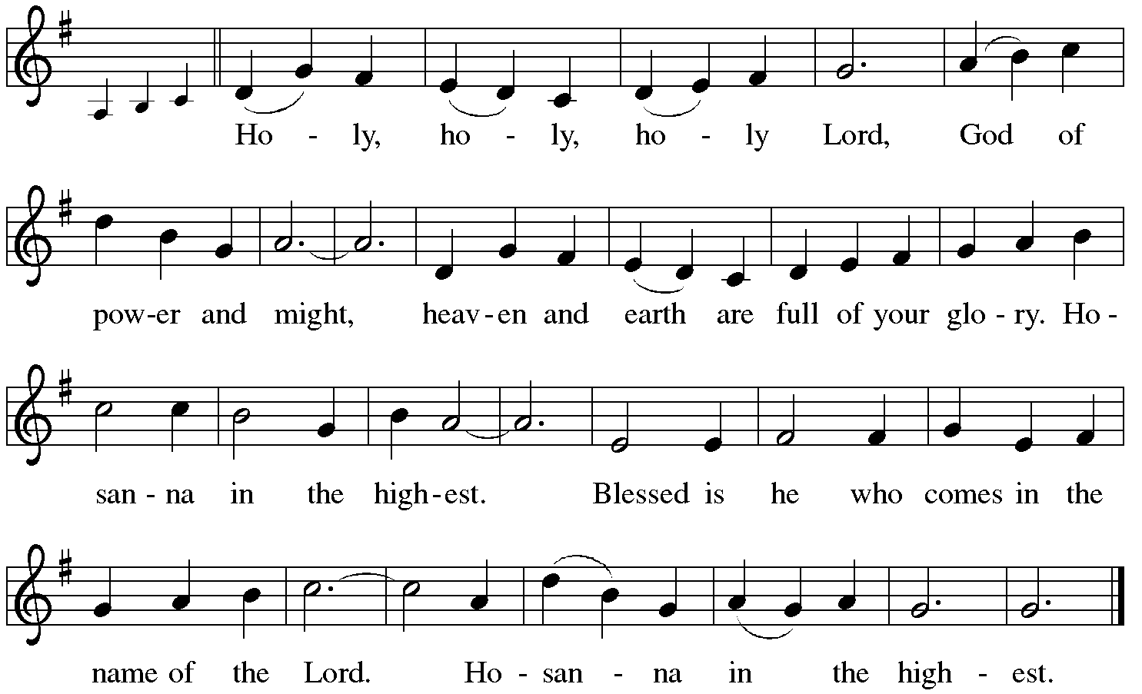

*Eucharistic Prayer/Words of Institution
In the night in which he was betrayed, our Lord Jesus took bread, and gave thanks; broke it, and gave it to his disciples, saying: Take and eat; this is my body, given for you. Do this for the remembrance of me.
Again, after supper, he took the cup, gave thanks, and gave it for all to drink, saying: This cup is the new covenant in my blood, shed for you and for all people for the forgiveness of sin. Do this for the remembrance of me.
For as often as we eat of this bread and drink from this cup,
we proclaim the Lord’s death until he comes.
Christ has died.
Christ is risen.
Christ will come again….
to share with us the great and promised feast.
Amen. Come, Lord Jesus….
and receive our inheritance with all your saints in light.
Amen. Come, Holy Spirit.

The Lord’s Prayer
Our Father, who art in heaven, hallowed be thy name,
thy kingdom come, thy will be done, on earth as it is in heaven.
Give us this day our daily bread; and forgive us our trespasses,
as we forgive those who trespass against us;
and lead us not into temptation, but deliver us from evil.
For thine is the kingdom, and the power, and the glory,
forever and ever. Amen

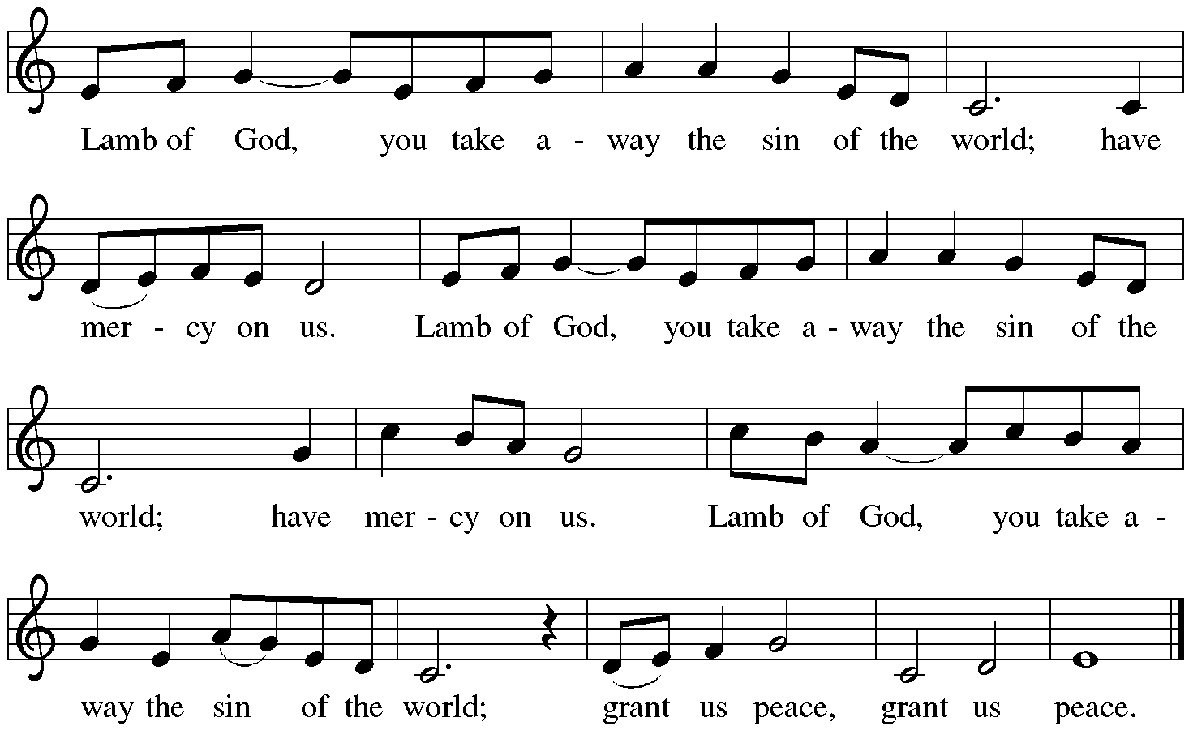

Communion Distribution
Red Book Hymns:
836 Joyful, Joyful, We Adore Thee
886 Oh, for a Thousand Tongues to Sing
434 Jesus Shall Reign
858 Praise to the Lord, the Almighty
Post Communion Blessing
Post Communion Prayer: Eternal God, through baptism into the death and resurrection of Christ you welcome us to this table and nourish us with the food and drink of the promised land. Now send us forth into the world, that we may be witnesses to your glory made known to us in Jesus Christ, our risen Lord.
C Amen

Announcements
*Blessing
P Alleluia! Christ is risen.
C Christ is risen indeed. Alleluia!
Almighty God, Father, + Son, and Holy Spirit
bless you and raise you to newness of life, now and forever.
C Amen

Up From the Grave He Arose
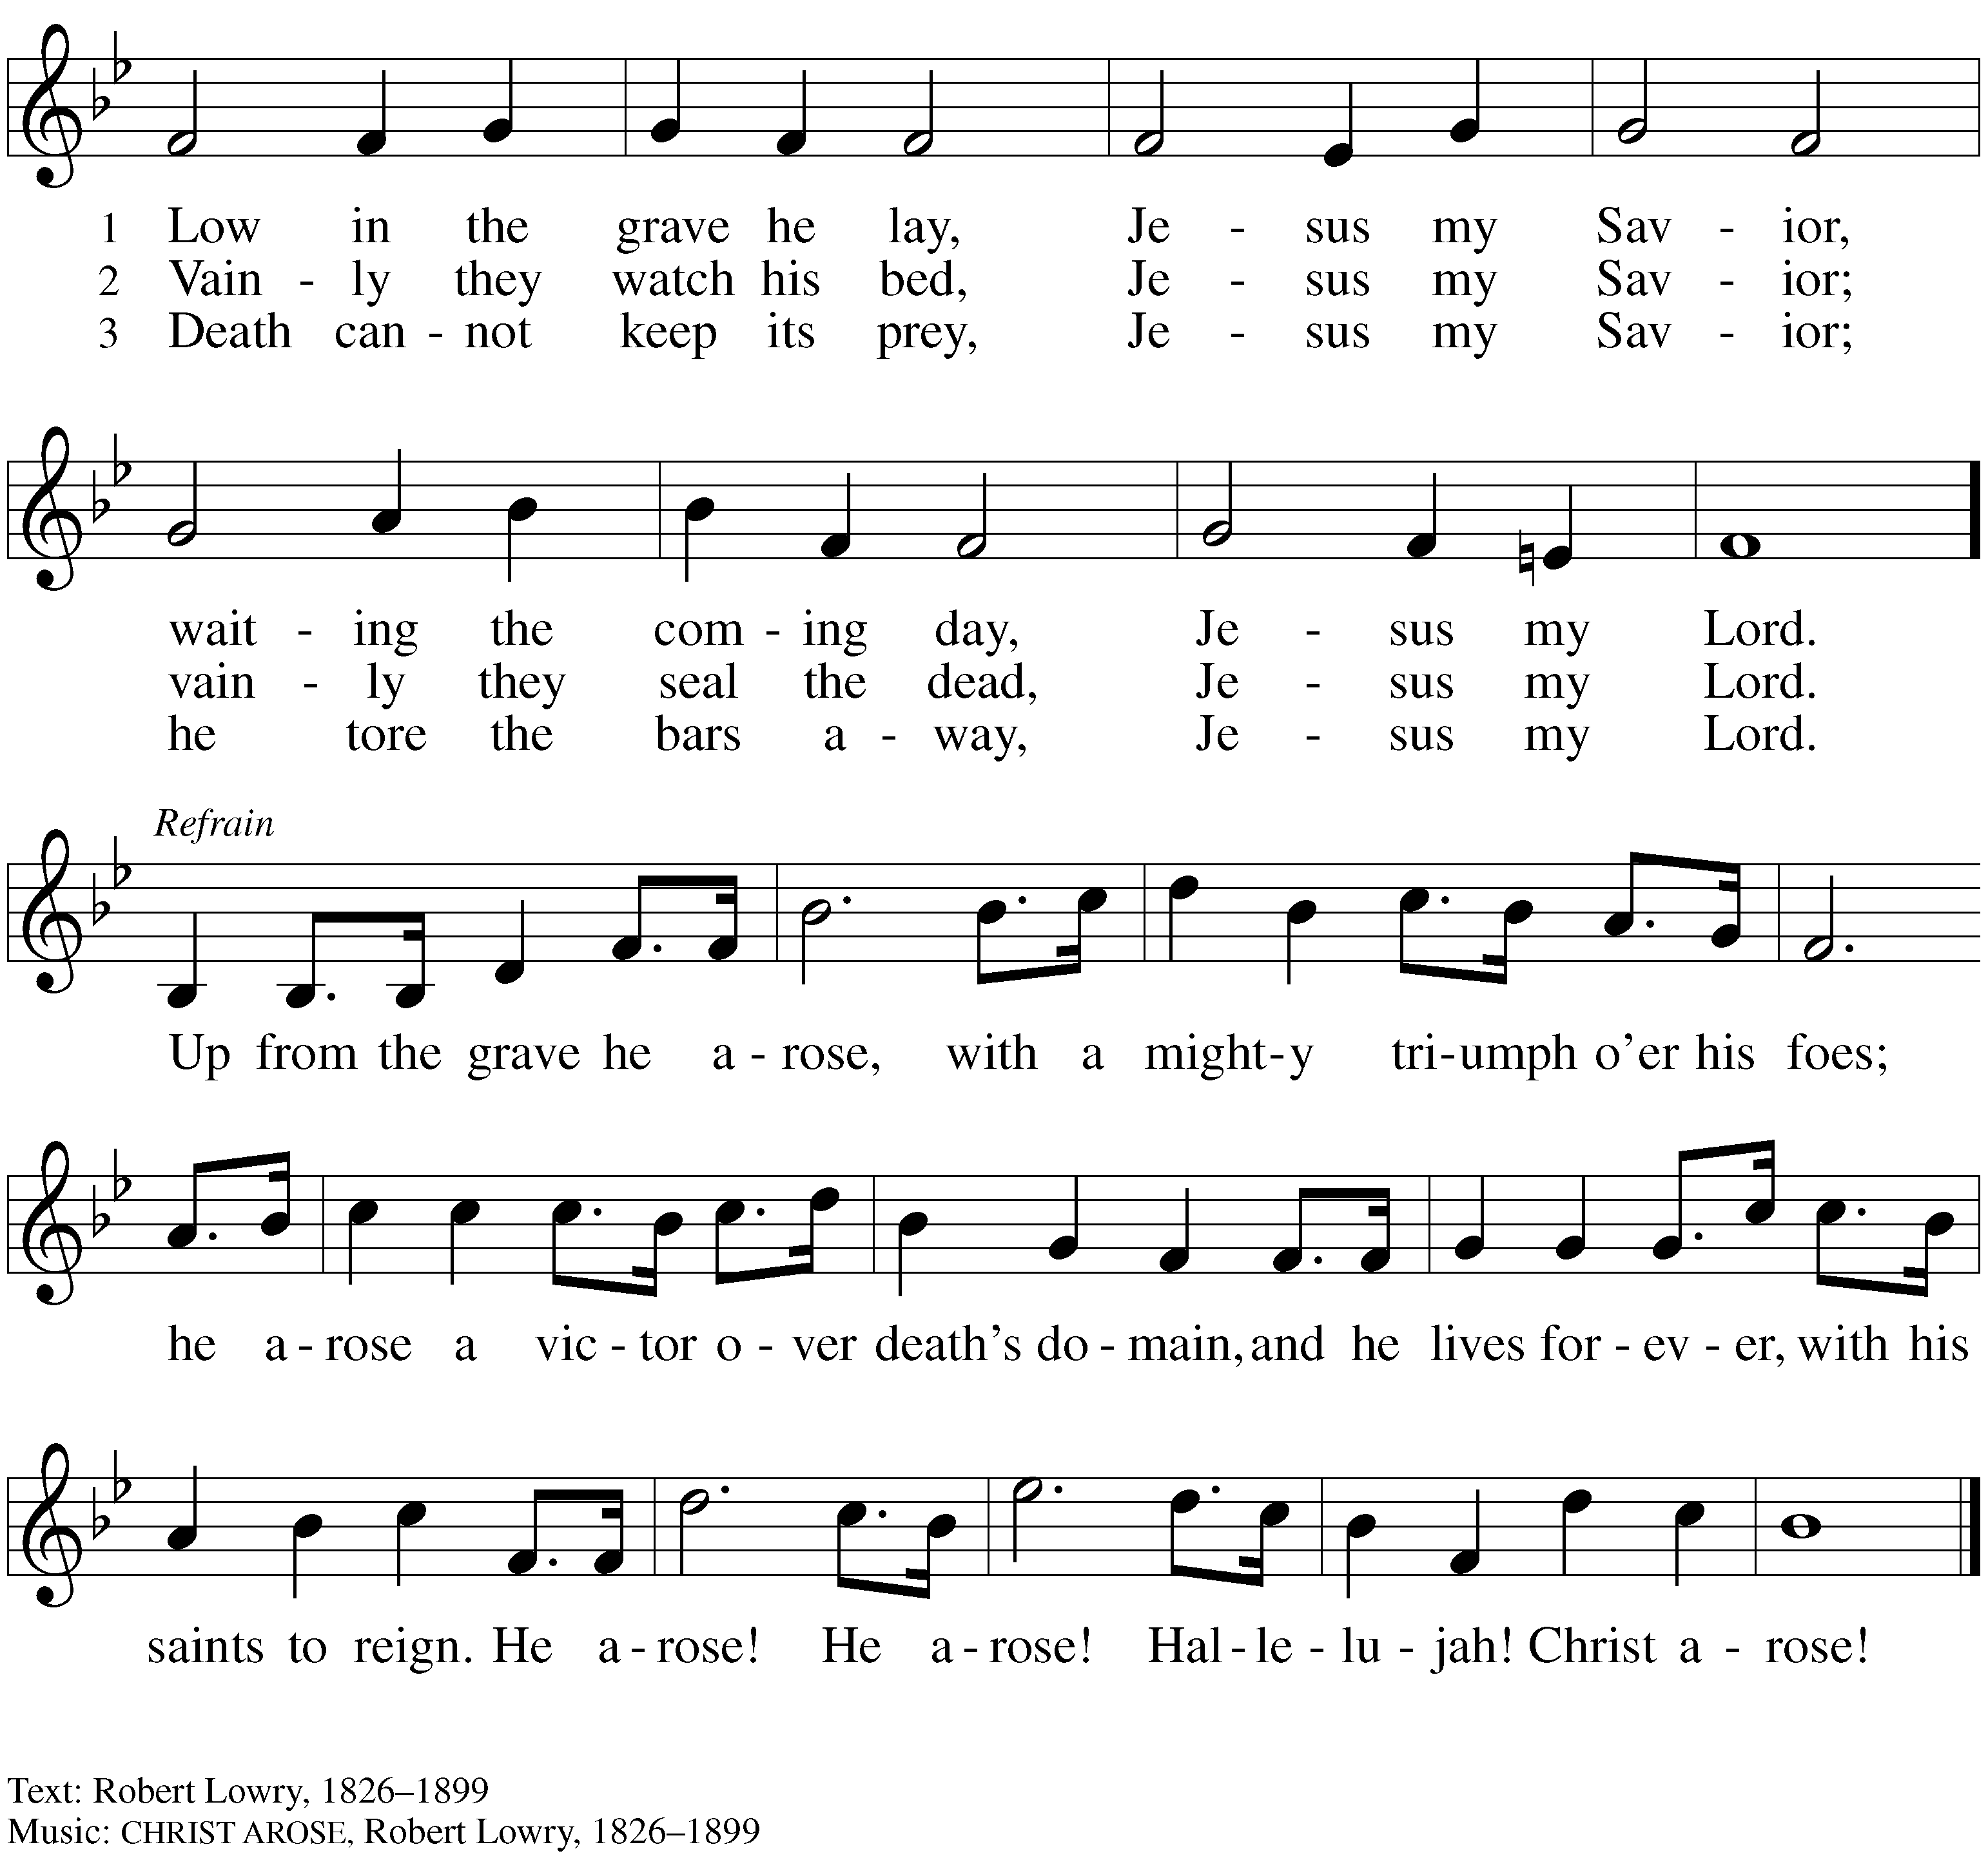
Public Domain

*Dismissal
A Go in peace. Serve the risen Christ.
C Thanks be to God! Alleluia, alleluia!

Postlude
Liturgy and texts from Sundays and Seasons.com. Copyright 2022 Augsburg Fortress.
All rights reserved. Reprinted by permission under Augsburg Fortress Liturgies Annual License #23628.

