Faith Evangelical Lutheran Church, Washington, IL

**Sunday of the Passion**

**April 10, 2022**

The congregation will gather outside for the procession with palms

**Gathering**

**P** Blessed is the one who comes in the name of the Lord.

**C** **Hosanna in the highest.**

**Processional Gospel**

**P** The holy gospel according to Luke, the 19th chapter.

C **Glory to you, O Lord.**

Jesus went on ahead, going up to Jerusalem. 29When he had come near Bethphage and Bethany, at the place called the Mount of Olives, he sent two of the disciples, 30saying, "Go into the village ahead of you, and as you enter it you will find tied there a colt that has never been ridden. Untie it and bring it here. 31If anyone asks you, 'Why are you untying it?' just say this, 'The Lord needs it.'" 32So those who were sent departed and found it as he had told them. 33As they were untying the colt, its owners asked them, "Why are you untying the colt?" 34They said, "The Lord needs it." 35Then they brought it to Jesus; and after throwing their cloaks on the colt, they set Jesus on it. 36As he rode along, people kept spreading their cloaks on the road. 37As he was now approaching the path down from the Mount of Olives, the whole multitude of the disciples began to praise God joyfully with a loud voice for all the deeds of power that they had seen, 38saying,

"Blessed is the king who comes in the name of the Lord!  
Peace in heaven, and glory in the highest heaven!"

39Some of the Pharisees in the crowd said to him, "Teacher, order your disciples to stop." 40He answered, "I tell you, if these were silent, the stones would shout out."

**MCSO01651_0000[1]P** The Gospel of the Lord.

**C** **Praise to you, O Christ.**

**Blessing of Palms**

**P** The Lord be with you.

**C** **And also with you.**

Faith Lutheran Church

2206 Washington Rd,

Washington, IL 61571

Website and online worship:

[www.shareourfaith.org](http://www.shareourfaith.org)

Church: 309-745-9306

[faithlth@shareourfaith.org](mailto:faithlth@shareourfaith.org)

Pastor John Rothfusz

Home: 309-745-9282

[pastor@shareourfaith.org](mailto:pastor@shareourfaith.org)

P Let us Pray.

We praise you, O God, for your redemption of the world through our Lord Jesus Christ. Today he entered the holy city in triumph and was proclaimed Messiah and King by those who spread garments and branches along his way. Bless these branches and those who carry them. Grant us grace to follow him in the way of the cross, so that, dying and rising with him, we may enter into your kingdom; through Jesus Christ, who lives and reigns with you and the Holy Spirit, now and forever.

**C** **Amen.**

**Processional Hymn:** “Lord, What a Parade!”

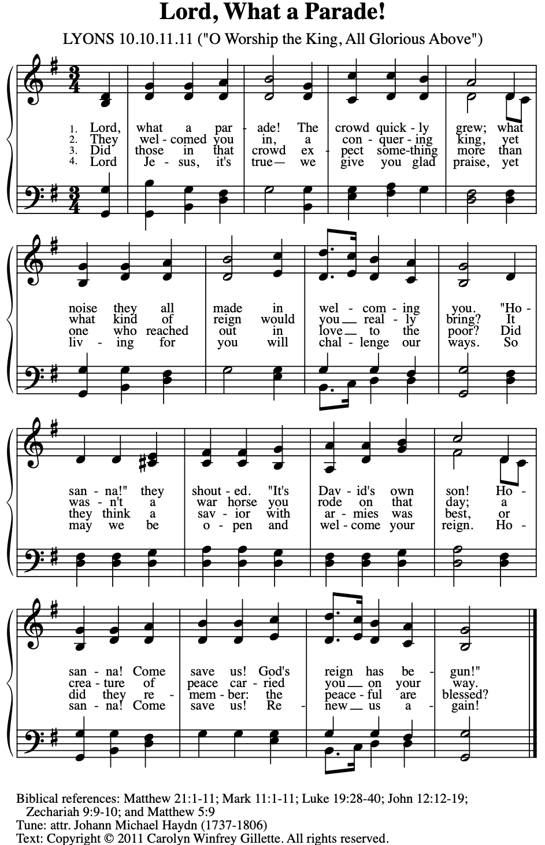

Text: Copyright © 2011 by Carolyn Winfrey Gillette. All rights reserved. Used by permission.

Music: LYONS, Joseph Martin Kraus, 1784; until recently attributed to Johann Michael Haydn

P The Lord be with you.

**C And also with you.**

Let us pray together the Prayer of the Day

Everlasting God, **in your endless love for the human race you sent our Lord Jesus Christ to take on our nature and to suffer death on the cross. In your mercy enable us to share in his obedience to your will and in the glorious victory of his resurrection, who lives and reigns with you and the Holy Spirit, one God, now and forever. Amen.**

Announcements

Children’s Sermon

**Reading – Philippians 2:5-11 Pew Bible Page #953**

5Let the same mind be in you that was in Christ Jesus, 6who, though he was in the form of God, did not regard equality with God as something to be exploited, 7but emptied himself, taking the form of a slave, being born in human likeness. And being found in human form, 8he humbled himself and became obedient to the point of death— even death on a cross. 9Therefore God also highly exalted him and gave him the name that is above every name, 10so that at the name of Jesus every knee should bend, in heaven and on earth and under the earth, 11and every tongue should confess that Jesus Christ is Lord, to the glory of God the Father.

R The Word of the Lord

**C Thanks be to God**

**The Passion Reading: Luke 22:14 – 23-56**

Sermon by Pastor John Rothfusz

Sermon Hymn Red Book #343

**My Song Is Love Unknown**

1 My song is love unknown, my Savior's love to me,

love to the loveless shown that they might lovely be.

Oh, who am I that for my sake

my Lord should take frail flesh and die?

2 He came from his blest throne salvation to bestow;

the world that was his own would not its Savior know.

But, oh, my friend, my friend indeed,

who at my need his life did spend!

3 Sometimes we strew his way and his sweet praises sing;

resounding all the day hosannas to our king.

Then "Crucify!" is all our breath,

and for his death we thirst and cry.

4 We cry out; we will have our dear Lord made away,

a murderer to save, the prince of life to slay.

Yet cheerful he to suff'ring goes

that he his foes from thence might free.

5 In life no house, no home my Lord on earth might have;

in death no friendly tomb but what a stranger gave.

What may I say? Heav'n was his home

but mine the tomb wherein he lay.

6 Here might I stay and sing—no story so divine!

Never was love, dear King, never was grief like thine.

This is my friend, in whose sweet praise

I all my days could gladly spend!

Text: Samuel Crossman, 1624-1683, alt.

**We believe in one God, the Father, the Almighty,**

**maker of heaven and earth,**

**of all that is, seen and unseen.**

**We believe in one Lord, Jesus Christ, the only Son of God,**

**eternally begotten of the Father,**

**God from God, Light from Light,**

**true God from true God,**

**begotten, not made,**

**of one Being with the Father;**

**through him all things were made.**

**For us and for our salvation**

**he came down from heaven,**

**was incarnate of the Holy Spirit and the virgin Mary**

**and became truly human.**

**For our sake he was crucified under Pontius Pilate;**

**he suffered death and was buried.**

**On the third day he rose again**

**in accordance with the scriptures;**

**he ascended into heaven**

**and is seated at the right hand of the Father.**

**He will come again in glory to judge**

**the living and the dead,**

**and his kingdom will have no end.**

**We believe in the Holy Spirit, the Lord, the giver of life,**

**who proceeds from the Father and the Son,\***

**who with the Father and the Son**

**is worshiped and glorified,**

**who has spoken through the prophets.**

**We believe in one holy catholic and apostolic church.**

**We acknowledge one baptism for the forgiveness of sins.**

**We look for the resurrection of the dead,**

**and the life of the world to come. Amen.**

\*Or, "who proceeds from the Father." The phrase "and the Son" is a later addition to the creed.

Prayers: After each portion of the prayers finishes with “Lord in your mercy,” please respond, **“Hear our prayer.”**

Offering: Jesus fills us with faith and sends us out as his witnesses. Let us commit ourselves to the Lord and joyfully lift our tithes and offerings to the Lord.

Please take a moment now to make an electronic offering to the church on the website, with the Tithe.ly app on your phone, or write a check and drop it in the plate at communion time.

Faith Lutheran website link www.shareourfaith.org

Offering Prayer

**Great Thanksgiving**

P The Lord be with you.

**C And also with you.**

P Lift up your hearts.

**C We lift them to the Lord.**

P Let us give thanks to the Lord our God.

**C It is right to give God thanks and praise.**

P It is indeed right, our duty and our joy… with the church on earth and the hosts of heaven, we praise your name and join their unending hymn:

*****

Holy Communion: Preface pp. 108-111 or other Eucharistic prayer

In the night in which he was betrayed,

our Lord Jesus took bread, and gave thanks;

broke it, and gave it to his disciples, saying:

Take and eat; this is my body, given for you.

Do this for the remembrance of me.

Again, after supper, he took the cup, gave thanks,

and gave it for all to drink, saying:

This cup is the new covenant in my blood,

shed for you and for all people for the forgiveness of sin.

Do this for the remembrance of me.

…we proclaim the Lord’s death until he comes.

**Christ has died, Christ has risen, Christ will come again….**

…from the bonds of slavery and death.

**Come Lord Jesus….**

…to pursue love and justice in all the world.

**Come Holy Spirit….**

…now and forever.

**Amen**

C **The Lord's Prayer**

**Our Father, who art in heaven, hallowed be thy name,**

**thy kingdom come, thy will be done, on earth as it is in heaven.**

**Give us this day our daily bread; and forgive us our trespasses,**

**as we forgive those who trespass against us;**

**and lead us not into temptation, but deliver us from evil.**

**For thine is the kingdom, and the power, and the glory,**

**forever and ever. Amen**

****

Distribution:

Communion Prayer

Announcements

**Blessing**

P The Lord bless you and keep you.

The Lord make his face shine on you and be gracious to you.

The Lord look upon you with favor and + give you peace.

In the name of the Father, and of the Son and of the Holy Spirit.

**C Amen**

**Hymn:** “Ah, Holy Jesus” Red Book #349

Text: Johann Heermann, 1585-1647; tr. Robert Bridges, 1844-1930, alt.

Music: HERZLIEBSTER JESU, Johann Crüger. 1598-1662

Dismissal

A Go in peace. Serve the Lord.

**C Thanks be to God!**

**Postlude**

Liturgy and texts from Sundays and Seasons.com. Copyright 2022 Augsburg Fortress. All rights reserved. Reprinted by permission under Augsburg Fortress Liturgies Annual License #23628.