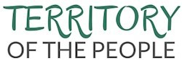
Monthly Bulletin – Season of Easter 7 April 2022

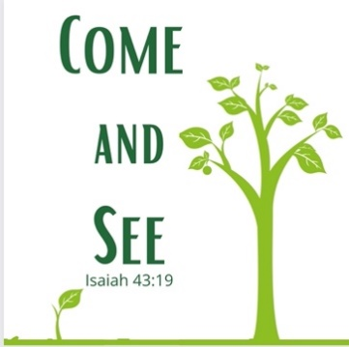
A Message from Bishop Jane…

It is that time of year when new life is springing up all around us and we see God doing new things. In creation I see buds appearing on the trees in my garden, geese returning and faint tinges of green in the grass and oh how it makes my heart sing.

In the world there are changes coming some of them longed for, and though they creak along slowly, they are coming. On March 30th a two-month ceasefire in Yemen began. We pray it might bring relief and hope to the terrible situation there. In Ukraine there are rumours of peace talks, and we pray with all our hearts this may happen. We know the situation there is fragile, countless families are torn apart, innocent people are losing their lives. Peace seems far off, but we continue to pray for it, to long for it and to work for it in whatever ways we can.

On Friday April 1st 2022, Pope Francis finally said words that generations of First Nations people here in Canada have been longing for. "I want to say to you with all my heart: I am very sorry, And I join my brothers, the Canadian bishops in asking your pardon." The Pope added he was "indignant" and "ashamed" of the abuses suffered in Canada's church-run residential schools, and said Catholic educators in these facilities disrespected Indigenous identity, culture and spiritual values. "It is chilling to think of determined efforts to instill a sense of inferiority, to rob people of their cultural identity, to sever their roots, and to consider all the personal and social effects this continues to entail, unresolved traumas that have become inter-generational traumas." Grandmothers and grandfathers who were children in the residential schools have died while waiting for these words. On the first day of April the Pope spoke into this history of pain. Words of apology, words that I hope indicate a new beginning. It is a start, it is not the end or the final word. It is a new thing.

In just a few days we will celebrate Easter and enter a season of resurrection. The ultimate new thing. Each year we enter a season of joy and hope. Resurrection life flows out and challenges and changes and expands the beloved family of God. Resurrection life always looks for a bigger family, more love, abundance and outrageous love in fact.

With all of that in mind let’s think about the church right here, right now. Here in the Territory of the People there are new things coming. I see them, I hear about them. I believe there is a renewed sense of hope and identity forming right here. In May we will gather for Assembly and our theme is taken from Isaiah 43:19 where God says “I am about to do a new thing; now it springs forth, do you not perceive it? I will make a way in the wilderness and rivers in the desert.” Our invitation for Assembly is “come and see”. We will come together and listen to stories of what God is doing in our midst. We will share our hopes for the future and set a course. In the middle of all of that, we will commission our three new Elders, Ursula Drynock, Ernie Michelle and Pauline Michelle. We will share in the ordination to the priesthood of Linda LaGroix. I pray for a time of rejoicing. Because God is always more than we can ask or imagine I know there will be more surprises in store. I can’t wait for us to be together in fellowship, in visioning and in worship.

Our Isaiah theme reading talks about how we springboard from the past into the future God has for us. So in May we will give thanks and remember all the people and events that have brought us to this place and we will look forwards and outwards to what God has in store for us. The church of every age is called to be the church of that age and place in which it finds itself. Who are we called to be? What are we called to do?

Let’s find out together!
+ Jane

Prayer Corner
- We pray for the people of Ukraine, and Russia during this time of conflict
- We pray for all communities affected by wildfires and floods; for the loss of homes, livelihoods, communities, friends and families; we pray for strength, healing and God’s grace
- We pray for our parishes and congregations during this time of uncertainty as restrictions from the Covid-19 Pandemic are lifted; we pray for those with anxiety and concern as we continue to find our way through this pandemic
- We pray for all Pastoral Elders: Ursula Drynock, Amy Charlie, Pauline and Ernie Michelle
- We pray for the Rev Canon Isabel Healy Morrow and all who support her, as she continues her journey of recovery, giving thanks for her ministry to St. Michael’s Merritt, especially in the aftermath of the floods
- We pray for Dwight Oatway, his wife Islay and their family
  - We pray for the Rev Bob Purdy recovering from illness
  - We pray for Bishop Jane and new ministry leadership in the Territory: St. Paul’s Cathedral Kamloops, the Lillooet Shared Ministry, the Three Rivers Ministry – Prince George and Quesnel
  - We pray for all who are confined by illness, praying they may find peace and strength in the love and care they receive from others
  - We pray for all those without the security, safety and comfort of a home, or economic stability
  - We pray for those with anxiety and stress concerning personal economic situations
“Head Above Water” – Avril Levigne
Music for the soul … click here for the music video

Territory News:
- Assembly 2022 – May 27-29, 2022 at St. Paul’s Cathedral, Kamloops. Marke your Calendars and set aside the dates! The Local Arrangements Committee, and the Worship Committee are getting underway with planning; at the Sunday morning worship we will be celebrating the ordination to the priesthood of Linda LaGroix and the Installation of Pastoral Elders… stay tuned for more information next month!
- Bishop Jane’s Appointments:
  - Effective April 1st, the Rev Linda LaGroix as incumbent to St. Alban’s Ashcroft
  - Effective May 1st, the Rt. Rev Barbara Andrews as incumbent for St. Peter’s Monte Creek
- Territory Resource Centre: with the Rev Linda LaGroix appointed to St. Alban’s, Ashcroft, Linda is now unable to fulfill the role of Coordinator for the Resource Centre. The Territory is looking for one or two people to take on this ministry; if you have a desire for this to be your ministry, or know of any persons in your parish who feel called to this work, please contact the Territory Office – office@territory.anglican.ca Phone: 778-471-5573
- Donations: The Territory website now has a “Donate Now” button linked through CanadaHelps.org –we have been receiving donations to the Lytton Fire Fund, the Nicola Valley Flood Fund and to our general revenue for which we are truly grateful. The button is at the lower right side of the Home Page. When donating, please complete the section relating to where the funds are to be directed.
- The Territory is still accepting donations for our communities devastated by fire and flood last year:
  - Lytton Fire Fund
  - Nicola Valley Flood Fund
The need for funds is great and more than our resources can supply. Donations can be made by using the “Donate Now” button on the Territory website (see above) or by cheque made payable to the Territory of the People. All donations are to be earmarked “Lytton Fire Fund” or “Nicola Valley Flood Fund.” An official tax receipt will be issued for donations from individuals and non charitable organizations. For more information, please contact the Territory office: office@territory.anglican.ca or by phone: 778-471-5573. Please keep the Territory in your prayers as we continue to deal with the diverse needs of all those affected by these disastrous events.

- Lay Ministers of Word and Sacrament Study Courses: - offered by the Diocese of Huron, these courses offer continuing education:
This Photo by Unknown Author is licensed under CC BY-NC-ND
  - “Saying Grace”: Preaching and Proclamation in Worship, with Bishop Todd Townshend, Tuesdays from 7pm-9pm hosted on Zoom beginning April 19, 2022.
  - Huron University College is also offering one-day courses in Administration and Leadership.
    - The first course, Parish Administration 101, has some Diocese of Huron specific content, but Archdeacon Tanya Phibbs will be asking students to have a copy of their own diocesan Canons on hand for those particular parts of the course content. These three half-credit courses are one-day format intensive and there is no evaluative component. Should Licentiate Theological students wish to receive a full credit for them, there is an additional book requirement and an essay to be completed after the one-day course takes place.
This Photo by Unknown Author is licensed under CC BY-NC-ND

You may register with the following information:
Name (with titles please); Mailing Address; Email; Preferred Contact Telephone Number; Status in the Course Registered (Credit or Audit) - Send to admin@brandon.anglican.ca
- Lenten Series – the last in the series “Living from the Heart” led by the Rev Louise Peters - a six week series to explore how we live the way of Jesus by: Tending the Heart; Praying; Fasting; Giving; Forgiving; Living. Video and weekly study guide available Mondays during Lent on the Territory website here. This is a self study for individuals and small groups, no registration required.

Other News:
  - Primates World Relief and Development Fund (PWRDF) – is supporting Ukrainians forced to flee their homes due to the Russian invasion. Click here for more information and how you can help.
- Sorrento Centre Workshops:
  - May 1-4, 2022 – Developing Resilience and Restoring Self: Managing Stress in Clerical Work. Details and Registration here
  - May 18-19, 2022 – ASIST – Applied Suicide Intervention Skills Training – a 2 day in person workshop for clergy and lay persons. Registration deadline is May 1st with cheques payable to the Diocese of Kootenay. Details and Registration here
- Anglican Foundation –Territory parishes are encouraged to keep their membership up to date, as we have always received grant funding when requested, click here for a list of grants received. More information on the Anglican Foundation can be found on their website here
- Parish Development - The School for Parish Development is happening on-line and in person at Sorrento Centre this summer. This is an excellent programme from the Diocese of New Westminster, now being offered to other Dioceses in the Province.
Dates: August 28 – September 2. And virtual preparation dates are July 25, August 1, 8, 15 and 22.
Registration details here. This programme is most useful if undertaken with a team of parish leaders: priest, deacon, wardens and other lay people.
- Anglican Foundation – Announces $50,000 Matching Gift for Say Yes! to Kids 2022 fundraising teams.
“With the incredible generosity of our matching gift donors, the first 50 peer-to-peer (P2P) teams to raise $1,000 through their local efforts will immediately see their campaign total jump to $2,000, as AFC provides an additional $1,000 in the form of a matching gift,” says Dr. Scott Brubacher, AFC’s Executive Director. Currently, there are approximately 20 teams from across Canada readying their fundraising projects for the 2022 national campaign launch on April 19. Brubacher says, “We hope this matching gift will encourage other teams to join the Say Yes! to Kids movement.” READ MORE
- Festival Biblical Story Telling - Friday, Saturday and Sunday, April 22-24, 2022 an ONLINE event sponsored by the Network of Biblical Storytellers Canada. This is an interdenominational and international event, co-sponsored by LeaderShift. Attend on your own or with a group. All will be recorded so once registered you will have 3 months' access to anything you may have missed. More information, keynote bios, and links to register here or here. Wondering what Biblical storytelling is? please visit this site

Easter by Dennis Saddleman - March 20th 2022
A walk with the man carrying a heavy cross.
(The red brick building, is the residential school in Kamloops BC)

I was there in the red brick building.
I was there for many, many years.
I went to church in the red brick building.
I looked past the altar.
I saw the man on the cross.
I heard about this man.
He's a powerful man.
He can heal the sick.
He can walk on water.
He can turn water into wine.

This child that's me.
This child entered the red brick building.
In the building they said, "You cannot wear your brown skin.
You do not own your freedom."
Just like the man carrying the cross.
"You do not own your innocence."
Just like the man carrying the cross.
"You're guilty of everything you do."
Just like the man carrying the cross.
They beat me.
They spat on me.
They mocked me.
Just like the man carrying the cross.
I was hurting.
I was bleeding.
I was tortured.
Just like the man carrying the cross.

The cross, the heavy cross.
My burden.
The cross, the heavy cross.
My struggles.
The cross, the heavy cross.
My agony.

On the cross.
They nailed everything I had.
They nailed my destination of hope.
They nailed the Indian in me.
They nailed my cries for help.
They nailed my courage.

On the cross.
Should I live or die?
On the cross.
Should I die from drugs and alcohol?
On the cross.
They speared my heart.
On the cross.
My love, my kindness dripped on the ground.
Above me, around me.
Thunder and lightening.
Thunder and lightening.
And silence.
Silence.
Silence.

In the red brick building.
In the church.
I looked at the man on the cross.
His name is Jesus.
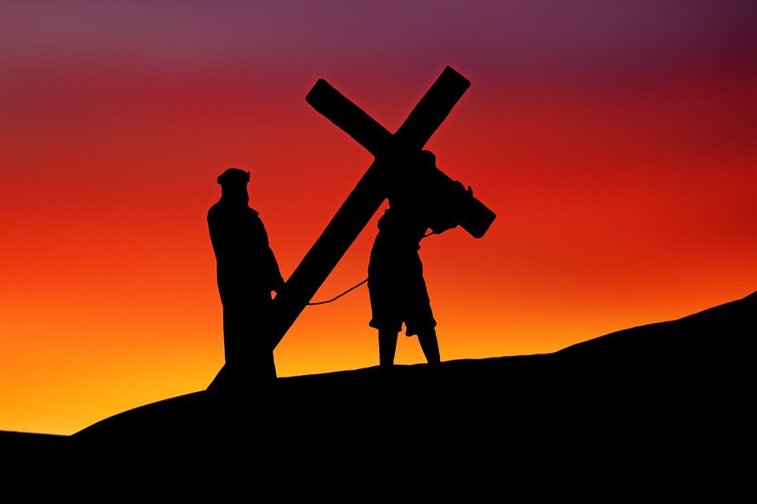
I looked at the man on the cross.
He was looking towards heaven, where I wanna be.
I looked at the man on the cross.
There's forgiveness written all over him.

The man on the cross.
He walked the road of sorrow.
He died for my sins.
And me, I walked in the hallway of the red brick building.
I walked in the halls looking for beauty and peace.
To me, that's Easter.
To me, I was walking with the man carrying the heavy cross.

Dennis Saddleman is resident of Lytton and a committed leader and member of the Lytton Parishes, a delegate to Territory Assembly, and a member of Coordinating Council. Dennis has been writing for 25 years and earned the name Wordwarrior because his poems and stories are very powerful. Dennis has written poems for special occasions within the Territory, and with funding from the Territory Ministry Fund Grant, published a book of his poems in 2019 – titled Wordwarrior.
Important Dates and Bishop Jane’s Schedule:

April 10 Palm Sunday – Bishop Jane in 100 Mile House
April 12-18 Holy Week - Bishop Jane in the Territory
April 14 Maundy Thursday
April 15 Deadline Capital Fund Grant Applications
April 15 Extended Deadline – Ministry Fund Grant Applications
April 15 Good Friday – Bishop Jane at North Thompson Ecumenical Shared Ministry, Barriere
April 16 Easter Vigil – Bishop Jane at St. Paul’s Cathedral
April 17 Easter Sunday – Bishop Jane in Lytton
April 21 Administration Committee – 7pm Zoom
April 26 Archbishop Lynne’s monthly visit to the Territory office
April 26 – May 2 Margaret away (Territory Office vacant)
May 13-15 ACPO – Sorrento Centre
May 14-21 Margaret away (Territory Office vacant)
May 24 Archbishop Lynne’s monthly visit to the Territory office
May 27-29 5th Territory Assembly – St. Paul’s Cathedral, Kamloops

I’ve learned … That the best classroom in the world is at the feet of an elderly person…
I’ve learned … That I can always pray for someone when I don’t have the strength to help him or her in any other way…
I’ve learned … That sometimes all a person needs is a hand to hold and a heart to understand…
I’ve learned … That love, not time, heals all wounds.
Andy Rooney

