KNOXVILLE CHURCH

CONSULTATION REPORT: OBSERVATIONS AND RECOMMENDATIONS

April 3, 2022

TABLE OF CONTENTS

INTRODUCTION 3
LEADERSHIP TIMELINE 4
GROWTH 5
EXECUTIVE SUMMARY 6
THE APPRECIATIVE INQUIRY CONCEPT & SURVEY 7
OBSERVATIONS 13
RECOMMENDATIONS 17
General Advice for All Churches 17
Specific Advice for the Knoxville Church 23
CONCLUSION 29

INTRODUCTION

This consultation was established out of conversations between Steve Staten and the Knoxville Church leadership group. The leadership group is comprised of:
Hoyt Williams
Al & Ibel Growdon
Dan & Kristin Downs
Lynne & Jesse Carty
Eric Decker
Parker Helton
Shelby Stevens

The following agreements and responsibilities were determined:

The Responsibilities of the Consultant(s)
- Interview as many members as are willing of a total membership of around fifty individuals (in person or virtually).
- Interview the leadership—face to face unless availability or health is a factor. Tricia can meet with some of the women virtually, or both Statens can meet with couples virtually.
- Interview and survey the congregation; this will be more than forty hours spread out over two or more weeks.
- Teach a series in a workshop on conflict competence, apologies, forgiveness, and reconciliation.
- Provide Observations and Recommendations for senior leadership and the congregation.
- Introduce the congregation to a hiring and vetting process for hiring a full-time minister.
- Work closely on insights from the consultation with Steve & Diane Brown and the leadership team.

The Responsibilities of Knoxville Church Leadership
- Provide copies of significant resources that explain structure, history, membership, and core values.
- Align schedules with the congregation for Monday morning to Friday morning, January 24–28, which was adjusted to Sunday evening to Thursday morning, January 23–27.
- Set up the interviews—the Calendly tool was set up.

Steve & Diane Brown were hired to serve in an interim leadership role for approximately four months. It was agreed that Browns and the Statens planned to work together as a consulting team.

LEADERSHIP TIMELINE

The Greater Nashville Church of Christ oversaw the plans for the Knoxville Church, which began with members who moved from a house church in Kingsport nearly 100 miles away and Christian students who moved to Knoxville to study at the University of Tennessee.

- Nashville House Church in Kingsport early 1990s (15–20 disciples)
- Bill & Amanda Burke 8/1993–7/1995 (official planting)
- Bobby Lee & Theresa Bobbitt 7/1995–1996
Rotating preaching/teaching 1996–1997 (a few months)
- Dean & Cheryl Toscano 1997–2000
- Alan & Jennifer Rosenfeld 2000–8/2002
Temporarily led by young interns 2002
- Ward & Ellyn Herbert 12/2002–early 2011
Rotating preaching/teaching early 2011–6/2012
- CJ & Sheree Wakefield 6/2012–2/2016
CJ consulting/leading from the UK 3/2016–6/2016
- Anton & Sharon Ivy 7/2016–12/2021

Steve Staten and Steve Brown were able to talk with most of the leaders. Some of them provided helpful information. All but one couple are confirmed members in an International Church of Christ, Church of Christ, or Christian Church.

GROWTH
Year-End Membership

Year Mbrs Year Mbrs

1 1993 30
2 1994 43
3 1995 58
4 1996 78
5 1997 90
6 1998 89
7 1999 101
8 2000 120
9 2001 117
10 2002 116
11 2003 114
12 2004 114
13 2005 85
14 2006 96
15 2007 108
16 2008 108
17 2009 108
18 2010 114
19 2011 102
20 2012 90
21 2013 95
22 2014 94
23 2015 107
24 2016 98
25 2017 96
26 2018 100
27 2019 91
28 2020 76
29 2021 57

Between the late 1990s and 2010 about one fourth of the church was composed, on average, of campus students. As is usually the case with campus ministries, most students tended to leave the area upon graduation for career-related reasons. Graphs don’t tell the whole story. For instance, thirty-three members moved in 2000–2001 for a variety of reasons.
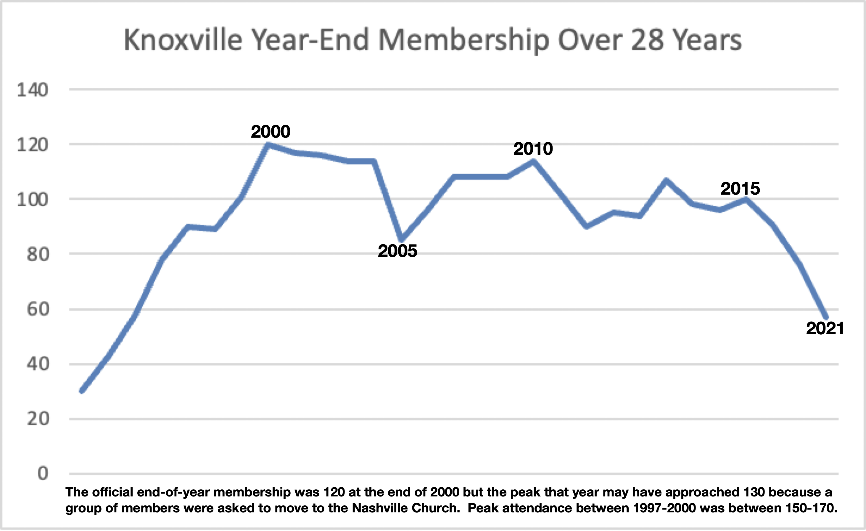

EXECUTIVE SUMMARY

This report focuses on 4 recommendations for the Knoxville church derived from 37 interviews of members, 6 interviews of former members living in Knoxville, and 6 former ministers. The 21 Appreciative Inquiry surveys also strengthened the report. Tricia’s interviews were by Zoom or phone. Steve and Diane Brown also talked to the same individuals and others. They’ve met with approximately 40 church members as well as former members. We each strove to take something meaningful away from every conversation.

OBSERVATIONS
Strengths
#1 There is a warm, generous, and hospitable spirit in the congregation.
#2 The interviews revealed both a humility about the past and your desire to learn.
#3 The congregation has a faithful core that will persevere in the face of challenges.
#4 The current leadership is approachable and very responsive to outside counsel.
Room for Improvement
#1 Prior difficulties required greater biblical clarity, processes, and records.
#2 Hiring processes would benefit from greater vetting and clear job descriptions.
#3 Shepherding must become the highest priority of the leadership group.
#4 There is a lack of consistency in being in each other’s lives.

RECOMMENDATIONS
For the KC Leadership and the Board
#1 Memorialize major lessons learned.
#2 Define and align leadership roles.
#3 Improve decision-making practices.
For all KC Members
Make an earnest effort to recapture your greatest faithfulness (Heb. 10:32–36).

THE APPRECIATIVE INQUIRY CONCEPT & SURVEY

Appreciative Inquiry (AI), a common practice, is not an exact science. It is the art of asking the right questions of committed participants and developing a composite picture of the past, present, and desired future. Aspirational organizations like churches are perfectly suited for this approach because it resonates with Scripture. Nearly two thousand years ago, the author of Hebrews was practicing a rough model of AI.
- Remember the reasons for the community’s existence (Heb. 1:1–4, 2:1–4).
- Purposefully think about the good things of the past (Heb. 6:10, 10:32–34).
- Retain the best basics yet move on to what is transformative (Heb. 6:1–4).
- Get rid of things that entangle (Heb. 12:1).
- Imagine, with faith, an improved future. What we focus on, and how we frame our situations and opportunities, does much to cultivate our reality. The Hebrew writer stresses the superiority of Jesus (Heb. 7:21–8:6, 9:11–14), the heavenly Jerusalem (Heb. 12:18–29), and the examples of faithful forerunners and leaders (Heb. 11:1–40).
- Encourage transformative attitude and behavioral changes (Heb. 10:23–25, 12:1–17).
- Promote productive surplus thinking (we have these advantages and treasures) rather than only deficit thinking (what’s wrong with us and what’s broken).
The result of an integrative process like this inquiry is that it taps into our hearts, minds, and collective aspirations, discovering what enlivens and gives energy to the broader church family. Author Mark Lau Branson suggests a lens for looking at the past:
Organizations are heliotropic. This is a botanical term about a plant’s orientation—plants lean toward the sun. Similarly, organizations lean toward the source of energy—whether that energy is healthy or not… As memories and imaginations are engaged to nourish participants with the best and most life-giving resources, the church will lean in the direction of those narratives and practices.
In any congregation, leaning into healthy energy would be thinking about Christ, knowing our story of faith, seizing great memories, living up to what we already know, and doing what still works while also grabbing new opportunities and practices. It is important to balance these features for change because some people overly reminisce about the past and others too quickly disparage the past.

Survey Questions
- Strive to remember the experiences at the Knoxville Church when were you most spiritually alive, most motivated, and excited about your involvement. Describe what made it exciting.
- What practice or characteristic of the church would you like to discard and leave in the past?
- What past strength would you like to recover?
- What is a positive feature of the Knoxville Church?
- If you were able to peer thirty years into the future, and you discovered that the Knoxville Church was large and collectively achieving great things to God’s glory, what are some things that you think would have enabled us to get there? (in other words, your suggestions for a strong and resilient future)
- Do you have COVID concerns related to church meetings?

Survey Responses
There were twenty-two members who participated in the Appreciative Inquiry survey. The selections in this section were chosen based on perspectives that:
- resonated with the thoughts of others
- helped underscore “surplus thinking”
- stayed within the topic
- would not give away the identity of the source
There were some judgment calls on which ones to include. Several of the responses were chosen because they echoed with a variety of perspectives from the interviews. The responses contain quotes, rather than just my impressions. Minor edits were made for grammar, spelling, and flow. I chose to leave out interesting thoughts about various doctrines, issues in the world, and the ICOC to maintain a focus on the inquiry.

When were you most spiritually alive, most motivated, and excited about your involvement? Describe what made it exciting.

Early on, leading up to my baptism and after. Was always spending time with other disciples.
I have felt most alive in two different venues: one is when I have met in small group men’s Saturday morning times of Bible study, prayer, and sharing. And secondly, when I had a message of encouragement and was able to preach and share that message and inspiration.
When I felt like I was emotionally close to people.
Several years after becoming a disciple, service was lively yet reverent, and visitors were coming out each Sunday. There was high energy at each service, whether Sunday or midweek, and the singing had a lot to do with it. People were in each other’s lives regularly, and there was a level of accountability— people just seemed to care. The children’s ministry was also ALIVE, and children were learning and growing and had fun things to do in Kingdom Kids.
I want to say the first five years were exceptionally exciting because we were experiencing the gospel in real relationships, and intellectually in spiritual convictions about truth in the Scriptures. People were joyous, faith filled, loving us, and helping us. We were also finding answers to our messes and how to navigate and live life, to love unconditionally, to serve wholeheartedly, to build stronger relationships, and, through discipleship, to mirror Jesus’ heart. We grew in faith and felt the deepest sense of hope for ourselves, family, friends, and this world.
We remain profoundly grateful for answering God’s call and for all the years sharing the journey with our brothers and sisters, several leaders, and their families, through challenges and mistakes, lessons learned and joyous victories, loss and growth, heartache and comfort, distance and restoration, new life and death, celebration, and sorrow … all the while, Jesus is Lord!
Various community service projects involving the whole church or small groups. Church suppers with invited guests and speakers from other churches. Marriage retreats, women's days, book study groups. A music ministry that made you want to stand up and pour your heart into every single note. All of the above fostered a sense of community, learning, growth, and shepherding.
When we had, before five years ago, a healthy balance of every age group and we operated as a family.
We had monthly potlucks after church … people were connected and encouraged.
I'm excited about the present, to see the Knoxville church moving toward repentance and unity, and watch expectantly for God to work.
During COVID “shutdown” 2020–2021 … a special bond that evolved within our house group by having Zoom meetings weekly (Tuesdays) in addition to Sundays and Wednesdays.
Being involved in some Bible studies with some college students a few years ago. It was exciting to be helping some young people find God.
During the time of the Wakefields, we had both a man and woman leader that SERVED the church and it felt like a family. They were so full of love, joy, and life that it made me feel that way too. We had regular activities outside of church attended by many.
When the music ministry was growing, we had just started regular practices outside of Sunday morning, and I think we were in a good place spiritually.
Serving in leadership for the church.

What practice or characteristic of the church would you like to discard and leave in the past?

Having people “over” each other. Appointing discipleship partners. Assigning people to groups.
The practice of checkbox agreement. What I mean by that is when we simply ask questions like: Do you believe in discipleship? Do you believe in evangelism? Are you committed to the body? This hasn’t just been done in the leadership team, but it seems it is wanted to be done with members of the church. We want to take shortcuts to get unity rather than do the hard work to get there.
The feeling that we all have to think and be the same, instead of the freedom to be who we are in Christ.
The in-your-face accountability where if one didn’t meet the “quota” for visitors, etc., he was made to feel inadequate or less than a disciple. In addition to that, the “you’re going to hell if you’re not part of our church body” philosophy.
Discipling was often misunderstood and abused. Evangelistic campaigns had enormous unrealistic and superficial goals.
Spirit of individualism within membership.
I think one thing that needs to be done is when people leave, we should figure out what the problem is so that it doesn’t happen again, so we can grow and flourish.
The belief that we are the only church. Even though we say we don't believe that anymore, it seems that people have dropped others that have left. I think reaching out and still being friends with those that have left is another good thing.

What past strength would you like to recover?

Spending time with people. A sense of family within the church, deeper relationships. Fun times together as a family building unity and connection.
When we would all go to conferences, marrieds’ retreats, and such. They were so binding and gave a bigger picture of God’s church.
Disciples were excited to get together to worship God and reach out to others.
Excellence in everything. Some Sundays it feels as if things are just thrown together—and they often are. Planning and coordination are needed to pull things together.
Serving our community in different ways.
Sincere and committed shepherding (a huge loss in recent years).
A revitalized and vibrant music ministry.
Family atmosphere … sense of loving others so deeply we will fight to help them when they struggle or are weak, not push others out of membership without a lack of compassion for their circumstances. Too many stories of members confronted with an authoritarian attitude instead of Christlike love.
Accountability partners and individual devotion to God.
Family group times with Bible discussion and MEALS, not just snacks. Like real family times, with kids and dogs and everything.
I felt the church was much better off when we had a more vibrant campus ministry and young professionals.
I would like to recover my energy and enthusiasm for God, Jesus, the church, and all people. As far as recovering a strength of the church, I would love to recapture the connected community.

What is a positive feature of the Knoxville Church?

We are able to know everyone.
A significant amount of perseverance. And this church has a lot of servants.
Faithful people.
We do rally together when there is a need.
Disciples are warm and friendly.
Then Knoxville Church is still very much a FAMILY of believers, with many of us who will go down strong and fight hard to keep the fellowship of family alive.
We are loving. And located in an amazingly beautiful part of our US with the great Smoky Mountains.
Inclusivity, diversity, in the past an upbeat and joyful music ministry.
Our teachers.
Caring for one another’s needs. Serving.
A loving and caring current leadership team.
A faithful core that will stay the course in the face of any adversity.
We are very real and not fake about our lives.
United in belief in following the whole Bible and, in particular, Matthew 28:16–20 and Acts 2:38.
Its location near a big campus for campus outreach, outdoor activities for us to do fun things as a church, and we get many visitors from other churches on vacation.
I think we have quality people here, thanks be to Jesus, that are genuinely interested in each other, friendly and glad to be together when we are together. I haven't met many that are grumblers and complainers. Those who do serve are enthusiastic about it, for the most part.
I think there are some really dedicated, faithful disciples that are willing to do whatever it takes to build up God's kingdom in the church.

If you were able to peer thirty years into the future, and you discovered that the Knoxville Church was large and collectively achieving great things to God’s glory, what are some things that you think would have enabled us to get there? (in other words, your suggestions for a strong and resilient future)

Most immediately, a spiritual, humble, passionate leadership team. A leader more pastoral-evangelist who leads us with an inspiring vision and collaborative leadership.
We also need to mature in our understanding of the grace of God, in terms of how we deal with each other, be we weak or strong, and also how the grace of God leads us to live more holy and passionate lives. Ultimately, we have to have eldership locally.
A church that is transparent to one another and those outside the church.
Building the morale, being encouraged, believing in the best of everyone and how God really loves us.
Perseverance, not to give up due to businesses of life, come to church to serve, not just to get.
Openness, striving for excellence as God calls us to do, recommitment on all levels, and a genuine love for God, each other, and the lost.
People actively striving wholeheartedly in practice to become like Jesus, faithfully loving people/one another, caring deeply about the needs of others.
Building into the fabric of church dialogue the acceptance of questioning without being judged or shamed, exploring multiple biblical resources to enrich our understanding of our faith. Partnering with established community organizations like Habitat, prison ministry, senior centers, etc. (there are so many).
To live within our means. We have a history of spending the majority of our funds on leaders even if it is an unhealthy ratio. This is financially reckless. We should invest in our campus; kids make it attractive for others.
When all of us follow God and make the church as strong as possible.
Real family relationships from open hearts. Eagerness to repress sin through confessing to each other through mutually edifying and committed relationships.
More people with a heart and desire to serve in some way, along with great accountability relationships that are not just on Sundays and Wednesdays but daily.
Buying our own church building instead of renting somewhere all the time.
Leadership by example, being focused on evangelism, utilizing spiritually strong families: both natural and spiritual (e.g., family groups, campus, teens). Consistent dependence on prayer, fasting, and love (1 Cor. 13:4–8a). Consistent acknowledgement of Jesus as Lord, both as a goal and in practice, with the Bible always used as the guide.
Focus on strong, spiritual relationships with each other and others in our community.
Stable, strong leadership and members that participate in church needs, building a family feeling that others would want to join.
In 2052 … we have a dedicated team of leaders who are genuinely connected to the people in their group. They know what their boundaries are in giving advice, and they have the resources to turn to when discipling needs to move into counseling or therapy. This team of leaders is guided by experienced ministry folks (even if they are in another church), is constantly seeking and being provided training to lead well. Our local church is tied into our regional group, sharing resources and visiting each other’s churches and special events. We have people dedicated to street preaching and Bible study in our local community. We have geographically based house churches supplemented by special events for the benefit of those in the same age group/stage of life. We have volunteers with high standards of work ethic, and the leadership that will oversee them and guide people into and out of volunteer work as the need arises. Each member wishes to be held accountable to walking the path Jesus has set before them, to obey and teach the truth.
I think having strong, dynamic, faith-filled leaders with an outward focus and extroverted nature would help build this church. I think building a core group of like-minded leaders to support the work and guide the members is a must.

OBSERVATIONS

Interview Questions

Most of the observations came from interviews because they were interactive and lasted between 45 minutes and 2 hours each. There were a few questions frequently asked during interviews of members of the KC congregation. The wording varied, but the questions were:
- “Are there any elephants in the room or general topics that need attention?”
- “What else would you think is helpful for us to know or understand?”
- “Who do you think has the abilities and trust to help the congregation in the event of a significant challenge?”
- “Who are those who can preach or teach and edify the congregation?”

We were able to delve into the history of the congregation with those who have been around a long time.
Those who moved to the KC more recently were able to convey fresh impressions.

Strengths
Each of the following strengths was observed or affirmed by the consultants as well as former ministers and current KC members.
#1 There is a warm, generous, and hospitable spirit in the congregation.
#2 The interviews revealed both a humility about the past and your desire to learn.
#3 The congregation has a faithful core that will persevere in the face of challenges.
#4 The current leadership is approachable and very responsive to outside counsel.

Room for Improvement

#1 Prior difficulties required greater biblical clarity, processes, and records. The most significant development in recent Knoxville history, according to nearly every long-time member, has to do with events in 2017 that involved hurtful interactions, strong emotions, few records, and memories that nearly five years later are in contradiction to others. The main flashpoint was the departure of house church leaders and a handful of others and a public action against one of the members that allegedly took place. None of the individuals who took part in one of the momentous private discussions are currently in the KC, the ICOC, or the area. The few documents that have survived, such as emails, don’t correspond to memories. A thread of truth appears to exist in perspectives, but they were never objectively harmonized and recorded to make sense of them.
The main issues were leadership styles, the philosophy and practice of house churches, unmet needs of families with younger children, unpleasant interactions and allegedly poor behavior, and a group that was meeting on its own against the wishes of leadership. Some left the congregation, some were unlisted as members against their wishes, and some were spoken about publicly. What was said to the congregation and in private and public meetings is still a subject of debate. It is also up for debate whether there were warning processes that followed the passages in Matthew 18:15–17 and Titus 3:10, and what the proper process should have been. (This is a common challenge in the ICOC, and a task force was established seven years ago to provide a roadmap for mitigating challenges that become a public disciplinary matter.)
The reasons for the stance of each former member differed but, in some cases, they were grouped together even though they weren’t very involved with each other back then or since. The result was a collective disappointment for everyone involved—the leadership, those who are no longer in the Knoxville Church, and the current members of the congregation.
Christians who moved into the KC after 2017 reported observing a low morale. At this time there are still differing opinions about what went wrong and where the blame lies, as the perspectives vary in the KC. We are not challenging anyone’s honesty about their perspective, but we know from experience that memories of painful events tend to be unreliable. Instead of taking sides on this matter, the consultants suggest two ways forward; first, creating a lessons-learned approach by identifying ways to avoid this in the future, and second, cultivating an atmosphere for reconnecting with all former members if they so desire. We realize that some members and former members may feel the need for mediation because of past hurts, while others will choose to forgive and move forward: “Above all, love each other deeply, because love covers over a multitude of sins” (1 Pet. 4:8).
Due to the lack of sufficient documentation, contradictory perspectives, and questionable processes, it is our advice to eliminate any stigma of discipline, shunning, or warning. And where possible and mutually desired, we suggest slow and purposeful reengagement with former members. We also suggest that you use a supplemental document, a Church Discipline Template, when handling serious matters. It is merely a guide to ensure thoroughness and care.
#2 Hiring processes would benefit from greater vetting and clear job descriptions. It is our impression that the processes that led to hiring the last two church leader couples, the Wakefields and the Ivys, were substantially more thorough than what was routine in ICOC history. The length of these processes differed significantly, but with both hirings there were personal references, thorough questions and answers, and a recommendation from their previous congregation.
In hindsight, there was not always a sufficiently developed job description that was agreed upon by the board, the leadership group, and the leader hired. This resulted in distinctly different expectations in regard to accessibility and discipling. To explain how helpful this could be, I will illustrate it with a personal example.
Nearly twelve years ago, I had a fourteen-page job description because of my roles with my ministry, the teaching ministry, Disciples Today, the ICOC Teachers Service Team, and brotherhood unity projects. Many people weighed in on it, and the result was great clarity and reasonable expectations. I could not decide for myself to just travel out of town for a noble purpose, because I was under authority and had responsibilities. Nonetheless, because I was proficient in specialized areas, I was supported to help the brotherhood, and my peers and local ministry always knew where I was.
An ideal job description for most ministers would include a cover letter, an autobiographical or biographical overview (1–2 pages), a description of roles and responsibilities (2 pages), a statement of commitment, and named disciplers/mentors (1 page).
There has also been a question of authority in the event that there is a problem with a minister’s performance, which is normally solvable through a combination of having elders or bringing in objective outsiders, and board authority if there is blatant failure of duty. To avoid long impasses, the use of these approaches should be noted in a hiring agreement.
Also, it is suggested that some problems can be foreseen by deeper vetting, which can be accomplished by a small team of qualified members who can check education and certification credentials as well as ministry history going back at least a few churches and many years. Confidentiality is important, so this team should be picked carefully.
Once the individual has been vetted and brought through an interview process involving the congregation, it is important that there be clarity concerning the minister’s ongoing discipling and development (see “Strengthen Mentoring for Prominent Roles,” page 18). The minister’s development usually means training and requires having funds in the budget for classes or certification courses.
The leadership will be introduced to a hiring process that has been successfully used in a variety of churches. It is suggested that the current leadership, the board, and the Statens and Browns work closely on making sure the job description and hiring process make sense for the KC and become part of the KC record.

#3 Shepherding must become the highest priority of the leadership group. The current leadership group has been carrying an extra load because of the sudden departure of the previous lead couple as well as engaging with the Statens and the Browns. Based on our involvement in these meetings and comments made by members of the group, the leadership has been operating more like a board tackling operational issues.
The situation bears some similarity to the story in Acts 6:1–7. KC leadership has a two-pronged focus: 1) shepherding needs and 2) other needs served by operational leadership. Partly out of necessity, the service and operational functions have become the focus, whereas the ministry of the Word and shepherding need to be given increasing weight in the next chapter of the KC. We can explore distinguishing shepherding roles from operational roles, both of which are spiritual and necessary.

#4 There is a general lack of consistency in being in each other’s lives. The impact of COVID is felt everywhere and in many ways. Many of us in our churches have lost “muscle memory” of previously healthy habits such as confessing sin, having regular intimate one-another times, and seeking counsel from more mature Christians. For married and single disciples alike, this has been a quandary, and the gospel witness has suffered because of it. The net result can be discouragement and losing our convictions.
In the case of the KC, this weakness preceded the pandemic to some degree. It appears that a small number of Christians have been picking up the slack and assisting their fellow Christians, but a more deliberate focus is necessary.

RECOMMENDATIONS

The recommendations are presented in two categories, general and specific. It is suggested that readers skim this section and read it more closely later with a focus on specific recommendations.

General Advice for All Churches
This section identifies transformative mindsets and practices that are helpful for every congregation that desires to be resilient in times of difficulty. It is based on the “General Practices for All Churches” section I often include in my reports and amended for the overall KC situation. Some churches use these proactive practices sections as yearlong homework. It involves taking a long view, considering events or circumstances apt to occur at some point in the future.

- Strengthen Mentoring for Prominent Roles. The suggestion is that there should be, besides spouses, multiple respected people whom leading staff members can name and count on for discipling, advice, and guidance. A commitment to mentoring protects individuals and the community and is a means of transformation. The following categories are common for discussing opportunities and vulnerabilities:
- What are your strengths and unique abilities?
- What are your known weaknesses and blind spots? “Let us examine our ways and test them, and let us return to the Lord” (Lam. 3:40).
- What are your occasional struggles? (i.e., sin, addictions, unresolved relationships, areas of grief, health, psychological issues, etc.)
- Family life: What are the dynamics of your marriage and/or household? How are your children developing?
- What are your lifelong aspirations?
- What stage of life are you in vocationally, and how are you managing it? (midlife uncertainties, experiencing a shift of roles)
- What mode (or mood) do you go into during stress or strong disagreement?
- What are your full responsibilities and extended commitments? (i.e., all income streams, roles, boards that you serve on, and other time-consuming efforts)

NOTE: Each of the good kings of Judah was associated with a prophet. We can see evidence that these kings were mentored or “calibrated,” while the bad ones were either aloof or uninfluenceable. Everyone who leads others, including parents, can learn from this example—to have at least one person in their life who will speak truth. It is better to have one or two people in our life who will speak the truth in love than a hundred friends who always tend to see things similarly to the way we do.

- Embrace Robust Problem-Solving Processes. Make use of biblically based processes for members, including the staff, to present a concern or grievance.

- A preliminary inquiry can determine whether a situation calls for moderation, mediation, arbitration, et cetera (see the diagram, “Classifying and Processing Concerns”).
- The responder(s) will assume responsibility for assimilating a mutually agreeable process. Meetings involving serious personal matters are to be conducted, where everyone knows who will be in attendance, is informed on the general topics, and has the option of bringing a mutually trusted witness or advocate.
- When a disruption or problem involves a mixture of issues, it is important to clear matters of obvious sin and relationship discord before tackling disputes, unmet needs, or opinions.

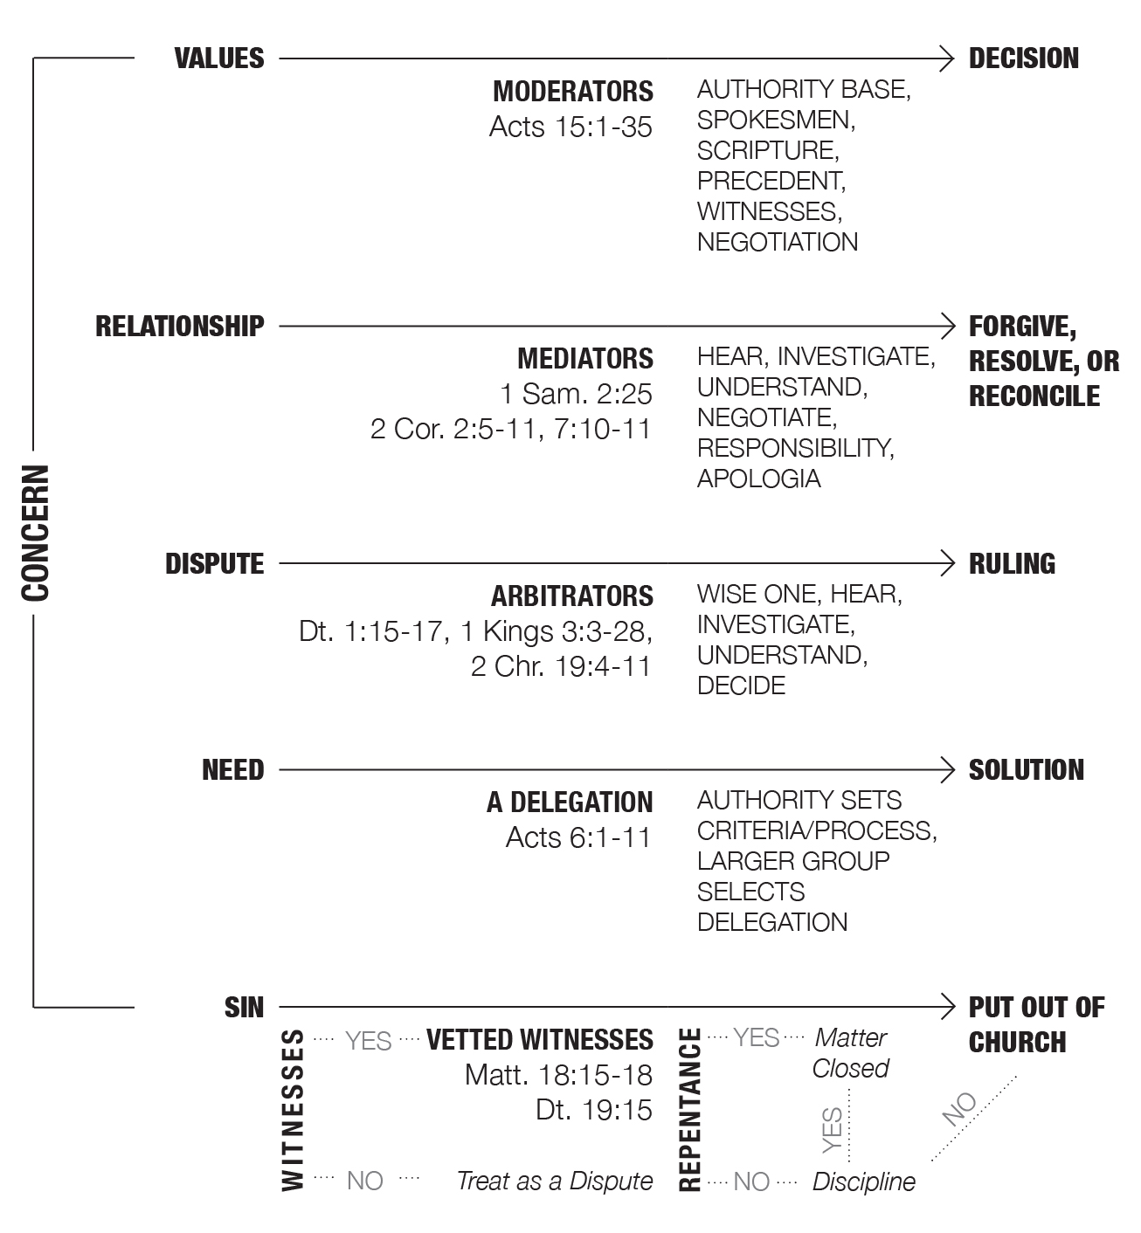
Classifying and Processing Concerns

A crucial aspect in solving problems is communication. Sometimes problems are misinterpreted, resulting in danger (Joshua 22). Calm, fact-based communication is a prerequisite to understanding and solving a matter (Acts 6:1–7; Acts 15).

- Identify Gifted Mediators & Moderators. When a community develops problem solvers, there are numerous benefits. It means that problems can be solved before they even reach the leadership. This recommendation is not without biblical precedent.
Much of the foundation for conflict resolution in congregational life is grounded in the Old Testament’s dictates for the use of competent third-party guides, the requirement for impartial investigations, and the pursuit of justice (Deut. 16:18–20, 17:8–13, 19:15–19). It was common to have a tribal leader, a priest, a king, or other dedicated officials serve in this way (Deut. 1:15, 21:5; 1 Kings 3:16–28; 2 Chr. 19:4–11). By following this example, the Christian community can avoid the debacle described in 1 Corinthians 6:1–6.
One of the hidden benefits of identifying mediators and establishing solid processes is that misbehaving Christians, including some leaders, will be less likely to act unruly. A proactive approach is a deterrent to internal disruption and allows the church to be a stronger witness.
Recommended Reading for Mediators: Arbinger Institute, The Anatomy of Peace: Resolving the Heart of Conflict; Kenneth C. Newberger, Hope in the Face of Conflict: Making Peace with Others the Way God Makes Peace with Us; and William Ury, The Third Side: Why We Fight and How We Can Stop

- Recapture Your Congregation’s Vision, Mission, etc. Over time, congregations are prone to develop a blurred recollection of their greater story, including their core values, vision, and mission. These elements, which serve as a community’s organizing principles, determine how we collectively experience the world. But they can become casualties of transition and disuse.
Generally speaking, a disoriented congregation can recover from plateauing or disorientation when it does three things: 1) collectively recalls the reasons for its unique existence, 2) recovers (and even revises) its positive organizing principles, and 3) continues practices based on the first two.
Memorable and concise expressions help keep the most precious elements of our church communities alive. Consider a collaborative approach to putting each of the following statements into one or two sentences and then integrating them to form a single-page statement.
Story: When, why, how, and who
Core (non-negotiable) Values: What do we collectively believe?
Vision: Where are we collectively headed and what do we hope to accomplish?
Mission: What are we currently striving to do? For the next leg of our journey?

Story. Certain aspects of a congregational story are usually present—its beginning, the reason it began, and progress over time. “We began in ____ with only __ members, originally meeting in _____ with the express purpose of being disciples of Jesus. By ____ our economically and racially diverse congregation grew to ____ and eventually spread out as far as _______.”
Core Values. The tenets are usually based on passages such as Matthew 5:1–16, Matthew 28:16–20, John 13:34–35, John 17:20–23, Acts 2:29–39, 1 Corinthians 15:3–8, Philippians 2:6–8, and Ephesians 4:3–6.
Vision. A standard vision serves as a unifying focal point for members in the congregation—a type of North Star. Your vision statement should be something this generation or the next generation can achieve.
For instance, the nation of Israel set out to move over two million men, women, and children to the home of their ancestors, a land filled with milk and honey. Going to the Promised Land was an awe-inspiring vision that took forty years to accomplish—yet it would have taken less time if they had stayed grounded spiritually.
Visions can inspire. The following parable illustrates the importance of knowing the answer to the question, “What is your vision?”
A man came upon a construction site where three people were working. He asked the first, “What are you doing?” and the man replied, “I am laying bricks.” He asked the second, “What are you doing?” and the man replied, “I am building a wall.” As he approached the third, he heard him humming a tune as he worked, and asked, “What are you doing?” The man stood, looked up at the sky, and smiled, “I am building a cathedral!”
The parable is based on the true story of Sir Christopher Wren’s 1673 masterpiece in central London, St. Paul’s Cathedral, which took nearly thirty-five years to construct. The term cathedral thinking is used in both religion and business, borrowing from this story the idea that workers who build large endeavors may not see the result in their lifetime.
King David and the people of Israel employed cathedral thinking when God provided a vision for the temple that Solomon would complete. Think of the overlapping ministries of Ezra the priest and Nehemiah the governor, and what they were able to accomplish under great adversity—rebuilding the temple and walls of Jerusalem. Similarly, the early Boston Church of Christ embraced the saying, “We will reach the entire world in one generation.” The result of this cathedral thinking was the planting of fifty churches around the world, many of which planted other churches.
Mission. A mission is one leg on the longer journey. A mission, like a vision, can provide much inspiration. For instance, Paul’s intention of launching missions in unreached Gentile regions such as Spain is inspiring (Rom. 15:14–29).
Missional declarations inspire because they are tangible and measurable. Sometime around 1995 the ICOC established a mission to “plant a true church of disciples in all 170 nations with a city of over 100,000 by the year 2000.” At times, this mission was not accompanied by the necessary circumspection and competencies, but it was a clear mission. When a mission is reaching fulfillment, whether it has succeeded or failed, a suitable assessment helps prepare for the next mission—what worked? What didn’t, and what are our new priorities?
It is recommended that sometime in the future, after following the following the “Specific Advice” section, the KC leadership dedicate whatever time and energy is required to refresh its vision and mission. Due to the prominence of the University of Tennessee in the state and the country, this will certainly involve campus ministry.

- Come Together “with One Accord.” The Knoxville Church is rethinking how it will be led. This can be challenging and will require that the church members work to come together with one accord, beginning with the representative leaders and board.
The Greek word homothumadon means a purposeful agreement to move together as one. It is formed by two words: homo and thumas. Homo means one or the same. Thumas can mean spirited, passionate, or fierce, often associated with intense fury. When these two words come together, the new word means to “rush along” and “in unison,” suggesting “progressive power” or “harmonic progression.” The NASB translates it as “with one accord” and “with one mind.”
The word homothumadon occurs most often in the Book of Acts and is linked with progress (Acts 1:14, 2:46, 4:24, 5:12, 8:6, 15:25).
Acts 1:14 – These all with one mind (homothumadon) were continually devoting themselves to prayer, along with the women, and Mary the mother of Jesus.
Acts 2:46 – Day by day continuing with one mind (homothumadon) in the temple, and breaking bread from house to house, they were taking their meals together with gladness and sincerity of heart.
Acts 4:24 – And when they heard this, they lifted their voices to God with one accord (homothumadon) and said, “O Lord, it is You who made the heaven and the earth and the sea, and all that is in them.”
Acts 5:12 – many signs and wonders were taking place among the people; and they were all with one accord (homothumadon) in Solomon’s portico.
Acts 8:6 – The crowds with one accord (homothumadon) were giving attention to what was said by Philip, as they heard and saw the signs which he was performing.
Acts 15:25 – It seemed good to us, having become of one mind (homothumadon), to select men to send to you with our beloved Barnabas and Paul.
There are harmful versions of homothumadon, such as angry mobs on the warpath and stampeding in Acts 7:57, 12:20, 18:12, and 19:29.
The only use of the word in the epistles occurs near the end of Paul’s letter to “all in Rome who are loved by God and called to be his holy people” (Rom. 1:7)
Now may the God who gives perseverance and encouragement grant you to be of the same mind with one another according to Christ Jesus, so that with one accord (homothumadon) you may with one voice glorify the God and Father of our Lord Jesus Christ. (15:5–6, emphasis added)
We are supposed to be of the same mind about Jesus while we are in one accord as we collectively glorify God. We each have a part in this achievement.
    - “One Accord” Practice for Leaders – Cultivate ways for people’s voices to be heard. Develop processes and roadmaps for presenting a different idea to be listened to, heard, and examined. This includes concerns and questions. James describes the kind of people that are approachable and easy to work with: “But the wisdom that comes from heaven is first of all pure; then peace-loving, considerate, submissive, full of mercy and good fruit, impartial and sincere” (James 3:17).
    - A “One Accord” Disposition for Everyone – There is no rank of worth in the body of Christ. See 1 Corinthians 12:15–25.
Paul’s correlation between the interdependent nature of the human body and the church body can be expanded upon. The heart is not more essential than the lungs, the kidneys, or the nervous system. The heart cannot trump other parts with, “I pump blood, so everyone depends on me,” nor is it correct for the nervous system to say, “I do all the communicating, so I am top dog.” All parts are essential.

Specific Advice for the Knoxville Church

This section lists the things that initially address most of the areas described under “Room for Improvement.” It is not necessary to focus on all areas for improvement at the same time, because a wise starting point can cascade to the other areas. The following recommendations were created specifically for the KC, and they are based on the idea that the church needs a reset of decision-making processes, aligning people in their roles, and congregational shepherding.
The idea of a reset is not new. Sometimes a leadership team can internally reevaluate its alignment and make significant changes, and at other times they can do so through outside counsel. Some resets are serious, and others are minor. The reasons for a realignment vary, but they usually involve increased insight about the strengths, gifts, and weaknesses of the leadership team. A reset typically results in some combination of enhanced structure, roles, commitments, and processes. Let’s look at two examples.
The Bible. King David and Israel’s elders brought together warring parties within Israel after the death of Saul through a concise review of what happened and a commitment to a covenant (2 Sam. 5:1–3). King Jehoshaphat had slipped into a dangerous alliance, but after a correction from an observer, he recovered long-lost organizing principles and processes that go back to the time of Moses (2 Chr. 19:1–11). Following the death of Ahaz, the new king, Hezekiah, presented an objective narrative of what happened during the previous generation. They were able to recover long-ignored practices and purify the temple (2 Chr. 29). In all three situations, the larger system was given priority, rather than the interests of those in power. A corollary approach has been used in secular society, alongside restorative justice practices, to resolve tribal and national conflicts.
Mediation & Consulting. The Japanese horticultural concept of cleansing centered on bonsai plants became a metaphor for organizational cleansing. There are over thirty diseases that can occur in a bonsai colony, and the infection can spread through the air, through plant-to-plant contact, or through the soil. It is often very difficult to diagnose the source of an illness, so even an expert gardener might misidentify the source and remove an otherwise good plant. To address the situation with the much greater possibility of a safe colony, the solution is found in nemawashi, an agricultural term that means “the preparation of the soil and the roots before transplanting.” The gardener digs up each of the plants in and close to the contaminated system and cleans them from top to bottom, then replants each bonsai but not in the same place.
By metaphorical extension, the wellness of the conflicted individuals and their relational system might need cleansing and a new arrangement. Japanese problem solvers propose practices, changes, and realignments in order that the group will find itself in a new relational dynamic—even if the exact cause of a problem was not entirely clear or completely agreed upon.
The “comprehensive reset” that has been described borrows concepts from the Old Testament and other sources. In some cases, it can involve conventional investigative and conciliation techniques that call on conflicted parties to allow for a fresh start where old issues have created a serious impasse. This method has been very useful for many situations, such as: when crucial facts of a matter were difficult or impossible to verify, memories were unreliable or conflicting, the conflicts were high on the scale of intensity, and/or other efforts to address the dilemma had not been effective. It is also helpful after a significant disorienting event. Even though the KC church doesn’t possess known unresolved internal conflicts, it experienced challenges in 2017 that have lingered, as well as the disorienting departure of its previous leaders.

Recommendations for the KC Leadership and the Board
#1 Memorialize major lessons learned. Well-recorded events in the past are useful for teaching us essential lessons (1 Cor. 10:1–13). It is difficult to memorialize lessons from past challenges when the events happened long before and went unrecorded. Therefore, it is recommended that churches keep records for major high-stakes events such as a crisis, carrying out a church discipline, a public warning, a reported conflict of interest, or the termination of an employee. This is also true for positive actions such as hiring a lead couple or appointing elders. If the event went exceptionally well or unusually badly, it is wise to perform a review. There are two basic kinds of reviews that can serve a church.
A Postmortem Review is a process, usually performed following an organizational failure or an event with significant consequences, for understanding the matter and determining how it was mitigated. This form of review is sometimes labeled a Retrospective or Lessons-Learned Report.
An After-Action Review is a concept that originated in the military. It is sometimes used as a planned, structured debriefing process for analyzing events, and it includes questions about what happened, why it happened, and how it could have been done better by those responsible for the project or event. It is also used when the matter at hand turned out to be an unprecedented success.
The goal of both review processes is to codify the learnings for future benefit. Typical questions include: What was expected to happen according to plan? Or what should have happened during the unplanned event? What occurred? Why was there a difference between expectations and reality? What can be learned?

Moderating Congregational Change and Conflict
What happened in 2017? There is a consensus that the way matters were handled in 2017 that led to the departure of prominent members could have gone differently. What should have happened? We should have used a comprehensive, widely trusted third-party process for moderating the topic of members meeting in separate house churches, addressing alleged issues of poor behaviors, mediating conflicts among relationships, advising on church discipline, and issuing warnings. What can be learned? There was some helpful outside assistance. However, a more formal team approach was needed that would have required conciliators to be present (comparable in scope to the current consultation). Even the best leadership teams benefit from having outside guides, especially when emotions run high.

Vetting Processes for Hiring in Leadership Roles
The overall hiring processes for the ICOC and KC can benefit from the learning curve of other congregations. What kinds of things go wrong? Over the years, the following missteps and mistakes have occurred:
- Due to overly relying on a mother church or prominent person that decided on behalf of the local church, they were sent an evangelist without consideration. This rarely happens today.
- Due to weak inquiry, the local leaders and board were unaware of the candidate’s legacy as a minister in other churches; their gifts, certifications and qualifications; and their ongoing mentoring.
- Due to hasty decision-making, the leaders were unclear on the candidate’s primary role (as an elder, evangelist, etc.), responsibilities (training, teaching, shepherding), and outside commitments involving income or travel.
- Due to a lack of familiarity with legal and ethical requirements for charities, there has sometimes been a failure to discuss possible conflicts of interest, which usually means inappropriately benefitting in some way from a role.
What have other congregations learned? The way to reduce the likelihood of disappointment is to take the following steps when hiring ministers:
- Identify what is needed for a paid minister in a collaborative manner with the leadership, the congregation, and possibly even nearby churches.
- Contact the leadership of previous congregations where the candidate has served, going back at least three distinct ministries or ten years.
- Include in the decision-making process:
- The current leadership that focuses on the needs, job description, and search.
- A separate vetting team comprising those with strong experience in hiring and/or human resources. They will make recommendations and protect the confidentiality of the candidate.
- An interviewing process involving additional representatives of the congregation, which typically takes place on a weekend.
- Avoid bringing the names before the congregation until the first two steps have taken place, regardless of how their availability or interest is known. It can be hurtful for both the congregation and the candidates if hopes are dashed after a background check.
- A process that has been used in a variety of situations is described in a separate document, “Vetting Candidates for Ministry,” which is available for the leadership team.

#2 Define and align leadership roles. Picture a large ship carrying many passengers on a long journey to a distant place. A safe and orderly voyage requires that each occupant knows their role, responsibilities, strengths, and limitations. From time to time, we should ask ourselves the question, “Are people in the right seat on the ministry ship, and are there essential seats that are not filled?” Whereas a passenger ship has navigation, food service, inventory, mechanical, and many other needs, a modern congregation has shepherding and governance, the ministry of the Word, the board, and various operations for weekly and daily functions. Just as it is unwise to neglect roles and responsibilities for passenger ships, it is also the case for congregations.
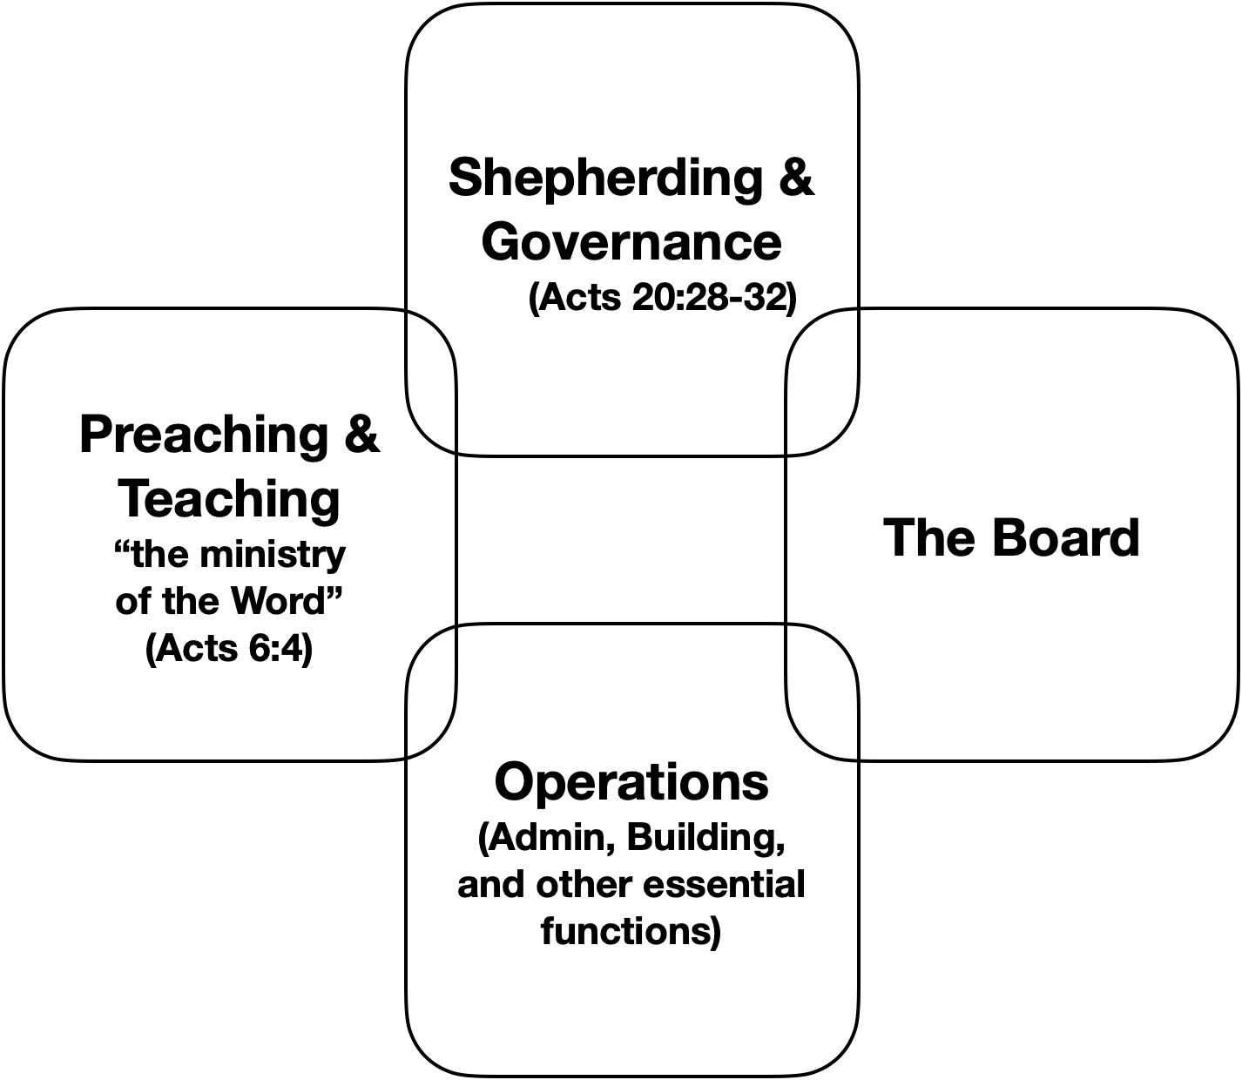
A change of roles in the KC should not be seen as punitive or political. It’s about all influencers finding their best lane and the church benefitting from the best alignment. When we serve with the unique gifts and resources that God has given our congregations, we see the best things happen. That occurs when we are valued for tasks that we are suited for and in which we find joy. When we serve in roles that don’t align with our gifts, we run the risk of disappointing ourselves and others.
The current leadership group is quite large. There is not a sense that anyone should be moved out the KC leadership but that there should be a distinction made between shepherding/governance and other spiritual services such as administration and operational functions, yet these can overlap when major decisions are made. The illustration to the right identifies the distinct categories where the congregation is being served; however, the shepherding needs to be further clarified and promoted.
Qualifications for all official roles. It is suggested that churches tie the qualifications of a deacon to all official roles even if the individual is not recognized as a deacon. This would apply to members who serve on the board, in administrative capacities (communications), in overseeing volunteers (children’s ministry), and in operations (rental arrangement, sound, a/v). All servants should “be worthy of respect, sincere, not indulging in much wine, and not pursuing dishonest gain. They must keep hold of the deep truths of the faith with a clear conscience” (1 Tim. 3:8–9).
The qualifications for shepherding and managing difficulties would require additional parameters:
- Are trustworthy (Exo. 18:21)—fears God, hates dishonest gain
- Are wise, possess understanding, and are respectable (Deut. 1:9-18)
- Have the availability of time, the capacity to fully engage, and the willingness to serve
- Are calm during storms—the word nephalios in 1 Timothy 3:2 (men) and 3:11 (women) is usually translated “temperate,” “sober-minded,” or “self-controlled” and means free from excessive influence of passion of emotion.
The KC has individuals who appear to be qualified to serve as elders, though most of the functions of shepherding do not require an official appointment.
Alignments. A rule of thumb is that individuals should be valued for tasks that they are suited for and in which they find joy. The Browns and the Statens learned from our interviews who is valued for preaching and teaching, as well as for shepherding. We did not ask about operations or the board.
Those who seem to possess the qualifications required to fulfill shepherding responsibilities include some members of the current leadership team and others in the congregation. When asked during interviews, “Who do you think has the abilities and trust to help the congregation in the event of a significant challenge?” the names that were most frequently mentioned were Dan Downs, Al Growdon, Hoyt Williams, and Bill Graham.
When asked, “Who are those who can preach or teach and edify the congregation?” the responses in order of frequency of mention were Kent Defee, Dan Downs, Parker Helton, and Eric Decker.

#3 Improve decision-making practices. Congregations can get stuck when making decisions because responsibilities have not been clearly defined and processes are unclear. And a decision made by one person or group might indirectly affect another group, which requires collaboration.
Major decisions can be made in one of three ways:
- A lone leader makes a unilateral decision—high risk, eventually has consequences
- The requirement of unanimity—often troublesome because it usually keeps the church in limbo and gives even a struggling or potentially unqualified person veto power
- Support a consensus (majority support)—very good, providing the topic was thoroughly considered and the right people were in the room

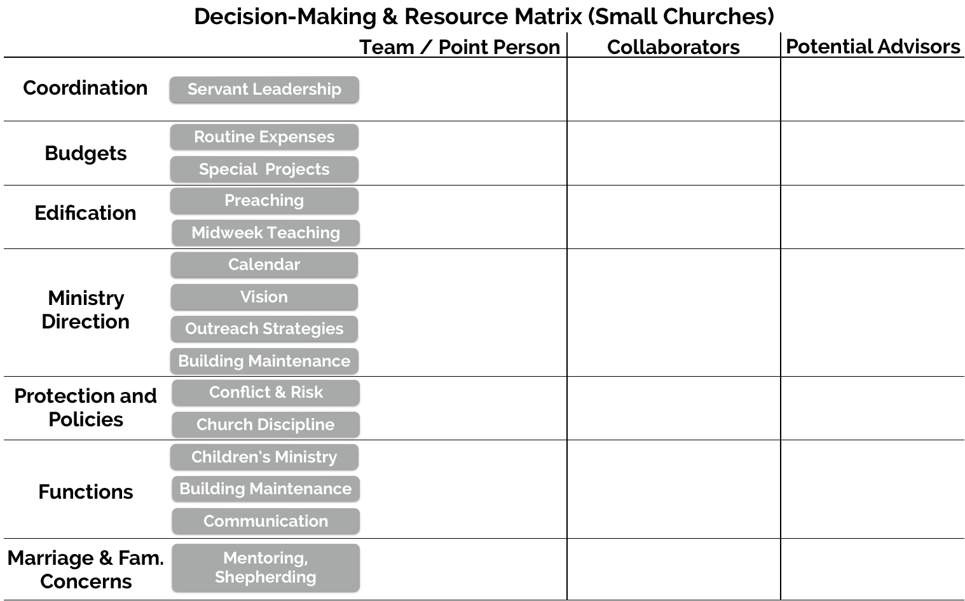
The following matrix is based on the idea that number 3 is the best way for congregational leaders to make decisions. The graphic is for illustration purposes. A custom KC matrix may look different.

Recommendations for All KC Members

Make an earnest effort to recapture your greatest faithfulness (Hebrews 10:32–36).
The Hebrew writer draws the reader to the endurance, joy, and confidence of their “earlier days.” For some of the older saints in Rome (Acts 2:10, Rom. 1:7), this could have been three decades earlier.
Remember those earlier days after you had received the light, when you endured in a great conflict full of suffering. Sometimes you were publicly exposed to insult and persecution; at other times you stood side by side with those who were so treated. You suffered along with those in prison and joyfully accepted the confiscation of your property, because you knew that you yourselves had better and lasting possessions. So do not throw away your confidence; it will be richly rewarded.
You need to persevere so that when you have done the will of God, you will receive what he has promised. (Heb. 10:32–36, emphasis added)
When congregations find themselves in a plateau or decline, it becomes tempting for members of the body to overly focus on causes outside themselves. Sure, it can be explained by leadership weaknesses and other things outside the responsibility of the congregant, but there is a role that everyone plays in helping the church recover. Ask yourself an important question: Are you being as faithful as you were in “those earlier days,” are you as resilient against “insult and persecution,” and are you joyful when wronged?
While some aspects of the past are not retrievable or practical, and the glory days of our memories had their own set of problems, we can achieve a similar inner spiritual life to the one we had during our greater times. To a large degree, we get out of our Christian walk and church experience what we put into it. When we invest time in our devotional practices and our spiritual relationships, we experience the same benefits that we had during our best days—endurance, joy, and confidence.
One of the keys, the author of Hebrews believes, was recovering the “daily” aspect of our fellowship for encouragement and spurring one another on (Heb. 3:12–14, 10:24–25). Consider what attitudes and practices you have lost and are willing to recover.

CONCLUSION

The order of priories, attention, and timing are to be established by the local leadership. It is advised that the leadership have at least one week to look over the report and its main recommendations before releasing it to a wider audience.
We suggest that the leadership group begins by embracing the portions of the “Specific Advice” section that it believes will have the greatest cascading effect on the KC. You might not all fully agree with each recommendation, and that’s okay, so I suggest you begin with the ones with which you are in greatest agreement. Prayerfully, some sections of the report will still be useful for a long time to come. We look forward to hearing about your progress.
The full consulting team (the Browns and the Statens), as well as other representatives in Nashville and the Southeast are interested in your progress and available as advisors. We will coordinate with each other if consulted so that we don’t offer contradictory counsel.

Best wishes, in Christ,
Stephen F. Staten, congregational health consultant

Reviewed by
Patricia J. Staten, consultant, mediator
Steve Brown, consultant, interim leader
Diane Brown, consultant, interim leader

Mark Lau Branson, Memories, Hopes, and Conversations: Appreciative Inquiry and Congregational Change (Lanham, MD: Rowman & Littlefield), Kindle Edition, Kindle locations 621–622.
Verses in this section are from the NASB1995, with emphasis added.

