Faith Evangelical Lutheran Church, Washington, IL
Fifth Sunday of Lent
April 3, 2022

Welcome
Confession and Forgiveness

P: In the name of the Father, and of the + Son, and of the Holy Spirit.
C: Amen.
You may make the sign of the cross as a reminder of your baptism.
We come before God, who makes a way in the wilderness,
walks with us, and guides us in our pilgrimage.

Holy One,
we confess that we have wandered far from you:
we have not trusted your promises,
we have ignored your prophets in our own day,
we have squandered our inheritance of grace,
we have failed to recognize you in our midst.
Have mercy on us!
Forgive us and turn us again to you.
Teach us to follow in your ways,
assure us again of your love,
and help us to love our neighbor.
Amen.
Beloved in Christ,
the Word draws near to you,
and all who call out to God shall be saved.
In Jesus, God comes to you again and again
and gathers you under wings of love.
In ☩ Jesus’ name, your sins are forgiven.
God journeys with you and teaches you how to live in love.
Amen.

Peace: As baptized and forgiven children of God,
Faith Lutheran Church
2206 Washington Rd,
Washington, IL 61571
Website and online worship:
www.shareourfaith.org
Church: 309-745-9306
faithlth@shareourfaith.org
Pastor John Rothfusz
Home: 309-745-9282
pastor@shareourfaith.org
we have peace with God, and peace with one another.
P The peace of the Lord be with you always.
C And also with you.
P Let us share that peace with one another.
*Hymn: “Through the Night of Doubt and Sorrow” Red Book #327

Text: Bernhardt S. Ingemann, 1789-1862; tr. Sabine Baring-Gould, 1834-1924, alt.
Music: EBENEZER, Thomas J. Williams, 1869-1944
Reprinted under OneLicense.net#A-711151
P The grace of our Lord Jesus Christ, the love of God,
and the communion of the Holy Spirit be with you all.
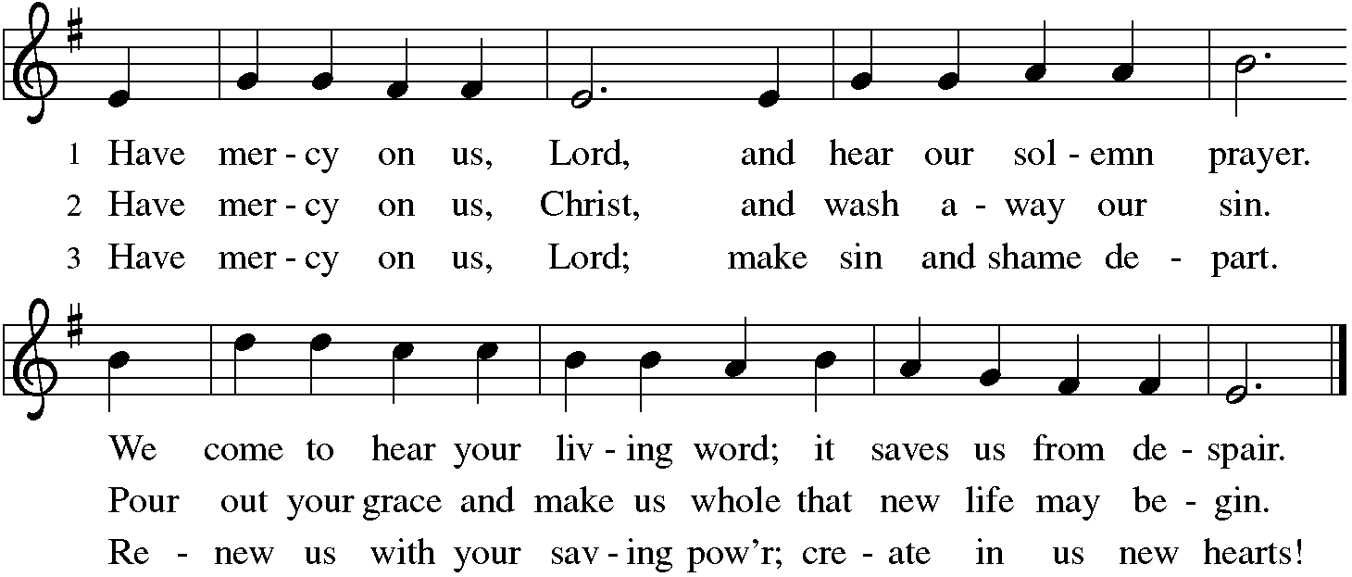
C And also with you.

Hymn of Praise
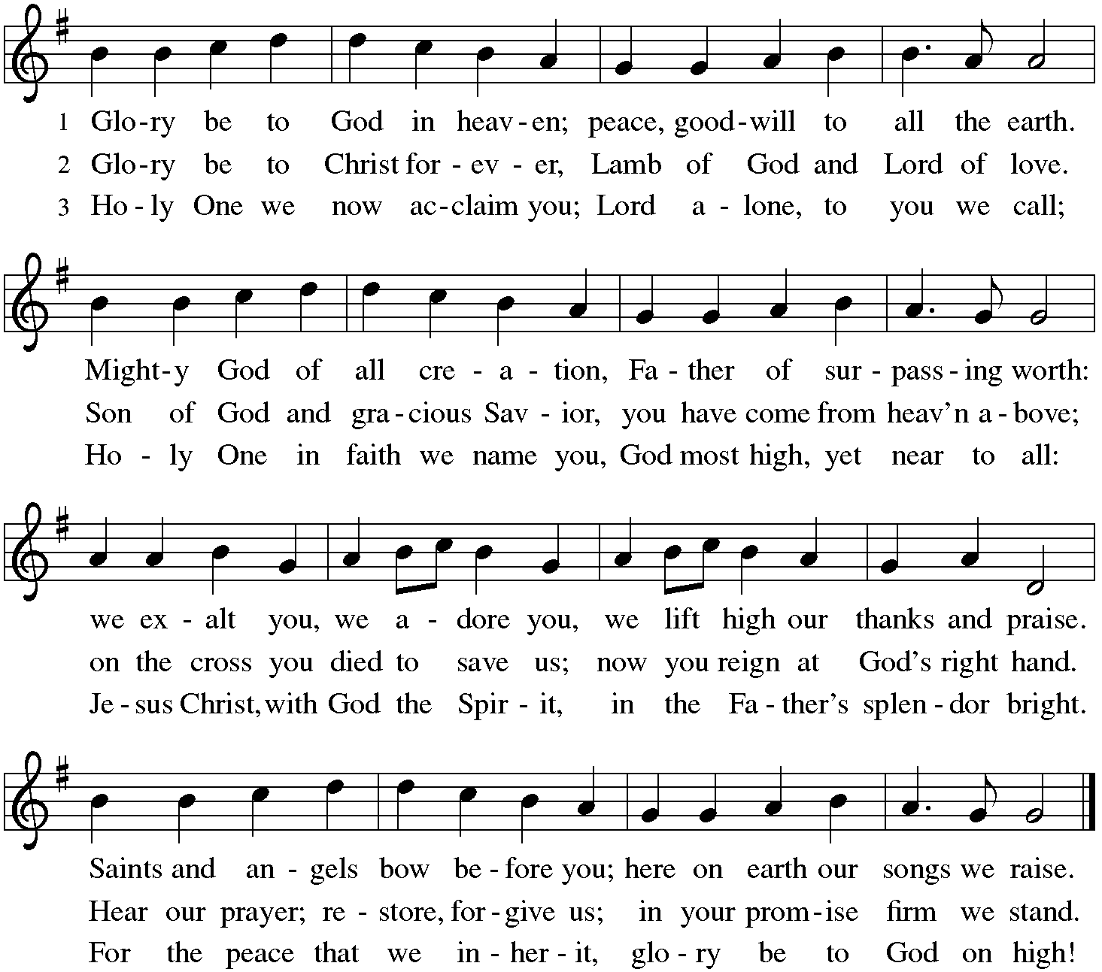

P The Lord be with you.
C And also with you.

Let us pray together the Prayer of the Day
Creator God, you prepare a new way in the wilderness, and your grace waters our desert. Open our hearts to be transformed by the new thing you are doing, that our lives may proclaim the extravagance of your love given to all through your Son, Jesus Christ, our Savior and Lord, who lives and reigns with you and the Holy Spirit, one God, now and forever. Amen.

Children’s Message

First Reading: Isaiah 43:16-21 Pew Bible Page #582
¹⁶Thus says the Lord, who makes a way in the sea, a path in the mighty waters,
¹⁷who brings out chariot and horse, army and warrior; they lie down, they cannot rise, they are extinguished, quenched like a wick: ¹⁸Do not remember the former things, or consider the things of old. ¹⁹I am about to do a new thing; now it springs forth, do you not perceive it? I will make a way in the wilderness and rivers in the desert. ²⁰The wild animals will honor me, the jackals and the ostriches; for I give water in the wilderness, rivers in the desert, to give drink to my chosen people,
²¹the people whom I formed for myself so that they might declare my praise.
R The Word of the Lord
C Thanks be to God

Psalm 126
¹When the Lord restored the fortunes of Zion,
then were we like those who dream.
²Then was our mouth filled with laughter, and our tongue with shouts of joy.
Then they said among the nations, “The Lord has done great things for them.”
³The Lord has done great things for us,
and we are glad indeed.
⁴Restore our fortunes, O Lord,
like the watercourses of the Negeb.
⁵Those who sowed with tears
will reap with songs of joy.
⁶Those who go out weeping, carrying the seed,
will come again with joy, shouldering their sheaves.

Second Reading – Philippians 3:4b-14 Pew Bible Page #953
[Paul writes:] ^{4b}If anyone else has reason to be confident in the flesh, I have more: ⁵circumcised on the eighth day, a member of the people of Israel, of the tribe of Benjamin, a Hebrew born of Hebrews; as to the law, a Pharisee; ⁶as to zeal, a persecutor of the church; as to righteousness under the law, blameless.
⁷Yet whatever gains I had, these I have come to regard as loss because of Christ. ⁸More than that, I regard everything as loss because of the surpassing value of knowing Christ Jesus my Lord. For his sake I have suffered the loss of all things, and I regard them as rubbish, in order that I may gain Christ ⁹and be found in him, not having a righteousness of my own that comes from the law, but one that comes through faith in Christ, the righteousness from God based on faith. ¹⁰I want to know Christ and the power of his resurrection and the sharing of his sufferings by becoming like him in his death, ¹¹if somehow I may attain the resurrection from the dead.
¹²Not that I have already obtained this or have already reached the goal; but I press on to make it my own, because Christ Jesus has made me his own. ¹³Beloved, I do not consider that I have made it my own; but this one thing I do: forgetting what lies behind and straining forward to what lies ahead, ¹⁴I press on toward the goal for the prize of the heavenly call of God in Christ Jesus.

R The Word of the Lord
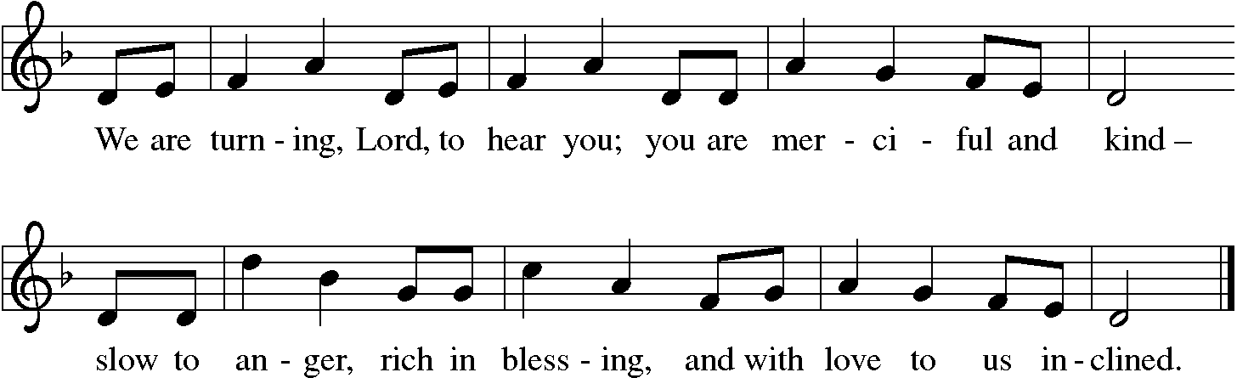
C Thanks be to God

Gospel Reading: John 12:1-8 Pew Bible Page #871

C Glory to you, O Lord
¹Six days before the Passover Jesus came to Bethany, the home of Lazarus, whom he had raised from the dead. ²There they gave a dinner for him. Martha served, and Lazarus was one of those at the table with him. ³Mary took a pound of costly perfume made of pure nard, anointed Jesus’ feet, and wiped them with her hair. The house was filled with the fragrance of the perfume. ⁴But Judas Iscariot, one of his disciples (the one who was about to betray him), said, ⁵“Why was this perfume not sold for three hundred denarii and the money given to the poor?” ⁶(He said this not because he cared about the poor, but because he was a thief; he kept the common purse and used to steal what was put into it.) ⁷Jesus said, “Leave her alone. She bought it so that she might keep it for the day of my burial. ⁸You always have the poor with you, but you do not always have me.”

The Gospel of the Lord
C Praise to you, O Christ

Sermon by Pastor John Rothfusz
Sermon Hymn: “My House Is Built on Nothing Less” Red Book #597

Text: Edward Mote, 1797-1874, alt.
Music: MELITA, John B. Dykes, 1823-1876
Public Domain

Let us confess our faith in the words of the Nicene Creed:

We believe in one God, the Father, the Almighty,
maker of heaven and earth,
of all that is, seen and unseen.
We believe in one Lord, Jesus Christ, the only Son of God,
eternally begotten of the Father,
God from God, Light from Light,
true God from true God,
begotten, not made,
of one Being with the Father;
through him all things were made.
For us and for our salvation
he came down from heaven,
was incarnate of the Holy Spirit and the virgin Mary
and became truly human.
For our sake he was crucified under Pontius Pilate;
he suffered death and was buried.
On the third day he rose again
in accordance with the scriptures;
he ascended into heaven
and is seated at the right hand of the Father.
He will come again in glory to judge
the living and the dead,
and his kingdom will have no end.
We believe in the Holy Spirit, the Lord, the giver of life,
who proceeds from the Father and the Son,*
who with the Father and the Son
is worshiped and glorified,
who has spoken through the prophets.
We believe in one holy catholic and apostolic church.
We acknowledge one baptism for the forgiveness of sins.
We look for the resurrection of the dead,
and the life of the world to come. Amen.

*Or, "who proceeds from the Father." The phrase "and the Son" is a later addition to the creed.

Prayers: After each portion of the prayers finishes with “Lord in your mercy,” please respond, “Hear our prayer.”

Offering: Jesus fills us with faith and sends us out as his witnesses. Let us commit ourselves to the Lord and joyfully lift our tithes and offerings to the Lord.

Please take a moment now to make an electronic offering to the church on the website, with the Tithe.ly app on your phone, or write a check and drop it in the plate at communion time.
Faith Lutheran website link www.shareourfaith.org

Offering Prayer

Great Thanksgiving
P The Lord be with you.
C And also with you.
P Lift up your hearts.
C We lift them to the Lord.
P Let us give thanks to the Lord our God.
C It is right to give God thanks and praise.

P It is indeed right, our duty and our joy… with the church on earth and the hosts of heaven, we praise your name and join their unending hymn:
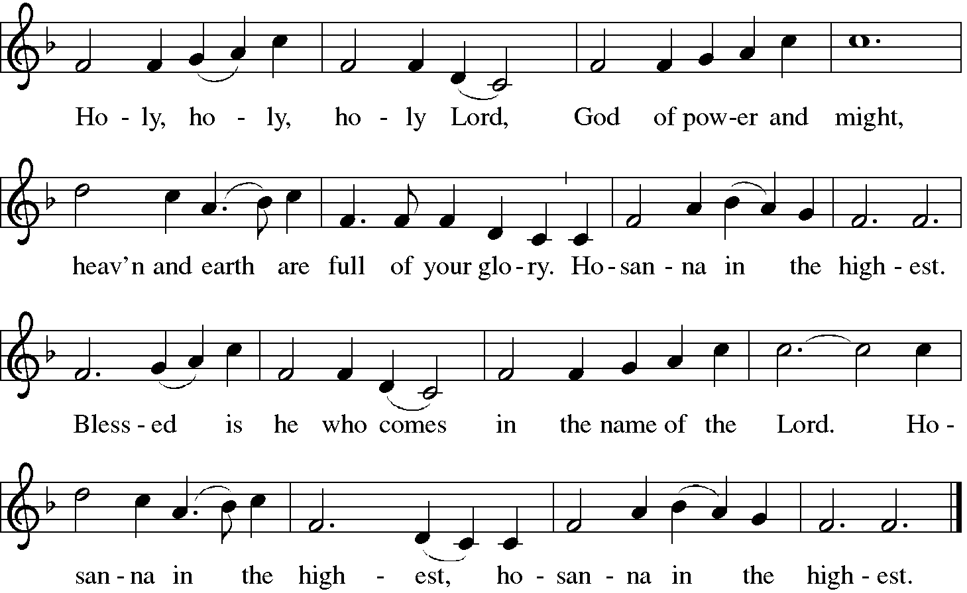
Sanctus (Holy, Holy, Holy)

Holy Communion: Preface pp. 108-111 or other Eucharistic prayer
In the night in which he was betrayed,
our Lord Jesus took bread, and gave thanks;
broke it, and gave it to his disciples, saying:
Take and eat; this is my body, given for you.
Do this for the remembrance of me.
Again, after supper, he took the cup, gave thanks,
and gave it for all to drink, saying:
This cup is the new covenant in my blood,
shed for you and for all people for the forgiveness of sin.
Do this for the remembrance of me.
…we proclaim the Lord’s death until he comes.
Christ has died, Christ has risen, Christ will come again….
…from the bonds of slavery and death.
Come Lord Jesus….
…to pursue love and justice in all the world.
Come Holy Spirit….
…now and forever.
Amen

C The Lord's Prayer
Our Father, who art in heaven, hallowed be thy name,
thy kingdom come, thy will be done, on earth as it is in heaven.
Give us this day our daily bread; and forgive us our trespasses,
as we forgive those who trespass against us;
and lead us not into temptation, but deliver us from evil.
For thine is the kingdom, and the power, and the glory,
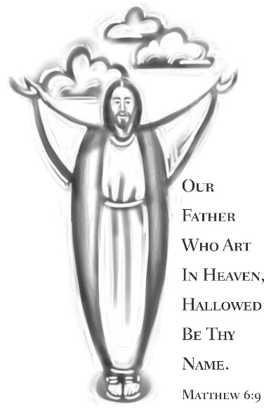
forever and ever. Amen

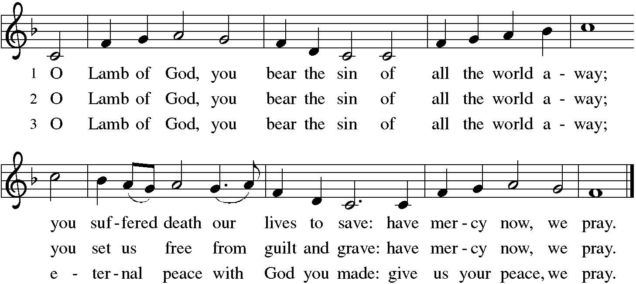

Distribution:

Communion Prayer

Announcements
Blessing
P The Lord bless you and keep you.
The Lord make his face shine on you and be gracious to you.
The Lord look upon you with favor and + give you peace.
In the name of the Father, and of the Son and of the Holy Spirit.
C Amen

Hymn: “Beneath the Cross of Jesus” Red Book #338

Text: Elizabeth Clephane, 1830-1869
Music: ST. CHRISTOPHER, Frederick C. Maker, 1844-1927 Public Domain

Dismissal
A Go in peace. Serve the Lord. C Thanks be to God!
Postlude
Liturgy and texts from Sundays and Seasons.com. Copyright 2022 Augsburg Fortress. All rights reserved. Reprinted by permission under Augsburg Fortress Liturgies Annual License #23628.

