March 27, 2022
Loving Our Neighbor
Welcome, Welcome, Welcome
“Living and Loving Like Jesus”
Living and loving like Jesus is only possible if Jesus is abiding in us and us in Him!!!

John 15:5c “…apart from me you can do nothing.”
But…If a person remains in me and I in them, he/she will bear much fruit… John 15:5b
Prayer
Love, Grow, Give, Go
Today we are going to focus on the concept of LOVING Our Neighbor
Please remember that we are to AGAPE LOVE our neighbor both, personally and corporately
What are the greatest Commandments?
Matthew 22:37-40 “Love the Lord your God with all your heart and with all your soul and with all your mind. This is the first and greatest commandment. And the second is like it: ‘Love your neighbor as yourself.’ All the Law and the Prophets hang on these two commandments.”
Let’s look a little closer
The “Second” Commandment “And the second is like it: ‘Love you neighbor as yourself.’”
Actually, “’AGAPE’ Love your neighbor as yourself.”
“Agape Love” – Acting in another person’s best interest, with eternity in view, even if it costs me personally.
BUT there appears to be an underlying assumption in the Second Command?

AGAPE love your neighbor AS you AGAPE love yourself.
A person might argue that, although implied, there appears to be a THIRD Commandment
Is it possible that before a person can fully AGAPE LOVE someone else, he/she must first love himself/herself?
“The illiterate of the 21st Century will not be those who cannot read and write, but those who cannot learn, unlearn and re-learn,” Alvin Toffler
In his Institutes, some scholars say that John Calvin basically says that a person must have knowledge of self, in order to deny oneself.
Question: What is the difference between a healthy self-image and Narcissism/self-centeredness? It seems as though many parents unknowingly tend to instill shame in children to avoid creating a Narcissistic child!
For a Believer, our worth and value comes from God and Jesus Christ’s finished work on the cross.
For others there is an ongoing desire to feel good about oneself through striving for a sense of being accepted, having significance, or striving for a sense of security (SDI).

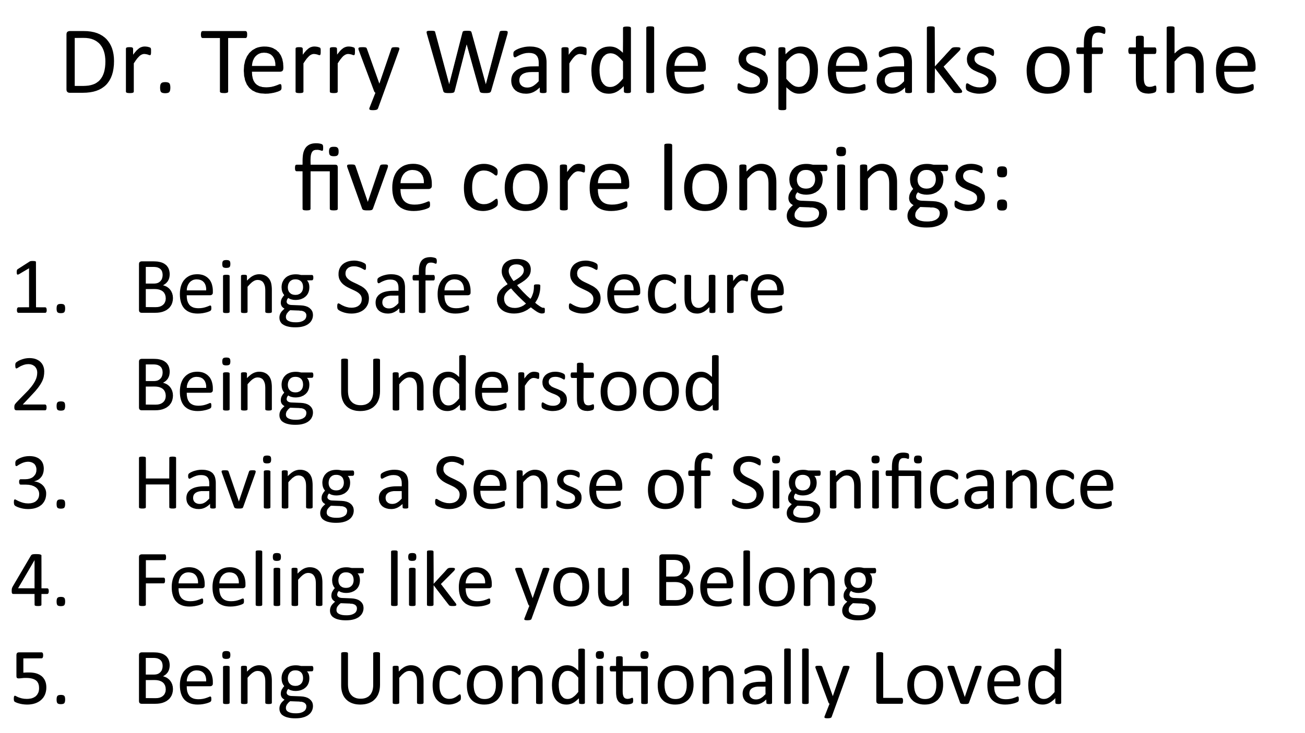

Many times, rather than looking to God, people turn to other things/people to meet these core longings.
“My people have committed two sins: 1) They have forsaken me, the spring of living water, and 2) have dug their own cisterns, broken cisterns that cannot hold water.” Jeremiah 2:13
What did Adam & Eve do in the Garden of Eden? One aspect of the temptation was: You don’t need God to be significant, just eat the fruit and you will be like God. (You will have wisdom, knowledge, etc.)
Every temptation and sin is based upon a lie!!!
Then Adam & Eve hid and made coverings out of fig leaves. Humanity is still making fig leaf coverings.
As the Apostle Paul and Scripture states, “Let him who boasts, boast in the Lord.” 1 Corinthians 1:31 (Jer. 9:23, Ps 34:2, 44:8, 2 Cor 10:17)
ANOTHER SCENIC VIEW
Food for thought related to the difference between: Healthy Self-image & Self-centered Narcissism
Key Question: What or who is the primary source of our Core Longings? Things/People or God
For many of us, we know this in our heads, but not in our hearts! Sometimes, it seems easier to pretend to love others rather than it is to love oneself!
Rhetorical Question: Can a person truly AGAPE love others more than he/she currently AGAPE loves himself/herself?
KEY CONCEPT: One way to have and maintain a healthy view of oneself: REMEMBER who has been made in the image of God? (Ps 119) All people!!! (Does that include YOU?) YES! Does God ever make mistakes or junk? NO!!!
‘AGAPE love your neighbor as yourself.’ What are some practical ways to AGAPE love our neighbor?
Please shout out some ways to AGAPE LOVE our neighbor
As we grow into our identity in Christ, let’s start with the Golden Rule, then move onto the Royal Rule!!! (What would Jesus do?)
Key Transitional Question: Who is close to me but far from God that needs some AGAPE LOVING?
One of the best ways to AGAPE love our neighbor is by introducing them to JESUS 😊 We may not know who BUT, we know who does know. So, let’s ask Jesus!!!!

Prayer

Table Talk (Discussion Points)
Please Consider Sharing:
- What do you think about the concept that we cannot AGAPE love others beyond our ability to AGAPE love ourselves?
- What are your thoughts on hearing Jesus’ voice?
- Please share how you best hear His voice.
- What have you done to make the leap from head knowledge to heart knowledge related to your identity in Christ?
- What are some practical ways that you have used to AGAPE love your neighbor?
- What do you think about Dr. Wardle’s core longings and how people tend to fill them?
- Who do you know that is close to you and far from God? How can you demonstrate Jesus’ love to them this week?
- (OVERALL) Sharing what the Holy Spirit impressed upon you personally, during our time together.

Benediction

