Faith Evangelical Lutheran Church, Washington, IL
Fourth Sunday of Lent
March 27, 2022

Welcome
Confession and Forgiveness

P: In the name of the Father, and of the + Son, and of the Holy Spirit.
C: Amen.
You may make the sign of the cross as a reminder of your baptism.
We come before God, who makes a way in the wilderness,
walks with us, and guides us in our pilgrimage.

Holy One,
we confess that we have wandered far from you:
we have not trusted your promises,
we have ignored your prophets in our own day,
we have squandered our inheritance of grace,
we have failed to recognize you in our midst.
Have mercy on us!
Forgive us and turn us again to you.
Teach us to follow in your ways,
assure us again of your love,
and help us to love our neighbor.
Amen.
Beloved in Christ,
the Word draws near to you,
and all who call out to God shall be saved.
In Jesus, God comes to you again and again
and gathers you under wings of love.
In ☩ Jesus’ name, your sins are forgiven.
God journeys with you and teaches you how to live in love.
Amen.

Peace: As baptized and forgiven children of God,
Faith Lutheran Church
2206 Washington Rd,
Washington, IL 61571
Website and online worship:
www.shareourfaith.org
Church: 309-745-9306
faithlth@shareourfaith.org
Pastor John Rothfusz
Home: 309-745-9282
pastor@shareourfaith.org
we have peace with God, and peace with one another.
P The peace of the Lord be with you always.
C And also with you.
P Let us share that peace with one another.
*Hymn: “Amazing Grace, How Sweet the Sound” Red Book #779

Text: John Newton, 1725-1807, alt. sts. 1-4; anonymous, st. 5
Music: NEW BRITIAN, W. Walker, Southern Harmony, 1835
Public Domain

P The grace of our Lord Jesus Christ, the love of God,
and the communion of the Holy Spirit be with you all.
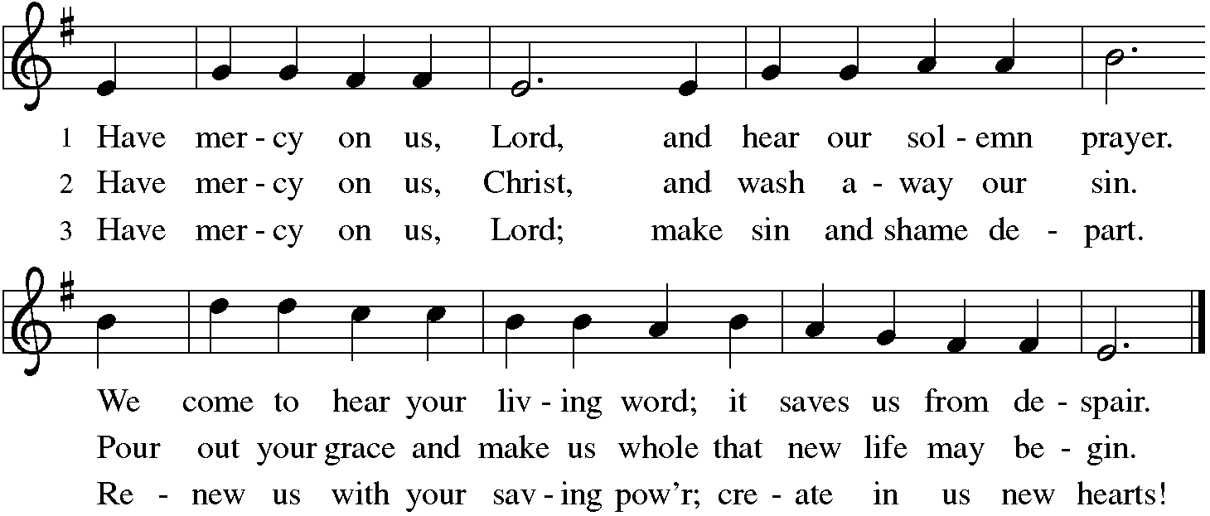
C And also with you.

Hymn of Praise
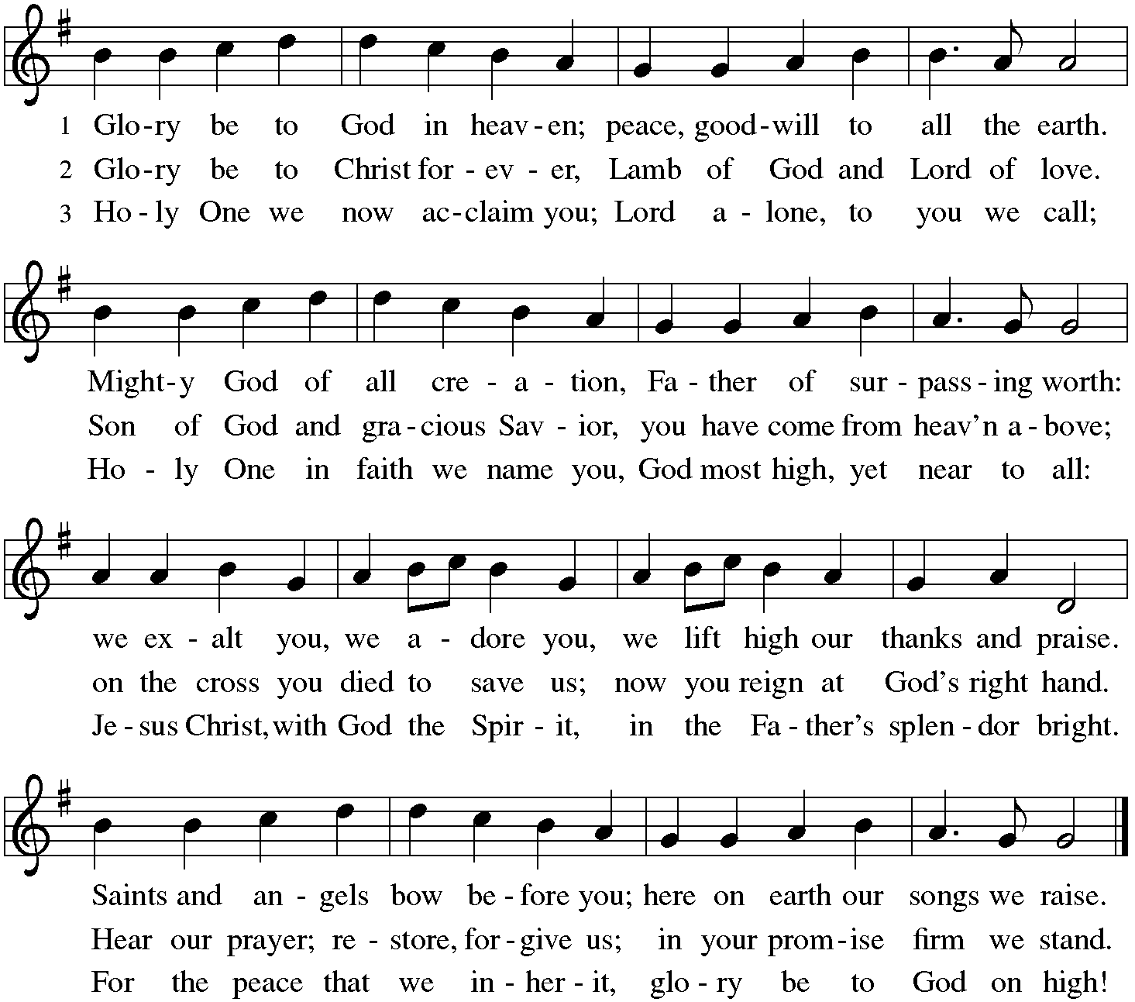

P The Lord be with you
C And also with you.

P The Lord be with you.
C And also with you.

Let us pray together the Prayer of the Day
God of compassion, you welcome the wayward, and you embrace us all with your mercy. By our baptism clothe us with garments of your grace, and feed us at the table of your love, through Jesus Christ, our Savior and Lord, who lives and reigns with you and the Holy Spirit, one God, now and forever.
Amen.

Children’s Message

First Reading: Genesis Joshua 5:9-12 Pew Bible Page #176
⁹The Lord said to Joshua, “Today I have rolled away from you the disgrace of Egypt.” And so that place is called Gilgal to this day.
¹⁰While the Israelites were camped in Gilgal they kept the passover in the evening on the fourteenth day of the month in the plains of Jericho. ¹¹On the day after the passover, on that very day, they ate the produce of the land, unleavened cakes and parched grain. ¹²The manna ceased on the day they ate the produce of the land, and the Israelites no longer had manna; they ate the crops of the land of Canaan that year.

R The Word of the Lord
C Thanks be to God

Psalm 32
¹Happy are they whose transgressions are forgiven,
and whose sin is put away!
²Happy are they to whom the Lord imputes no guilt,
and in whose spirit there is no guile!
³While I held my tongue, my bones withered away,
because of my groaning all day long.
⁴For your hand was heavy upon me day and night;
my moisture was dried up as in the heat of summer.
⁵Then I acknowledged my sin to you, and did not conceal my guilt.
I said, “I will confess my transgressions to the Lord.” Then you forgave me the guilt of my sin
⁶Therefore all the faithful will make their prayers to you in time of trouble when the great waters overflow, they shall not reach them.
⁷You are my hiding-place; you preserve me from trouble;
you surround me with shouts of deliverance.
⁸“I will instruct you and teach you in the way that you should go;
I will guide you with my eye.
⁹Do not be like horse or mule, which have no understanding;
who must be fitted with bit and bridle, or else they will not stay near you.”
¹⁰Great are the tribulations of the wicked;
but mercy embraces those who trust in the Lord.
¹¹Be glad, you righteous, and rejoice| in the Lord;
shout for joy, all who are true of heart.

Second Reading – 2 Corinthians 5:16-21 Pew Bible Page #937
¹⁶From now on, therefore, we regard no one from a human point of view; even though we once knew Christ from a human point of view, we know him no longer in that way. ¹⁷So if anyone is in Christ, there is a new creation: everything old has passed away; see, everything has become new! ¹⁸All this is from God, who reconciled us to himself through Christ, and has given us the ministry of reconciliation; ¹⁹that is, in Christ God was reconciling the world to himself, not counting their trespasses against them, and entrusting the message of reconciliation to us. ²⁰So we are ambassadors for Christ, since God is making his appeal through us; we entreat you on behalf of Christ, be reconciled to God. ²¹For our sake he made him to be sin who knew no sin, so that in him we might become the righteousness of God.

R The Word of the Lord
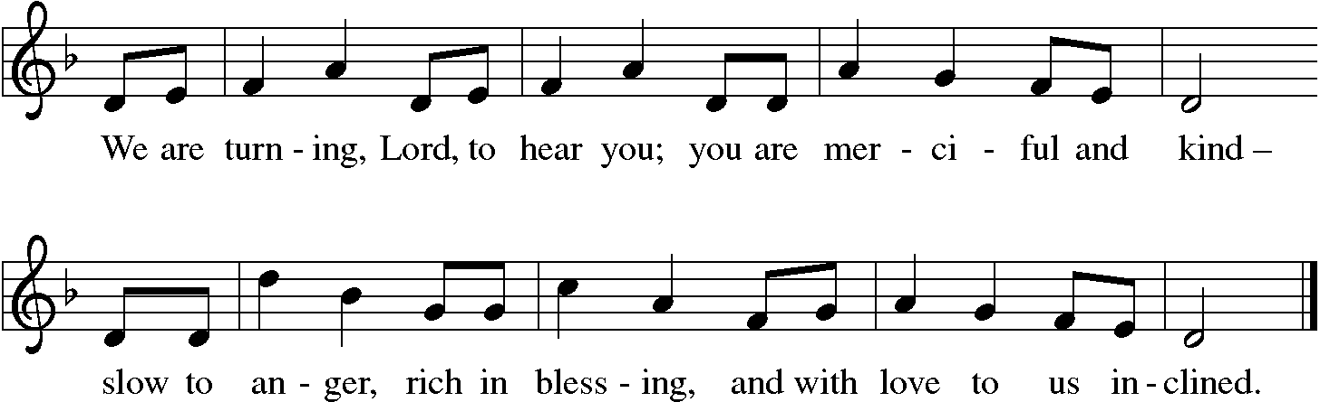
C Thanks be to God

Gospel Reading: Luke 15:1-3, 11b-32 Pew Bible Page #845

C Glory to you, O Lord
¹Now all the tax collectors and sinners were coming near to listen to [Jesus.] ²And the Pharisees and the scribes were grumbling and saying, “This fellow welcomes sinners and eats with them.”
³So he told them this parable: ^{11b}“There was a man who had two sons. ¹²The younger of them said to his father, ‘Father, give me the share of the property that will belong to me.’ So he divided his property between them. ¹³A few days later the younger son gathered all he had and traveled to a distant country, and there he squandered his property in dissolute living. ¹⁴When he had spent everything, a severe famine took place throughout that country, and he began to be in need. ¹⁵So he went and hired himself out to one of the citizens of that country, who sent him to his fields to feed the pigs. ¹⁶He would gladly have filled himself with the pods that the pigs were eating; and no one gave him anything. ¹⁷But when he came to himself he said, ‘How many of my father’s hired hands have bread enough and to spare, but here I am dying of hunger! ¹⁸I will get up and go to my father, and I will say to him, “Father, I have sinned against heaven and before you; ¹⁹I am no longer worthy to be called your son; treat me like one of your hired hands.” ’ ²⁰So he set off and went to his father. But while he was still far off, his father saw him and was filled with compassion; he ran and put his arms around him and kissed him. ²¹Then the son said to him, ‘Father, I have sinned against heaven and before you; I am no longer worthy to be called your son.’ ²²But the father said to his slaves, ‘Quickly, bring out a robe—the best one—and put it on him; put a ring on his finger and sandals on his feet. ²³And get the fatted calf and kill it, and let us eat and celebrate; ²⁴for this son of mine was dead and is alive again; he was lost and is found!’ And they began to celebrate.
²⁵“Now his elder son was in the field; and when he came and approached the house, he heard music and dancing. ²⁶He called one of the slaves and asked what was going on. ²⁷He replied, ‘Your brother has come, and your father has killed the fatted calf, because he has got him back safe and sound.’ ²⁸Then he became angry and refused to go in. His father came out and began to plead with him. ²⁹But he answered his father, ‘Listen! For all these years I have been working like a slave for you, and I have never disobeyed your command; yet you have never given me even a young goat so that I might celebrate with my friends. ³⁰But when this son of yours came back, who has devoured your property with prostitutes, you killed the fatted calf for him!’ ³¹Then the father said to him, ‘Son, you are always with me, and all that is mine is yours. ³²But we had to celebrate and rejoice, because this brother of yours was dead and has come to life; he was lost and has been found.’ ”

The Gospel of the Lord
C Praise to you, O Christ

Sermon by Pastor John Rothfusz

Sermon Hymn: “Our Father, We Have Wandered” Red Book #606

Let us confess our faith in the words of the Nicene Creed:

We believe in one God, the Father, the Almighty,
maker of heaven and earth,
of all that is, seen and unseen.
We believe in one Lord, Jesus Christ, the only Son of God,
eternally begotten of the Father,
God from God, Light from Light,
true God from true God,
begotten, not made,
of one Being with the Father;
through him all things were made.
For us and for our salvation
he came down from heaven,
was incarnate of the Holy Spirit and the virgin Mary
and became truly human.
For our sake he was crucified under Pontius Pilate;
he suffered death and was buried.
On the third day he rose again
in accordance with the scriptures;
he ascended into heaven
and is seated at the right hand of the Father.
He will come again in glory to judge
the living and the dead,
and his kingdom will have no end.
We believe in the Holy Spirit, the Lord, the giver of life,
who proceeds from the Father and the Son,*
who with the Father and the Son
is worshiped and glorified,
who has spoken through the prophets.
We believe in one holy catholic and apostolic church.
We acknowledge one baptism for the forgiveness of sins.
We look for the resurrection of the dead,
and the life of the world to come. Amen.

*Or, "who proceeds from the Father." The phrase "and the Son" is a later addition to the creed.

Prayers: After each portion of the prayers finishes with “Lord in your mercy,” please respond, “Hear our prayer.”

Offering: Jesus fills us with faith and sends us out as his witnesses. Let us commit ourselves to the Lord and joyfully lift our tithes and offerings to the Lord.

Please take a moment now to make an electronic offering to the church on the website, with the Tithe.ly app on your phone, or write a check and drop it in the plate at communion time.
Faith Lutheran website link www.shareourfaith.org

Offering Prayer

Great Thanksgiving
P The Lord be with you.
C And also with you.
P Lift up your hearts.
C We lift them to the Lord.
P Let us give thanks to the Lord our God.
C It is right to give God thanks and praise.

P It is indeed right, our duty and our joy… with the church on earth and the hosts of heaven, we praise your name and join their unending hymn:
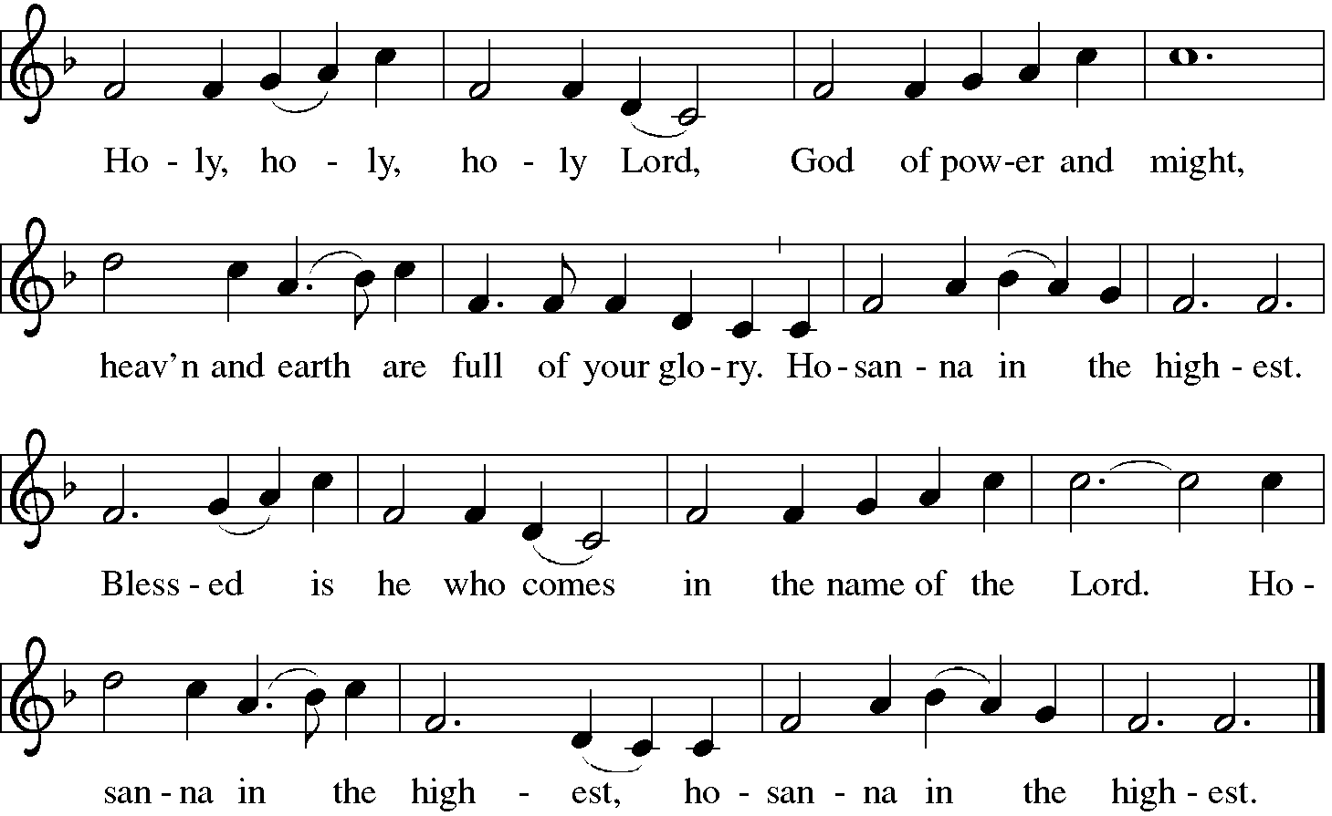
Sanctus (Holy, Holy, Holy)

Holy Communion: Preface pp. 108-111 or other Eucharistic prayer
In the night in which he was betrayed,
our Lord Jesus took bread, and gave thanks;
broke it, and gave it to his disciples, saying:
Take and eat; this is my body, given for you.
Do this for the remembrance of me.
Again, after supper, he took the cup, gave thanks,
and gave it for all to drink, saying:
This cup is the new covenant in my blood,
shed for you and for all people for the forgiveness of sin.
Do this for the remembrance of me.
…we proclaim the Lord’s death until he comes.
Christ has died, Christ has risen, Christ will come again….
…from the bonds of slavery and death.
Come Lord Jesus….
…to pursue love and justice in all the world.
Come Holy Spirit….
…now and forever.
Amen

C The Lord's Prayer
Our Father, who art in heaven, hallowed be thy name,
thy kingdom come, thy will be done, on earth as it is in heaven.
Give us this day our daily bread; and forgive us our trespasses,
as we forgive those who trespass against us;
and lead us not into temptation, but deliver us from evil.
For thine is the kingdom, and the power, and the glory,
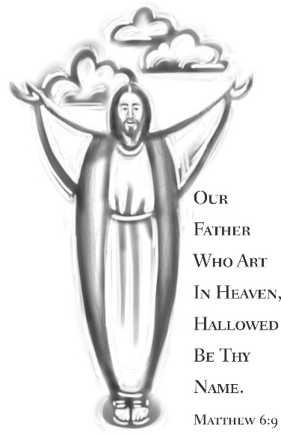
forever and ever. Amen

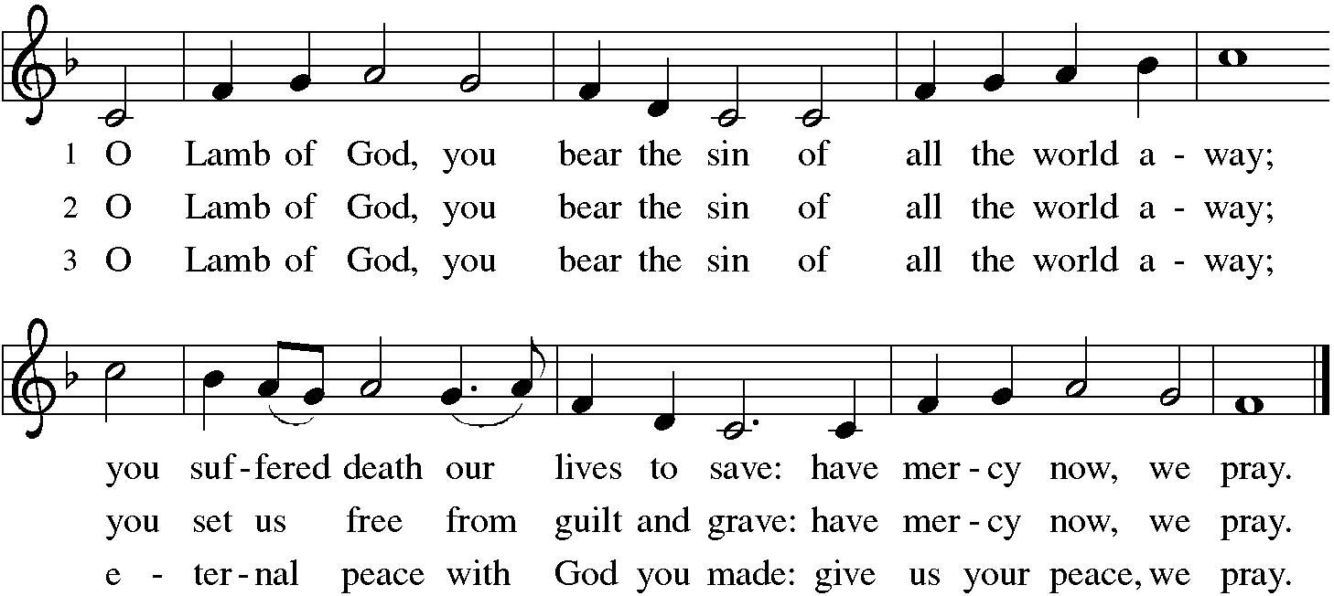

Distribution:

Communion Prayer

Announcements
Blessing
P The Lord bless you and keep you.
The Lord make his face shine on you and be gracious to you.
The Lord look upon you with favor and + give you peace.
In the name of the Father, and of the Son and of the Holy Spirit.
C Amen

Hymn: “Come, Thou Fount of Every Blessing” Red Book #807

Text: Robert Robinson, 1735-1790, alt
Music: NETTLETON, J. Wyeth, Repository of Sacred Music, Part II, 1813
Public Domain

Dismissal
A Go in peace. Serve the Lord. C Thanks be to God!
Postlude
Liturgy and texts from Sundays and Seasons.com. Copyright 2022 Augsburg Fortress. All rights reserved. Reprinted by permission under Augsburg Fortress Liturgies Annual License #23628.

