Faith Evangelical Lutheran Church, Washington, IL
First Sunday of Lent
March 6, 2022

Welcome
Confession and Forgiveness

P: In the name of the Father, and of the + Son, and of the Holy Spirit.
C: Amen.
You may make the sign of the cross as a reminder of your baptism.
We come before God, who makes a way in the wilderness,
walks with us, and guides us in our pilgrimage.

Holy One,
we confess that we have wandered far from you:
we have not trusted your promises,
we have ignored your prophets in our own day,
we have squandered our inheritance of grace,
we have failed to recognize you in our midst.
Have mercy on us!
Forgive us and turn us again to you.
Teach us to follow in your ways,
assure us again of your love,
and help us to love our neighbor.
Amen.
Beloved in Christ,
the Word draws near to you,
and all who call out to God shall be saved.
In Jesus, God comes to you again and again
and gathers you under wings of love.
In ☩ Jesus’ name, your sins are forgiven.
God journeys with you and teaches you how to live in love.
Amen.

Peace: As baptized and forgiven children of God,
Faith Lutheran Church
2206 Washington Rd,
Washington, IL 61571
Website and online worship:
www.shareourfaith.org
Church: 309-745-9306
faithlth@shareourfaith.org
Pastor John Rothfusz
Home: 309-745-9282
pastor@shareourfaith.org
we have peace with God, and peace with one another.
P The peace of the Lord be with you always.
C And also with you.
P Let us share that peace with one another.
*Hymn: “The Glory of These Forty Days” Red Book #320
Used by permission. Reprinted under OneLicense.net#A-711151

P The grace of our Lord Jesus Christ, the love of God,
and the communion of the Holy Spirit be with you all.
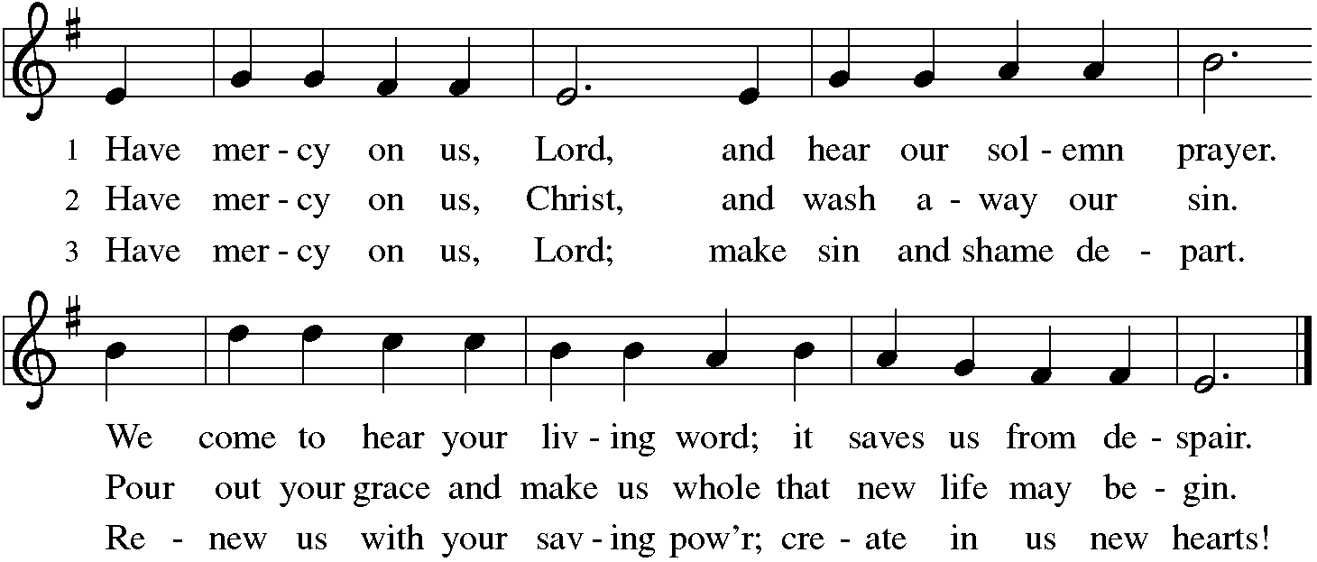
C And also with you.
Hymn of Praise
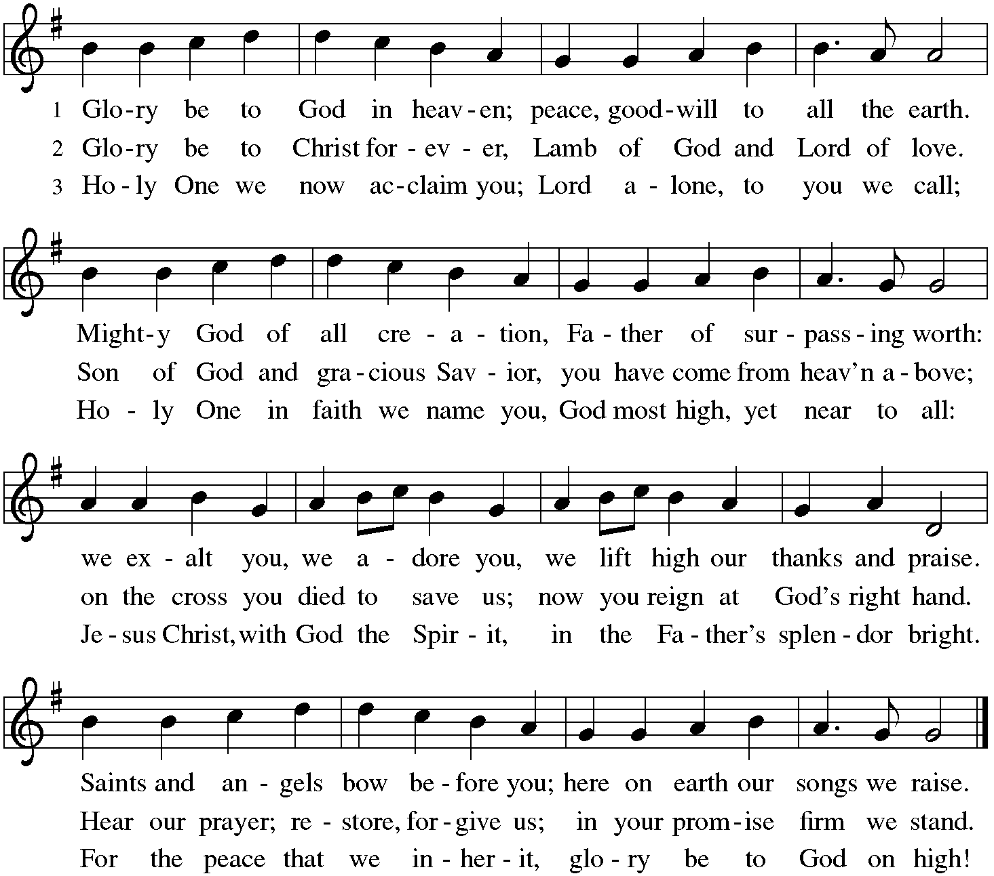

P The Lord be with you
C And also with you.
Let us pray together the Prayer of the Day
O Lord God, you led your people through the wilderness and brought them to the promised land. Guide us now, so that, following your Son, we may walk safely through the wilderness of this world toward the life you alone can give, through Jesus Christ, our Savior and Lord, who lives and reigns with you and the Holy Spirit, one God, now and forever. Amen.

Children’s Message

First Reading: Deuteronomy 26:1-11 Pew Bible Page #162
¹When you have come into the land that the Lord your God is giving you as an inheritance to possess, and you possess it, and settle in it, ²you shall take some of the first of all the fruit of the ground, which you harvest from the land that the Lord your God is giving you, and you shall put it in a basket and go to the place that the Lord your God will choose as a dwelling for his name. ³You shall go to the priest who is in office at that time, and say to him, “Today I declare to the Lord your God that I have come into the land that the Lord swore to our ancestors to give us.” ⁴When the priest takes the basket from your hand and sets it down before the altar of the Lord your God, ⁵you shall make this response before the Lord your God: “A wandering Aramean was my ancestor; he went down into Egypt and lived there as an alien, few in number, and there he became a great nation, mighty and populous. ⁶When the Egyptians treated us harshly and afflicted us, by imposing hard labor on us, ⁷we cried to the Lord, the God of our ancestors; the Lord heard our voice and saw our affliction, our toil, and our oppression. ⁸The Lord brought us out of Egypt with a mighty hand and an outstretched arm, with a terrifying display of power, and with signs and wonders; ⁹and he brought us into this place and gave us this land, a land flowing with milk and honey. ¹⁰So now I bring the first of the fruit of the ground that you, O Lord, have given me.” You shall set it down before the Lord your God and bow down before the Lord your God. ¹¹Then you, together with the Levites and the aliens who reside among you, shall celebrate with all the bounty that the Lord your God has given to you and to your house.

R The Word of the Lord
C Thanks be to God
Psalm 91:1-2, 9-16
¹You who dwell in the shelter of the Most High,
who abide in the shadow of the Almighty—
²you will say to the Lord, “My refuge and my stronghold,
my God in whom I put my trust.”
⁹Because you have made the Lord your refuge,
and the Most High your habitation,
¹⁰no evil will befall you,
nor shall affliction come near your dwelling.
¹¹For God will give the angels charge over you,
to guard you in all your ways.
¹²Upon their hands they will bear you up,
lest you strike your foot against a stone.
¹³You will tread upon the lion cub and viper;
you will trample down the lion and the serpent.

¹⁴I will deliver those who cling to me;
I will uphold them, because they know my name.
¹⁵They will call me, and I will answer them;
I will be with them in trouble; I will rescue and honor them.
¹⁶With long life will I satisfy them,
and show them my salvation.
Second Reading – Romans 10:8b-13 Pew Bible Page #917
^{8b}“The word is near you, on your lips and in your heart” (that is, the word of faith that we proclaim); ⁹because if you confess with your lips that Jesus is Lord and believe in your heart that God raised him from the dead, you will be saved. ¹⁰For one believes with the heart and so is justified, and one confesses with the mouth and so is saved. ¹¹The scripture says, “No one who believes in him will be put to shame.” ¹²For there is no distinction between Jew and Greek; the same Lord is Lord of all and is generous to all who call on him. ¹³For, “Everyone who calls on the name of the Lord shall be saved.”
R The Word of the Lord
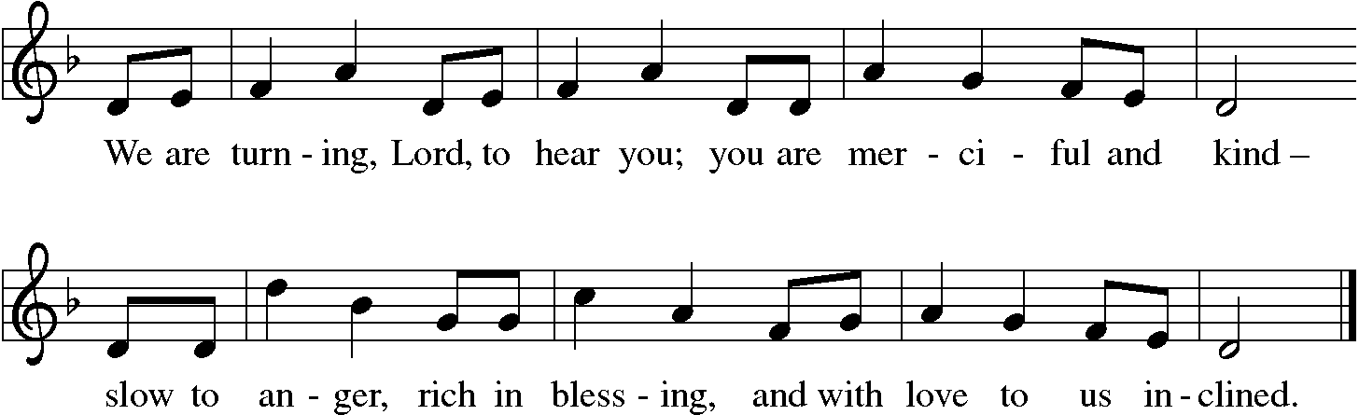
C Thanks be to God

Gospel Reading: Luke 4:1-13 Pew Bible Page #830

C Glory to you, O Lord
¹Jesus, full of the Holy Spirit, returned from the Jordan and was led by the Spirit in the wilderness, ²where for forty days he was tempted by the devil. He ate nothing at all during those days, and when they were over, he was famished. ³The devil said to him, “If you are the Son of God, command this stone to become a loaf of bread.” ⁴Jesus answered him, “It is written, ‘One does not live by bread alone.’ ”
⁵Then the devil led him up and showed him in an instant all the kingdoms of the world. ⁶And the devil said to him, “To you I will give their glory and all this authority; for it has been given over to me, and I give it to anyone I please. ⁷If you, then, will worship me, it will all be yours.” ⁸Jesus answered him, “It is written,
‘Worship the Lord your God,
and serve only him.’ ”
⁹Then the devil took him to Jerusalem, and placed him on the pinnacle of the temple, saying to him, “If you are the Son of God, throw yourself down from here, ¹⁰for it is written,
‘He will command his angels concerning you,
to protect you,’
¹¹and ‘On their hands they will bear you up,
so that you will not dash your foot against a stone.’ ”
¹²Jesus answered him, “It is said, ‘Do not put the Lord your God to the test.’ ” ¹³When the devil had finished every test, he departed from him until an opportune time.
The Gospel of the Lord
C Praise to you, O Christ
Sermon by Pastor John Rothfusz
Sermon Hymn: “I Want Jesus To Walk With Me” Red Book #325

All Rights Reserved. Used by permission. Reprinted under OneLicense.net#A-711151 Text: African American spiritual Music: SOJOURNER, African American spiritual All rights Reserved. Used by permission. Reprinted under OneLicense.net#A-711151
Let us confess our faith in the words of the Nicene Creed:

We believe in one God, the Father, the Almighty,
maker of heaven and earth,
of all that is, seen and unseen.
We believe in one Lord, Jesus Christ, the only Son of God,
eternally begotten of the Father,
God from God, Light from Light,
true God from true God,
begotten, not made,
of one Being with the Father;
through him all things were made.
For us and for our salvation
he came down from heaven,
was incarnate of the Holy Spirit and the virgin Mary
and became truly human.
For our sake he was crucified under Pontius Pilate;
he suffered death and was buried.
On the third day he rose again
in accordance with the scriptures;
he ascended into heaven
and is seated at the right hand of the Father.
He will come again in glory to judge
the living and the dead,
and his kingdom will have no end.
We believe in the Holy Spirit, the Lord, the giver of life,
who proceeds from the Father and the Son,*
who with the Father and the Son
is worshiped and glorified,
who has spoken through the prophets.
We believe in one holy catholic and apostolic church.
We acknowledge one baptism for the forgiveness of sins.
We look for the resurrection of the dead,
and the life of the world to come. Amen.

*Or, "who proceeds from the Father." The phrase "and the Son" is a later addition to the creed.

Prayers: After each portion of the prayers finishes with “Lord in your mercy,” please respond, “Hear our prayer.”

Offering: Jesus fills us with faith and sends us out as his witnesses. Let us commit ourselves to the Lord and joyfully lift our tithes and offerings to the Lord.

Please take a moment now to make an electronic offering to the church on the website, with the Tithe.ly app on your phone, or write a check and drop it in the plate at communion time.
Faith Lutheran website link www.shareourfaith.org

Offering Prayer

Great Thanksgiving
P The Lord be with you.
C And also with you.
P Lift up your hearts.
C We lift them to the Lord.
P Let us give thanks to the Lord our God.
C It is right to give God thanks and praise.

P It is indeed right, our duty and our joy… with the church on earth and the hosts of heaven, we praise your name and join their unending hymn:
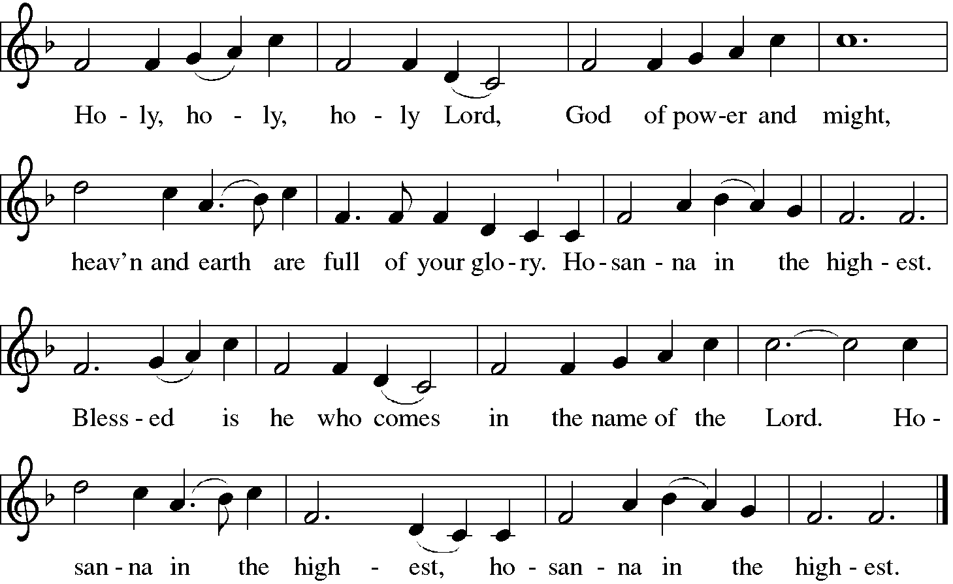
Sanctus (Holy, Holy, Holy)

Holy Communion: Preface pp. 108-111 or other Eucharistic prayer
In the night in which he was betrayed,
our Lord Jesus took bread, and gave thanks;
broke it, and gave it to his disciples, saying:
Take and eat; this is my body, given for you.
Do this for the remembrance of me.
Again, after supper, he took the cup, gave thanks,
and gave it for all to drink, saying:
This cup is the new covenant in my blood,
shed for you and for all people for the forgiveness of sin.
Do this for the remembrance of me.
C The Lord's Prayer
Our Father, who art in heaven, hallowed be thy name,
thy kingdom come, thy will be done, on earth as it is in heaven.
Give us this day our daily bread; and forgive us our trespasses,
as we forgive those who trespass against us;
and lead us not into temptation, but deliver us from evil.
For thine is the kingdom, and the power, and the glory,
forever and ever. Amen
The Iona Invitation (Iona Community, Scotland)
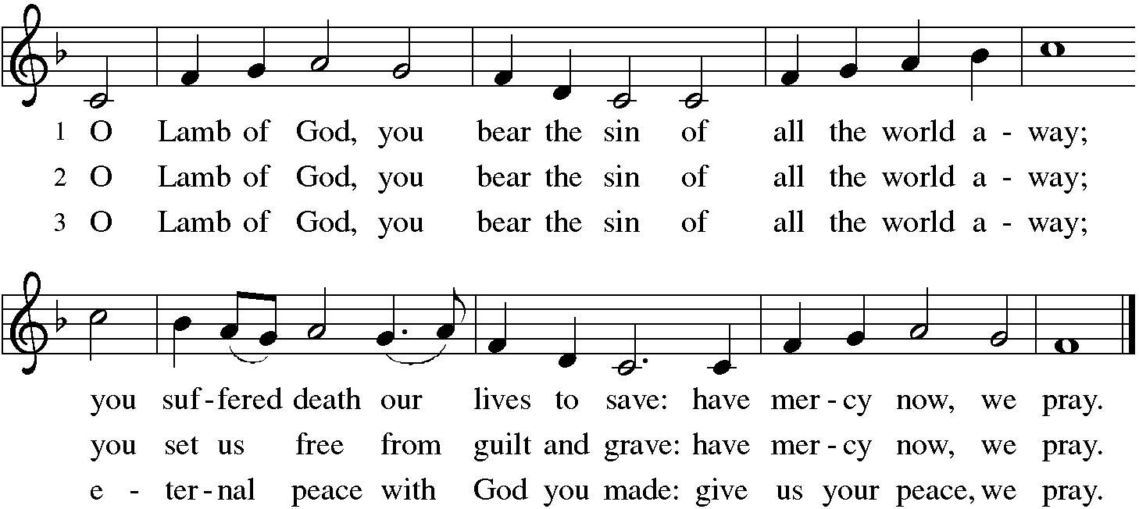
This is the table not of the righteous, but of the poor in spirit. It is the table of sharing with the poor of the world, with whom our Savior identified. It is the table of communion with the earth, in which our Lord became incarnate. This is the table not of the church, but of Jesus Christ. So come to this table, you who have much faith and you who would like to have more; you who have been here often, and you who have not been for a while or ever before; you who have tried to follow Jesus, and you who have failed; Come—not because the Church invites you— It is Christ who invites you to be known and fed here.
Distribution:
Communion Prayer
Announcements
Blessing
P The Lord bless you and keep you.
The Lord make his face shine on you and be gracious to you.
The Lord look upon you with favor and + give you peace.
In the name of the Father, and of the Son and of the Holy Spirit.
C Amen
Hymn: “Guide Me Ever, Great Redeemer” Red Book #618
Text: William Williams, 1717-1791; tr. William Williams and Peter Williams, 1722-1796, alt.
Music: CWM RHONDDA, John Hughes, 1873-1932 Public Domain

Dismissal
A Go in peace. Serve the Lord. C Thanks be to God!
Postlude
Liturgy and texts from Sundays and Seasons.com. Copyright 2022 Augsburg Fortress. All rights reserved. Reprinted by permission under Augsburg Fortress Liturgies Annual License #23628.

