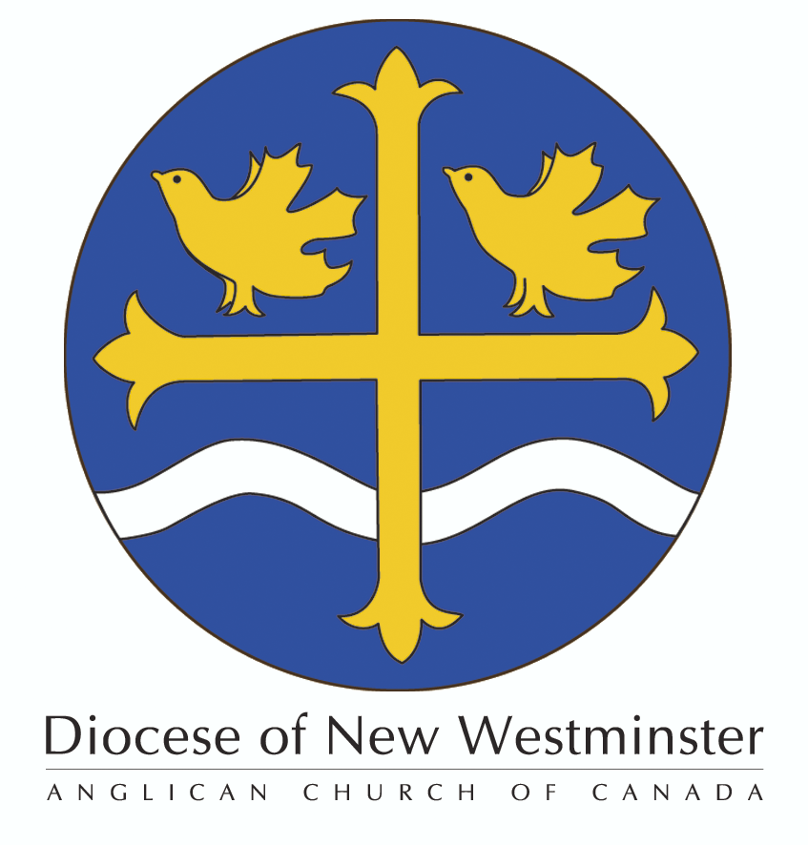

The Order of the
Diocese of New Westminster

Nomination Form 2022

Please review the eligibility requirements and other information on the Parish Nomination Information Sheet before completing this form. Each parish may nominate only one person for the 2022 honours.
Please print clearly and do not change the layout of this form.
NOMINEE
Please provide the Nominee’s FULL formal Name and indicate the name they normally use.

Title: (Circle preferred) Mr. / Ms / Mrs. / Dr.

Given Name(s):

Surname:

Name normally used: _________________________________________________________________

Parish: _____________________________________________________________________________

Nominee Contact Information:

Address:

Town/City: ______________________________________________ Postal Code:___________________

Home phone ( ) Work Phone: ( )

Mobile Phone: ( ) E-mail:
Acceptance of Nomination
I accept this nomination to the Order of the Diocese of New Westminster and consent to the publication of my photograph and and details of my service to my Parish and the Diocese should my nomination be approved.
Nominee’s Signature: _____________________________________ Date:_________________________
Biography: Please provide a narrative biography (i.e. no bullet points) of the Nominee focusing on their service to their Parish and/or the Diocese (include the dates of that service). This bio should be not more than 450 words. If more space is needed please use a separate sheet clearly indicating that it is a continuation of this section. The Biography should also be emailed to bsiksay@vancouver.anglican.ca as a Word document.

________________________________________________________________________________________________________________________________________________________________________________________________________________________________________________________________________________________________________________________________________________________________________________________________________________________________________________________________________________________________________________________________________________________________________________________________________________________________________________________________________________________________________________________________________________________________________________________________________________________________________________________________________________________________________________________________________________________________________

Citation: Please provide a narrative description (i.e. no bullet points) of this person’s service to the Parish and/or the Diocese. This Citation will be read at the Investiture Service. Try to convey the person’s personality in what you write. This Citation must be no more than 80 words. Applications with Citations longer than 80 words will be returned. If more space is needed please use a separate sheet clearly indicating that it is a continuation of this section. We reserve the right to edit Citations. The Citation should also be emailed to bsiksay@vancouver.anglican.ca as a Word document.

______________________________________________________________________________________________________________________________________________________________________________________________________________________________________________________________________________________________________________________________________________________________________________________________________________________________________________________________________________________________________________________________

Special Needs
Does the nominee have any special needs at the Investiture Service?
Please check all that apply:
___ Uses a walker/cane/wheelcahir
___ Sight issues
___ Hearing issues
___ Will require family member/friend to accompany them to the stage
___ Will require family member/friend to remain with them on-stage
Other special requirements: _______________________________________________________

Note: The venue, Massey Theatre, is accessible. The ability to climb stairs is not required for access to the stage at the Massey Theatre.

Parish Support
Nominated by:
Name:

Signature:

Parish Approval:
This Nomination has been reviewed by the Rector. Following consultation between the Rector and the Wardens of this parish we are pleased to approve and support this Nomination for consideration by the ODNW Selection Committee.
Rector’s Name:

Rector’s Signature:

Warden’s Name:

Warden’s Signature:

Warden’s Name:

Warden’s Signature:
(Please add additional names and signatures as needed to ensure that all parish wardens have signed this form.)
Date:

Nomination Deadline, Photo and Fee
The deadline for nominations is April 30, 2022.
This Nomination Form must be accompanied by a photo of the Nominee (3” x 5” preferred; a digital/emailed photo is acceptable) and a $35 processing fee payable to the “Diocese of New Westminster” (please note in the memo line of the cheque “ODNW”). The completed Nomination Form, photo, and cheque must be received in the Bishop’s Office by April 30th, 2022.
Please send them to:
The Diocese of New Westminster
Attention: Bill Siksay
1410 Nanton Avenue
Vancouver, BC V6H 2E2
Fax: 604-684-7017
e-mail: bsiksay@vancouver.anglican.ca
If you have any questions regarding the Order of the Diocese of New Westminster please call Bill Siksay at 604-684-6306 ext. 228.
To be completed by the Synod Office
Date Rec’d: Fee: Photo: Ack:
Comments of Selection Committee:
Selection Committee Member Signature
Approved: YES NO Notified on: ______________(attach letter to this form) Db:__________

