Faith Evangelical Lutheran Church, Washington, IL
Fifth Sunday after Epiphany
February 6, 2022

Welcome
Confession and Forgiveness

P: In the name of the Father, and of the + Son, and of the Holy Spirit.
C: Amen.
You may make the sign of the cross as a reminder of your baptism.
P: Almighty God, to whom all hearts are open, all desires known, and from whom no secrets are hid: cleanse the thoughts of our hearts by the inspiration of your Holy Spirit, that we may perfectly love you and worthily magnify your holy name, through Jesus Christ our Lord.
C: Amen.
P: Let us confess our sin in the presence of God and of one another.
Please keep silence for reflection
P: Most merciful God,
C: we confess that we are captive to sin and cannot free ourselves. We have sinned against you in thought, word, and deed, by what we have done and by what we have left undone. We have not loved you with our whole heart; we have not loved our neighbors as ourselves. For the sake of your Son, Jesus Christ, have mercy on us. Forgive us, renew us, and lead us, so that we may delight in your will and walk in your ways, to the glory of your holy name. Amen.
P: In the mercy of almighty God, Jesus Christ was given to die for us, and for his sake God forgives us all our sins. As a called and ordained minister of the church of Christ, and by his authority, I therefore declare to you the entire forgiveness of all your sins, in the name of the Father, and of the + Son, and of the Holy Spirit.
C: Amen.
Faith Lutheran Church
2206 Washington Rd,
Washington, IL 61571
Website and online worship:
www.shareourfaith.org
Church: 309-745-9306
faithlth@shareourfaith.org
Pastor John Rothfusz
Home: 309-745-9282
pastor@shareourfaith.org
Peace: As forgiven children of God, we have peace
with God, and peace with one another.
P The peace of the Lord be with you always.
C And also with you.
P Let us share that peace with one another.

*Hymn: “Here I Am, Lord” Red Book #574

Text: Daniel L. Schutte, b. 1946
Music: HERE I AM, LORD, Daniel L. Shuttle
Text and music © 1981 OCP Publications, Inc., 5536 NE Hassalo, Portland, OR 97213. All rights reserved. Used by permission. Reprinted under OneLicense.net#A-711151

P The grace of our Lord Jesus Christ, the love of God,
and the communion of the Holy Spirit be with you all.
C And also with you.

Hymn of Praise
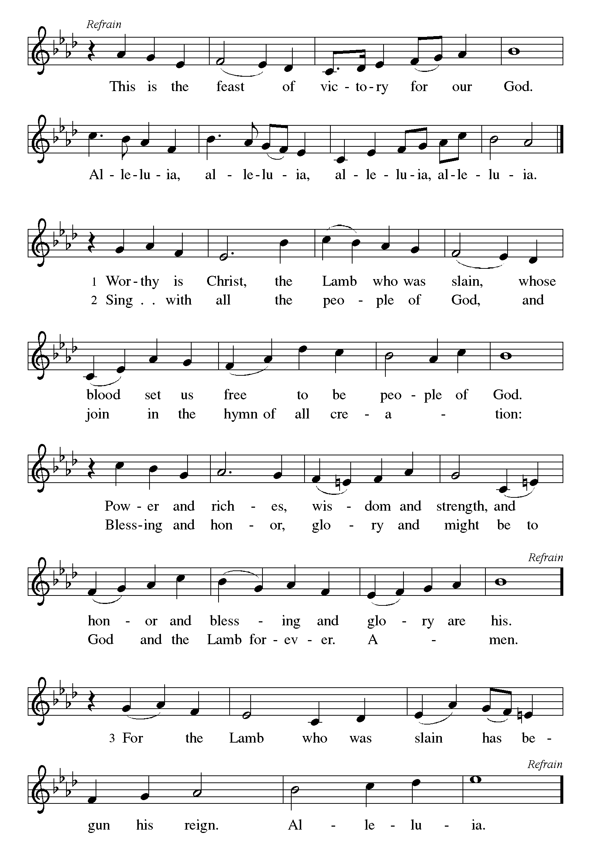

P The Lord be with you
C And also with you.
Let us pray together the Prayer of the Day
Most holy God, the earth is filled with your glory, and before you angels and saints stand in awe. Enlarge our vision to see your power at work in the world, and by your grace make us heralds of your Son, Jesus Christ, our Savior and Lord. Amen.
Children’s Message
First Reading: Isaiah 6:1-8 Pew Bible Page #551
¹In the year that King Uzziah died, I saw the Lord sitting on a throne, high and lofty; and the hem of his robe filled the temple. ²Seraphs were in attendance above him; each had six wings: with two they covered their faces, and with two they covered their feet, and with two they flew. ³And one called to another and said:
“Holy, holy, holy is the Lord of hosts;
the whole earth is full of his glory.”
⁴The pivots on the thresholds shook at the voices of those who called, and the house filled with smoke. ⁵And I said: “Woe is me! I am lost, for I am a man of unclean lips, and I live among a people of unclean lips; yet my eyes have seen the King, the Lord of hosts!”
⁶Then one of the seraphs flew to me, holding a live coal that had been taken from the altar with a pair of tongs. ⁷The seraph touched my mouth with it and said: “Now that this has touched your lips, your guilt has departed and your sin is blotted out.” ⁸Then I heard the voice of the Lord saying, “Whom shall I send, and who will go for us?” And I said, “Here am I; send me!”

R The Word of the Lord
C Thanks be to God

Psalm 138
¹I will give thanks to you, O Lord, with my whole heart;
before the gods I will sing your praise.
²I will bow down toward your holy temple and praise your name, because of your steadfast love and faithfulness;
for you have glorified your name and your word above all things.
³When I called, you answered me;
you increased my strength within me.
⁴All the rulers of the earth will praise you, O Lord,
when they have heard the words of your mouth.
⁵They will sing of the ways of the Lord,
that great is the glory of the Lord.
⁶The Lord is high, yet cares for the lowly,
perceiving the haughty from afar.
⁷Though I walk in the midst of trouble, you keep me safe;
you stretch forth your hand against the fury of my enemies; your right hand shall save me.
⁸You will make good your purpose for me;
O Lord, your steadfast love endures forever; do not abandon the works of your hands.

Second Reading – 1 Corinthians 15:1-11 Pew Bible Page #932
¹Now I would remind you, brothers and sisters, of the good news that I proclaimed to you, which you in turn received, in which also you stand, ²through which also you are being saved, if you hold firmly to the message that I proclaimed to you—unless you have come to believe in vain.
³For I handed on to you as of first importance what I in turn had received: that Christ died for our sins in accordance with the scriptures, ⁴and that he was buried, and that he was raised on the third day in accordance with the scriptures, ⁵and that he appeared to Cephas, then to the twelve. ⁶Then he appeared to more than five hundred brothers and sisters at one time, most of whom are still alive, though some have died. ⁷Then he appeared to James, then to all the apostles. ⁸Last of all, as to one untimely born, he appeared also to me. ⁹For I am the least of the apostles, unfit to be called an apostle, because I persecuted the church of God. ¹⁰But by the grace of God I am what I am, and his grace toward me has not been in vain. On the contrary, I worked harder than any of them—though it was not I, but the grace of God that is with me. ¹¹Whether then it was I or they, so we proclaim and so you have come to believe.

R The Word of the Lord
C Thanks be to God

Gospel Reading: Luke 5:1-11 Pew Bible Page #831

C Glory to you, O Lord
¹Once while Jesus was standing beside the lake of Gennesaret, and the crowd was pressing in on him to hear the word of God, ²he saw two boats there at the shore of the lake; the fishermen had gone out of them and were washing their nets. ³He got into one of the boats, the one belonging to Simon, and asked him to put out a little way from the shore. Then he sat down and taught the crowds from the boat. ⁴When he had finished speaking, he said to Simon, “Put out into the deep water and let down your nets for a catch.” ⁵Simon answered, “Master, we have worked all night long but have caught nothing. Yet if you say so, I will let down the nets.” ⁶When they had done this, they caught so many fish that their nets were beginning to break. ⁷So they signaled their partners in the other boat to come and help them. And they came and filled both boats, so that they began to sink. ⁸But when Simon Peter saw it, he fell down at Jesus’ knees, saying, “Go away from me, Lord, for I am a sinful man!” ⁹For he and all who were with him were amazed at the catch of fish that they had taken; ¹⁰and so also were James and John, sons of Zebedee, who were partners with Simon. Then Jesus said to Simon, “Do not be afraid; from now on you will be catching people.” ¹¹When they had brought their boats to shore, they left everything and followed him.

The Gospel of the Lord
C Praise to you, O Christ
Sermon by Pastor John Rothfusz

Sermon Hymn: “You Have Come Down to the Lakeshore” Red Book #817

Text: Cesáreo Gabaráin, 1936-1991; tr. Madeline Forell Marshall, b. 1946
Music: PESADOR DE HOMBRES, Cesáreo Gabaráin
Spanish text and music © 1979 Cesáreo Gabaráin, OCP Publications. All rights reserved.
Tr. © Editorial Avance Luterano Reprinted under OneLicense.net#A-711151

Apostles’ Creed
C: I believe in God, the Father almighty,
creator of heaven and earth.
I believe in Jesus Christ, God's only Son, our Lord,
who was conceived by the Holy Spirit,
born of the virgin Mary,
suffered under Pontius Pilate,
was crucified, died, and was buried;
he descended to the dead.
On the third day he rose again;
he ascended into heaven,
he is seated at the right hand of the Father,
and he will come to judge the living and the dead.
I believe in the Holy Spirit,
the holy catholic church, the communion of saints,
the forgiveness of sins, the resurrection of the body,
and the life everlasting. Amen.

Prayers: After each portion of the prayers finishes with “Lord in your mercy,” please respond, “Hear our prayer.”

Offering: Jesus fills us with faith and sends us out as his witnesses. Let us commit ourselves to the Lord and joyfully lift our tithes and offerings to the Lord.

Please take a moment now to make an electronic offering to the church on the website, with the Tithe.ly app on your phone, or write a check and drop it in the plate at communion time.
Faith Lutheran website link www.shareourfaith.org

Offering Prayer

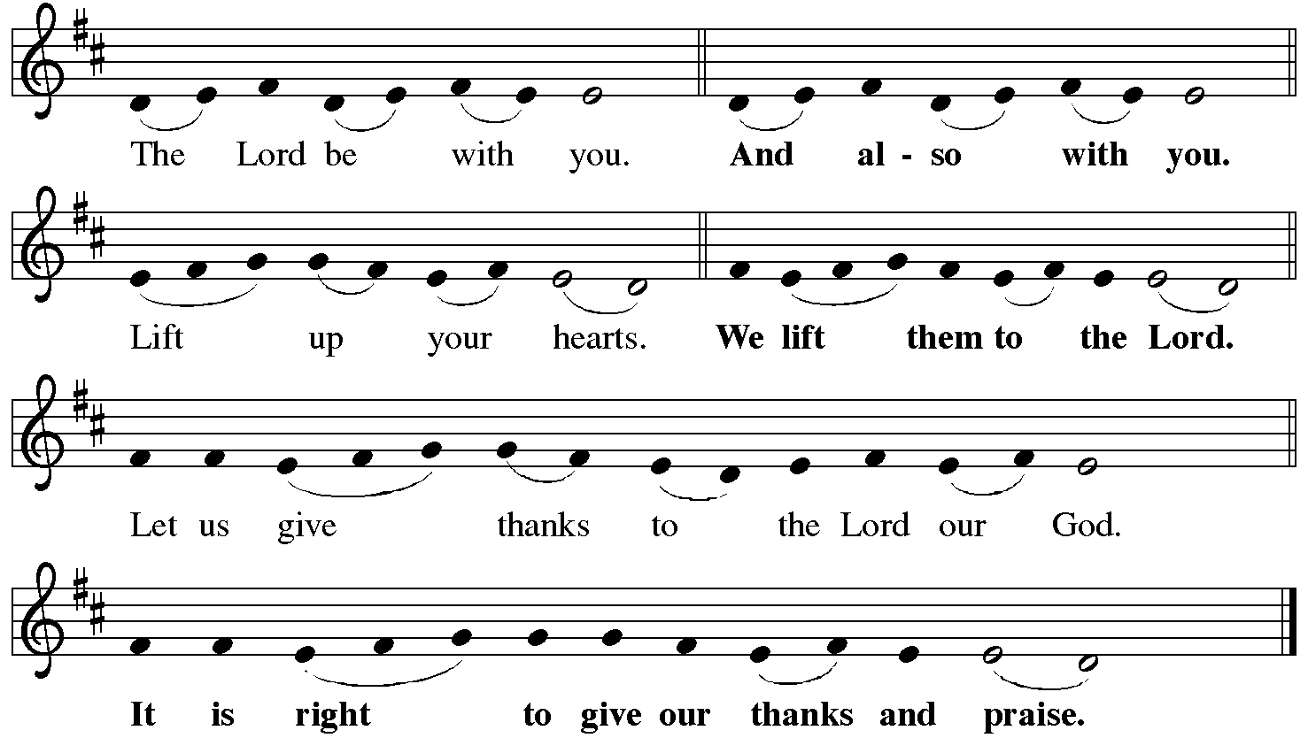

P It is indeed right, our duty and our joy… with the church on earth and the hosts of heaven, we praise your name and join their unending hymn:
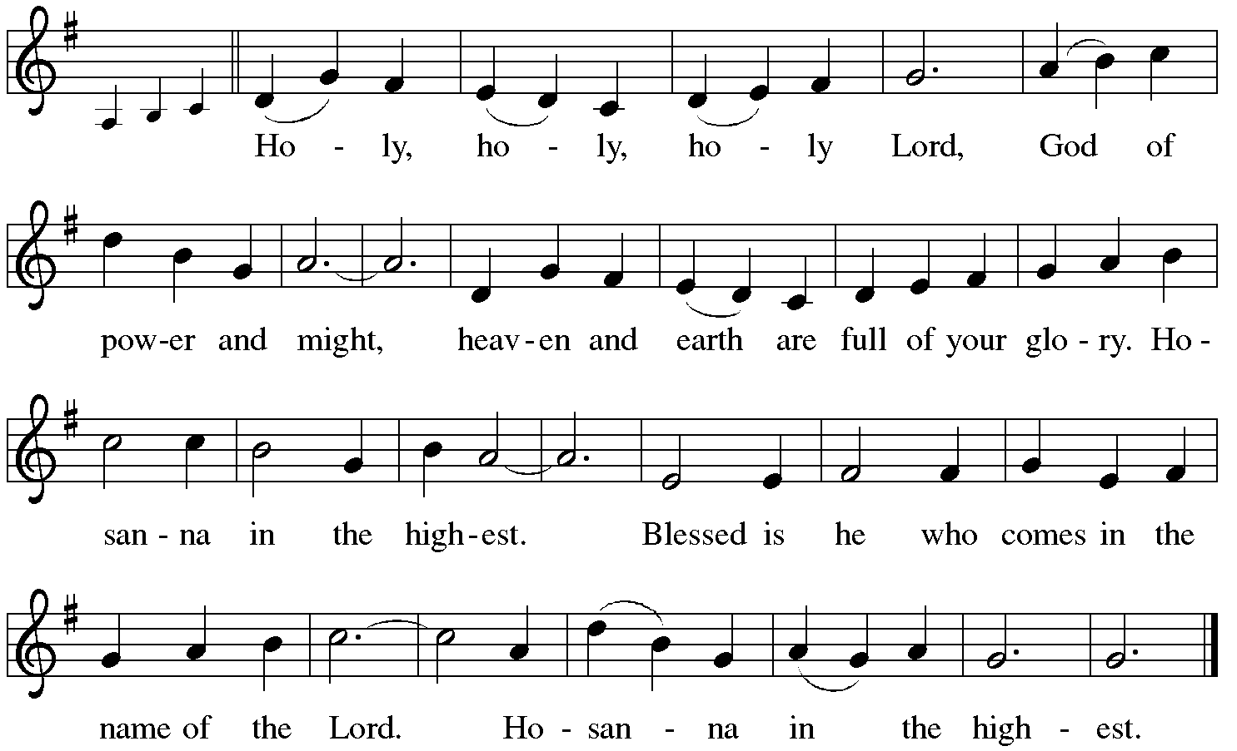

Holy Communion: Preface pp. 108-111 or other Eucharistic prayer
In the night in which he was betrayed,
our Lord Jesus took bread, and gave thanks;
broke it, and gave it to his disciples, saying:
Take and eat; this is my body, given for you.
Do this for the remembrance of me.
Again, after supper, he took the cup, gave thanks,
and gave it for all to drink, saying:
This cup is the new covenant in my blood,
shed for you and for all people for the forgiveness of sin.
Do this for the remembrance of me.

C The Lord's Prayer
Our Father, who art in heaven, hallowed be thy name,
thy kingdom come, thy will be done, on earth as it is in heaven.
Give us this day our daily bread; and forgive us our trespasses,
as we forgive those who trespass against us;
and lead us not into temptation, but deliver us from evil.
For thine is the kingdom, and the power, and the glory,
forever and ever. Amen

The Iona Invitation (Iona Community, Scotland)
This is the table not of the righteous, but of the poor in spirit. It is the table of sharing with the poor of the world, with whom our Savior identified. It is the table of communion with the earth, in which our Lord became incarnate. This is the table not of the church, but of Jesus Christ. So come to this table, you who have much faith and you who would like to have more; you who have been here often, and you who have not been for a while or ever before; you who have tried to follow Jesus, and you who have failed; Come—not because the Church invites you— It is Christ who invites you to be known and fed here.

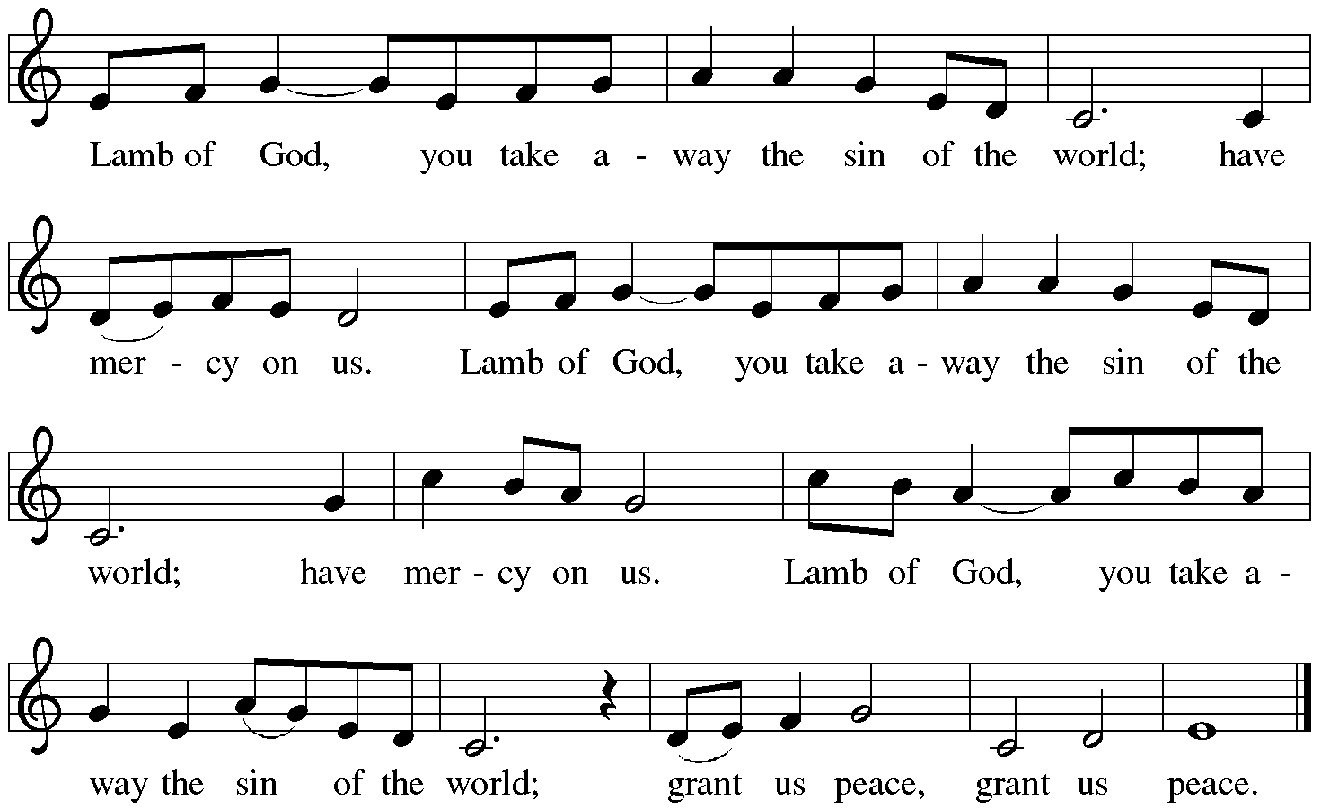

Distribution:

Communion Prayer

Announcements

Blessing
P The Lord bless you and keep you. The Lord make his face shine on you and be gracious to you. The Lord look upon you with favor and + give you peace.
In the name of the Father, and of the Son and of the Holy Spirit.
C Amen

Hymn: “Will You Come and Follow Me” Red Book #798

Text: John L. Bell, b. 1949
Music: KELVINGROVE, Scottish traditional
Text © 198 Iona Community, GIA Publications, Inc., agent. 7404 S. mason Ave., Chicago, IL 60638. www.giamusic.com. 800.442.3358. All rights reserved. Reprinted under OneLicense.net#A-711151
Dismissal
A Go in peace. Serve the Lord. C Thanks be to God!
Liturgy and texts from Sundays and Seasons.com. Copyright 2021 Augsburg Fortress. All rights reserved.
Reprinted by permission under Augsburg Fortress Liturgies Annual License #23628.

