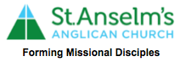
Nominations Form
Parish Elections: Vestry 2022,
February 27, 2022

I ­­­­­­­­­­­­­­­­­­­______________________ parishioner of St. Anselm’s Anglican Church, freely allow my name to stand for election to the office of

_______________________.

Signed_____________________ Date: ­­­__________________

Nominator and Seconder to the Election:

We move and second the nomination of ­­­­­­­­­­­­­­­­____________________ to the office of ____________________

Nominator__________________ Seconder___________________ Date:____________________ Date:____________________

