Vital Church Maritimes Conference
Wilderness Calling – Trusting in Jesus

October 14th to 16th, 2021

Evening Worship

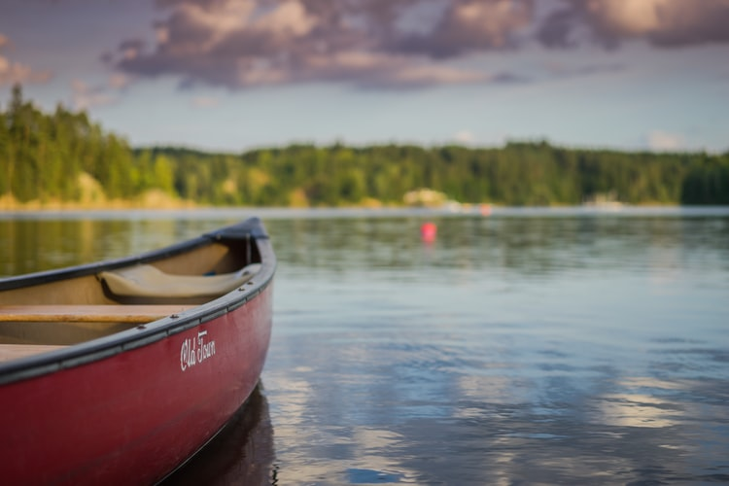

The Diocese of Nova Scotia & Prince Edward Island

Celebrant: Lord, you have always led your people,
and travelled with them.
People (left): You called Abraham from the city to the desert.
People (right): You met Hagar in the wilderness.

Celebrant: As Moses and the Hebrews travelled in the desert,
you went before them always –
People (left): A pillar of cloud by day
People (right): And a pillar of fire by night.

Celebrant: No darkness is too dark for you;
People: No depth nor height is beyond your reach.

Celebrant: You are there at our going out and our coming in.
People: From this time forth and for evermore.

Guide My Feet #513 (Common Praise)
Guide my feet while I run this race;
guide my feet while I run this race;
guide my feet while I run this race,
for I don’t want to run this race in vain! (race in vain!)

Hold my hand while I run this race;
hold my hand while I run this race;
hold my hand while I run this race,
for I don’t want to run this race in vain! (race in vain!)

Stand by me while I run this race;
stand by me while I run this race;
stand by me while I run this race,
for I don’t want to run this race in vain! (race in vain!)

I’m your child while I run this race;
I’m your child while I run this race;
I’m your child while I run this race,
for I don’t want to run this race in vain! (race in vain!)

Search my heart while I run this race;
search my heart while I run this race;
search my heart while I run this race,
for I don’t want to run this race in vain! (race in vain!)

Guide my feet while I run this race;
guide my feet while I run this race;
guide my feet while I run this race,
for I don’t want to run this race in vain! (race in vain!)

A reading from the Book of Genesis (Genesis 28:10-19a)
Sermon – Finding Blessing Between a Rock and a Hard Place

Song: Bless Now, O God, the Journey
Bless now, O God, the journey that all your people make,
the path through noise and silence, the way of give and take.
The trail is found in desert and winds the mountain round,
then leads beside still waters, the road where faith is found.

Bless sojourners and pilgrims who share this winding way;
your hope burns through the terrors, your love sustains the day.
We yearn for holy freedom while often we are bound;
together we are seeking the road where faith is found.
Divine eternal lover, you meet us on the road.
We wait for land of promise where milk and honey flow,
but waiting not for places, you meet us all around.
Our covenant is written on roads, as faith is found.
An Affirmation of Faith based on Psalm 139
(said alternating from side to side)

Lord, you have searched me out and known me.

You know my sitting down and my rising up;
you discern my thoughts from afar.

You trace my journeys and my resting-places
and are acquainted with all my ways.

Indeed, there is not a word on my lips,
but you, O Lord, know it altogether.

You press upon me behind and before
and lay your hand upon me.

Such knowledge is too wonderful for me;
it is so high that I cannot attain to it.

Where can I go then from your Spirit?
Where can I flee from your presence?

If I climb up to heaven, you are there;
if I make the grave my bed, you are there also.

If I take the wings of the morning
and dwell in the uttermost parts of the sea,

even there your hand will lead me
and your mighty hand hold me fast.

If I say, “Surely the darkness will cover me,
and the light around me turn to night.”

Darkness is not dark to you; the night is as bright
as the day; darkness and light to you are both alike.

For you yourself created my inmost parts;
you knit me together in my mother’s womb.

I will thank you because I am marvellously made;
your works are wonderful, and I know it well.

The Prayers of the People
A Prayer of the Iona Community in Scotland

You keep us waiting.
You, the God of all time,
Want us to wait for the right time in which to discover
Who we are, where we must go,
Who will be with us, and what we must do.
So, thank you…for the waiting time.

Pause

You keep us looking.
You, the God of all space,
Want us to look in the right and wrong places for signs of hope,
For people who are hopeless,
For visions of a better world that will appear
among the disappointments of the world we know.
So, thank you…for the looking time.

Pause

You keep us loving.
You, the God whose name is love,
Want us to be like you –
To love the loveless and the unlovely and the unlovable;
To love without jealousy or design or threat,
And most difficult of all, to love ourselves.
So, thank you…for the loving time.

Pause

And in all this you keep us,
Through hard questions with no easy answers;
Through failing where we hoped to succeed
and making an impact when we felt useless;
Through the patience and the dreams and the love of others;
And through Jesus Christ and his Spirit, you keep us.

© The Iona Community in Scotland

Closing Prayer
Heavenly Father, you see how your children hunger for food, and fellowship, and faith. As we journey through the wilderness of these uncertain times, nourish us by your Word, and help us to meet one another’s needs of body, mind and spirit, in the strength and love of Christ our Saviour. Amen.

A Form of the Lord’s Prayer
Joining with our Anglican siblings in New Zealand,
who crafted these words, so we pray,
Eternal Spirit,
Earth-maker, Pain-bearer, Life-giver,
Source of all that is and that shall be,
Father and Mother of us all,
Loving God, in whom is heaven:

The hallowing of your name echo through the universe!
The way of your justice be followed by the peoples
of the world!
Your heavenly will be done by all created beings!

Your commonwealth of peace and freedom
sustain our hope and come on earth.

With the bread we need for today, feed us.
In the hurts we absorb from one another, forgive us.
In times of temptation and test, strengthen us.
From trials too great to endure, spare us.
From the grip of all that is evil, free us.

For you reign in the glory of the power that is love,
now and for ever. Amen.

Blessing
May Jesus Christ, our Saviour and companion on the Way, meet you in the wilderness places, refresh your soul,
and lead you to the water that leads to abundant life.
And the blessing of God Almighty, Creator,
Redeemer and Sustainer, be upon you and remain with you,
now and always. Amen.

Closing Song – We Are Marching
We are marching in the light of God,
We are marching in the light of God. (Repeat)
We are marching, marching, we are marching, oh-oh,
We are marching in the light of God. (Repeat)

We are living in the love of God,
We are living in the love of God. (Repeat)
We are living, living, we are living, oh-oh,
We are living in the love of God. (Repeat)

We are moving in the power of God,
We are moving in the power of God. (Repeat)
We are moving, moving, we are moving, oh-oh,
We are moving in the power of God. (Repeat)

Siyahamb' ekukhanyen' kwenkhos',
Siyahamb' ekukhanyen' kwenkhos'. (Repeat)
Siyahamba, hamba, siyahamba, hamba,
Siyahamb' ekukhanyen' kwenkhos'. (Repeat)

