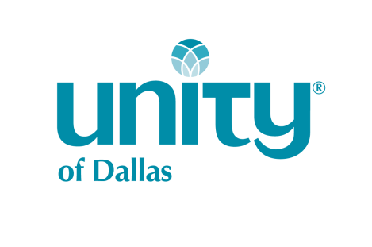

Board of Directors Application-2022

Name: Click here to enter text. Date: Click here to enter a date.

Address: Click here to enter text. City: Click here to enter text. Zip:Click here to enter text.

Phone: Click here to enter text. Email: Click here to enter text.

Please complete each of the following questions in 100 words or less. You will also need to submit a brief biography of yourself, your background and experience in 300 words or less. Please submit your bio and a recent picture with your application. To qualify for the UOD Board of Directors you must have been an ACTIVE MEMBER, as defined in the bylaws section 3.01(a), for a minimum of one year preceding the election. Applications will be accepted until midnight 3/1/2022.

- How long have you been an ACTIVE MEMBER of Unity of Dallas? What year did you become an ACTIVE MEMBER? Click here to enter text.

- How long have you attended Unity of Dallas? Have you attended any other Unity Churches, if so where?

Click here to enter text.

- What attracted you to the Unity movement and to Unity of Dallas in particular?
Click here to enter text.

- How often do you attend services at Unity of Dallas?

Click here to enter text.

- List the areas of the church in which you have served as a volunteer and in what capacity. Click here to enter text.

- Please describe the most rewarding volunteer ministry that you have served here at UOD and describe why you found it to be the most rewarding. Click here to enter text.

- Please list any other community service and outreach volunteer activities that you participate in outside of the church and describe why you find these service opportunities to be personally rewarding to you.

Click here to enter text.

- What special and or unique qualifications, strengths and areas of expertise would you bring to the UOD Board of Directors? Explain how you would use these talents for the betterment of UOD.

Click here to enter text.

- What areas would you describe as challenges for you and opportunities that you would embrace for spiritual, personal, or professional growth?

Click here to enter text.

- Please share your vision for the future of Unity of Dallas.

Click here to enter text.

- Why do you feel led to serve on the Unity of Dallas Board of Directors?

Click here to enter text.

- What is your definition and philosophy of “tithing” to support the church community?
Do you currently consistently contribute/tithe to financially support Unity of Dallas?

Click here to enter text.

- Describe your daily spiritual practices and explain how these practices help to bring strength to your life and to the community of Unity of Dallas.

Click here to enter text.

- Could you commit, and would you be willing, to attend the following regularly as a Board member at UOD? Yes No

- Monthly Board meeting-4th Thursday of each month, 5:30 pm
Board members must have the technology and ability to attend virtual meetings
- Special Board meetings as needed
- Annual 1-day weekend training or retreat
- Sunday services
- Special events and activities
- Meetings of committees that you might represent as a Board member
- A class at the church at least once a year

- If elected to the UOD Board of Directors, would you agree to and sign the Code of Conduct, Ethics and Confidentiality as set forth and approved by the By-Laws of UOD? Yes No

Deadline to submit your completed application, bio and picture is Sunday, March 1, 2022 before midnight.

You may email your application to the Nominating Committee Chair, Lesa Walker at lesacwalker@yahoo.com. You may also turn it in personally to the UOD office or to a Nominating Committee or UOD Board member at the NEXT desk in the hallway.

Signature:____________ Date: Click here to enter a date.

