-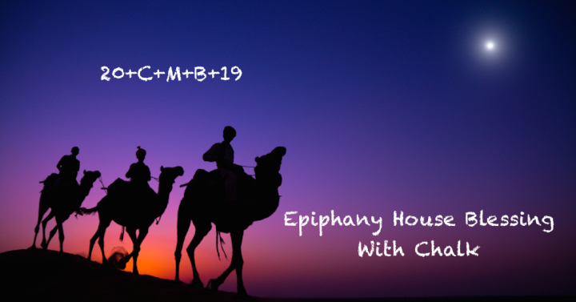

A traditional way of doing this is to use chalk blessed during the liturgy for the Feast of Epiphany and write above the home’s entryway, 20 + C + M + B + 22.
The letters C, M, B have two meanings. They are the initials of the traditional names of the three magi: Caspar, Melchior, and Balthazar. They also abbreviate the Latin words Christus mansionem benedicat, “May Christ bless the house.” The “+” signs represent the cross and 2019 is the year.

Instructions for Blessing the Home
Using the blessed chalk mark the lintel of your front door (or front porch step) as follows:
20 + C + M + B + 19 saying:
The three Wise Men, Caspar, Melchior, and Balthazar followed the star of
God’s Son who became human two thousand and nineteen years ago.
May Christ bless our home and remain with us throughout the new year. Amen.
Then say the following prayer:
Visit, O blessed Lord, this home with the gladness of your presence. Bless all who live or visit here with the gift of your love; and grant that we may manifest your love to each other and to all whose lives we touch. May we grow in grace and in the knowledge and love of you; guide, comfort, and strengthen us in peace, O Jesus Christ, now and forever. Amen.

“Chalking the door” is a way to celebrate and physically mark the occasion of the Epiphany and God’s blessing of our lives and home. With time the chalk will fade. As it does we let the meaning of the written symbols sink into the depths of our hearts and be manifest in our words and actions.

