Faith Evangelical Lutheran Church, Washington, IL
Second Sunday in Christmas
January 2, 2022

Welcome
Confession and Forgiveness

P: In the name of the Father, and of the + Son, and of the Holy Spirit.
C: Amen.
You may make the sign of the cross as a reminder of your baptism.
P: Almighty God, to whom all hearts are open, all desires known, and from whom no secrets are hid: cleanse the thoughts of our hearts by the inspiration of your Holy Spirit, that we may perfectly love you and worthily magnify your holy name, through Jesus Christ our Lord.
C: Amen.
P: Let us confess our sin in the presence of God and of one another.
Please keep silence for reflection
P: Most merciful God,
C: we confess that we are captive to sin and cannot free ourselves. We have sinned against you in thought, word, and deed, by what we have done and by what we have left undone. We have not loved you with our whole heart; we have not loved our neighbors as ourselves. For the sake of your Son, Jesus Christ, have mercy on us. Forgive us, renew us, and lead us, so that we may delight in your will and walk in your ways, to the glory of your holy name. Amen.
P: In the mercy of almighty God, Jesus Christ was given to die for us, and for his sake God forgives us all our sins. As a called and ordained minister of the church of Christ, and by his authority, I therefore declare to you the entire forgiveness of all your sins, in the name of the Father, and of the + Son, and of the Holy Spirit.
C: Amen.
Faith Lutheran Church
2206 Washington Rd,
Washington, IL 61571
Website and online worship:
www.shareourfaith.org
Church: 309-745-9306
faithlth@shareourfaith.org
Pastor John Rothfusz
Home: 309-745-9282
pastor@shareourfaith.org

Peace: As forgiven children of God, we have peace
with God, and peace with one another.
P The peace of the Lord be with you always.
C And also with you.
P Let us share that peace with one another.

*Hymn: “What Child Is This” Red Book #296

P The grace of our Lord Jesus Christ, the love of God,
and the communion of the Holy Spirit be with you all.
C And also with you.

Hymn of Praise
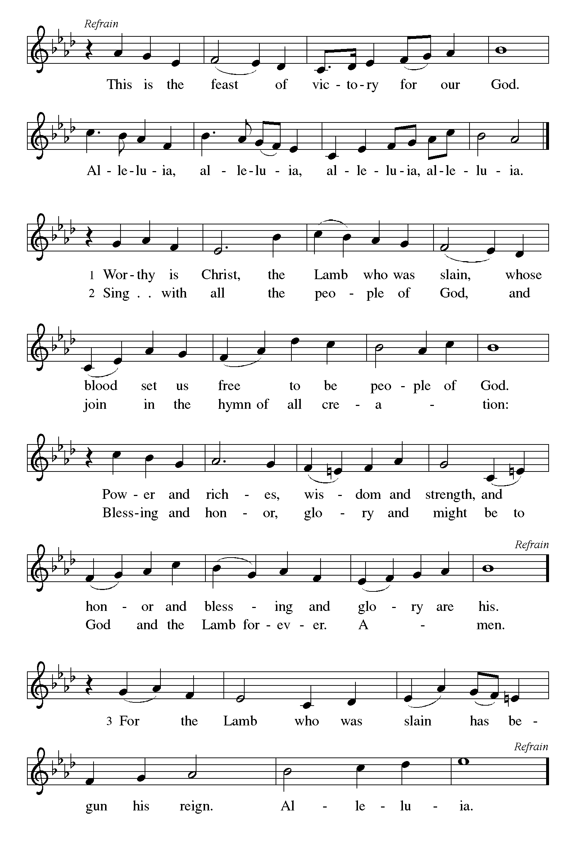

P The Lord be with you
C And also with you.
Let us pray together the Prayer of the Day
Almighty God, you have filled all the earth with the light of your incarnate Word. By your grace empower us to reflect your light in all that we do, through Jesus Christ, our Savior and Lord, who lives and reigns with you and the Holy Spirit, one God, now and forever. Amen.

Children’s Message

First Reading: Jeremiah 31:7-14 Pew Bible Page #633
⁷Thus says the Lord: Sing aloud with gladness for Jacob, and raise shouts for the chief of the nations; proclaim, give praise, and say, “Save, O Lord, your people,
the remnant of Israel.” ⁸See, I am going to bring them from the land of the north,
and gather them from the farthest parts of the earth, among them the blind and the lame, those with child and those in labor, together; a great company, they shall return here. ⁹With weeping they shall come, and with consolations I will lead them back, I will let them walk by brooks of water, in a straight path in which they shall not stumble; for I have become a father to Israel, and Ephraim is my firstborn.
¹⁰Hear the word of the Lord, O nations, and declare it in the coastlands far away; say, “He who scattered Israel will gather him, and will keep him as a shepherd a flock.” ¹¹For the Lord has ransomed Jacob, and has redeemed him from hands too strong for him. ²They shall come and sing aloud on the height of Zion, and they shall be radiant over the goodness of the Lord, over the grain, the wine, and the oil, and over the young of the flock and the herd; their life shall become like a watered garden, and they shall never languish again. ¹³Then shall the young women rejoice in the dance, and the young men and the old shall be merry.
I will turn their mourning into joy, I will comfort them, and give them gladness for sorrow. ¹⁴I will give the priests their fill of fatness, and my people shall be satisfied with my bounty,

R The Word of the Lord
C Thanks be to God

Psalm 147:12-20
¹²Worship the Lord O Jerusalem;
praise your God, O Zion,
¹³who has strengthened the bars of your gates
and has blessed your children within you.
¹⁴God has established peace on your borders
and satisfies you with the finest wheat.
¹⁵God sends out a command to the earth,
a word that runs very swiftly.
¹⁶God gives snow like wool,
scattering frost like ashes.
¹⁷God scatters hail like bread crumbs.
Who can stand against God’s cold?
¹⁸The Lord sends forth the word and melts them;
the wind blows, and the waters flow.
¹⁹God declares the word to Jacob,
statutes and judgments to Israel.
²⁰The Lord has not done so to any other nation;
they do not know God’s judgments. Hallelujah!

Second Reading – Ephesians 1:3-14 Pew Bible Page # 948
³Blessed be the God and Father of our Lord Jesus Christ, who has blessed us in Christ with every spiritual blessing in the heavenly places, ⁴just as he chose us in Christ before the foundation of the world to be holy and blameless before him in love. ⁵He destined us for adoption as his children through Jesus Christ, according to the good pleasure of his will, ⁶to the praise of his glorious grace that he freely bestowed on us in the Beloved. ⁷In him we have redemption through his blood, the forgiveness of our trespasses, according to the riches of his grace ⁸that he lavished on us. With all wisdom and insight ⁹he has made known to us the mystery of his will, according to his good pleasure that he set forth in Christ, ¹⁰as a plan for the fullness of time, to gather up all things in him, things in heaven and things on earth. ¹¹In Christ we have also obtained an inheritance, having been destined according to the purpose of him who accomplishes all things according to his counsel and will, ¹²so that we, who were the first to set our hope on Christ, might live for the praise of his glory. ¹³In him you also, when you had heard the word of truth, the gospel of your salvation, and had believed in him, were marked with the seal of the promised Holy Spirit; ¹⁴this is the pledge of our inheritance toward redemption as God’s own people, to the praise of his glory.

R The Word of the Lord
C Thanks be to God

Gospel Reading: John 1:1-18 Pew Bible Page #858
¹In the beginning was the Word, and the Word was with God, and the Word was God. ²He was in the beginning with God. ³All things came into being through him, and without him not one thing came into being. What has come into being ⁴in him was life, and the life was the light of all people. ⁵The light shines in the darkness, and the darkness did not overcome it.
⁶There was a man sent from God, whose name was John. ⁷He came as a witness to testify to the light, so that all might believe through him. ⁸He himself was not the light, but he came to testify to the light. ⁹The true light, which enlightens everyone, was coming into the world.
¹⁰He was in the world, and the world came into being through him; yet the world did not know him. ¹¹He came to what was his own, and his own people did not accept him. ¹²But to all who received him, who believed in his name, he gave power to become children of God, ¹³who were born, not of blood or of the will of the flesh or of the will of man, but of God.
¹⁴And the Word became flesh and lived among us, and we have seen his glory, the glory as of a father’s only son, full of grace and truth. ¹⁵(John testified to him and cried out, “This was he of whom I said, ‘He who comes after me ranks ahead of me because he was before me.’ ”) ¹⁶From his fullness we have all received, grace upon grace. ¹⁷The law indeed was given through Moses; grace and truth came through Jesus Christ. ¹⁸No one has ever seen God. It is God the only Son, who is close to the Father’s heart, who has made him known.

C Glory to you, O Lord
The Gospel of the Lord
C Praise to you, O Christ

Sermon by Pastor John Rothfusz

Sermon Hymn: “Word of God, Come Down on Earth” Red Book #510

Text: James Quinn, Sȷ, b. 1919
Music: LIEBSTER JESU, WIR SIND HIER, Johann R. Ahle, 1625-1673
Text © James Quinn, Sȷ, admin. Selah Publishing Co., Inc., North American Agent.
Reprinted under OneLicense.net#A-711151

Apostles’ Creed
C: I believe in God, the Father almighty,
creator of heaven and earth.
I believe in Jesus Christ, God's only Son, our Lord,
who was conceived by the Holy Spirit,
born of the virgin Mary,
suffered under Pontius Pilate,
was crucified, died, and was buried;
he descended to the dead.
On the third day he rose again;
he ascended into heaven,
he is seated at the right hand of the Father,
and he will come to judge the living and the dead.
I believe in the Holy Spirit,
the holy catholic church, the communion of saints,
the forgiveness of sins, the resurrection of the body,
and the life everlasting. Amen.

Prayers: After each portion of the prayers finishes with “Lord in your mercy,” please respond, “Hear our prayer.”

Offering: Jesus fills us with faith and sends us out as his witnesses. Let us commit ourselves to the Lord and joyfully lift our tithes and offerings to the Lord.

Please take a moment now to make an electronic offering to the church on the website, with the Tithe.ly app on your phone, or write a check and drop it in the plate at communion time.
Faith Lutheran website link www.shareourfaith.org

Offering Prayer

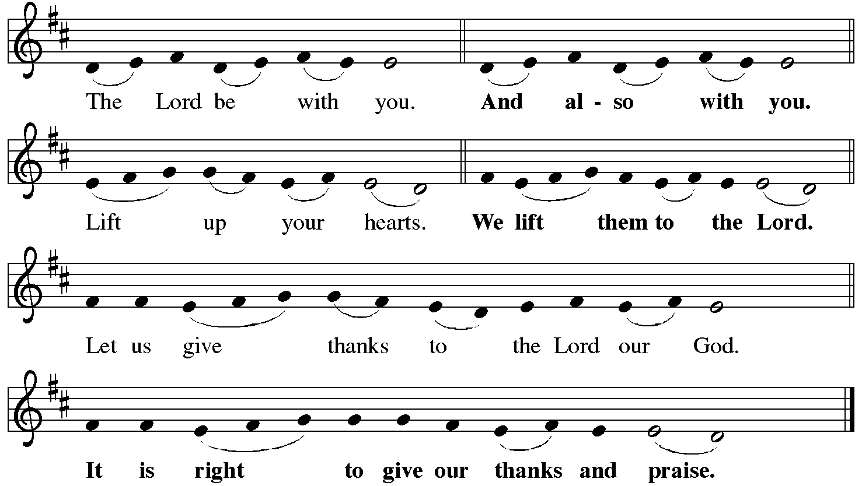

P It is indeed right, our duty and our joy… with the church on earth and the hosts of heaven, we praise your name and join their unending hymn:
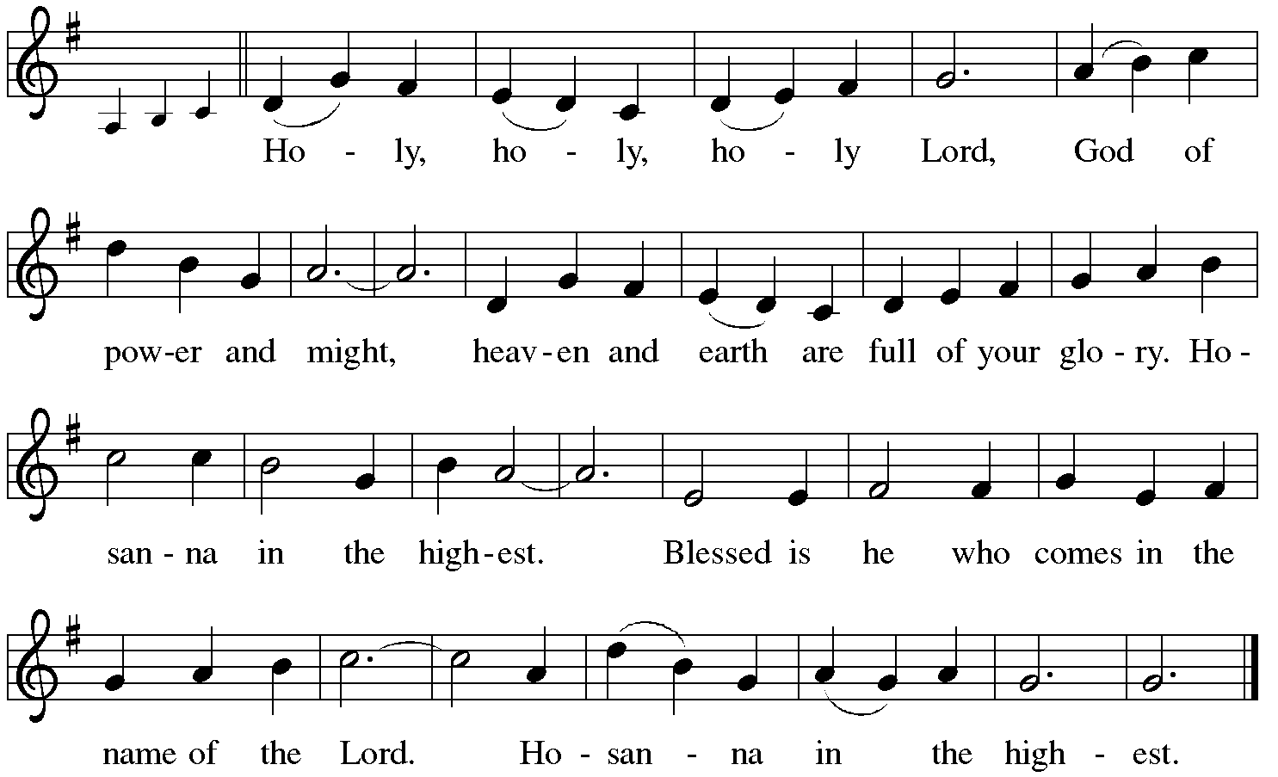

Holy Communion: Preface pp. 108-111 or other Eucharistic prayer
In the night in which he was betrayed,
our Lord Jesus took bread, and gave thanks;
broke it, and gave it to his disciples, saying:
Take and eat; this is my body, given for you.
Do this for the remembrance of me.
Again, after supper, he took the cup, gave thanks,
and gave it for all to drink, saying:
This cup is the new covenant in my blood,
shed for you and for all people for the forgiveness of sin.
Do this for the remembrance of me.

C The Lord's Prayer
Our Father, who art in heaven, hallowed be thy name,
thy kingdom come, thy will be done, on earth as it is in heaven.
Give us this day our daily bread; and forgive us our trespasses,
as we forgive those who trespass against us;
and lead us not into temptation, but deliver us from evil.
For thine is the kingdom, and the power, and the glory,
forever and ever. Amen

The Iona Invitation (Iona Community, Scotland)
This is the table not of the righteous, but of the poor in spirit. It is the table of sharing with the poor of the world, with whom our Savior identified. It is the table of communion with the earth, in which our Lord became incarnate. This is the table not of the church, but of Jesus Christ. So come to this table, you who have much faith and you who would like to have more; you who have been here often, and you who have not been for a while or ever before; you who have tried to follow Jesus, and you who have failed; Come—not because the Church invites you— It is Christ who invites you to be known and fed here.

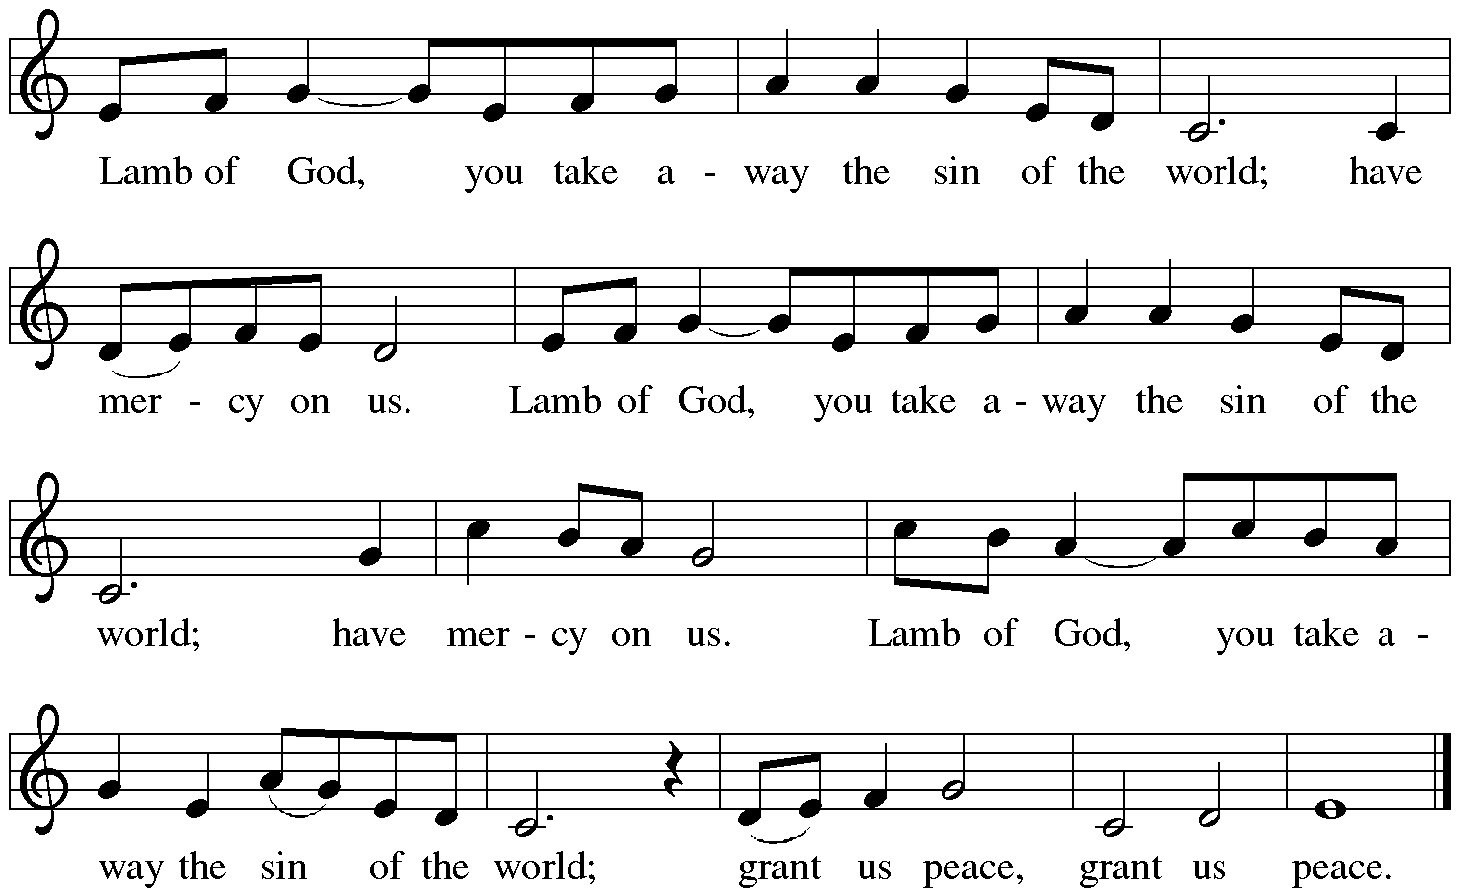

Distribution:

Communion Prayer

Announcements

Blessing
P The Lord bless you and keep you. The Lord make his face shine on you and be gracious to you. The Lord look upon you with favor and + give you peace.
In the name of the Father, and of the Son and of the Holy Spirit.
C Amen

Hymn: “Holy Child within the Manger” Blue Book #638
Text: Marty Haugen, b. 1950 Music: JOYOUS LIGHT, Marty Haugen, b. 1950
Text and music © 1987 GIA Publications, Inc., All rights reserved. Reprinted under OneLicense.net#A-711151

Dismissal
A Go in peace. Serve the Lord.
C Thanks be to God!
Postlude

Liturgy and texts from Sundays and Seasons.com. Copyright 2021 Augsburg Fortress. All rights reserved.
Reprinted by permission under Augsburg Fortress Liturgies Annual License #23628.

