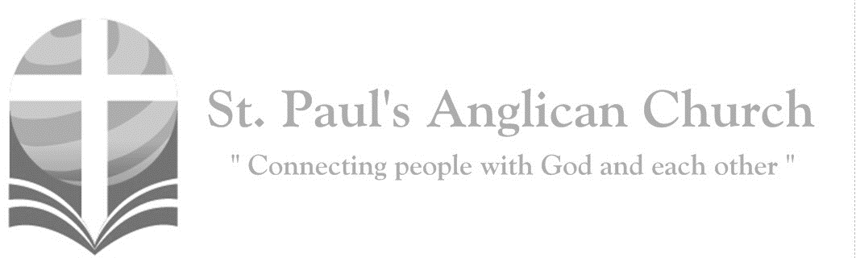
I am the servant of the Lord; let it be to me according to his word. (Luke 1:38)
Sunday, December 19, 2021: Advent 4 – Love

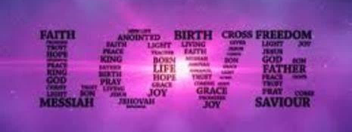
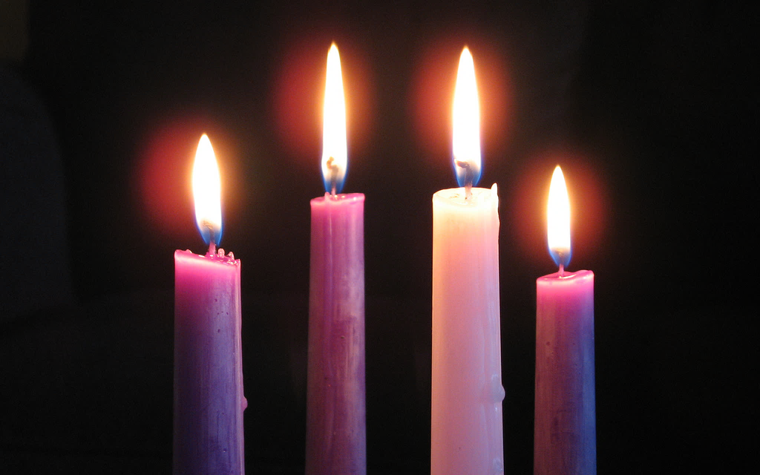

Opening Song: Come Thou Fount, Come Thou King
Come Thou Fount of every blessing
Tune my heart to sing Thy grace
Streams of mercy never ceasing
Call for songs of loudest praise
Teach me some melodious sonnet
Sung by flaming tongues above
Praise the mount I'm fixed upon it
Mount of Thy redeeming love

I was lost in utter darkness
'Til You came and rescued me
I was bound by all my sin when
Your love came and set me free
Now my soul can sing a new song
Now my heart has found a home
Now Your grace is always with me
And I'll never be alone
(Chorus) Come Thou Fount
Come Thou King
Come Thou precious Prince of Peace
Hear Your bride, to You we sing
Come Thou Fount of our blessing
O to grace how great a debtor
Daily I'm constrained to be
Let Thy goodness like a fetter
Bind my wand'ring heart to Thee
Prone to wander, Lord, I feel it
Prone to leave the God I love
Here's my heart, Lord, take and seal it
Seal it for Thy courts above
(To Chorus)

Lighting of the Fourth Advent Candle: LOVE (Andrew W-S. & Jasper R.)
Reader 1: Today is the fourth Sunday of Advent. Advent is a time of waiting. We wait for God to send divine love and light into our dark world.
Reader 2: Today we light the first, second, third, and fourth candles of the Advent wreath. Each candle has a meaning. The first candle represents Hope; the second candle represents Peace; the third candle represents Joy; and the fourth candle represents Love.
The candles are lit.
Reader 1: Leviticus 19:18b says, “You shall love your neighbour as yourself.”
Reader 2: John 13:34 says, “Jesus said to them, I give you a new commandment, that you love one another. Just as I have loved you, you also should love one another. By this everyone will know that you are my disciples, if you have love for one another.” Let us pray together:
All: Loving God, your mercy and compassion endure forever. Open our hearts, that we may receive your love; and following the example of your Son, spread that love to a love-starved world. Through Jesus Christ, who loved us to the end. Amen.
Children’s Focus
The Lord’s Prayer
Leader: As our Saviour Christ has taught us, we are bold to say,
All: Our Father, who art in heaven, hallowed be thy name, thy kingdom come, thy will be done, on earth as it is in heaven. Give us this day our daily bread. And forgive us our trespasses, as we forgive those who trespass against us. And lead us not into temptation, but deliver us from evil. For thine is the kingdom, the power, and the glory, for ever and ever. Amen.

Opening Collect
Celebrant: Heavenly Father, who chose the Virgin Mary, full of grace, to be the mother of our Lord and Saviour, now fill us with your grace, that we in all things may embrace your will and with her rejoice in your salvation; through Jesus Christ our Lord, who lives and reigns with you and the Holy Spirit, one God, now and for ever.
People: Amen.

Service of Lessons and Carols – Opening Song: You’ll Come (led by choir)
I have decided, I have resolved
To wait upon You Lord
My Rock and Redeemer
Shield and reward
I'll wait upon You Lord
As surely as the sun will rise
You'll come to us
Certain as the dawn appears

(Chorus) You'll come
Let Your glory fall as You respond to us
Spirit rain
Flood into our thirsty hearts again
You'll come, You'll come

We are not shaken, we are not moved
We wait upon You Lord
Mighty deliverer, triumph and truth
We wait upon You Lord
As surely as the sun will rise
You'll come to us
Certain as Your word endures
(To Chorus)

Chains be broken, lives be healed
Eyes be opened, Christ is revealed (2x)

As surely as the sun will rise
You'll come to us
Certain as the dawn appears
As surely as the sun will rise
You'll come to us
Certain as Your word endures
(To Chorus)

First Lesson: Genesis 3:8-15, 17-19 (Laurier B.) – God tells sinful Adam that he has lost the life of Paradise and that his seed will bruise the serpent’s head.
They heard the sound of the Lord God walking in the garden at the time of the evening breeze, and the man and his wife hid themselves from the presence of the Lord God among the trees of the garden. But the Lord God called to the man, and said to him, “Where are you?” He said, “I heard the sound of you in the garden, and I was afraid, because I was naked; and I hid myself.” He said, “Who told you that you were naked? Have you eaten from the tree of which I commanded you not to eat?” The man said, “The woman whom you gave to be with me, she gave me fruit from the tree, and I ate.” Then the Lord God said to the woman, “What is this that you have done?” The woman said, “The serpent tricked me, and I ate.” The Lord God said to the serpent, “Because you have done this, cursed are you among all animals and among all wild creatures; upon your belly you shall go, and dust you shall eat all the days of your life. I will put enmity between you and the woman, and between your offspring and hers; he will strike your head, and you will strike his heel.” And to the man he said, “Because you have listened to the voice of your wife, and have eaten of the tree about which I commanded you, ‘You shall not eat of it,’ cursed is the ground because of you; in toil you shall eat of it all the days of your life; thorns and thistles it shall bring forth for you; and you shall eat the plants of the field. By the sweat of your face you shall eat bread until you return to the ground, for out of it you were taken; you are dust, and to dust you shall return.”

Song: Emmanuel
A virgin shall bring forth a firstborn son
Conceived by the Spirit of God
He shall save all His people
And die, our ransom for sin

(Chorus) Emmanuel, Emmanuel
Come and live in our midst
Emmanuel, Emmanuel
Come make Your home in our hearts

Unto you this day shall be born a king
The light for a world full of dark
He shall be our salvation
And so His name shall be Jesus

A child who was born
Of such lowly state
Wrapped only in swaddling clothes
Kings shall pause to behold His sight
All knees shall bend at His name

All nations stand ready to greet His face
A vigil we keep for His birth
He shall be filled with wisdom
And reign His people with love

Second Lesson: Genesis 22:15-18 (Margot B.) – God promises to faithful Abraham that in his seed shall all the nations of the earth be blessed.
The angel of the Lord called to Abraham a second time from heaven, and said, “By myself I have sworn, says the Lord: Because you have done this, and have not withheld your son, your only son, I will indeed bless you, and I will make your offspring as numerous as the stars of heaven and as the sand that is on the seashore. And your offspring shall possess the gate of their enemies, and by your offspring shall all the nations of the earth gain blessing for themselves, because you have obeyed my voice.”

Song: Blessed Be Your Name

Blessed be Your name
In the land that is plentiful
Where Your streams of abundance flow
Blessed be Your name

Blessed be Your name
When I'm found in the desert place
Though I walk through the wilderness
Blessed be Your name

(Pre-Chorus)
Every blessing You pour out I’ll
Turn back to praise
When the darkness closes in Lord
Still I will say
(Chorus)
Blessed be the name of the Lord
Blessed be Your name
Blessed be the name of the Lord
Blessed be Your glorious name

Blessed be Your name
When the sun's shining down on me
When the world's all as it should be
Blessed be Your name

Blessed be Your name
On the road marked with suffering
Though there's pain in the offering
Blessed be Your name (To Pre-Chorus)

Third Lesson: Isaiah 9:2, 6-7 (Barb M.) – The prophet foretells the coming of the Saviour.
The people who walked in darkness have seen a great light; those who lived in a land of deep darkness – on them light has shined. For a child has been born for us, a son given to us; authority rests upon his shoulders; and he is named Wonderful Counselor, Mighty God, Everlasting Father, Prince of Peace. His authority shall grow continually, and there shall be endless peace for the throne of David and his kingdom. He will establish and uphold it with justice and with righteousness from this time onward and forevermore. The zeal of the Lord of hosts will do this.

Song: Gaudete (special music – small ensemble)

Gaudete
Christus est natus ex Maria Virgine
Tempus adest gratiae
hoc quod optabamus
Camina laetitiae devote reddamus
Deus homo factus est, natura mirante
Mundus renovates
est a Christo regnante
(Translation) Rejoice
Christ is born of the virgin Mary
The time of grace which we seek
Is here
Let us devoutly sing songs of joy
God has become man, a thing of wonder
The world is renewed
By the reigning Christ

Fourth Lesson: Isaiah 11:1-4a, 6-9 (Jim R.) – The peace that Christ will bring is foreshown.
A shoot shall come out from the stump of Jesse, and a branch shall grow out of his roots. The spirit of the Lord shall rest on him, the spirit of wisdom and understanding, the spirit of counsel and might, the spirit of knowledge and the fear of the Lord. His delight shall be in the fear of the Lord. He shall not judge by what his eyes see, or decide by what his ears hear; but with righteousness he shall judge the poor, and decide with equity for the meek of the earth. The wolf shall live with the lamb, the leopard shall lie down with the kid, the calf and the lion and the fatling together, and a little child shall lead them. The cow and the bear shall graze, their young shall lie down together; and the lion shall eat straw like the ox. The nursing child shall play over the hole of the asp, and the weaned child shall put its hand on the adder’s den. They will not hurt or destroy on all my holy mountain; for the earth will be full of the knowledge of the Lord as the waters cover the sea.

Song: Your Name (Christmas Version)

God with us, Emmanuel (3x)
Now we adore Your Name

Humbly to the earth You came
Born into this world to save
God with us, Emmanuel
Now we adore Your Name

(Chorus)
Your Name is a strong and mighty tower
Your Name is a shelter like no other
Your Name let the nations sing it louder
For nothing has the power to save
But Your Name
Jesus in Your Name we pray
Come and fill our hearts today
Lord give us strength to live for You
And glorify Your Name (To Chorus)

Wonderful Counselor, Prince of Peace
Wonderful Counselor, Prince of Peace
(To Chorus)

Fifth Lesson: Luke 1:26-35,38 (Deanna K.) – Gabriel salutes the Blessed Virgin Mary.
In the sixth month the angel Gabriel was sent by God to a town in Galilee called Nazareth, to a virgin engaged to a man whose name was Joseph, of the house of David. The virgin’s name was Mary. And he came to her and said, “Greetings, favoured one! The Lord is with you.” But she was much perplexed by his words and pondered what sort of greeting this might be. The angel said to her, “Do not be afraid, Mary, for you have found favour with God. And now, you will conceive in your womb and bear a son, and you will name him Jesus. He will be great, and will be called the Son of the Most High, and the Lord God will give to him the throne of his ancestor David. He will reign over the house of Jacob forever, and of his kingdom there will be no end.” Mary said to the angel, “How can this be, since I am a virgin?” The angel said to her, “The Holy Spirit will come upon you, and the power of the Most High will overshadow you; therefore, the child to be born will be holy; he will be called Son of God. Then Mary said, “Here am I, the servant of the Lord; let it be with me according to your word.” Then the angel departed from her.

Song: Breath of Heaven (special music by St. Paul’s choir)

I have traveled many moonless nights
Cold and weary with a Babe inside
And I wonder what I've done
Holy Father, You have come
And chosen me now to carry Your Son

I am waiting in a silent prayer
I am frightened by the load I bear
In a world as cold as stone
Must I walk this path alone?
Be with me now, be with me now
Breath of Heaven, hold me together
Be forever near me, Breath of Heaven
Breath of Heaven, lighten my darkness
Pour over me Your holiness
For You are holy, Breath of Heaven

Do You wonder as You watch my face
If a wiser one should have had my place
But I offer all I am
For the mercy of Your plan
Help me be strong, help me be, help me

Sixth Lesson: Luke 2:1, 3-7 (David H.) – St. Luke tells of the birth of Jesus.
In those days a decree went out from Emperor Augustus that all the world should be registered. All went to their own towns to be registered. Joseph also went from the town of Nazareth in Galilee to Judea, to the city of David called Bethlehem, because he was descended from the house and family of David. He went to be registered with Mary, to whom he was engaged and who was expecting a child. While they were there, the time came for her to deliver her child. And she gave birth to her firstborn son and wrapped him in bands of cloth, and laid him in a manger, because there was no place for them in the inn.
Offertory Song: O Little Town of Bethlehem (led by small ensemble)

O little town of Bethlehem
How still we see thee lie
Above thy deep and dreamless sleep
The silent stars go by
Yet in thy dark streets shineth
The everlasting Light
The hopes and fears of all the years
Are met in thee tonight

For Christ is born of Mary
And gathered all above
While mortals sleep, the angels keep
Their watch of wondering love
O morning stars together
Proclaim the holy birth
And praises sing to God the King
And peace to all on earth

How silently, how silently
The wondrous gift is given
So God imparts to human hearts
The blessings of His heaven
No ear may hear His coming
But in this world of sin
Where meek souls will receive Him still
The dear Christ enters in

Where children pure and happy
Pray to the blessed Child
Where misery cries out to Thee
Son of the mother mild
Where charity stands watching
And faith holds wide the door
The dark night wakes, the glory breaks
And Christmas comes once more

O holy Child of Bethlehem
Descend to us we pray
Cast out our sin and enter in
Be born in us today
We hear the Christmas angels
The great glad tidings tell
O come to us, abide with us
Our Lord, Emmanuel

Seventh Lesson: Luke 2:8-16 (Carol R.) – The shepherds go to the manger.
In that region there were shepherds living in the fields, keeping watch over their flock by night. Then an angel of the Lord stood before them, and the glory of the Lord shone around them, and they were terrified. But the angel said to them, “Do not be afraid; for see—I am bringing you good news of great joy for all the people: to you is born this day in the city of David a Saviour, who is the Messiah, the Lord. This will be a sign for you: you will find a child wrapped in bands of cloth and lying in a manger.” And suddenly there was with the angel a multitude of the heavenly host, praising God and saying, “Glory to God in the highest heaven, and on earth peace among those whom he favors!” When the angels had left them and gone into heaven, the shepherds said to one another, “Let us go now to Bethlehem and see this thing that has taken place, which the Lord has made known to us.” So they went with haste and found Mary and Joseph, and the child lying in the manger.

Song: Angels We Have Heard on High

Angels we have heard on high
Sweetly singing o'er the plains
And the mountains in reply
Echoing their joyous strains

(Chorus) Gloria, In excelsis Deo (2x)
Shepherds why this jubilee
Why your joyous strains prolong
What the gladsome tidings be
Which inspire your heav'nly song
(To Chorus)
Come to Bethlehem and see
Christ whose birth the angels sing
Come adore on bended knee
Christ the Lord the newborn King
(To Chorus)

See Him in a manger laid
Whom the choirs of angels praise
Mary Joseph lend your aid
While our hearts in love we raise
(To Chorus)

Eighth Lesson: Matthew 2:1-12 (Lauren H.) – The wise men are led by the star to Jesus.
In the time of King Herod, after Jesus was born in Bethlehem of Judea, wise men from the East came to Jerusalem, asking, “Where is the child who has been born king of the Jews? For we observed his star at its rising, and have come to pay him homage.” When King Herod heard this, he was frightened, and all Jerusalem with him; and calling together all the chief priests and scribes of the people, he inquired of them where the Messiah was to be born. They told him, “In Bethlehem of Judea; for so it has been written by the prophet: ‘And you, Bethlehem, in the land of Judah, are by no means least among the rulers of Judah; for from you shall come a ruler who is to shepherd my people Israel.’” Then Herod secretly called for the wise men and learned from them the exact time when the star had appeared. Then he sent them to Bethlehem, saying, “Go and search diligently for the child; and when you have found him, bring me word so that I may also go and pay him homage.” When they had heard the king, they set out; and there, ahead of them, went the star that they had seen at its rising, until it stopped over the place where the child was. When they saw that the star had stopped, they were overwhelmed with joy. On entering the house, they saw the child with Mary his mother; and they knelt down and paid him homage. Then, opening their treasure chests, they offered him gifts of gold, frankincense, and myrrh. And having been warned in a dream not to return to Herod, they left for their own country by another road.

Song: Joy Has Dawned

Joy has dawned upon the world
Promised from creation
God's salvation now unfurled
Hope for every nation
Not with fanfares from above
Not with scenes of glory
But a humble gift of love
Jesus born of Mary

Sounds of wonder fill the sky
With the songs of angels
As the mighty Prince of Life
Shelters in a stable
Hands that set each star in place
Shaped the earth in darkness
Cling now to a mother's breast
Vulnerable and helpless
Shepherds bow before the Lamb
Gazing at the glory
Gifts of men from distant lands
Prophesy the story
Gold, a King is born today
Incense, God is with us
Myrrh, His death will make a way
By His blood He'll win us

Son of Adam, Son of heaven
Given as a ransom
Reconciling God and man
Christ our mighty Champion
What a Saviour, what a Friend
What a glorious mystery
Once a babe in Bethlehem
Now the Lord of history

Ninth Lesson: John 1:1-14 (Jennifer B.) – St. John unfolds the great mystery of the Incarnation.
In the beginning was the Word, and the Word was with God, and the Word was God. He was in the beginning with God. All things came into being through him, and without him not one thing came into being. What has come into being in him was life, and the life was the light of all people. The light shines in the darkness, and the darkness did not overcome it. There was a man sent from God, whose name was John. He came as a witness to testify to the light, so that all might believe through him. He himself was not the light, but he came to testify to the light. The true light, which enlightens everyone, was coming into the world. He was in the world, and the world came into being through him; yet the world did not know him. He came to what was his own, and his own people did not accept him. But to all who received him, who believed in his name, he gave power to become children of God, who were born, not of blood or of the will of the flesh or of the will of man, but of God. And the Word became flesh and lived among us, and we have seen his glory, the glory as of a father’s only son, full of grace and truth.

Song: O Come, All Ye Faithful

O come, all ye faithful
Joyful and triumphant
O come ye, O come ye to Bethlehem
Come and behold Him
Born the King of angels

(Chorus) O come, let us adore Him
O come, let us adore Him
O come, let us adore Him
Christ the Lord

Sing choirs of angels, sing in exultation
O sing all ye bright
Hosts of heav'n above
Glory to God, all glory in the highest
(To Chorus)

Yea, Lord, we greet Thee
Born this happy morning
Jesus to Thee be all glory giv'n
Word of the Father
Now in flesh appearing (To Chorus)

Closing Collect
Celebrant: Almighty God, you make us glad each year as we remember the birth of thy only son, Jesus Christ: Grant that, as we joyfully receive him for our redeemer, we may with sure confidence behold him when he comes to be our judge; who is alive and reigns with you and the Holy Spirit, one God, world without end.
All: Amen.

Blessing

Congregational Announcements

The Dismissal
Celebrant: Go in peace to love and serve the Lord.
All: Thanks be to God. Amen.

Christmas Services at St. Paul’s
All Christmas services at St. Paul’s will also be available on our YouTube Channel (search “St. Paul’s Anglican – Edmonton”). Please plan to join us!!
- December 24: Christmas Eve service starting at 7:00PM
- December 25: Christmas Day service starting at 9:00AM
- December 26: 1st Sunday after Christmas service starting at 10:00AM

Daily Morning Prayer
Myron and a few parishioners are beginning to meet daily for morning prayer on Zoom at 8am during the season of Advent. Every Thursday we will meet at St. Paul’s in person for morning prayer and to discuss Joan Chittister’s book Wisdom Distilled from the Daily. If you would like to join, please talk to Myron or email the office for the link.

Community Corner for December 19
Our church and city are built on Treaty 6 land, but what does that mean? To learn more about Treaty Six, please visit https://treaty6education.lskysd.ca Many resources have been created for school-aged citizens and their teachers, yet these are good resources for citizens of any age to increase our own understanding.

Do you need assistance with mental health or other needs? Asking for help can be very hard. First and foremost, please reach out to our staff, vestry members, or others in the congregation; and let us know so we can partner with you. There are many resources for help and we are here to support. Also, in Alberta, 211 is an essential service that helps Albertans find the right resource or service for any issue they need help with, at the right time. 211 is available 24/7 by phone, text, and chat online. The service is free, confidential and available in over 170 languages. www.ab.211.ca

Stony Plain Road hosts a wonderful array of businesses that are interested in serving you. As you are doing Christmas shopping this season, please think about shopping local! There are many small businesses such as Ben’s Meats, Blue Jar Antique Mall and Yans Flowers, to name a few. Visit the Stoney Plain Road Business Association Website at https://www.stonyplainroad.com for a full listing of stores.

For prayer requests,
Email or phone the church office.
For pastoral emergencies call:
(587) 334-2130

St. Paul’s Anglican Church
10127 145 Street, Edmonton, T5N 2X6
Phone: (780) 455-0771
Email: office@stpauls-anglican.ca
Website: www.stpauls-anglican.ca
Envelopes Ready
2022 Giving Envelopes are available at the office for pickup.
Office Hours:
Monday-Thursday 9:30-11:30am
St. Paul’s Staff:
Rector: The Rev. Myron B. Penner
Community Outreach: Michelle Schurek
Youth Leader: Abigail Harding
Office Administrator: Asher Hébert

