Faith Evangelical Lutheran Church, Washington, IL
Fourth Sunday of Advent
December 19, 2021

Welcome

Lighting of the Advent Candles Red Book #242

Text: Marty Haugen, b. 1950 Music: REJOICE, REJOICE, Marty Haugen
Text and music © 1983 GIA Publications, Inc., 7404 S. Mason Ave., Chicago, IL 60638. www.giamusic.com.800.442.3358. All rights reserved. Used by permission. Reprinted under OneLicense #A-711151

Please pray with me as we light our Fourth Advent Candle.
Blessed are you, O Lord our God, ruler of the universe. In your Son, Emmanuel, you have shown us your light and saved us from the power of sin. Bless us as we light the candles of this wreath. Increase our longing for your presence, that at the celebration of your Son’s birth his Spirit might dwell anew in our midst, for he is our light and our salvation. Blessed be God forever. Amen.
Confession and Forgiveness

P: In the name of the Father, and of the + Son, and of the Holy Spirit.
C: Amen.
You may make the sign of the cross as a reminder of your baptism.
P: Blessed be the holy Trinity, ☩ one God, who alone does wonders,
who lifts up the lowly, who fills the hungry with good things.
C: Amen.
P: Let us confess our sin in the presence of God and of one another.
Please keep silence for reflection
P: God for whom we wait,
C: in the presence of one another, we confess our sin before you. We fail in believing that your good news is for us. We falter in our call to tend your creation. We find our sense of self in material wealth. We fear those different from ourselves. We forget that we are your children and turn away from your love. Forgive us, Blessed One, and assure us again of your saving grace.
Amen.

P: God, in Christ Jesus, has looked with favor upon you! Through the power of the Holy Spirit, ☩ your sins are forgiven. You are children of the Most High,
inheritors of the eternal promise, and recipients of divine mercy. God strengthens you anew to follow the way of peace.
C: Amen.
Faith Lutheran Church
2206 Washington Rd,
Washington, IL 61571
Website and online worship:
www.shareourfaith.org
Church: 309-745-9306
faithlth@shareourfaith.org
Pastor John Rothfusz
Home: 309-745-9282
pastor@shareourfaith.org
Peace: As forgiven children of God, we have peace
with God, and peace with one another.

P The peace of the Lord be with you always.
C And also with you.
P Let us share that peace with one another.

P The Lord be with you
C And also with you.

Let us pray together the Prayer of the Day
Stir up your power, Lord Christ, and come. With your abundant grace and might, free us from the sin that binds us, that we may receive you in joy and serve you always, for you live and reign with the Father and the Holy Spirit, one God, now and forever. Amen.

Sunday School Christmas Program
Away in a Manger

1 Away in a manger, no crib for his bed,
the little Lord Jesus laid down his sweet head;
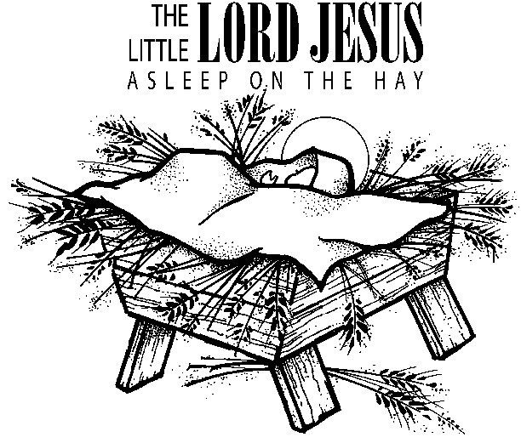
the stars in the bright sky looked down where he lay,
the little Lord Jesus asleep on the hay.

2 The cattle are lowing; the baby awakes,
but little Lord Jesus, no crying he makes.
I love you, Lord Jesus; look down from the sky
and stay by my cradle till morning is nigh.

3 Be near me, Lord Jesus; I ask you to stay
close by me forever and love me, I pray.
Bless all the dear children in your tender care
and fit us for heaven, to live with you there.

Silent Night, Holy Night

1 Silent night, holy night!
All is calm, all is bright
round yon virgin mother and child.
Holy Infant, so tender and mild,
sleep in heavenly peace,
sleep in heavenly peace.

2 Silent night, holy night!
Shepherds quake at the sight;
glories stream from heaven afar,
heav'nly hosts sing, alleluia!
Christ, the Savior, is born!
Christ, the Savior, is born!

Go Tell It on the Mountain

Refrain
Go tell it on the mountain, over the hills and ev’rywhere;
go tell it on the mountain that Jesus Christ is born!

1 While shepherds kept their watching o’er silent flocks by night,
behold, throughout the heavens there shone a holy light. Refrain

3 Down in a lonely manger the humble Christ was born;
and God sent us salvation that blessed Christmas morn. Refrain

Children’s Message
First Reading: Micah 5:2-5a Pew Bible Page #748
²But you, O Bethlehem of Ephrathah, who are one of the little clans of Judah, from you shall come forth for me one who is to rule in Israel, whose origin is from of old, from ancient days. ³Therefore he shall give them up until the time when she who is in labor has brought forth; then the rest of his kindred shall return to the people of Israel. ⁴And he shall stand and feed his flock in the strength of the Lord,
in the majesty of the name of the Lord his God. And they shall live secure, for now he shall be great to the ends of the earth; ^{5a}and he shall be the one of peace.

R The Word of the Lord C Thanks be to God

Psalm – Luke 1:46b-55
^{46b}My soul proclaims the greatness of the Lord,
⁴⁷my spirit rejoices in God my Savior,
⁴⁸for you, Lord, have looked with favor on your lowly servant.
From this day all generations will call me blessed:
⁴⁹you, the Almighty, have done great things for me
and holy is your name.
⁵⁰You have mercy on those who fear you,
from generation to generation.
⁵¹You have shown strength with your arm
and scattered the proud in their conceit,
⁵²casting down the mighty from their thrones
and lifting up the lowly.
⁵³You have filled the hungry with good things
and sent the rich away empty.
⁵⁴You have come to the aid of your servant Israel,
to remember the promise of mercy,
⁵⁵the promise made to our forebears,
to Abraham and his children forever.

Gospel Reading: Luke 1:39-45 Pew Bible Page #826

C Glory to you, O Lord
³⁹In those days Mary set out and went with haste to a Judean town in the hill country, ⁴⁰where she entered the house of Zechariah and greeted Elizabeth. ⁴¹When Elizabeth heard Mary’s greeting, the child leaped in her womb. And Elizabeth was filled with the Holy Spirit ⁴²and exclaimed with a loud cry, “Blessed are you among women, and blessed is the fruit of your womb. ⁴³And why has this happened to me, that the mother of my Lord comes to me? ⁴⁴For as soon as I heard the sound of your greeting, the child in my womb leaped for joy. ⁴⁵And blessed is she who believed that there would be a fulfillment of what was spoken to her by the Lord.”
The Gospel of the Lord
C Praise to you, O Christ

Sermon by Pastor John Rothfusz

Sermon Hymn: “Canticle of the Turning” Red Book #723

Text: Rory Cooney, b. 1952, based on the Magnificat
Music: STAR OF COUNTY DOWN, Irish traditional
Text © 1990 GIA Publications, Inc., 7404 S. Mason Ave., Chicago, IL 60638. www.giamusic.com. 800.442.3358.
All rights reserved. Used by permission. Reprinted under OneLicense #A-711151

Apostles’ Creed
C: I believe in God, the Father almighty,
creator of heaven and earth.
I believe in Jesus Christ, God's only Son, our Lord,
who was conceived by the Holy Spirit,
born of the virgin Mary,
suffered under Pontius Pilate,
was crucified, died, and was buried;
he descended to the dead.
On the third day he rose again;
he ascended into heaven,
he is seated at the right hand of the Father,
and he will come to judge the living and the dead.
I believe in the Holy Spirit,
the holy catholic church, the communion of saints,
the forgiveness of sins, the resurrection of the body,
and the life everlasting. Amen.

Prayers: After each portion of the prayers finishes with “Lord in your mercy,” please respond, “Hear our prayer.”

Offering: Jesus fills us with faith and sends us out as his witnesses. Let us commit ourselves to the Lord and joyfully lift our tithes and offerings to the Lord.

Please take a moment now to make an electronic offering to the church on the website, with the Tithe.ly app on your phone, or write a check and drop it in the plate at communion time.
Faith Lutheran website link www.shareourfaith.org

A Let us pray. Blessed are you, O God,
C maker of all things. Through your goodness you have blessed us with these gifts: our selves, our time, and our possessions. Use us, and what we have gathered, in feeding the world with your love, through the one who gave himself for us, Jesus Christ, our Savior and Lord. Amen.

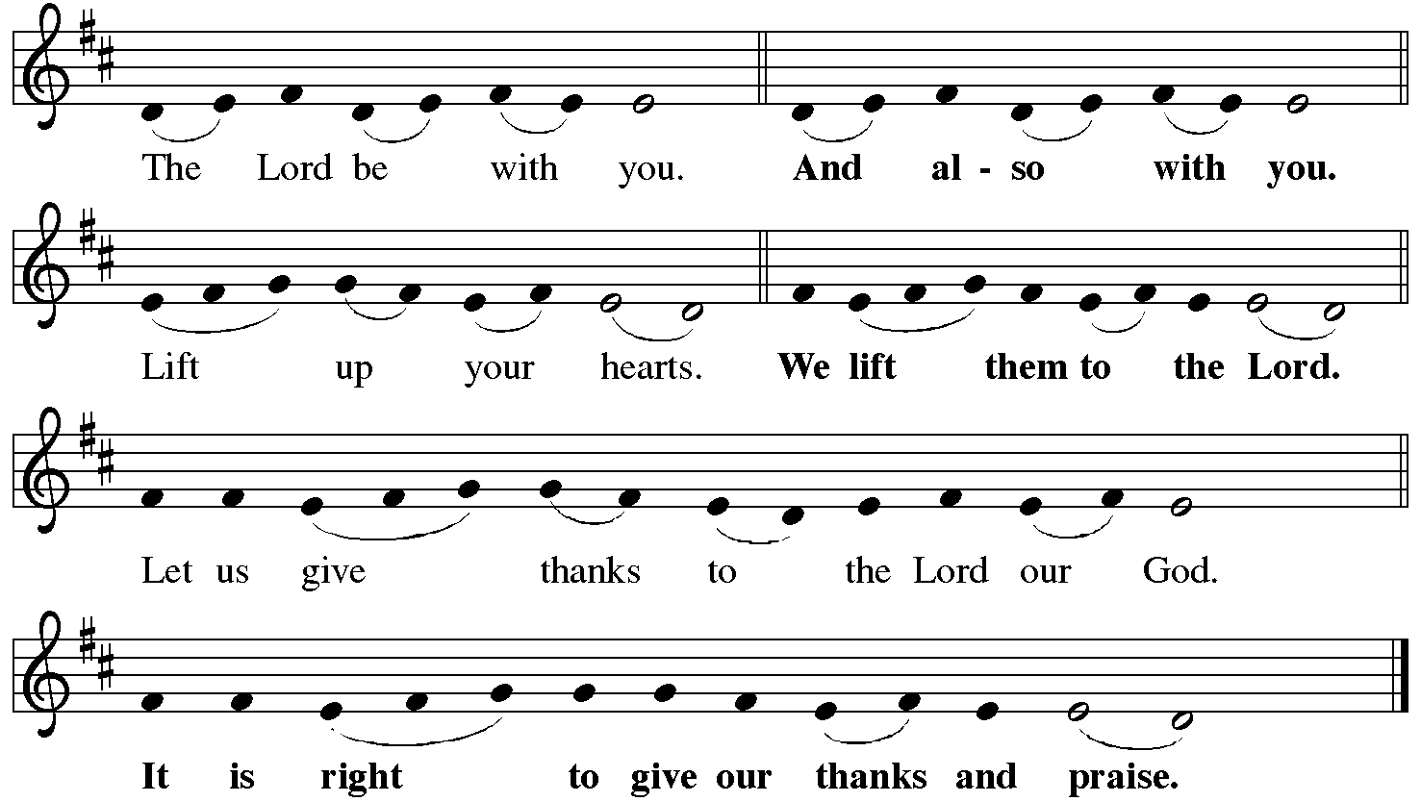

P It is indeed right, our duty and our joy… with the church on earth and the hosts of heaven, we praise your name and join their unending hymn:
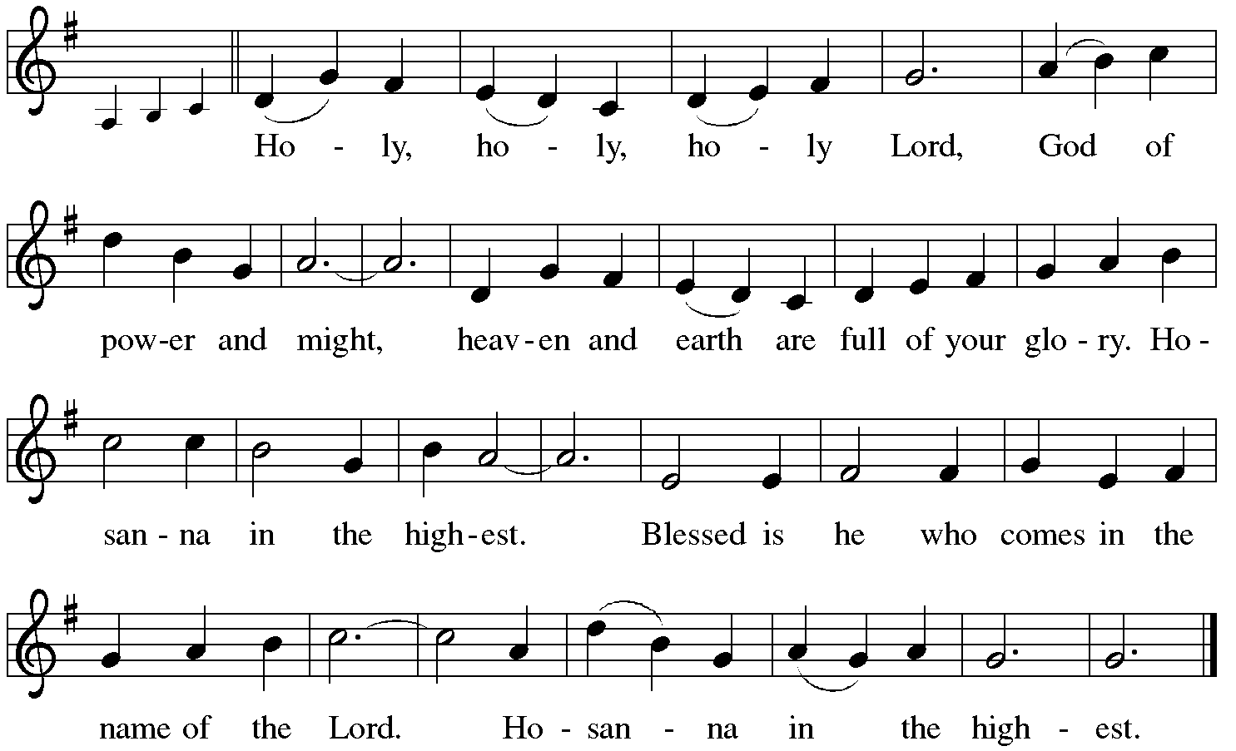

Holy Communion: Preface pp. 108-111 or other Eucharistic prayer

In the night in which he was betrayed,
our Lord Jesus took bread, and gave thanks;
broke it, and gave it to his disciples, saying:
Take and eat; this is my body, given for you.
Do this for the remembrance of me.
Again, after supper, he took the cup, gave thanks,
and gave it for all to drink, saying:
This cup is the new covenant in my blood,
shed for you and for all people for the forgiveness of sin.
Do this for the remembrance of me.

C The Lord's Prayer
Our Father, who art in heaven, hallowed be thy name,
thy kingdom come, thy will be done, on earth as it is in heaven.
Give us this day our daily bread; and forgive us our trespasses,
as we forgive those who trespass against us;
and lead us not into temptation, but deliver us from evil.
For thine is the kingdom, and the power, and the glory,
forever and ever. Amen

The Iona Invitation (Iona Community, Scotland)
This is the table not of the righteous, but of the poor in spirit. It is the table of sharing with the poor of the world, with whom our Savior identified. It is the table of communion with the earth, in which our Lord became incarnate. This is the table not of the church, but of Jesus Christ. So come to this table, you who have much faith and you who would like to have more; you who have been here often, and you who have not been for a while or ever before; you who have tried to follow Jesus, and you who have failed; Come—not because the Church invites you— It is Christ who invites you to be known and fed here.

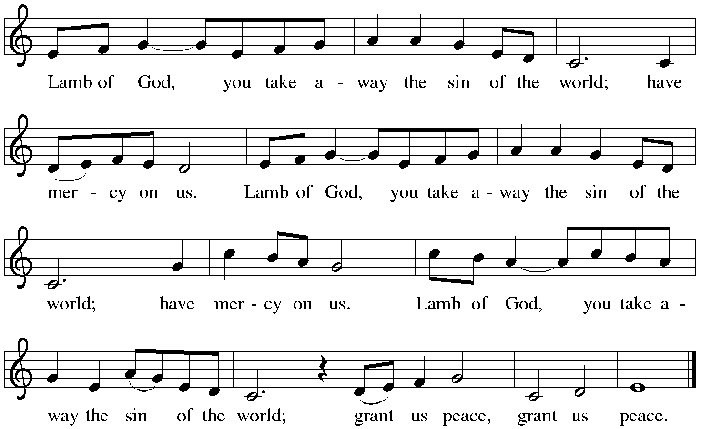

Distribution:

Communion Prayer

Announcements

Blessing
P The Lord bless you and keep you. The Lord make his face shine on you and be gracious to you. The Lord look upon you with favor and + give you peace.
In the name of the Father, and of the Son and of the Holy Spirit.
C Amen

Hymn: “Soon and Very Soon” Red Book #439

Text: Andraé Crouch, b. 1945
Music: VERY SOON, Andraé Crouch
Text and music © 1976 Bad John Songs, Inc./Crouch Music, admin. EMI Christian Music Publishing CCLI #1375910

Dismissal
A Go in peace. Serve the Lord. C Thanks be to God!

Postlude
Liturgy and texts from Sundays and Seasons.com. Copyright 2021 Augsburg Fortress. All rights reserved.
Reprinted by permission under Augsburg Fortress Liturgies Annual License #23628.

