Series, Good News for Troubling Times — Rediscover Christmas
Part 2: How to Rediscover Peace
December 5th, 2021

INTRODUCTION

Meditate on the word ‘peace’. What does peace mean to you? What would it look like if there was world peace? Peace in your family? Inner peace?

Luke 2:8-21
8 And there were shepherds living out in the fields nearby, keeping watch over their flocks at night. 9 An angel of the Lord appeared to them, and the glory of the Lord shone around them, and they were terrified. 10 But the angel said to them, “Do not be afraid. I bring you good news that will cause great joy for all the people. 11 Today in the town of David a Savior has been born to you; he is the Messiah, the Lord. 12 This will be a sign to you: You will find a baby wrapped in cloths and lying in a manger.”
13 Suddenly a great company of the heavenly host appeared with the angel, praising God and saying,
14 “Glory to God in the highest heaven, and on earth peace to those on whom his favor rests.”
15 When the angels had left them and gone into heaven, the shepherds said to one another, “Let’s go to Bethlehem and see this thing that has happened, which the Lord has told us about.”
16 So they hurried off and found Mary and Joseph, and the baby, who was lying in the manger. 17 When they had seen him, they spread the word concerning what had been told them about this child, 18 and all who heard it were amazed at what the shepherds said to them. 19 But Mary treasured up all these things and pondered them in her heart. 20 The shepherds returned, glorifying and praising God for all the things they had heard and seen, which were just as they had been told.
21 On the eighth day, when it was time to circumcise the child, he was named Jesus, the name the angel had given him before he was conceived.
P___________ in Greek, εἰρήνη, literary means: “to join or bind together that which has been separated”and this definition also captures the Hebrew concept, S___________.
Life consists of a web of relationships:
- Relationship with our Socio-economic context
- Relationship with Creation
- Relationship with Others
- Relationship with Ourselves
- Relationship with G___________

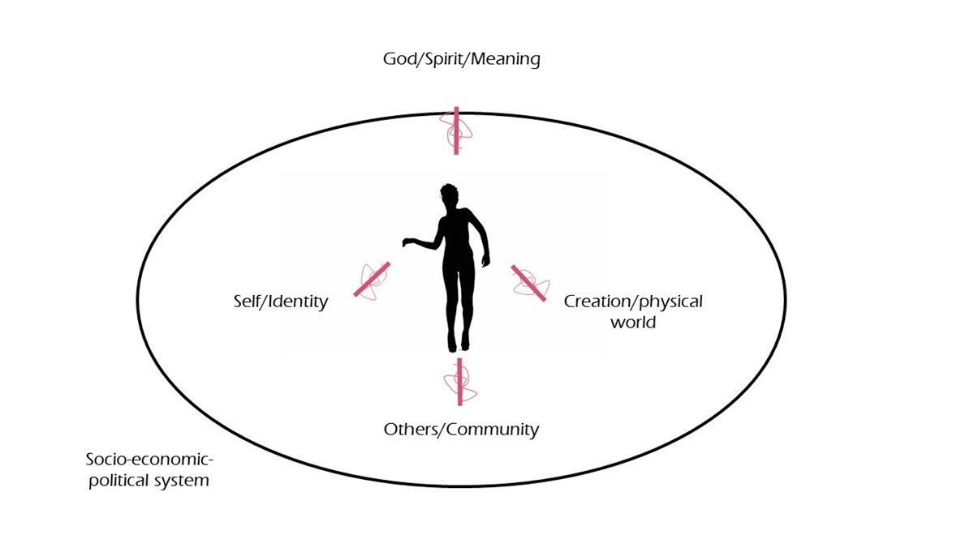
Peace, shalom, is the R___________ and H___________ of all these relationships – to bind together what has been separated so that we can live full flourishing lives.

Theme and goal: J___________ not only gives us peace, he is our P___________.

Jesus restores the Shepherds’ relationship to:
- G___________
- T___________
- O___________

A picture of Biblical peace: Luke 2:20
“The shepherds returned, glorifying and praising God for all the things they had heard and seen, which were just as they had been told.”

Isaiah 9:6b
“And he will be called Wonderful Counselor, Mighty God, Everlasting Father, Prince of Peace.”

Just like B___________ between us and God breaks other relationships, healing the relationship between God and us (salvation) H___________ other relationships.

John 14:27
“27 Peace I leave with you; my peace I give you. I do not give to you as the world gives. Do not let your hearts be troubled and do not be afraid.”

While the world-system gives peace by S___________ blood, Jesus brings peace by S___________ his own blood...Because Jesus experienced separation, God now gives us S___________!

Like the manger was a S___________ for the shepherds, God has made the church a sign to the world. The Spirit of Christ has created the church, his people, to be a place where people like the shepherds of Jesus’ day feel accepted, loved and cherished. We are called to be a place of joy and hope because Jesus is H___________ our broken relationships even now.

Micah 5:4-5a
“4 He will stand and shepherd his flock in the strength of the Lord,
in the majesty of the name of the Lord his God.
And they will live securely, for then his greatness
will reach to the ends of the earth.
5 And he will be our peace”

Jesus not only gives us peace, he is our peace. Jesus gives us peace, he is healing our brokenness, but also he is W___________ U___________ in our brokenness.

Jesus is E___________.

Philppians 4:4-7
4 Rejoice in the Lord always. I will say it again: Rejoice! 5 Let your gentleness be evident to all. The Lord is near. 6 Do not be anxious about anything, but in every situation, by prayer and petition, with thanksgiving, present your requests to God. 7 And the peace of God, which transcends all understanding, will guard your hearts and your minds in Christ Jesus.

