** GLADWIN HEIGHTS UNITED CHURCH**

3474 Gladwin Road  
Abbotsford, BC  
V2S 7B4 Canada

Phone:[604.852.3984](tel:1-604-852-3984)

Email:[info@gladwinheightsunitedchurch.org](mailto:info@gladwinheightsunitedchurch.org)

**December 12 2021**

**Minister:** Rev. Tim Bowman

**Song Leader:**  Rita Green

**Pianist:** Jacob Greenan

**Office Administrator:** Angela Darychuk



We look forward to seeing you all *in person* this Sunday! Worship is at 9:30

We are checking COVID vaccination status and please remember that masks will be mandatory for everyone over the age of 12. There will be a sign in sheet for everyone to sign. There are no exceptions aside from choir members, music leaders and readers / presiders while speaking or singing and physically distanced

**Worship via ZOOM**: We are working with Sapphire Sound to livestream our worship services. In the meantime, we understand that some of you are unable to join us in person and would like to do so remotely. Therefore, as a courtesy we are offering a Zoom option. However, please understand that this is a temporary measure and that there will be no video provided, the sound is what it is, and no one will be monitoring chat messages or admitting participants once the service has started

Link to the Zoom meeting:<https://us02web.zoom.us/j/5410632113?pwd=eDhHL3ZUMkszcFArQzIyZ2lXbEExdz09>  
Meeting ID: 541 063 2113  
Passcode: 123

Alternatively, go to [zoom.us](http://zoom.us), select Join a Meeting, and enter the above Meeting ID (and password if necessary.)

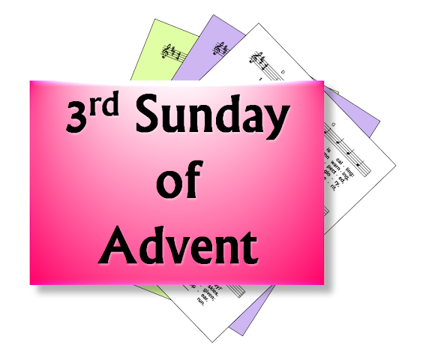

**Church office hours:**

**Gladwin Heights** office is open 9:30am - 2:30pm, Tuesday

**St. Andrews'** office is open 9:30am - 2:30 pm, Wednesday

Remote office hours for both Gladwin Heights and St Andrews' are Monday and Thursday 9 am to 4 pm

**Reverend Tim’s office hours:**

Tim can be reached from 10am - 4pm Monday and Wednesday at St Andrew’s office, 10am to 4pm Tuesday at Gladwin’s office. Please check for availability.

Tim’s contact is: 778-791-3545, or [bowmantimothyr@gmail.com](mailto:bowmantimothyr@gmail.com)

**Readings for December 12 2021**

Philippians 4: 4-7

Isaiah 12: 1a-6 [VU 880]

Luke 3: 7-18

**Hymns and Music for December 12 2021**

“Woke Up This Morning With Joy in My Heart”

“Come With Rejoicing” [Tune: UV 409]

MV 115 - “Behold I Make All Things New”

MV 79 - “Spirit Open my Heart

VU 49 – “Joy to the World”

VU 221 – “I am Walking a Path of Joy”



[This Photo](https://www.freeimageslive.co.uk/free_stock_image/celebration-background-jpg) by Unknown Author is licensed under [CC BY](https://creativecommons.org/licenses/by/3.0/)

**Birthdays for December**

Sam Assels December 6

Rita Green December 11

Kate Jordan December 12

Irene Hill December 22

Ross Gordon December 27

David Assels December 31



**Offering Envelopes**

The 2022 Offering Envelopes are available. Ask Gayle LaPointe for yours on Sunday.

**December Calendar of Events**

**Socks for Souls**

We are collecting toques, socks, mitts in the box in the Narthex. They will be collected on December 19th for Dennis at the 5/2 ministry.

**White Gift Sunday – December 12 2021**

There is a greater need than ever for our donations to the Christmas bureau and food bank. We encourage the gift of cash in an envelope as your White gift. This will enable the Christmas bureau to purchase their most needed items.

**Christmas Luncheon Potluck- December 12 2021**

Our Christmas Luncheon will take place after service December 12th. Turkey and Ham will be provided. **Bring your favorite side dish as potluck.** There will be a Bake sale and Bazaar. All are welcome!

**UCW Meeting December 15 2021**

the UCW meeting in December will be on the 15th at 1:30 (at the church), we will fill the Warm Zone bags and enjoy some pizza and good cheer!” All are welcome!

**Joint Service Christmas Pageant December 19 2021**

Our joint service will take place at Gladwin Heights United Church at **9:30 am**

**Christmas Eve Service December 24 2021**

Join our Christmas eve service

Gladwin Heights United Church 7:00 pm

St Andrews United Church 9:00 pm

**ROMEO {Retired Old Men Eating Out} Dec 24 2021**

All men from all congregations are invited to this breakfast meeting every other Friday at 8:00 am. The next meeting is on Friday, December 24 2021 Why not join and have some great breakfast company? The breakfast is held at

JoJo's Bana Restaurant in Abbotsford.

**Carols and Scriptures December 26 2021**

Join in on Carols and Lessons.

**Evening of Sung Prayers- In Person and Online Event**

Sunday, December 19, 2021   7:30 - 8:30 pm  
Hosted By: Cathy AJ Hardy & St. Dunstan's Anglican Church  
You are invited to an hour of Sung Prayer, Poetry, Scripture, and Stillness featuring music from Taize, Iona, and Cathy AJ Hardy.  Our theme will be "Recall".   This service will be offered in person at St. Dunstan's Anglican Church and online through Facebook Live.  We will be following the current Covid 19 Provincial Restrictions regarding vaccination.  Masks will be required.  
FACEBOOK LIVE LINK:  <https://www.facebook.com/eveningofsungprayers>



**Gladwin Heights United Church**

**Board Members**

Chair – Gayle LaPointe

Secretary – Gina Hartley

Treasurer – Muriel Thomas

M & P Rep – Lois Chatham

Pastoral Care & Outreach – Arlene Kropp

Property Inside – Len & Carlene Stein

Property Outside – Daryl & Ellen Alstad

Sunday Morning Coordinator – Gladys Banks

UCW President – Carlene Stein

**Trustees:**

Secretary – Lois Gordon

Charles Bailey

Jan Green

Ross Gordon

**Members of Joint Committees**

**with St. Andrews**

**Joint Board:**

Gayle LaPointe

Arlene Kropp

Gladys Banks

**Joint M & P**:

Lois Chatham

Kate Jordan

**Joint Worship**:

Rita Green

Carlene Stein

Arlene Kropp