All Saints Anglican Church, Agassiz
6904 Lougheed Highway, BC, V0M 1A0

Bulletin November 29 – December 5, 2021
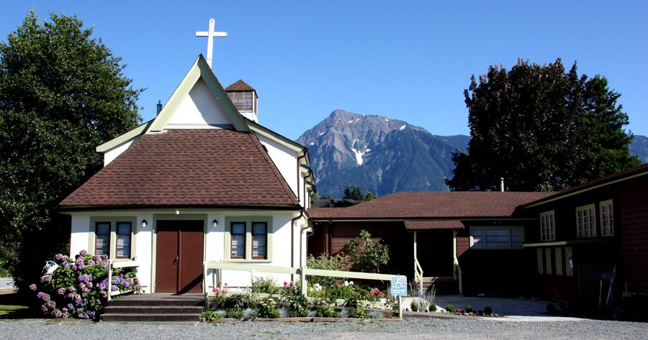

Situated on unceded Sto:lo traditional territory

Phone: 604-796-3553
Website: www.allsaints-agassiz.ca
https://www.facebook.com/groups/AllSaintsFamily

OUR DOOR IS OPEN AND ALL ARE WELCOME
5th December,2021
2nd Sunday in Advent

Priest-in-Charge: The Reverend Philip Barker
Hosts: Graham Featherstone/Jennifer Brooks
Intercessor: Graham Featherstone
Lay Administrator: Gail Thomson/Dorothy Cresswell
Announcer: Ginny Jennings
Piano: Fran Froehlich

PLEASE NOTE:

Zoom service will still be available and a link sent out around 09:45 by Graham. Email him at gfeatherstone@shaw.ca if you don’t think you’re on his list.
Vicar’s cell phone: Rev’d Philip Barker. 778-867-2461
Vicar’s Warden: Ginny Jennings. 604-796-2206
People’s Warden: Lynn Laughlin. 604-799-5131
Parish email: www.allsaints-agassiz.ca
Please contact either if you have an issue that needs to be brought to the attention of the Vicar - or contact the Vicar direct (see above for details).

WARDENS’ PITCH

-Wednesday Book Club is at 1600 (4.00 pm) for approximately an hour. We are now studying “The Whole Story: The Wedding of Science and Religion” by Norm Carroll. A Zoom link will be sent out by Valerie Hamilton (valeriejhamilton@yahoo.com) prior to 4:00 pm to all who have received the book.
-Evening Prayer with Valerie Hamilton is at 1900 (7.00 pm) on Sunday, Wednesday, and Friday, and can be found on our webpage.
-Those interested in helping with car-pooling on a Sunday morning to help folks get to church, please contact Lynn.
-Prayer requests can be given on a piece of paper to either of the Wardens or the Vicar, or entered into the Prayer Request Book on the piano in the church.
-Requests for hymns and other pieces of music that might enhance our worship are invited. Again, requests either to the Wardens or Vicar.
-Any jokes that are not too risqué are invited for inclusion in the Bulletin to add a little humour to our mix.
-Likewise, any parishioners that have items they wish to dispose of may advertise them in the Bulletin. Please do not price any items, but give a contact number or email address, so that negotiation is not done through this publication.
-Bible study is cancelled until further notice. Updates will be posted when available.
-We have not received any further offers to fill our coffee roster, so some Sundays will be coffee and tea only and maybe a cookie (if we haven’t eaten them all during the week). We appreciate that coffee hosts pay for the food they provide themselves, and what they bring is a donation to all of us. If you have any dietary sensitivities or needs, please bring what you need and we can keep your items in the freezer with your name attached, so that you have what you need each week. If you decide to sign up to host, please let Anthea, Ginny or Lynn know.
- Our new Lectionary was carefully and lovingly compiled by Fred before his death. It was a ministry he did very well and was happy to do over the years. Thanks to Valerie who volunteered to take this ministry over. We are so very blessed here at All Saints. If anyone is interested in putting their names forward for Reader, Intercessor or Lay Administrator, we will gratefully accept your offer, with thanks. If you have any questions or offers, please contact the Vicar or Wardens.

Ready to take another step towards reconciliation?

A vital step on the pathway to reconciliation with Indigenous People is educating all Canadians about the effects of colonialism and its ongoing impact on Indigenous individuals and communities today. The KinSHIFT series of Indigenous-led, virtual workshops, designed to help Non-Indigenous settlers “in building respectful relationships with Indigenous peoples and place” is being repeated in January and February 2022. The sessions are weekly and there are several times of day to choose from. It is not necessary to attend all 4 sessions but attending at least 2 opens the door to the new follow-on series ReconciliACTION.
It would be good if more people from the parish could attend. If the cost is prohibitive please speak to Revd Philip.

For full details of dates and times and how to obtain tickets follow the link to www.kinshift.ca or contact Sheila at sjbarker0379@gmail.com

Our wonderful sale is now postponed until Spring – maybe the weather will be better then!

Raising Hearts to Remember

Raising Hearts to Remember is an opportunity for individuals to learn about Canada’s Residential Schools while creating a felted heart that will become part of a work that commemorates the Missing Children in Kamloops and other Residential Schools, holding vision for them during the process of identification and repatriation. The hearts will be hung from a drum in the Diocesan Offices. Kerry Baisley, the Diocesan Missioner for Indigenous Justice will be leading a workshop here at All Saints on Saturday January 22nd, 2022 from 10am-12.30pm. This date has been changed from December 11th because of the unpredictable weather and travel conditions. The workshop is free and all materials will be provided. Participants must be fully vaccinated adults. Places are limited so please register by emailing mgp2000@shaw.ca or sjbarker0379@gmail.com . The feedback from the same workshop held at St John the Divine in Maple Ridge was excellent.

The 5 A’s

Agassiz Anglican All Saints AA group will be meeting in the church hall on Tuesdays at noon, starting December 7th. This is a new group designed to provide a local day time meeting. It is being advertised in The Observer and on the AA website but please spread the word.

Get Together for Games

From January we will be offering a chance for over 55s to enjoy a morning of board games, cards, puzzles and most importantly friendship. This will be on Wednesdays from 10am to 12 noon in the church hall. It will be open to the local community and will be a chance to share our lovely facilities. Lynn, Maureen and Sheila will be the organisers. More details will follow.

DO NOT FORGET TO SEND ME YOUR REPORTS FOR THE AGM

Ministerial Meandering
-You know how it is when you have been really irritated or annoyed by someone and you just have to walk away or you might slug them?
-I was talking to one of our ‘peripheral’ flock yesterday and explaining to him how the Zulus we lived and worked with in South Africa only had one method of discussion - with a weapon. It occurred to me since, that I was being rather superior in my attitude, as though I had so much better debating skills. I suspect that given prior warning and time for preparation I could probably make a decent fist of it, but in the heat of the moment and put on the spot, I am frequently dumb with rage.
-Only later can I summon up those stunningly apposite and pithy retorts that I wish I had had at the time - but by then, of course, it is way too late.
-So why do I let myself get into such an internal turmoil over issues that are often not that important in the grand scheme of things anyway? I think it is possibly because I want other people to see things the way I see them, and to be able to read my thoughts. Why are people so stupid? - my reasoning goes - they should know what I think about such and such.
Just because my brain is moving down a certain track, I seem to expect that yours should too.
-The result is an innate impatience - a permanent and instant annoyance with folks that I perceive as ‘not keeping up with me’.
But why the heck should they? They have their own paths to walk after all. Why should I expect them to instinctively follow mine?
-And that’s the clue to this whole business; the fact that I expect people to live up to my expectations - and I get thoroughly annoyed when they don’t. There is no reason on God’s earth why you should live up to my expectations, and so there is no reason why I should live up to yours. In other words, ‘How dare you say that I disappoint you? It is you who has disappointed me!’
But is this even true?

The answer to this is, ‘No’. The truth is that deep down it is myself that is disappointed with me. And how easy it is to turn around and blame someone else for our own shortcomings!
It is being aware of this dynamic in myself that is not easy; I need to learn to recognize it better. And then find the courage to change it.
-I wonder if any of you have ever felt the same?

Philip+

Chuckles
A man sued an airline company after it lost his luggage. Sadly he lost his case.

Birthdays This Month

Fran Froehlich the 19th, Carol Taylor the 25th and Ron Warren the 27th

Sunday Cycle of Prayer
2nd in Advent

The Deanery of Kingsway – The Reverend Wilmer Toyoken,
Regional Dean

Monthly Cycle of Prayer

St. John, Shaughnessy The Reverend Terry Dirbas (Dec 1)
The Reverend Liz Ruder-Celiz
St. Mary, Kerrisdale The Reverend Lindsay Hills
The Reverend Christine Rowe
St. Faith, Vancouver The Reverend Adam Yates
St. Hildegard’s Sanctuary The Reverend Melanie Calabrigo

Anglican Cycle of Prayer
Our Primate, Archbishop, Linda Nicolls. For National Indigenous Archbishop Mark MacDonald and for the Anglican Council of Indigenous People. We also pray for the “Missioner for Indigenous Justice” Kerry Baisley.
In our parish we pray for our priest, Philip; retired priests Mike, Jack, Bryson and Paul. Amen.

Collect – December 5, 2021
Almighty God, who sent your servant John the Baptist to prepare your people to welcome the Messiah, inspire us, the ministers and stewards of your truth, to turn our disobedient hearts to you, that when the Christ shall come again to be our judge, we may stand with confidence before his glory; who is alive and reigns with you and the Holy Spirit, one God, now and for ever.

Malachi 3: 1-4 Hilary Routley
Introduction: Malachi is a book of prophecy directed to the priests in the Temple. Priests have replaced kings as those closest to God on earth, but the priesthood is corrupt. The prophet speaks in God’s name.
Reading: See, I am sending my messenger to prepare the way before me, and the Lord whom you seek will suddenly come to his temple. The messenger of the covenant in whom you delight--indeed, he is coming, says the LORD of hosts.
But who can endure the day of his coming, and who can stand when he appears? For he is like a refiner's fire and like fullers' soap;
he will sit as a refiner and purifier of silver, and he will purify the descendants of Levi and refine them like gold and silver, until they present offerings to the LORD in righteousness.
Then the offering of Judah and Jerusalem will be pleasing to the LORD as in the days of old and as in former years.

Hear what the Spirit is saying to the Church. Thanks be to God.

Luke 1: 68-79 "Blessed be the Lord God of Israel, for he has looked favorably on his people and redeemed them.
He has raised up a mighty savior for us in the house of his servant David,
as he spoke through the mouth of his holy prophets from of old,
that we would be saved from our enemies and from the hand of all who hate us.
Thus he has shown the mercy promised to our ancestors, and has remembered his holy covenant,
the oath that he swore to our ancestor Abraham, to grant us
that we, being rescued from the hands of our enemies, might serve him without fear,
in holiness and righteousness before him all our days.
And you, child, will be called the prophet of the Most High; for you will go before the Lord to prepare his ways,
to give knowledge of salvation to his people by the forgiveness of their sins.
By the tender mercy of our God, the dawn from on high will break upon us,
to give light to those who sit in darkness and in the shadow of death, to guide our feet into the way of peace."

Philippians 1: 3-11 Sheila Barker
Introduction: In the verses following the salutation of the letter, Paul thanks God for the Christians at Philippi, for sharing in the community of faith ever since their conversion. He expresses confidence that God will complete, at the end of the era, the transformation to godliness already begun in them
Reading: I thank my God every time I remember you,
constantly praying with joy in every one of my prayers for all of you,
because of your sharing in the gospel from the first day until now.
I am confident of this, that the one who began a good work among you will bring it to completion by the day of Jesus Christ.
It is right for me to think this way about all of you, because you hold me in your heart, for all of you share in God's grace with me, both in my imprisonment and in the defense and confirmation of the gospel.
For God is my witness, how I long for all of you with the compassion of Christ Jesus.
And this is my prayer, that your love may overflow more and more with knowledge and full insight
to help you to determine what is best, so that in the day of Christ you may be pure and blameless,
having produced the harvest of righteousness that comes through Jesus Christ for the glory and praise of God.

Hear what the Spirit is saying to the Church. Thanks be to God

The Gospel Luke 3: 1 - 6

Introduction: In language first used in the book of Isaiah to foretell the return of the Israelites from exile, Luke tells us that John the Baptist’s mission is to prepare the way for Jesus, by inviting people to make new starts in life, to live ethically from now on.
Reading: In the fifteenth year of the reign of Emperor Tiberius, when Pontius Pilate was governor of Judea, and Herod was ruler of Galilee, and his brother Philip ruler of the region of Ituraea and Trachonitis, and Lysanias ruler of Abilene,
during the high priesthood of Annas and Caiaphas, the word of God came to John son of Zechariah in the wilderness.
He went into all the region around the Jordan, proclaiming a baptism of repentance for the forgiveness of sins,
as it is written in the book of the words of the prophet Isaiah, "The voice of one crying out in the wilderness: 'Prepare the way of the Lord, make his paths straight.
Every valley shall be filled, and every mountain and hill shall be made low, and the crooked shall be made straight, and the rough ways made smooth;
and all flesh shall see the salvation of God.'"

