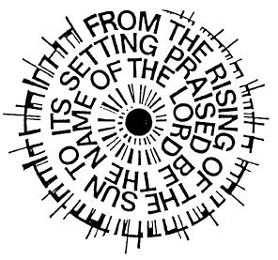
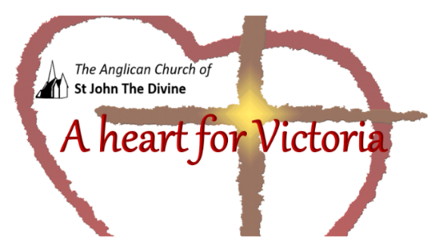
Celebrating Common Prayer

Society of St Francis

Midday Prayer – Tuesday (amended)

THE PREPARATION
O God, make speed to save us.
O Lord, make haste to help us.

Glory to God, Creator, Word, Spirit
As it was in the beginning, is now,
And shall be forever. Amen

Alleluia! (Omitted in Lent)

A HYMN is said or sung
O God of truth, O Lord of might,
You order time and change aright,
And send the early morning ray
And light the glow of perfect day.

Extinguish every sinful fire
And banish all our ill desire;
And, while you keep the body whole,
Shed forth your peace upon the soul.

O Father, that we ask be done
Through Jesus Christ, your only Son,
Who, with the Spirit, reigns above,
Three Persons in one God of love. Amen.

THE WORD OF GOD

THE PSALMODY

Psalm 13

1 How long will you forget me, O Lord; for ever? ♦
How long will you hide your face from me?
2 How long shall I have anguish in my soul
and grief in my heart, day after day? ♦
How long shall my enemy triumph over me?
3 Look upon me and answer, O Lord my God; ♦
lighten my eyes, lest I sleep in death;
4 Lest my enemy say, ‘I have prevailed against him,’ ♦
and my foes rejoice that I have fallen.
5 But I put my trust in your steadfast love; ♦
my heart will rejoice in your salvation.
6 I will sing to the Lord, ♦
for Godhas dealt so bountifully with me.

Glory to God, Creator, Word, Spirit
As it was in the beginning, is now,
And shall be forever. Amen

THE READING

John 9.1-5
A shoot shall come out from the stock of Jesse, and a branch shall grow out of his roots. The spirit of the Lord shall rest on him, the spirit of wisdom and understanding, the spirit of counsel and might, the spirit of knowledge and the fear of the Lord. His delight shall be in the fear of the Lord. He shall not judge by what his eyes see, or decide by what his ears hear; but with righteousness he shall judge the poor, and decide with equity for the meek of the earth; he shall strike the earth with the rod of his mouth, and with the breath of his lips he shall kill the wicked., ,
, , Isaiah 11.1-

THE RESPONSE:

Unless the Lord builds the house,
Those who build it labour in vain.

Unless the Lord defends the city,
The guard keeps watch in vain.

It is in vain that you rise up early
And go so late to rest.

Vain, also, to eat the bread of toil,
For God gives to God’s belovèd sleep.

The Lord shall preserve you from all evil;
Your Maker will guard your life.

God will keep your going out and your coming in,
Now and for evermore.

THE PRAYERS

PRAYERS OF INTERCESSION

THE KYRIES may be used as part of the intercessions

Lord, have mercy.
Lord, have mercy.

Christ, have mercy.
Christ, have mercy.

Lord, have mercy.
Lord, have mercy.

THE COLLECT:

Keep us, O Lord,
while we tarry on this earth,
in a serious seeking after you,
and in an affectionate walking with you,
every day of our lives;
that when you come,
we may be found not hiding our talent,
nor serving the flesh,
nor yet asleep with our lamp unfurnished,
but waiting and longing for our Lord,
our glorious God for ever.
Amen.

As we look for the coming of God’s reign in fullness,
Lord, teach us to pray:
Our Father in heaven,
hallowed be your name;
your kingdom come;
your will be done;
on earth as in heaven.
Give us today our daily bread.
And forgive us our sins,
as we forgive those who sin against us.
Keep us from the time of trial
but deliver us from evil.
For the kingdom, the power
and the glory, are yours
now and ever. Amen.

THE BLESSING

May God bless the work of our hands. Amen.

Let us bless the Lord.
Thanks be to God.

