Faith Evangelical Lutheran Church, Washington, IL
First Sunday of Advent
November 28, 2021

Welcome

Lighting of the Advent Candles Red Book #242

Text: Marty Haugen, b. 1950
Music: REJOICE, REJOICE, Marty Haugen
Text and music © 1983 GIA Publications, Inc., 7404 S. Mason Ave., Chicago, IL 60638. www.giamusic.com.800.442.3358. All rights reserved. Used by permission. Reprinted under OneLicense #A-711151

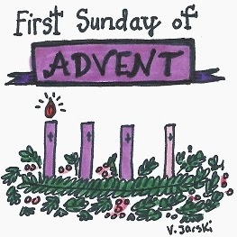
Please pray with me as we light our First Advent Candle.
Blessed are you, O Lord our God, ruler of the universe. In your Son, Emmanuel, you have shown us your light and saved us from the power of sin. Bless us as we light the candles of this wreath. Increase our longing for your presence, that at the celebration of your Son’s birth his Spirit might dwell anew in our midst, for he is our light and our salvation. Blessed be God forever. Amen.

Confession and Forgiveness

P: In the name of the Father, and of the + Son, and of the Holy Spirit.
C: Amen.
You may make the sign of the cross as a reminder of your baptism.
P: Blessed be the holy Trinity, ☩ one God, who alone does wonders,
who lifts up the lowly, who fills the hungry with good things.
C: Amen.
P: Let us confess our sin in the presence of God and of one another.
Please keep silence for reflection
P: God for whom we wait,
C: in the presence of one another, we confess our sin before you. We fail in believing that your good news is for us. We falter in our call to tend your creation. We find our sense of self in material wealth. We fear those different from ourselves. We forget that we are your children and turn away from your love. Forgive us, Blessed One, and assure us again of your saving grace.
Amen.

P: God, in Christ Jesus, has looked with favor upon you! Through the power of the Holy Spirit, ☩ your sins are forgiven. You are children of the Most High,
inheritors of the eternal promise, and recipients of divine mercy. God strengthens you anew to follow the way of peace.
C: Amen.
Faith Lutheran Church
2206 Washington Rd,
Washington, IL 61571
Website and online worship:
www.shareourfaith.org
Church: 309-745-9306
faithlth@shareourfaith.org
Pastor John Rothfusz
Home: 309-745-9282
pastor@shareourfaith.org

Peace: As forgiven children of God, we have peace
with God, and peace with one another.

P The peace of the Lord be with you always.
C And also with you.
P Let us share that peace with one another.

*Hymn: “Lost in the Night” Red Book #243

Text: Nordic hymn; tr. Olav Lee, 1859-1943, alt.
Music: LOST IN THE NIGHT, Finnish folk tune
Text © 1932 Augsburg Publishing House, admin. Augsburg Fortress
Reprinted under OneLicense.net#A-711151

P The grace of our Lord Jesus Christ, the love of God,
and the communion of the Holy Spirit be with you all.
C And also with you.

Hymn of Praise
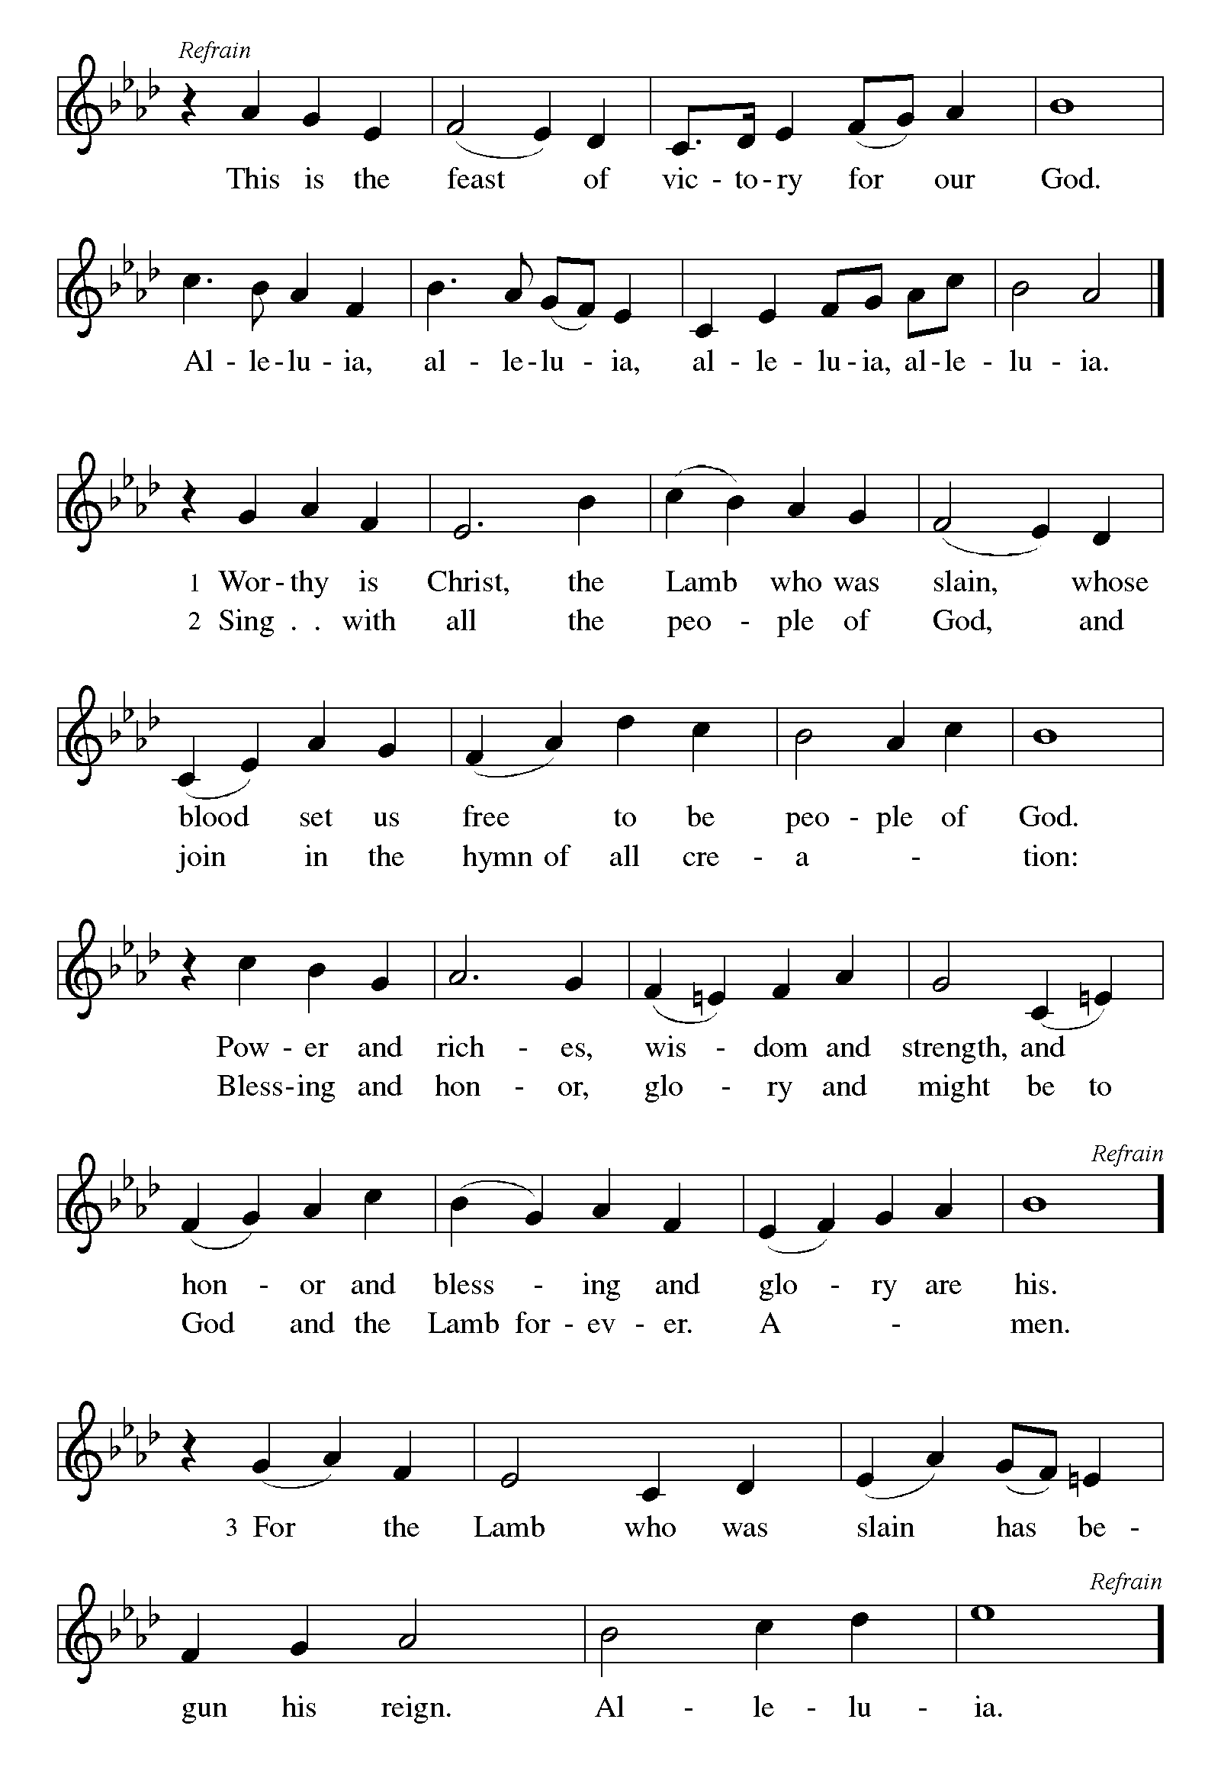

P The Lord be with you
C And also with you.
Let us pray together the Prayer of the Day
Stir up your power, Lord Christ, and come. By your merciful protection alert us to the threatening dangers of our sins, and redeem us for your life of justice, for you live and reign with the Father and the Holy Spirit, one God, now and forever. Amen

Children’s Message

First Reading: Jeremiah 33:14-16 Pew Bible Page #636
¹⁴The days are surely coming, says the Lord, when I will fulfill the promise I made to the house of Israel and the house of Judah. ¹⁵In those days and at that time I will cause a righteous Branch to spring up for David; and he shall execute justice and righteousness in the land. ¹⁶In those days Judah will be saved and Jerusalem will live in safety. And this is the name by which it will be called: “The Lord is our righteousness.”

R The Word of the Lord
C Thanks be to God
Psalm 25:1-10
¹To you, O Lord,
I lift up my soul.
²My God, I put my trust in you; let me not be put to shame,
nor let my enemies triumph over me.
³Let none who look to you be put to shame;
rather let those be put to shame who are treacherous.
⁴Show me your ways, O Lord,
and teach me your paths.
⁵Lead me in your truth and teach me,
for you are the God of my salvation; in you have I trusted all the day long.
⁶Remember, O Lord, your compassion and love,
for they are from everlasting.
⁷Remember not the sins of my youth and my transgressions;
remember me according to your steadfast love and for the sake of your
goodness, O Lord.
⁸You are gracious and upright, O Lord;
therefore you teach sinners in your way.
⁹You lead the lowly in justice
and teach the lowly your way.
¹⁰All your paths, O Lord, are steadfast love and faithfulness
to those who keep your covenant and your testimonies.
Second Reading – 1 Thessalonians 3:9-13 Pew Bible Page #959
⁹How can we thank God enough for you in return for all the joy that we feel before our God because of you? ¹⁰Night and day we pray most earnestly that we may see you face to face and restore whatever is lacking in your faith.
¹¹Now may our God and Father himself and our Lord Jesus direct our way to you. ¹²And may the Lord make you increase and abound in love for one another and for all, just as we abound in love for you. ¹³And may he so strengthen your hearts in holiness that you may be blameless before our God and Father at the coming of our Lord Jesus with all his saints.

R The Word of the Lord C Thanks be to God

Gospel Reading: Luke 21:24-36 Pew Bible Page #852

C Glory to you, O Lord
[Jesus said:] ²⁵“There will be signs in the sun, the moon, and the stars, and on the earth distress among nations confused by the roaring of the sea and the waves. ²⁶People will faint from fear and foreboding of what is coming upon the world, for the powers of the heavens will be shaken. ²⁷Then they will see ‘the Son of Man coming in a cloud’ with power and great glory. ²⁸Now when these things begin to take place, stand up and raise your heads, because your redemption is drawing near.”
²⁹Then he told them a parable: “Look at the fig tree and all the trees; ³⁰as soon as they sprout leaves you can see for yourselves and know that summer is already near. ³¹So also, when you see these things taking place, you know that the kingdom of God is near. ³²Truly I tell you, this generation will not pass away until all things have taken place. ³³Heaven and earth will pass away, but my words will not pass away.
³⁴“Be on guard so that your hearts are not weighed down with dissipation and drunkenness and the worries of this life, and that day does not catch you unexpectedly, ³⁵like a trap. For it will come upon all who live on the face of the whole earth. ³⁶Be alert at all times, praying that you may have the strength to escape all these things that will take place, and to stand before the Son of Man.”
The Gospel of the Lord
C Praise to you, O Christ
Sermon by Pastor John Rothfusz
Sermon Hymn: “Christ, Be Our Light” Red Book #715

Text: Bernadette Farrell, b. 1957
Music: CHRIST, BE OUR IGHT, Bernadette Farrell
Text and music © 1993 Bernadette Farrell. Published by OCP Publications, 5536 NE Hassalo, Portland, OR 97213,
All rights reserved. Reprinted under OneLicense.net#A-711151

Apostles’ Creed
C: I believe in God, the Father almighty,
creator of heaven and earth.
I believe in Jesus Christ, God's only Son, our Lord,
who was conceived by the Holy Spirit,
born of the virgin Mary,
suffered under Pontius Pilate,
was crucified, died, and was buried;
he descended to the dead.
On the third day he rose again;
he ascended into heaven,
he is seated at the right hand of the Father,
and he will come to judge the living and the dead.
I believe in the Holy Spirit,
the holy catholic church, the communion of saints,
the forgiveness of sins, the resurrection of the body,
and the life everlasting. Amen.

Prayers: After each portion of the prayers finishes with “Lord in your mercy,” please respond, “Hear our prayer.”

Offering: Jesus fills us with faith and sends us out as his witnesses. Let us commit ourselves to the Lord and joyfully lift our tithes and offerings to the Lord.

Please take a moment now to make an electronic offering to the church on the website, with the Tithe.ly app on your phone, or write a check and drop it in the plate at communion time.
Faith Lutheran website link www.shareourfaith.org

A Let us pray. Blessed are you, O God,
C maker of all things. Through your goodness you have blessed us with these gifts: our selves, our time, and our possessions. Use us, and what we have gathered, in feeding the world with your love, through the one who gave himself for us, Jesus Christ, our Savior and Lord. Amen.

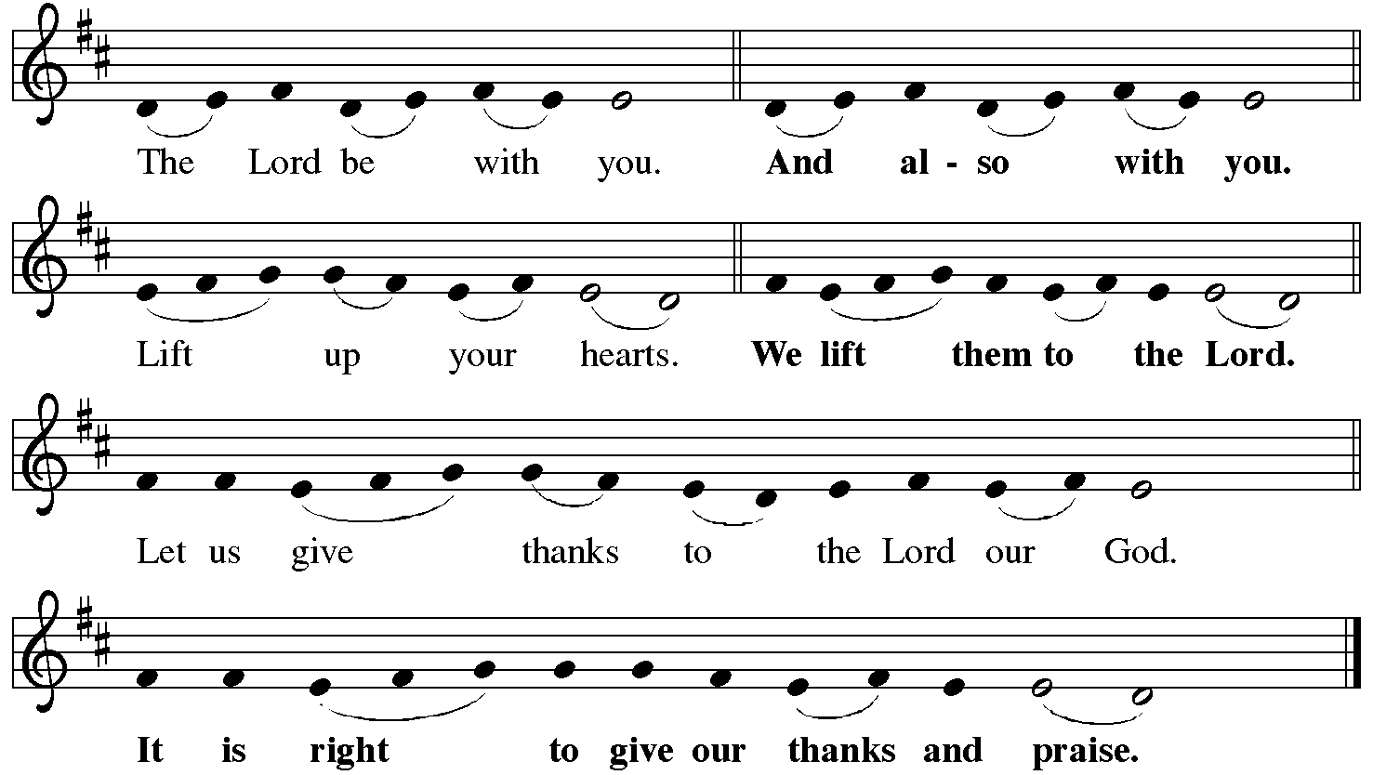

P It is indeed right, our duty and our joy… with the church on earth and the hosts of heaven, we praise your name and join their unending hymn:
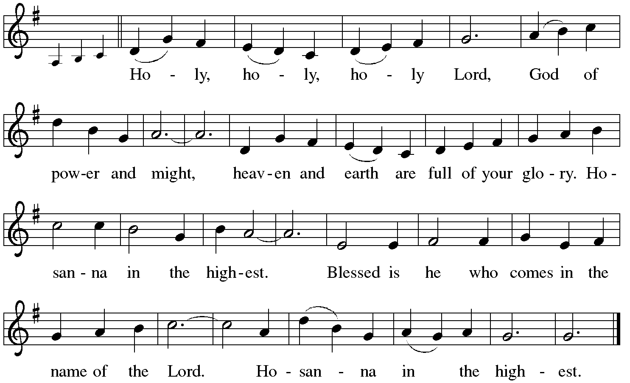

Holy Communion: Preface pp. 108-111 or other Eucharistic prayer

In the night in which he was betrayed,
our Lord Jesus took bread, and gave thanks;
broke it, and gave it to his disciples, saying:
Take and eat; this is my body, given for you.
Do this for the remembrance of me.
Again, after supper, he took the cup, gave thanks,
and gave it for all to drink, saying:
This cup is the new covenant in my blood,
shed for you and for all people for the forgiveness of sin.
Do this for the remembrance of me.
C The Lord's Prayer
Our Father, who art in heaven, hallowed be thy name,
thy kingdom come, thy will be done, on earth as it is in heaven.
Give us this day our daily bread; and forgive us our trespasses,
as we forgive those who trespass against us;
and lead us not into temptation, but deliver us from evil.
For thine is the kingdom, and the power, and the glory,
forever and ever. Amen
The Iona Invitation (Iona Community, Scotland)
This is the table not of the righteous, but of the poor in spirit. It is the table of sharing with the poor of the world, with whom our Savior identified. It is the table of communion with the earth, in which our Lord became incarnate. This is the table not of the church, but of Jesus Christ. So come to this table, you who have much faith and you who would like to have more; you who have been here often, and you who have not been for a while or ever before; you who have tried to follow Jesus, and you who have failed; Come—not because the Church invites you— It is Christ who invites you to be known and fed here.

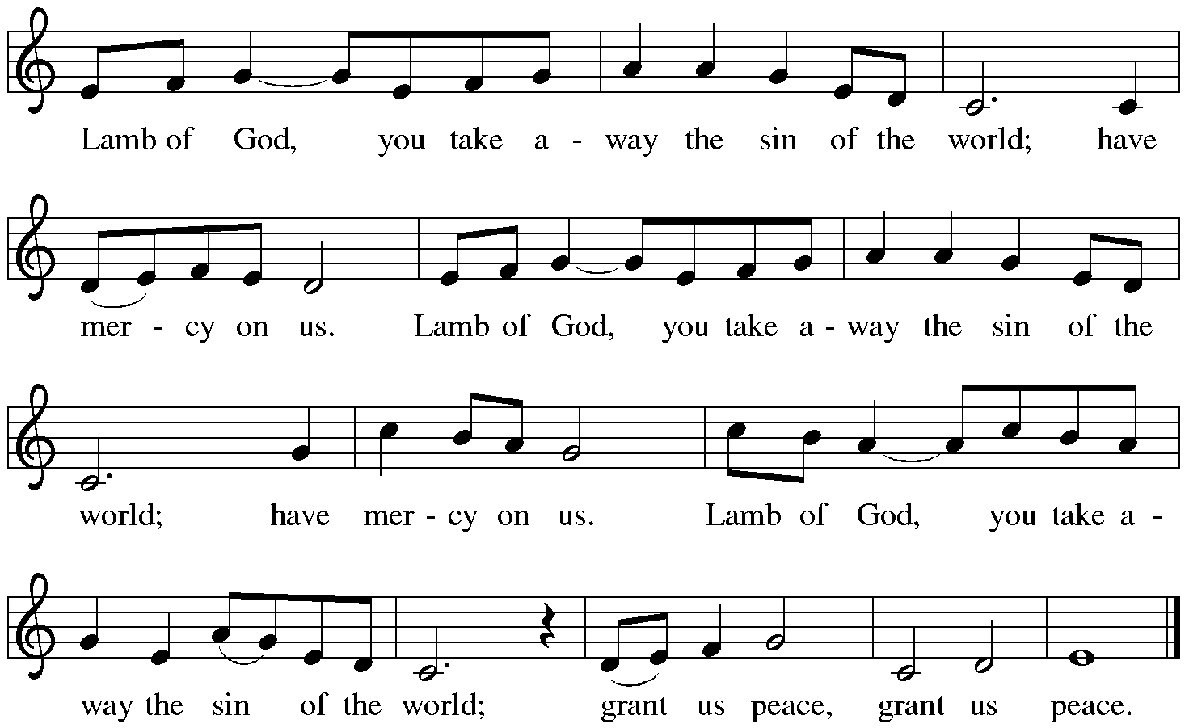

Distribution:

Communion Prayer

Announcements

Blessing
P The Lord bless you and keep you. The Lord make his face shine on you and be gracious to you. The Lord look upon you with favor and + give you peace.
In the name of the Father, and of the Son and of the Holy Spirit.
C Amen

Hymn: “Soon and Very Soon” Red Book #439
Text: Andraé Crouch
Text and music © 1976 Bud John Songs, Inc.,/Crouch Music, admin. EMI Christian Music Publishing CCLI License #1375910

Dismissal
A Go in peace. Serve the Lord.
C Thanks be to God!
Postlude

Liturgy and texts from Sundays and Seasons.com. Copyright 2021 Augsburg Fortress. All rights reserved.
Reprinted by permission under Augsburg Fortress Liturgies Annual License #23628.

